Checkout Service — Technical Design
Architecture, State Machines, Webhook Idempotency, Edge Cases & Strategic Improvements
Spring Boot 4.x • Java 21 • PostgreSQL / H2

1. Architecture & Key Decisions
The checkout-service is organised around three business modules — cart, order, payment — plus a shared module for cross-cutting contracts (facades, DTOs, exception handling). Each business module owns its domain aggregate, state transitions, repository, service, and REST controller. Cross-module communication is routed through explicit facades in the shared module; no module imports another module's service or domain classes directly.
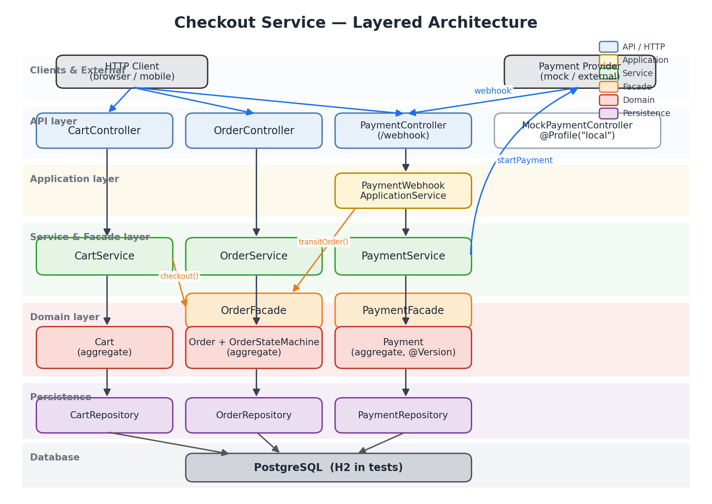
Figure 1 — Layered architecture with module boundaries

1.1 Module Boundaries
- cart — active shopping basket and its items (Cart, CartItem aggregates).
- order — confirmed purchases driven by an explicit state machine (Order, OrderItem, OrderStateMachine).
- payment — external-provider integration, webhook processing, idempotency (Payment aggregate with @Version optimistic lock).
- shared — OrderFacade, PaymentFacade, DTOs, global exception handler, i18n messages.

1.2 Key Architectural Decisions
Decision 1 — Facade pattern for cross-module calls.
CartService does not import OrderService. It calls OrderFacade, which lives in shared.facade.order. The facade interface accepts only shared DTOs, so cart has no knowledge of the Order entity.
// CartService.checkout(...)
Cart cart = findCart(cartId);
cart.checkout();
cartRepository.save(cart);
return orderFacade.createOrder(toCartCheckoutData(cart));
Decision 2 — Application service layer for webhook orchestration.
The webhook endpoint must update both the Payment aggregate and the Order aggregate in one logical step. Rather than leaking this coupling into a controller, PaymentWebhookApplicationService owns the orchestration and the PaymentStatus → OrderState mapping.
// PaymentWebhookApplicationService.processWebhook
paymentService.processWebhook(externalPaymentId, status)
.ifPresent(payment -> orderFacade.transitOrder(
payment.getOrderId(), toOrderState(payment.getStatus())));
Decision 3 — Rich domain aggregates, not anemic DTOs.
Every business invariant lives on the aggregate. Cart rejects inactive state changes; Order delegates to OrderStateMachine; Payment exposes confirm() / fail() that guard against illegal transitions.
// Payment.confirm()
public void confirm() {
if (status != PaymentStatus.PENDING) {
throw new PaymentException(
PaymentErrorCode.CONFIRM_PAYMENT_INVALID_STATUS, status);
}
status = PaymentStatus.CONFIRMED;
}
Decision 4 — Constructor injection, immutable DTOs, defensive copies.
- All Spring beans take dependencies via constructor — no field injection.
- Every DTO is a Java record — immutable by default.
- Aggregates return List.copyOf(items) to protect internal state from callers.
Decision 5 — Centralised exception handling with i18n.
Each module has its own *ErrorCode enum with a message key; *Exception carries a varargs Object... args for parameterised messages. GlobalExceptionHandler resolves the message key via Spring's MessageSource, enabling internationalisation without touching business logic.

2. State Machine & Payment Flow

2.1 Order State Machine
An Order moves through five states. Valid transitions are enumerated in OrderStateMachine — any attempted transition that is not in the allow-list throws an OrderException. The UML notation below uses the filled black circle (●) for the initial pseudostate and the bullseye (◉) for terminal states.
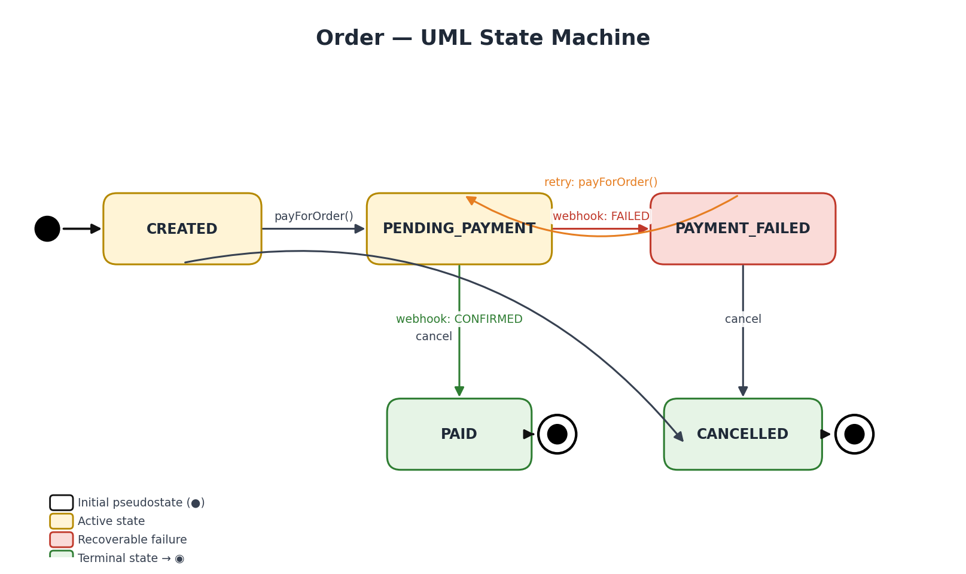
Figure 2 — Order state machine (UML)
// OrderStateMachine.TRANSITIONS
private static final Map<OrderState, Set<OrderState>> TRANSITIONS = Map.of(
OrderState.CREATED, Set.of(OrderState.PENDING_PAYMENT, OrderState.CANCELLED),
OrderState.PENDING_PAYMENT, Set.of(OrderState.PAID, OrderState.PAYMENT_FAILED),
OrderState.PAYMENT_FAILED, Set.of(OrderState.PENDING_PAYMENT, OrderState.CANCELLED),
OrderState.PAID, Set.of(),
OrderState.CANCELLED, Set.of()
);
- PAID and CANCELLED are terminal — no outgoing transitions.
- PAYMENT_FAILED → PENDING_PAYMENT is the only recoverable backward step, enabling retries.
- Invalid transitions raise OrderException(INVALID_STATE_TRANSITION) and return HTTP 400.

2.2 Payment State Machine
Payment's state is simpler but equally strict. A Payment can only move from PENDING to exactly one of its terminal states.
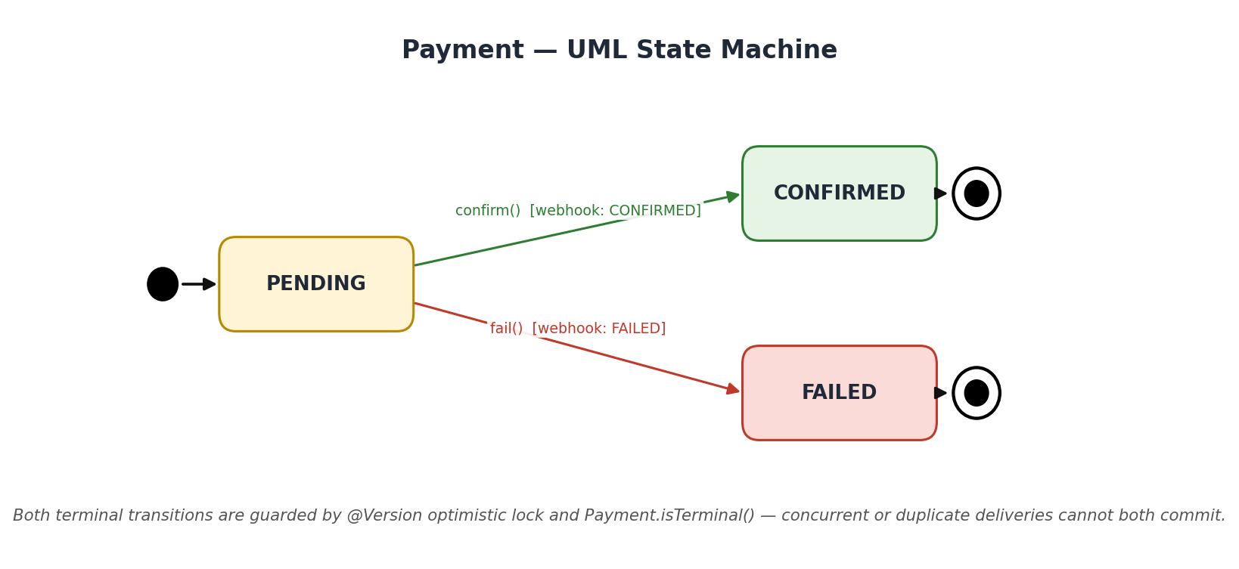
Figure 3 — Payment state machine (UML)

2.3 End-to-End Flow
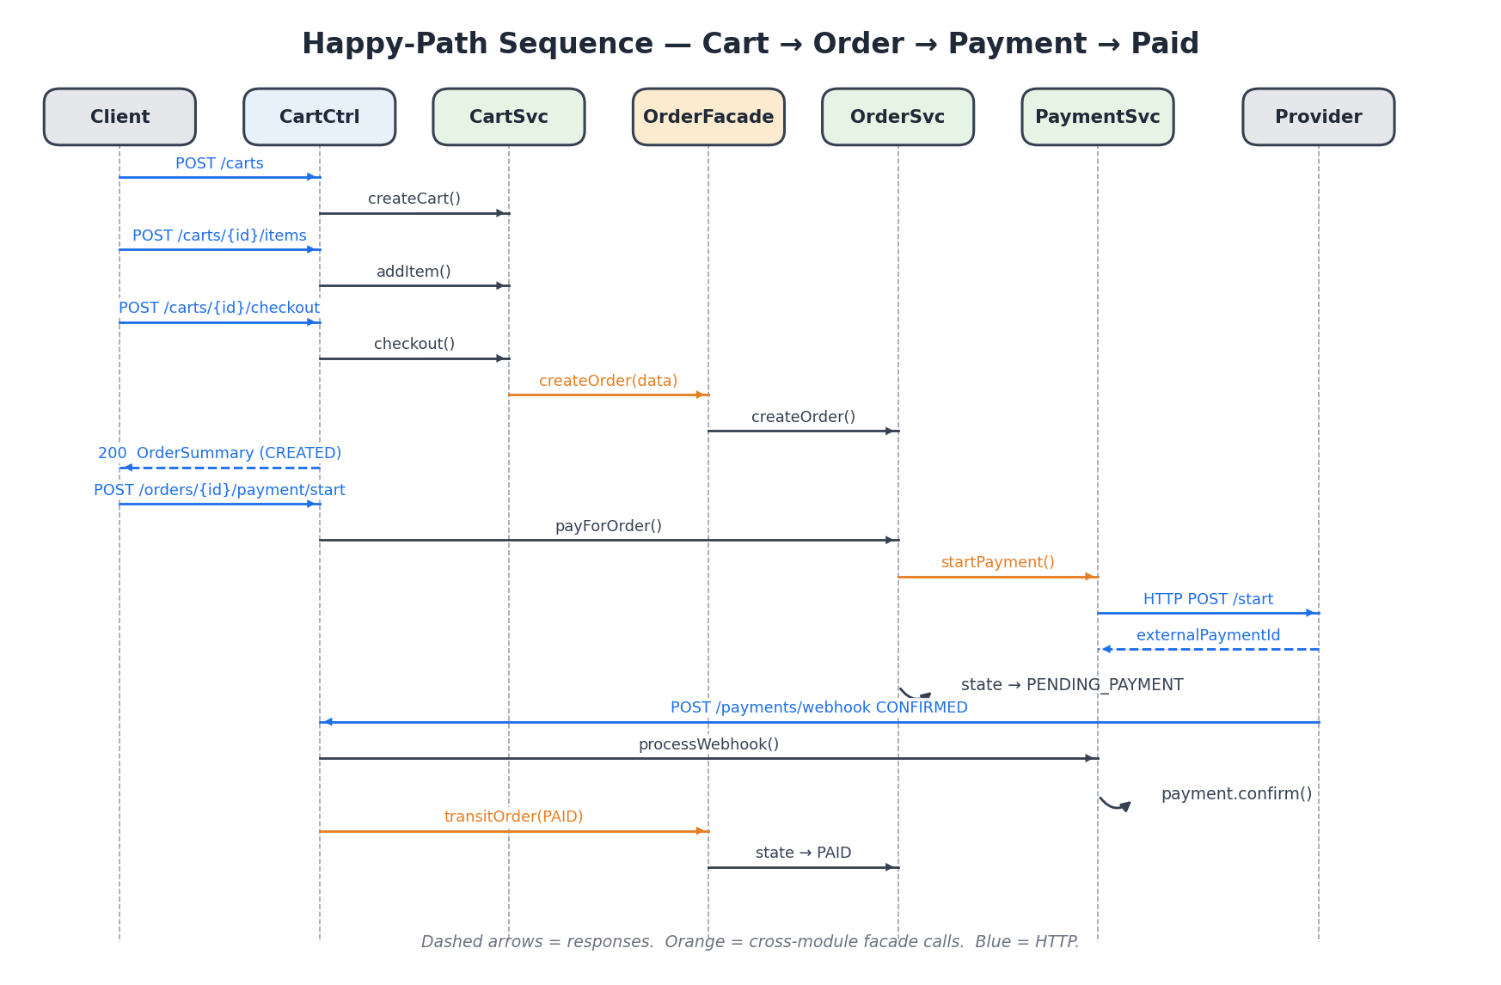
Figure 4 — Happy-path sequence: cart → order → payment → confirmed
- Client creates an empty cart, adds items, and calls checkout.
- CartService delegates order creation to OrderFacade.
- OrderService.payForOrder() calls PaymentService via PaymentFacade, which contacts the external provider.
- Order transitions to PENDING_PAYMENT; the provider later delivers a webhook.
- The webhook flow confirms the payment and transitions the order to PAID.

3. Webhook Handling & Idempotency
External payment providers guarantee at-least-once delivery of webhooks. The checkout service must therefore be idempotent: receiving the same webhook twice must leave the system in exactly the same state as receiving it once, and must not corrupt data.

3.1 Decision Flow
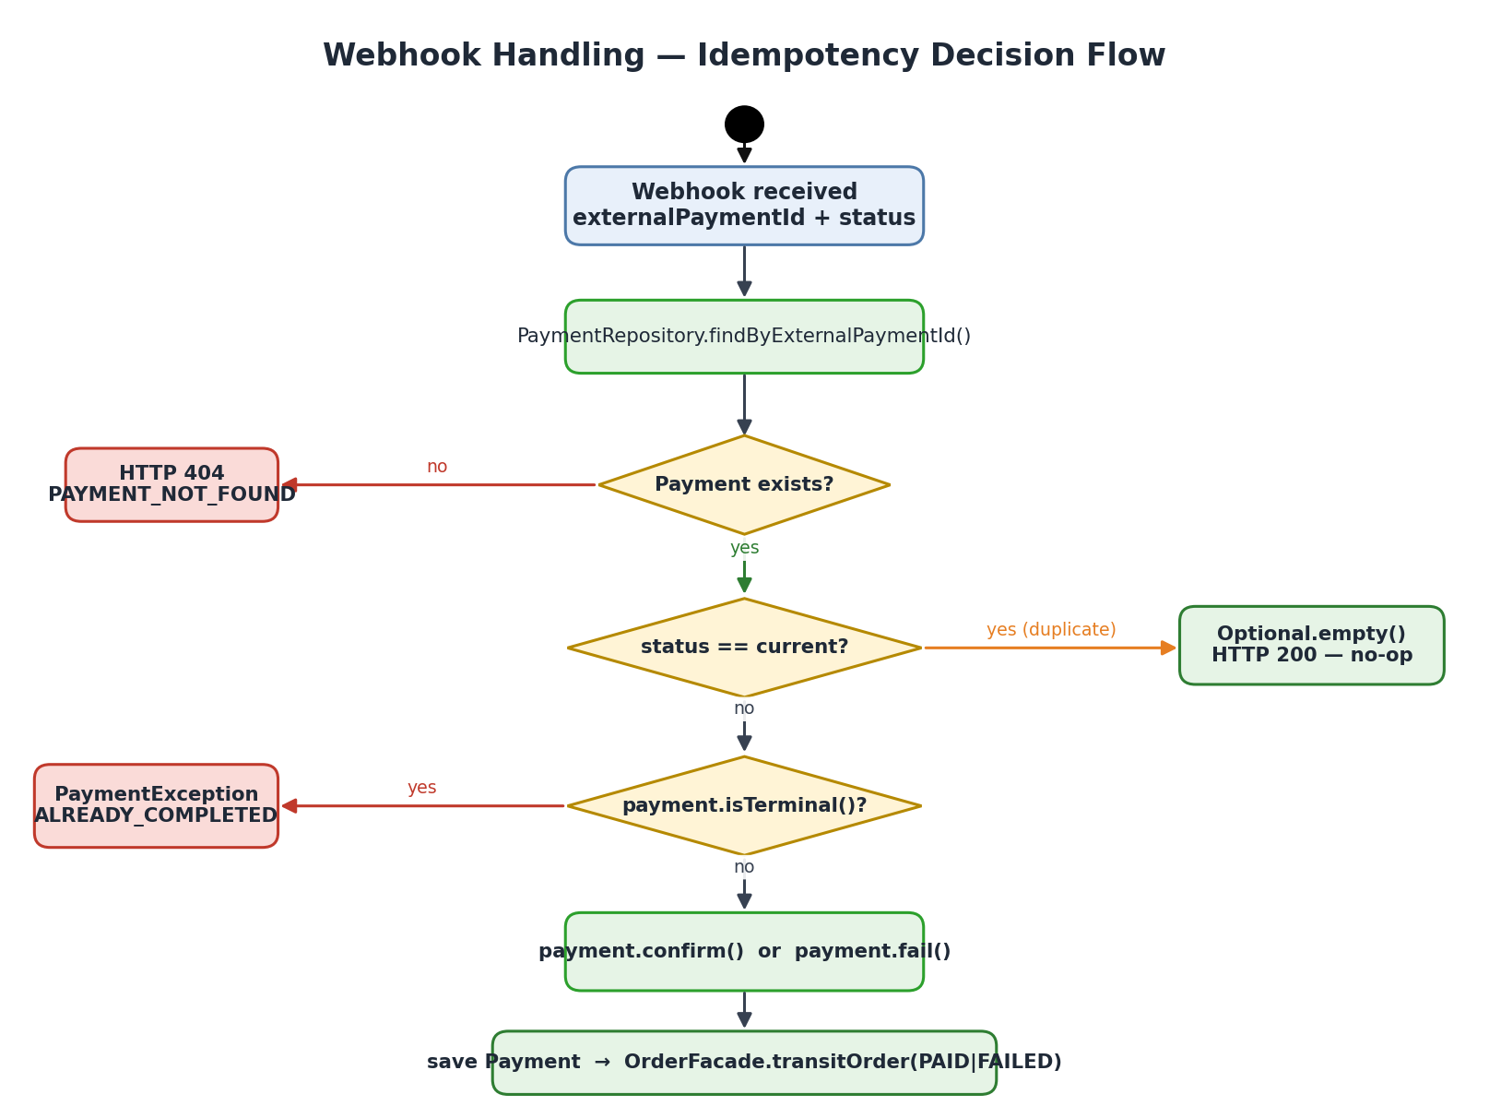
Figure 5 — Webhook decision flow inside PaymentService

3.2 Optional<Payment> Contract
PaymentService.processWebhook returns Optional<Payment>. A present value means a real state transition occurred and the caller must propagate it to the Order. An empty Optional means the webhook was a duplicate and nothing downstream should run.
// PaymentService.processWebhook — idempotency guard
PaymentStatus targetStatus = PaymentStatus.valueOf(status);
if (payment.getStatus().equals(targetStatus)) {
return Optional.empty(); // duplicate — no-op
}
if (payment.isTerminal()) {
throw new PaymentException(
PaymentErrorCode.PAYMENT_ALREADY_COMPLETED, payment.getStatus());
}
if (targetStatus.equals(PaymentStatus.CONFIRMED)) {
payment.confirm();
} else if (targetStatus.equals(PaymentStatus.FAILED)) {
payment.fail();
}
return Optional.of(paymentRepository.save(payment));

3.3 Idempotency at Three Layers
- PaymentService.startPayment — rejects duplicate active payments via existsByOrderIdAndStatus(PENDING) pre-check.
- PaymentService.processWebhook — idempotency guard on matching target status + terminal-state guard.
- Payment.@Version (optimistic lock) — concurrent webhook deliveries cannot both commit; the loser retries or fails fast.

3.4 Transactional Boundary
PaymentWebhookApplicationService.processWebhook is @Transactional — the payment state update and the order state transition commit or roll back together. A failure while transitioning the order undoes the payment confirmation, keeping payment and order states aligned.

4. Edge Cases — Failures, Retries, Duplicates

4.1 Payment Failure → Retry
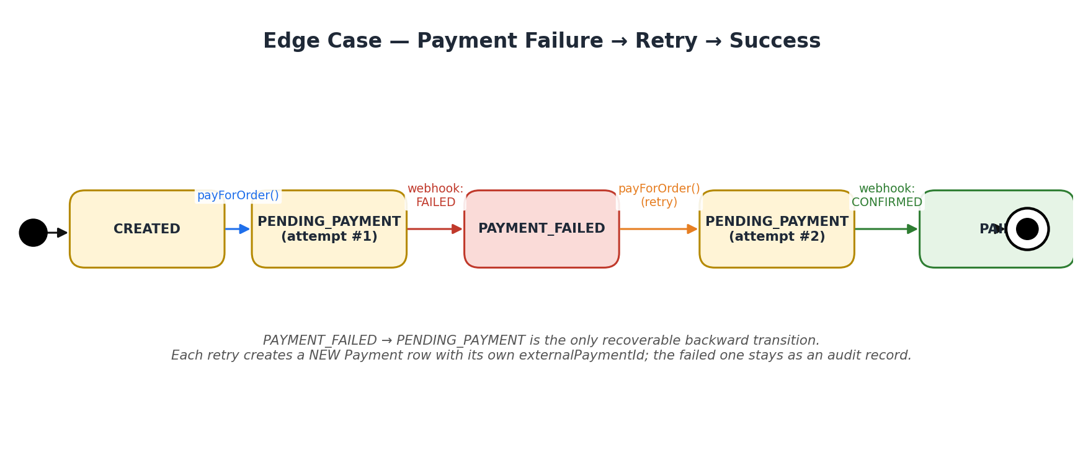
Figure 6 — Failed payment followed by successful retry
- First attempt's Payment row stays as an audit record (status FAILED).
- Retry creates a NEW Payment row with a fresh externalPaymentId from the provider.
- Order transitions PAYMENT_FAILED → PENDING_PAYMENT → PAID across attempts.

4.2 Duplicate Webhook Delivery
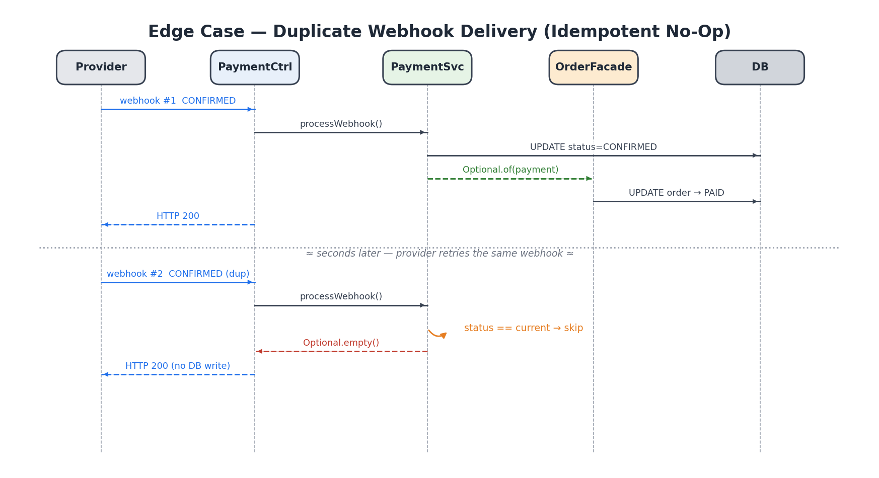
Figure 7 — Second delivery of the same CONFIRMED webhook is a no-op
- First delivery: Payment moves PENDING → CONFIRMED, Order moves PENDING_PAYMENT → PAID.
- Second delivery: status match triggers Optional.empty(), OrderFacade is never called, DB state unchanged.
- Verified by flow3_duplicateWebhook_isIdempotentAndOrderRemainsInPaidState in CheckoutIntegrationTest.

4.3 Duplicate Checkout on Same Cart
A cart that has already been checked out is marked CHECKED_OUT. A second checkout call is rejected by Cart.checkout() with CART_ALREADY_CHECKED_OUT (HTTP 400). OrderService.createOrder also has an extra layer of safety: it uses findByCartId(...) as idempotency, returning the existing Order if one exists for the cart.
// OrderService.createOrder — cart-level idempotency
return orderRepository.findByCartId(data.cartId())
.orElseGet(() -> buildAndSave(data));

4.4 Duplicate payForOrder While Pending
- Order is in PENDING_PAYMENT state; OrderStateMachine rejects the transition.
- PaymentService independently rejects via existsByOrderIdAndStatus(PENDING) check.
- Response: HTTP 400 with PAYMENT_ALREADY_EXISTS.

4.5 Webhook for Unknown externalPaymentId
PaymentService.processWebhook throws ResourceNotFoundException(PAYMENT_NOT_FOUND), handled globally to return HTTP 404.

4.6 Webhook With Invalid Status String
PaymentStatus.valueOf(status) throws IllegalArgumentException. The catch-all @ExceptionHandler(Exception.class) in GlobalExceptionHandler returns HTTP 500 INTERNAL_ERROR, preventing stack-trace leakage.

4.7 Concurrent Webhook Deliveries
If two webhook instances for the same payment hit the service at the same millisecond, Payment's @Version column causes the loser's commit to fail with OptimisticLockingFailureException. The provider's retry mechanism delivers the webhook again, at which point the idempotency guard turns it into a no-op.

5. Trade-offs & Strategic Improvements
The current design is deliberately a well-structured monolith with rich domain aggregates, explicit state machines, and in-process facades. That choice is right for the current scope: fast iteration, strong consistency, one deployable. As scale and organisational needs grow, the following strategic directions become worth the added complexity — each is presented with an honest trade-off.

5.1 Security Hardening — JWT + Webhook Signatures
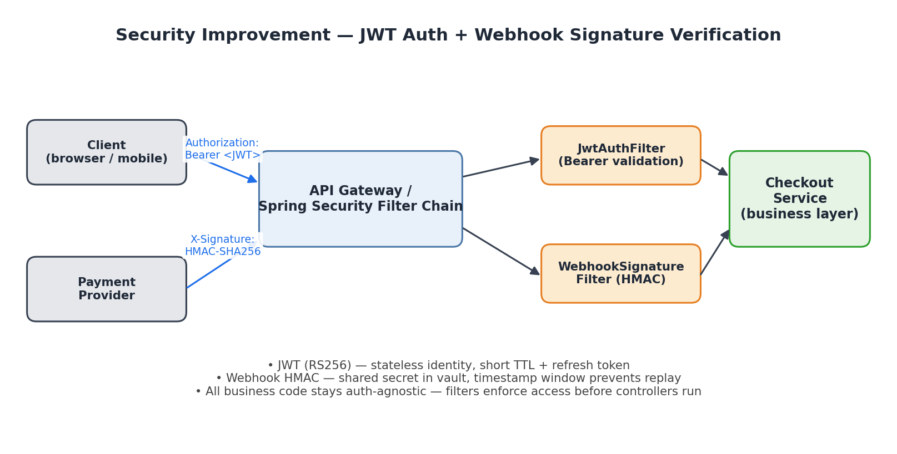
Figure 8 — Proposed security architecture: JWT for clients, HMAC for webhooks
Current state.
- No authentication on any endpoint; anyone with network access can create carts, pay orders, or POST webhooks.
- DB credentials now come from environment variables ({DB_USERNAME}, {DB_PASSWORD}) — a first step only.
Proposed — JWT for client-facing APIs (stateless, scalable).
- Short-lived access tokens (~15 min) signed with RS256; refresh tokens rotated via a secure token endpoint.
- Spring Security filter chain with JwtAuthenticationFilter in front of controllers — business code stays auth-agnostic.
- Claims carry userId + role; OrderService can enforce ownership checks ("order belongs to authenticated user").
- Public key (JWKS) exposed by the auth service — no shared secret sprawl across services.
Proposed — HMAC signature verification for provider webhooks.
- Provider signs the raw body with a shared secret stored in a secrets manager (AWS SM / Vault).
- A WebhookSignatureFilter recomputes the HMAC and rejects on mismatch — before any DB read.
- A timestamp header + replay window (e.g. ±5 min) stops replay attacks.
Trade-offs.
- Added infrastructure: an identity provider (Keycloak / Cognito / Auth0) or in-house auth service.
- Key-rotation procedures must exist — for JWT signing keys and webhook HMAC secrets.
- Marginal latency per request (JWT signature verification, claim parsing); negligible relative to DB I/O but real.
- Test setup becomes more involved — need helper to mint valid tokens in integration tests.

5.2 Event-Driven Design — Loose Coupling Between Modules
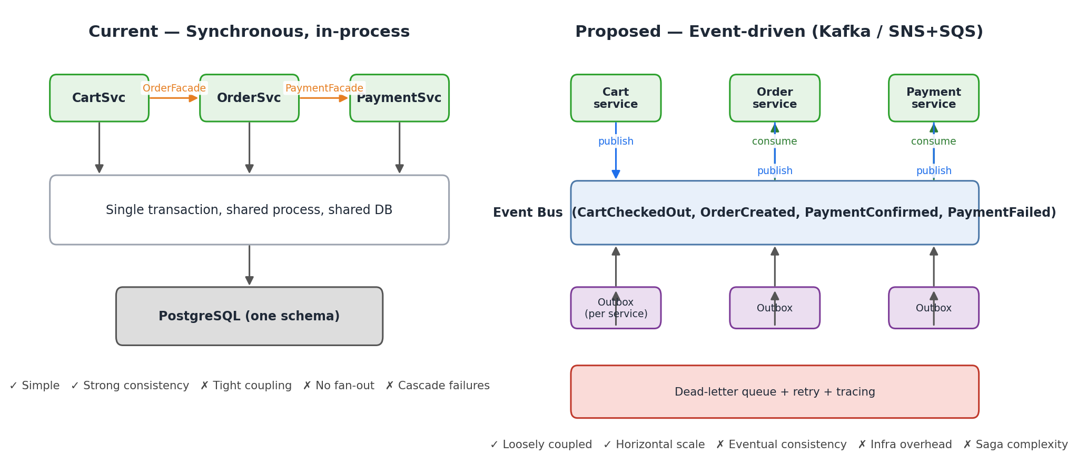
Figure 9 — Synchronous in-process design (left) vs event-driven split (right)
Current state.
- Cart → Order → Payment is a synchronous, in-process call chain through facades.
- One database, one transaction boundary per request — simple and strongly consistent.
- Failure in one module (e.g. PaymentService down) rolls the whole request back.
Proposed — domain events over a message broker.
- Services publish events: CartCheckedOut, OrderCreated, PaymentStarted, PaymentConfirmed, PaymentFailed.
- Consumers react asynchronously: order service reacts to PaymentConfirmed by transitioning to PAID.
- Transactional outbox pattern guarantees "publish exactly-once after DB commit" (save event + aggregate in same transaction; a relay publishes to Kafka).
- A Saga / Process Manager coordinates multi-step flows (place order → pay → confirm) with compensating actions on failure.
Why it unlocks value.
- Modules can be split into separately-deployed services with independent scaling, ownership, and release cadence.
- New consumers (fraud service, analytics, email-receipt service) can subscribe without touching existing code — the open/closed principle applied to runtime, not just source.
- Spikes in webhook traffic are absorbed by the broker instead of saturating the synchronous call chain.
Trade-offs.
- Complexity explosion: message broker (Kafka / SNS+SQS / RabbitMQ), schema registry, outbox relay, DLQ, retry policy — all must be operated and monitored.
- Eventual consistency becomes the default: the UI must show "Payment processing…" until the PaymentConfirmed event is consumed. No more "it's done the moment HTTP 200 returns."
- Distributed tracing is mandatory (OpenTelemetry / Jaeger); without it, debugging a single checkout across 5 services becomes intractable.
- Saga compensation logic is hard to get right — partial failures in the middle of a flow require careful design (e.g. reserving inventory then releasing it on payment failure).
- Schema evolution: events are a public API; every producer/consumer must handle old and new versions gracefully.
- Infrastructure cost: 24/7 broker cluster, additional compute for consumers, storage for event retention.
When to adopt: the jump is worth it when (a) the checkout flow is one of many systems that needs to react to payment outcomes, (b) teams want to own modules independently, or (c) traffic spikes exceed what a single transaction boundary can absorb. Until then, the current in-process design is the cheaper and more debuggable choice.

5.3 Resilience Patterns
- Circuit breaker (Resilience4j) around PaymentProviderClient — stop flooding a failing provider, fail fast, recover automatically.
- Retry with exponential backoff + jitter on transient HTTP 5xx from the provider.
- Timeouts everywhere — no RestClient call should hang indefinitely.
- Bulkhead isolation — limit concurrent provider calls so one slow dependency cannot exhaust the thread pool.
Trade-off: more dependencies, more tuning (timeout values, retry counts), and chaos-testing becomes necessary to validate the safety net actually works.

5.4 Observability
- OpenTelemetry traces — a single trace ID per checkout spans Cart → Order → Payment → webhook.
- Micrometer metrics — counters for webhook outcomes (confirmed / failed / duplicate / 404), histograms for provider latency.
- Structured JSON logs with correlation IDs — already partly in place; should become the default.
- Dashboards + alerts — SLOs on webhook processing latency and payment success rate.
Trade-off: the observability stack (Prometheus, Grafana, Tempo/Jaeger, Loki) is another set of moving parts to run, and high-cardinality metrics can become costly at scale.

5.5 Schema Management & Data Integrity
- Introduce Flyway or Liquibase — version-controlled DDL, reviewable migrations, safe rollbacks.
- Keep ddl-auto: validate in all environments to catch drift between JPA model and DB schema.
- Soft-delete + audit columns (created_at, updated_at, deleted_at, version) across all aggregates.
Trade-off: a second artefact to maintain (migration scripts) and a disciplined release process — no more "let Hibernate figure it out".

5.6 API Contract & Validation
- Add jakarta.validation annotations (@NotNull, @NotBlank, @Positive, @Size) to all request records, plus @Valid on controller parameters.
- springdoc-openapi for live, version-controlled API documentation.
- Contract tests (Pact / Spring Cloud Contract) between checkout-service and its consumers.

5.7 Summary — What to Adopt When
Improvement | Adopt When | Primary Cost
JWT auth | First real users / any production | IdP setup, test harness
Webhook HMAC | Immediately — security baseline | Secret rotation discipline
Event-driven split | ≥2 services react to payment events | Broker, saga, eventual consistency
Circuit breaker | Provider outages are visible | Tuning & chaos tests
OpenTelemetry | Multi-service debugging hurts | Observability stack
Flyway migrations | Before first production deploy | Migration discipline

