SQLServer lab

Note: Use ITI DB

1. Create a scalar function that takes date and returns Month name of that date.
2. Create a multi-statements table-valued function that takes 2 integers and returns the values between them.
3. Create inline function that takes Student No and returns Department Name with Student full name.
4. Create a scalar function that takes Student ID and returns a message to user
5. If first name and Last name are null then display 'First name & last name are null'
6. If First name is null then display 'first name is null'
7. If Last name is null then display 'last name is null'
8. Else display 'First name & last name are not null'
9. Create inline function that takes integer which represents manager ID and displays department name, Manager Name and hiring date
10. Create multi-statements table-valued function that takes a string

If string='first name' returns student first name

If string='last name' returns student last name

If string='full name' returns Full Name from student table

Note: Use “ISNULL” function

1. Write a query that returns the Student No and Student first name without the last char
2. Wirte query to delete all grades for the students Located in SD Department
3. Using Merge statement between the following two tables [User ID, Transaction Amount]

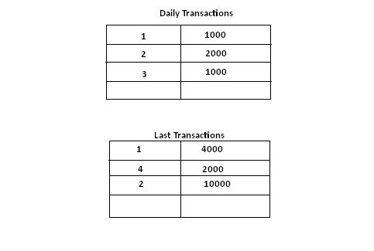

1. Try to Create Login Named(ITIStud) who can access Only student and Course tablesfrom ITI DB then allow him to select and insert data into tables and deny Delete and update