Asthma Exacerbations (AE) Database and Analysis:
Summarizing Report

1. AE database

1.1. Source database
The data in the source asthma exacerbations (AE) database was collected and transcribed by means of a retrospective chart study in the summer of 2004. The study was based on a sample of randomly selected patients with asthma who were seen in the ED at xxx between January 1, 2003 and December 31, 2003. In addition to visits occurring in 2003, charts of selected patients were reviewed for additional ED visits for asthma occurring at any time after January 1, 2000. The first visit in the database was on November 3, 2000, while the last one was on July 7, 2004.
The triage process and way by which the patients’ charts are filled out is as follows. First, when a patient with asthmatic exacerbations arrives at the ED, a triage nurse gathers basic information on the patient’s presenting complaint. At this point the patient is also registered (this includes collecting basic demographics). Then the physician collects and records multiple pieces of information, including the patient’s underlying disease severity, presence of known risk factors signifying more serious disease, outcomes of previous exacerbations, and the length and severity of symptoms during this exacerbation. At the same time the patient is assessed (physically examined) for the first time – this initial assessment is denoted as the triage assessment. Management of the asthma exacerbations includes repeated treatments (i.e., masks) at intervals from every few minutes (continuous) to every few hours. All prescribed treatments are recorded on the chart. Moreover, throughout the patient’s ED stay, the patient is reassessed by the physician or by the nurse to check her/his response to treatment and the same attributes which were collected during the triage assessment are recorded. Repeated assessments (reassessments) may be performed irregularly as they depend not only on the patient’s condition, but also on the load in the ED.
Data was transcribed from the charts into a database where each of the multiple assessments and treatments that were made for a given patient is recorded. The general schema of the database is presented in Figure 1. The database is aimed at storing information about visits – there may be several visits recorded for the same patient and each is represented as a separate entry. Each visit is linked to all conducted assessments (including the triage assessment and subsequent reassessments) and all prescribed and applied treatments (masks). Attributes describing visit, assessment and treatment are presented in Table 1, 2 and 3 respectively. Visits, assessments and treatments are also time-stamped, thus it is possible to calculate time offsets between specific assessments and treatments (the triage assessment is used as a starting point, as it is the actual moment when the management process starts).
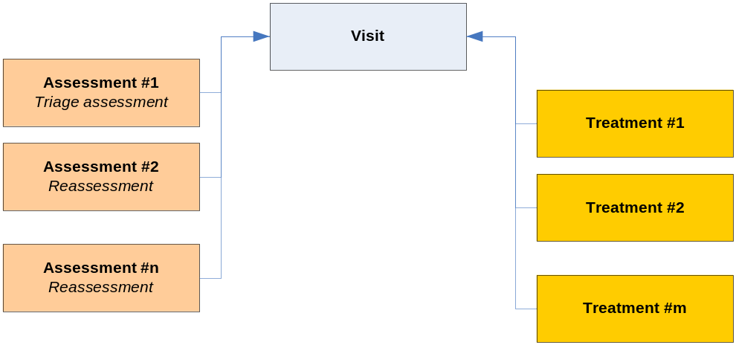
Figure 1. Schema of the source AE database
Table 1. Visit attributes
# | Attribute | Code | Possible values
1 | Registration Age | REG_AGE | Age in years (continuous)
2 | Primary Care | PRIM_CARE | FD, PEDS, OTHER, NONE
3 | Chest Clinic | CHEST_CLINIC | YES, NO
4 | Current Inhaled Steroids | CURR_INH_STEROID | LT_1W (< 1 week), GE_1W_LT_4W (≥ 1 week and < 4 weeks), GE_4W (≥ 4 weeks), NONE, PRN
5 | Age of First Symptoms | AGE_FIRST_SX | Age in years (continuous)
6 | Previous Oral Steroids | PREV_ORAL_STEROID | LT_1M(< 1 month), GE_1M_LT_3 (≥ 1 month and < 3 months), GE_3M_LT_12M (≥ 3 months and < 12 months), GE_12M (≥ 12 months), NONE
7 | Previous ED Last Year | PREV_ED_LAST_YEAR | 1_VISIT (1 visit), 2_VISTIS (2 visits), 3_VISITS (3 visits), GE_4_VISITS (≥ 4 visits), NONE
8 | Previous Admission | PREV_ADM | FLOOR, ICU, NONE
9 | Smokey Environment | ENV_SMOKE | YES, NO
10 | Dander in Environment | ENV_DANDER | YES, NO
11 | Carpets in Environment | ENV_CARPETS | YES, NO
12 | Allergic Environment | ALLG_ENV | YES, NO
13 | Allergic Pets | ALLG_PETS | YES, NO
14 | Allergic Food | ALLG_FOOD | YES, NO
15 | PTHX Atopy | PTHX_ATOPY | YES, NO
16 | FMHX Asthma | FMHX_ASTHMA | YES, NO
17 | Allergy Exposure | ALLG_EXP | YES, NO
18 | URTI Symptoms | URTI_SX | YES, NO
19 | Fever | FEVER | YES, NO
20 | Duration of Symptoms | DUR_ASTHMA_SX | Duration in hours (continuous)
21 | Ventilation in Last 24h | VENT_LAST_24H | Number of treatments (integer)
22 | Arrival to the ED | ARRV_ED | AMBULANCE, PARENTS
23 | Category | CORR_CATEGORY | SHORT, LONG, ADMIT

Table 2. Assessment attributes
# | Attribute | Code | Possible values
1 | Temperature | TEMP | Temperature in °C (continuous)
2 | Temperature Type | TEMP_TYPE | AXILLARY, ORAL, RECTAL
3 | Respiratory Rate | RESP_RATE | Breaths per minute (continuous)
4 | Heart Rate | HEART_RATE | Beats per minute (continuous)
5 | Oxygen Saturation | SAO2 | Saturation (continuous)
6 | Oxygen Environment | SAO2_ENV | ROOM_AIR (room air), SUPPL_O2 (supplemental oxygen)
7 | Air Entry | AIR_ENTRY | GOOD, FAIR, POOR
8 | Distress | DISTRESS | NONE, MILD, MODERATE, SEVERE
9 | Skin Colour | COLOUR | PINK, PALE, DUSKY
10 | Expiratory Wheeze | EXP_WHEEZE | NONE, MILD, MODERATE, SEVERE
11 | Inspiratory Wheeze | INSP_WHEEZE | NONE, MILD, MODERATE, SEVERE
12 | Retractions | RETRACTIONS | NONE, MILD, MODERATE, SEVERE
13 | Assessment Type | ASS_TYPE | TRIAGE, MD, RN

Table 3. Treatment attributes
# | Attribute | Code | Possible values
1 | Treatment Type | RX_TYPE | Type of treatment (text, e.g., VA, Vent, Tylenol, Pulmicort, Dex, Other, …)
2 | Treatment Other | RX_OTHER | Other treatment (text, e.g., gravol, codeine, ….)

In the next step retrieved numerical values were discretized. For the majority of numerical (either continuous or integer) attributes -- REG_AGE, AGE_FIRST_SX, DUR_ASTHMA_SX, VENT_LAST_24H and SAO2, we discretized values extracted directly from the database – discretization intervals for these attributes are presented in Tables 4, 5, 6, 7 and 10. We used conditional discretization of RESP_RATE and HEART_RATE, where different discretization intervals were defined for specific intervals of REG_AGE (discretization of RESP_RATE and HEART_RATE was age-dependent) – applied intervals are presented in Tables 11 and 12. Moreover, values of TEMP were corrected before discretization with regard to TEMP_TYPE (corrections are presented in Table 8) and then corrected values were discretized according to intervals from Table 9.
Discretized values of SAO2 were further corrected to consider oxygen environment identified by SAO2_TYPE (saturations measured in different environments would be difficult to compare and the correction solved this problem). Applied correction is presented in Table 13. Moreover, original values of INSP_WHEEZE, EXP_WHEEZE, RETRACTIONS and AIR_ENTRY were corrected into binary ones as presented in Tables 14 and 15. This minimized the number of possible values and diminished the impact of subjective assessment on the recorded information.
Table 4. Discretization for REG_AGE
Original value | Discretized value
< 3 years | LT_3Y
≥ 3 and < 7 years | GE_3Y_LT_7Y
≥ 7 years | GE_7Y

Table 5. Discretization for AGE_FIRST_SX
Original value | Discretized value
< 1 year | LT_1Y
≥ 1 and < 3 years | GE_1Y_LT_3Y
≥ 3 years | GE_3Y

Table 6. Discretization for DUR_ASTHMA_SX
Original value | Discretized value
< 12 hours | LT_12H
≥ 12 and < 48 hours | GE_12H_LT_48H
≥ 48 hours | GE_48H

Table 7. Discretization for VENT_LAST_24H
Original value | Discretized value
< 1 | LT_1
≥ 1 and < 3 | GE_1_LT_3
≥ 3 and < 6 | GE_3_LT_6
≥ 6 | GE_6

Table 8. Pre-discretization correction for TEMP
Temperature type (TEMP_TYPE) | Correction
AXILLARY | + 0.8
ORAL | 0.0
RECTAL | 0.0

Table 9. Discretization for TEMP
Original value | Discretized value
< 38 | LT_38
≥ 38 and < 39 | GE_38_LT_39
≥ 39 | GE_39

Table 10. Discretization for SAO2
Original value | Discretized value
< 88 | LT_88
≥ 88 and < 93 | GE_88_LT_93
≥ 93 and < 95 | GE_93_LT_95
≥ 95 | GE_95

Table 11. Discretization for RESP_RATE
Registration age (REG_AGE) | Original value | Discretized value
< 3 years | < 30 | NORMAL
(LT_3Y) | ≥ 30 and < 40 | MILD_ABNORMAL
 | ≥ 40 | ABNORMAL
≥ 3 and < 7 years | < 36 | NORMAL
(GE_3Y_LT_7Y) | ≥ 24 and < 36 | MILD_ABNORMAL
 | ≥ 36 | ABNORMAL
≥ 7 years | < 20 | NORMAL
(GE_7Y) | ≥ 20 and < 28 | MILD_ABNORMAL
 | ≥ 28 | ABNORMAL

Table 12. Discretization for HEART_RATE
Registration age (REG_AGE) | Original value | Discretized value
< 3 years | < 110 | NORMAL
(LT_3Y) | ≥ 110 and < 130 | MILD_ABNORMAL
 | ≥ 130 | ABNORMAL
≥ 3 and < 7 years | < 90 | NORMAL
(GE_3Y_LT_7Y) | ≥ 90 and < 120 | MILD_ABNORMAL
 | ≥ 120 | ABNORMAL
≥ 7 years | < 70 | NORMAL
(GE_7Y) | ≥ 70 and < 120 | MILD_ABNORMAL
 | ≥ 120 | ABNORMAL

Table 13. Post-discretization correction for SAO2
 | Oxygen environment (SAO2_ENV)
Discretized value | ROOM_AIR (room air) | SUPPL_O2 (supplemental oxygen)
LT_88 | LT_88 | LT_88
GE_88_LT_93 | GE_88_LT_93 | LT_88
GE_93_LT_95 | GE_93_LT_95 | GE_88_LT_93
GE_95 | GE_95 | GE_93_LT_95

Table 14. Correction for INSP_WHEEZE, EXP_WHEEZE and RETRACTIONS
Old value | New value
MILD | PRESENT
MOD | PRESENT
SEVERE | PRESENT
NONE | ABSENT

Table 15. Correction for AIR_ENTRY
Old value | New value
FAIR | GOOD
GOOD | GOOD
POOR | REDUCED

We assumed ORAL when no TEMP_TYPE was recorded in the database.
We assumed ROOM_AIR if no value of SAO2_ENV was recorded in the database.

