DM Helper

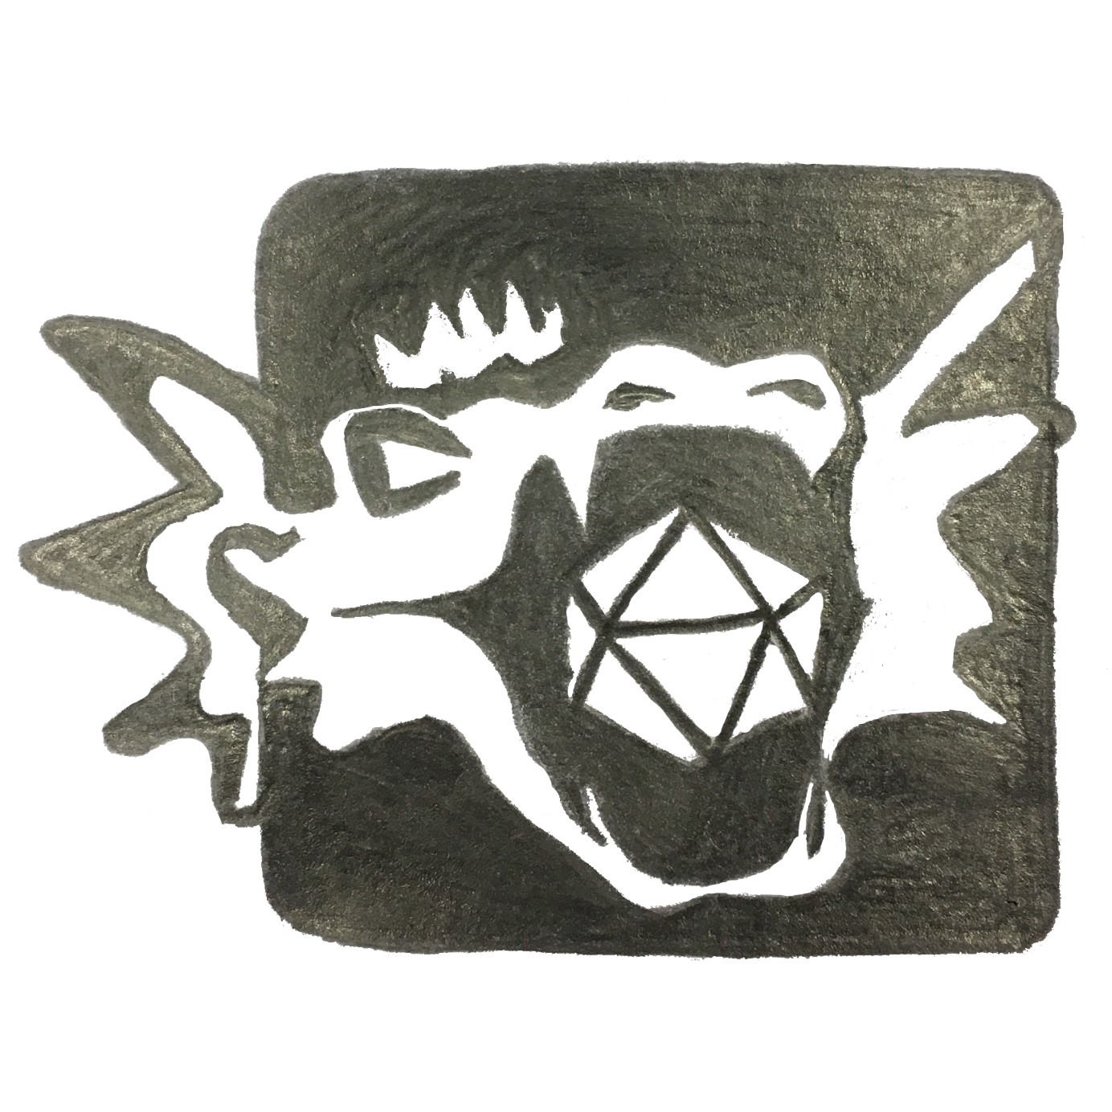

A Dungeon Master's Helping Hand

The DM Helper will act as your in-game assistance, taking care of the administrative tasks and allowing you to focus on your players, the narrative and the fun!

**Key Features**

* Presentation of all tool content in a Player's Window. This can be shown to players on an external monitor or shared via streaming tools for either face-to-face or ongoing games
* Full battle support including a full battle map, initiative and hit point tracking, area effects, mass saving throws/damage
* Map visualization, in or out of battles, including fog of war, zooming and an in-map pointer for highlighting items
* A detailed bestiary, pre-filled with all open-source SRD monsters
* A campaign structure for build-up of adventures, encounters, maps, locations, party members and NPCs.
* A quick reference to descriptions of actions/bonus actions/reactions, environmental issues and conditions
* A reference including all SRD equipment tables
* A campaign clock for tracking time and date throughout adventures
* Animation of scrolling text over a background for easy cut-scene creation

**New Features in v1.1**

* Import/Export: transfer your characters between campaigns, share maps or cool encounters or even prepare and import full adventures with all the bells and whistles into your existing campaign
* Editable Reference Tables (community request): not quite clear how, but you will be able to modify the reference tables, for example to include homebrew items
* Including a random contents generator for Marketplaces
* Configurable Calendar (community request): define the calendar for your campaign to be something other than the traditional Gregorian calendar
* Configurable Player's Window
  + Selectable background color
  + Toggleable fullscreen/borderless window mode

**Download**

You can get the DM Helper for free from the following portals:

Itch.io: <https://dm-helper.itch.io/dm-helper>

DriveThruRPG.com: <https://www.drivethrurpg.com/product/274208/DM-Helper>

**Contact**

You can reach us under the usual channels:

Email: info@dmhelper.net

Twitter: @TheRealDMHelper

Join us for discussions on our Discord server here: <https://discord.gg/C7zPKBp>

We are happy for everybody to use the DM Helper for free and believe in providing our tool in this way for anybody interested in using it.

If you would like to support us in our efforts to continually improve and expand, you are welcome to do so either through one of the download portals or via our Patreon here:

[www.patreon.com/dmhelper](http://www.patreon.com/dmhelper)

**References**

Many thanks to the following people for allowing us to use their amazing artwork and maps for our documentation! We highly recommend that you check out their work and support them in every way possible!

**Background images and character images donated by:**

Rixt Heerschop

Artist & Illustrator

www.rixtheerschop.com

**Maps donated by:**

Alex van der Aa

https://www.patreon.com/neutralparty

https://www.reddit.com/user/Urza_Is_Mine

Rustajb

https://www.reddit.com/user/rustajb

**Feature Improvements:**

Furthermore, thanks to the following community members for their ideas, requests and recommendations to help us make the DM Helper as good as possible!

* Cricketot (https://www.reddit.com/user/Cricketot) for the Random Marketplace inspiration and algorithm
* NutritiousCookie for the improvements to the Player's Window (rotation still to come!)
* anomalystic777 for the customizable calendars and reference tables
* Thanks to Alex (https://www.reddit.com/user/wurschtbrotwilli) for the original Python-based inspiration for the Translate Text menu

... and many more for their chats and wise words on Reddit or the other clever corners of the Internet