TR_DANG_KHANH_SON_20260318_Simulate FOC-Control for PMSM motor in Simulink
- Block Diagram of FOC Control: Field-Oriented Control - MATLAB & Simulink
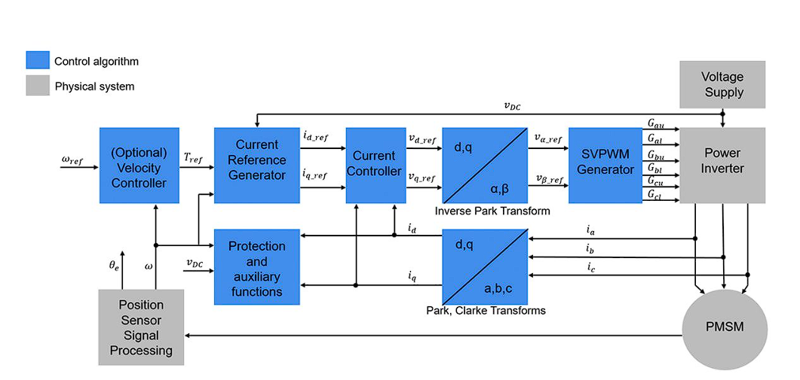
- Simulation Model in Simulink

- Design PMSM and Inverter Block (Power Circuit)
- Power Circuit:
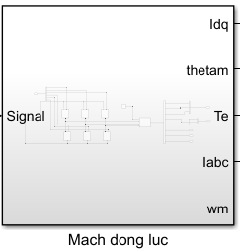
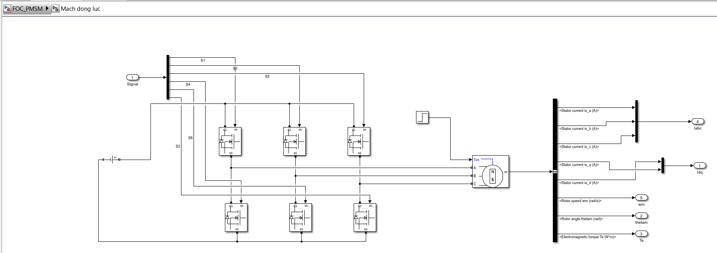
- Choosing PMSM Model:
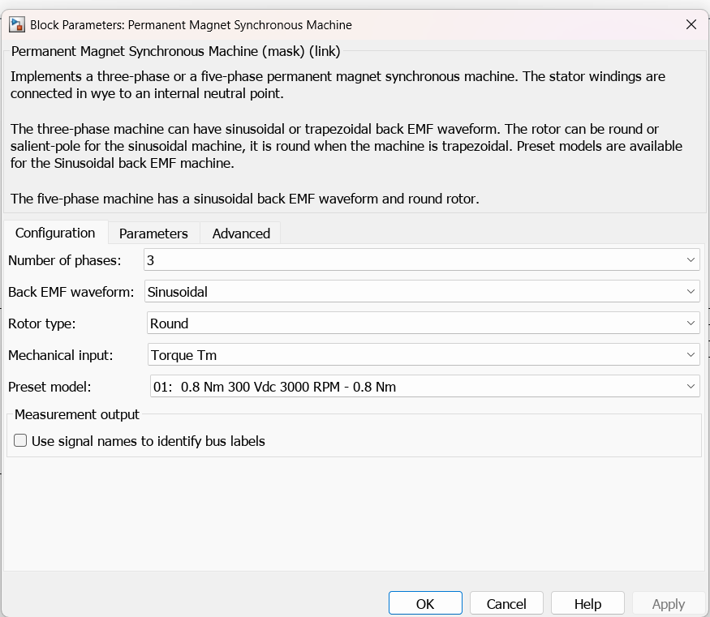
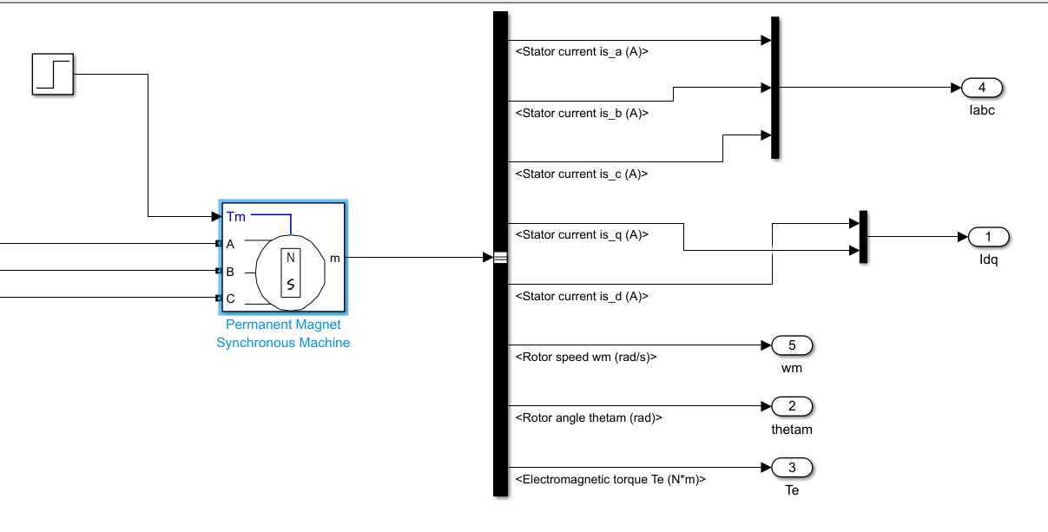

- Inverter:
  - Reference:
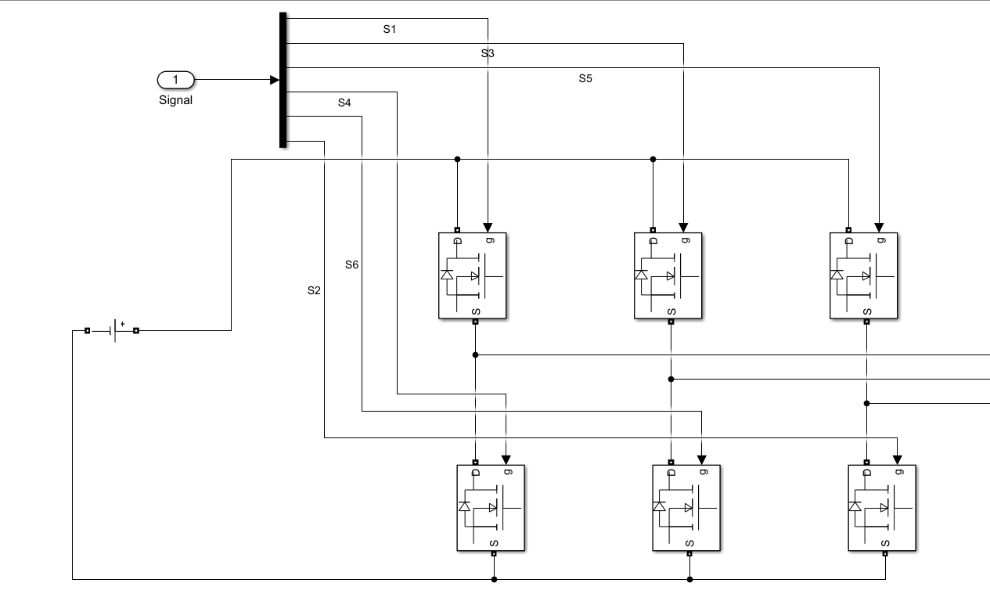
- SinPWM design:
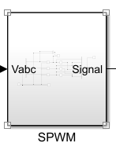
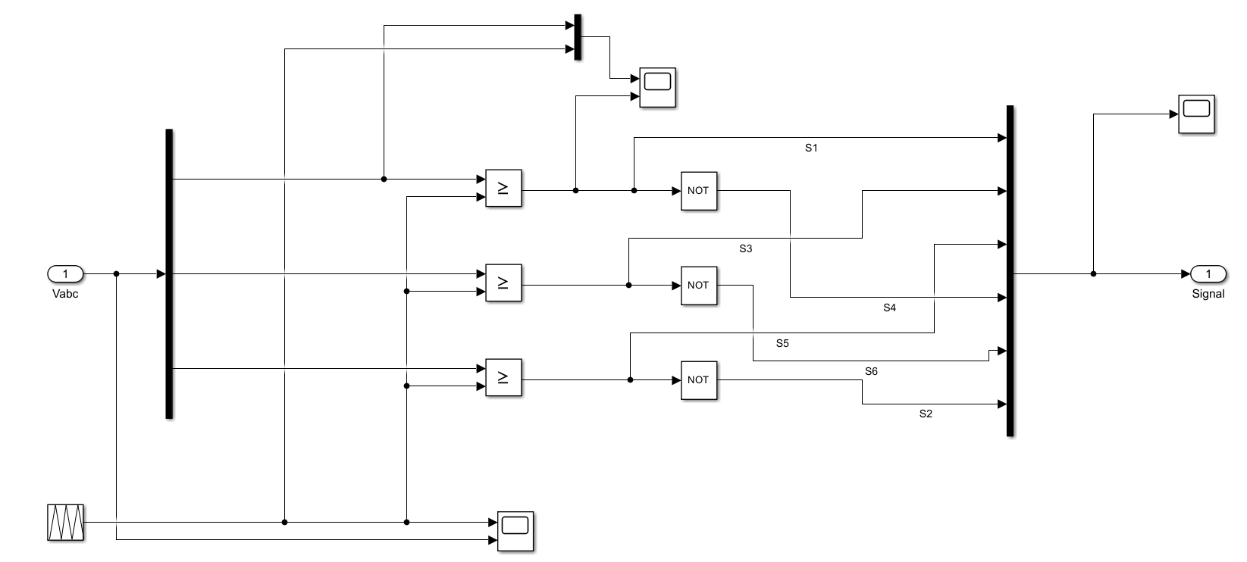

  - Carrier Signal
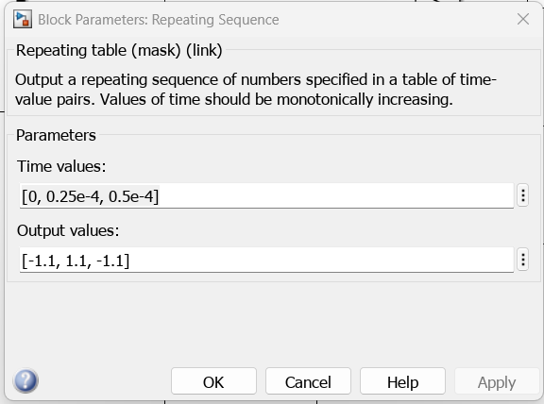
- Control Circuit
- Current Loop:
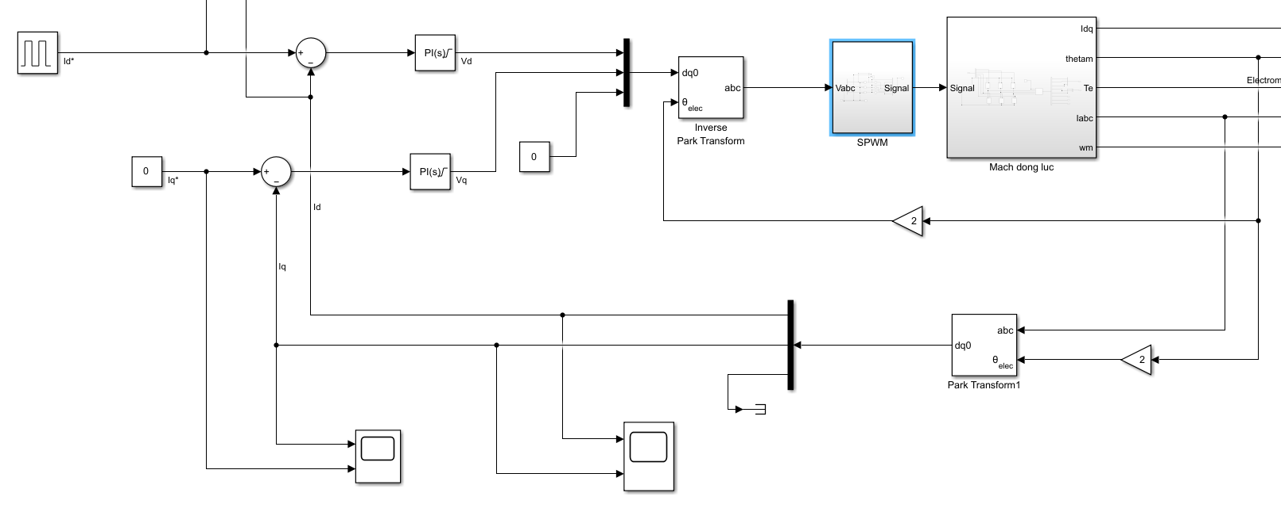
  - Tuning PI Controller:
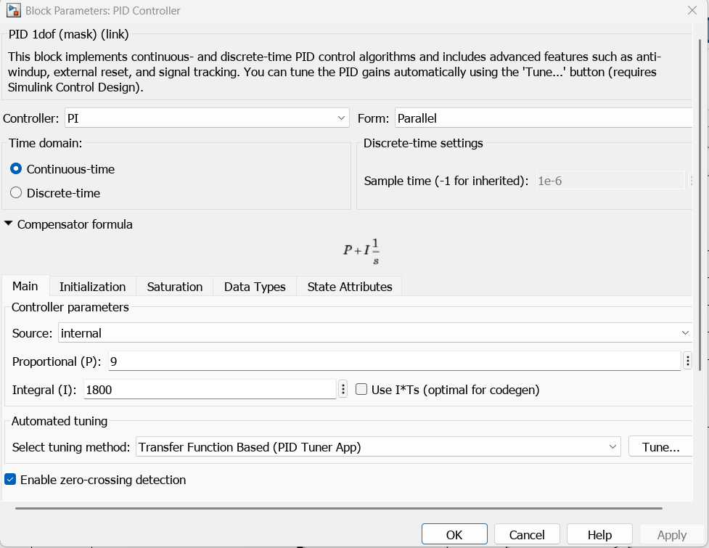
- Tuning xong PI của Id có thể áp thẳng xuống Iq do Lq $≈$ Ld
  - Id Result:
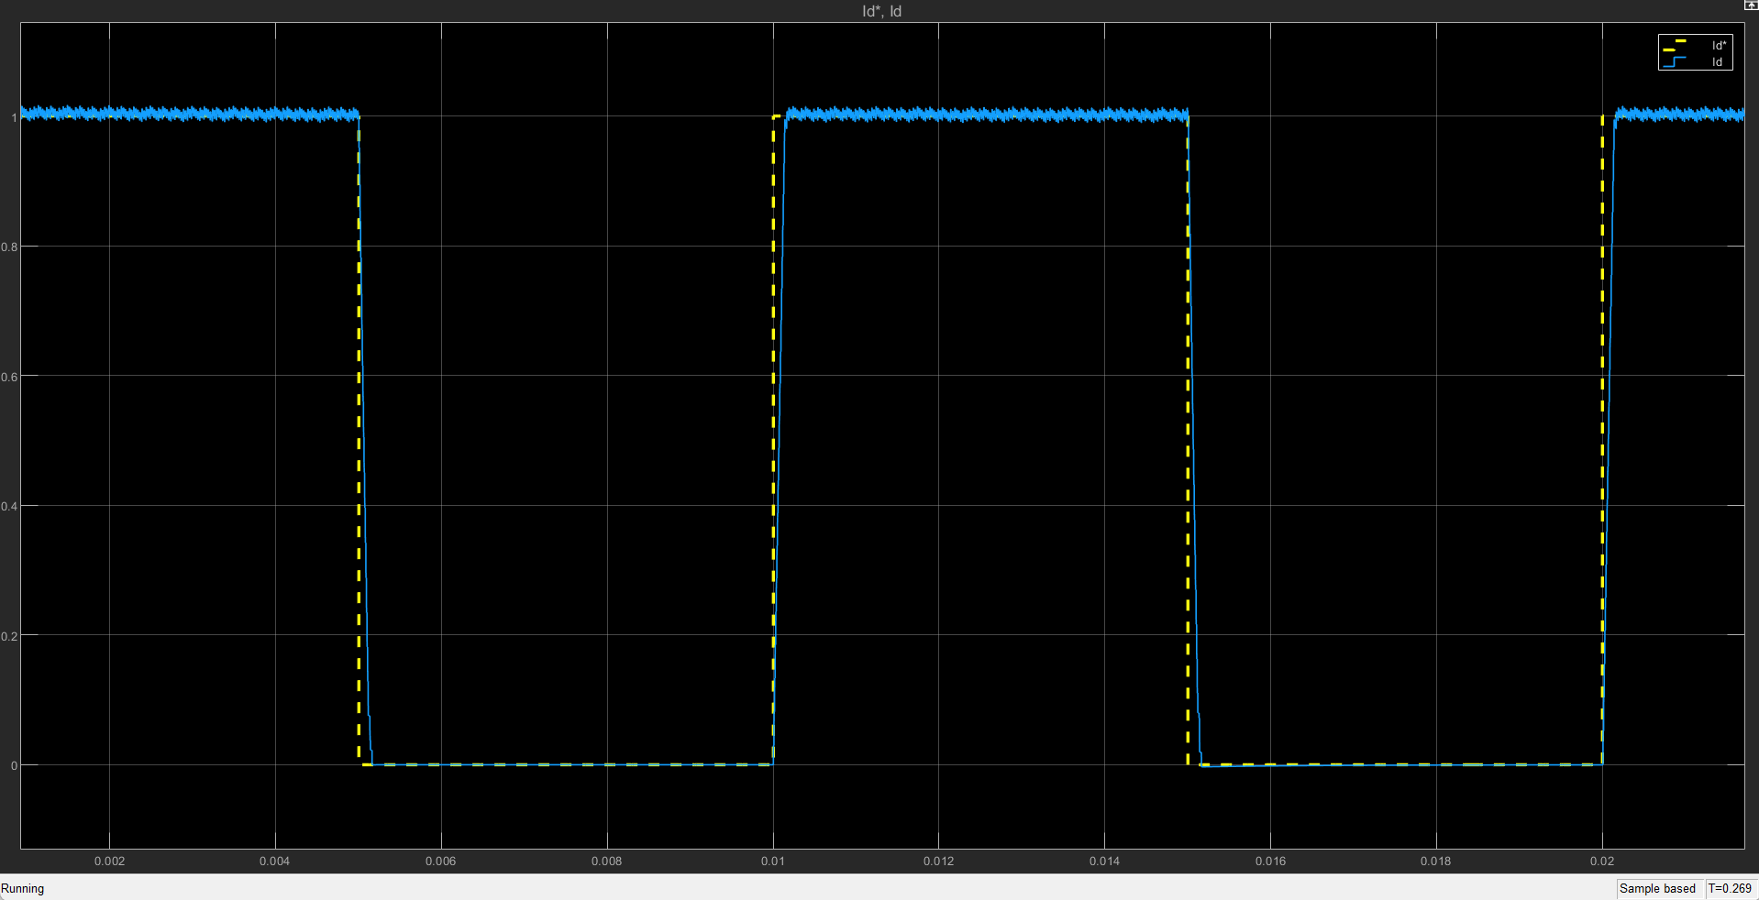
- Velocity Loop:
- Position Loop:

- Simulation Result:
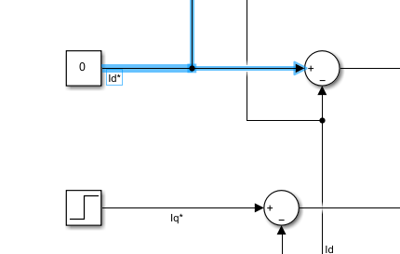
- Current Loop:
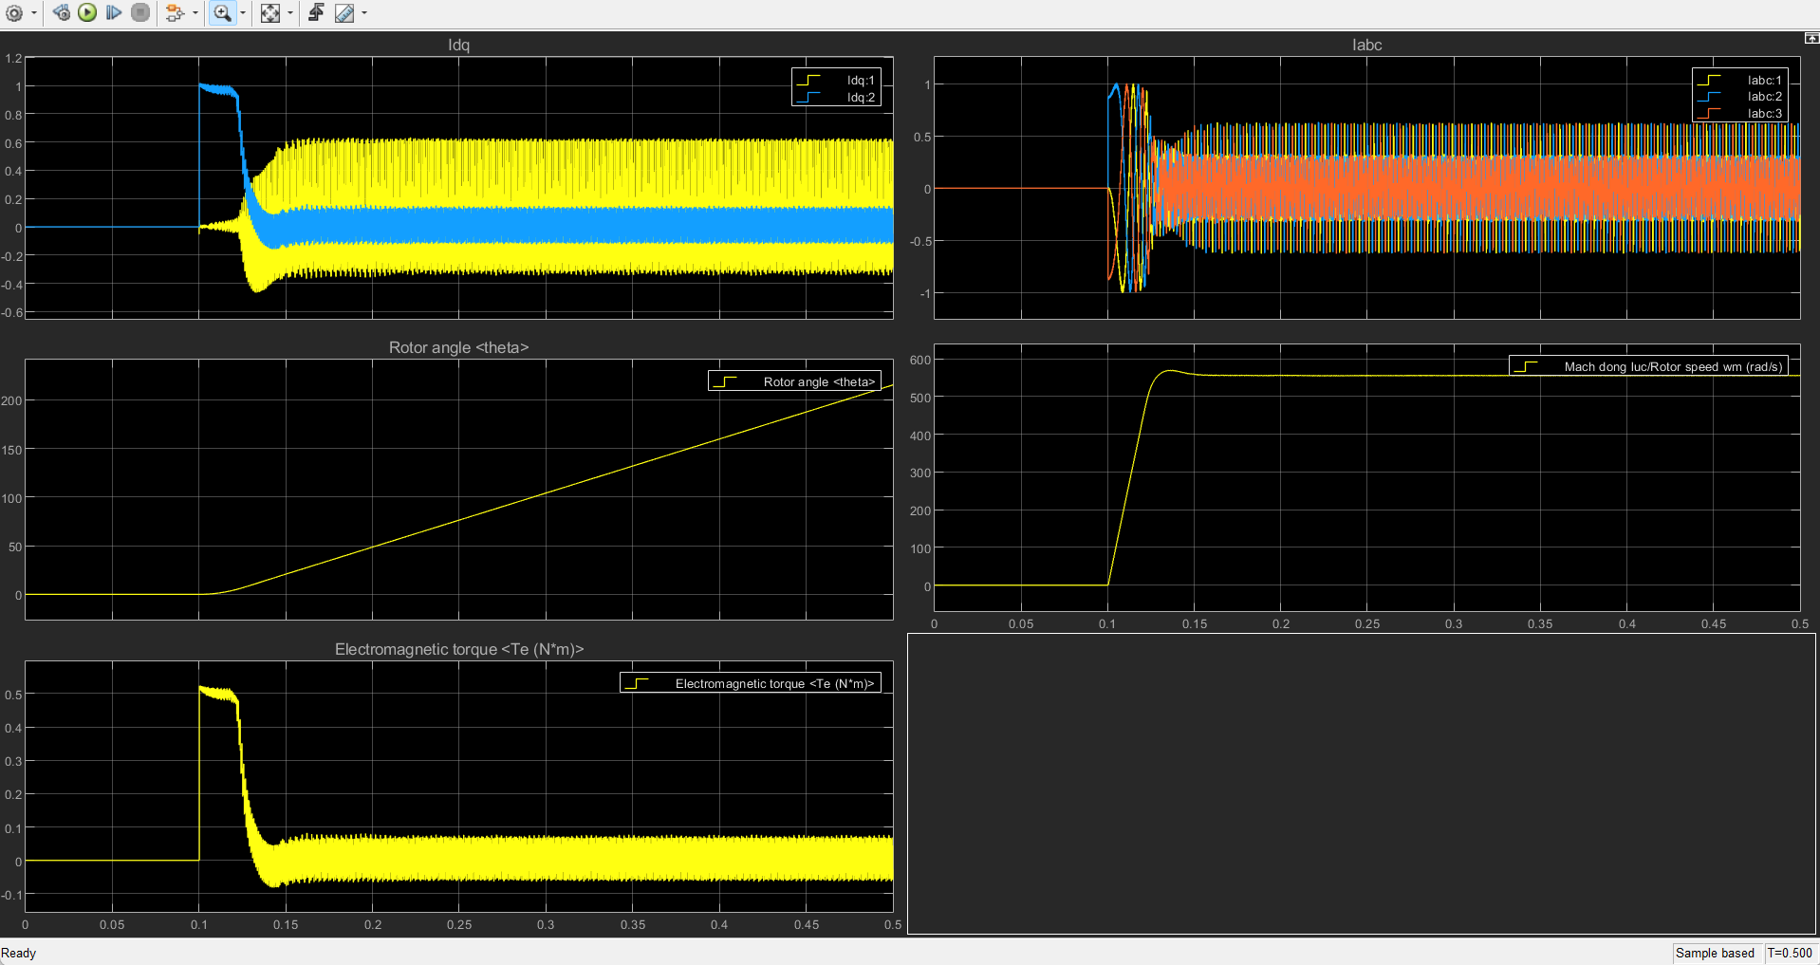
- Velocity Loop:
- Position Loop:

