Sample Test Case:

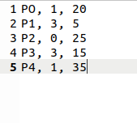

1. First Come First Serve(FCFS) Scheduling Algorithm Results:

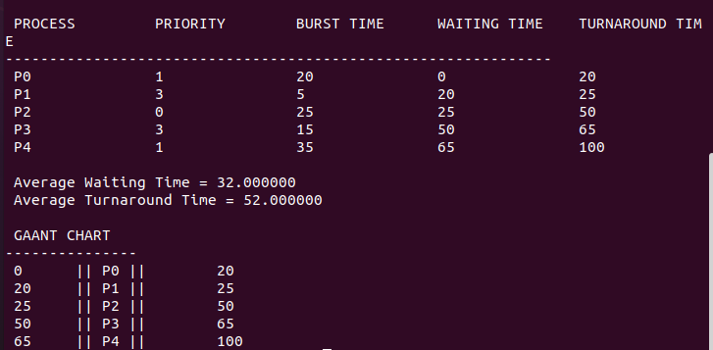

2. Shortest Job First(SJF) Scheduling Algorithm Results:

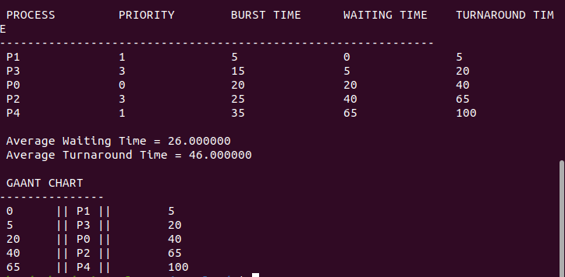

3. Priority Scheduling Algorithm Results:

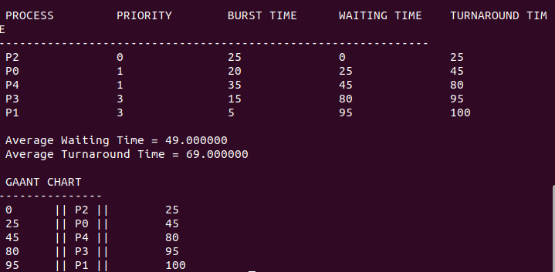

4. Round Robin(RR) Scheduling Algorithm Results with Time Quantum q = 10:

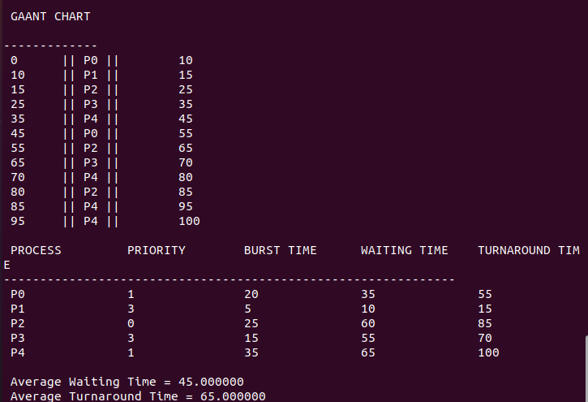

5. Priority Based Round Robin Scheduling Algorithm Results with Time Quantum q = 10:

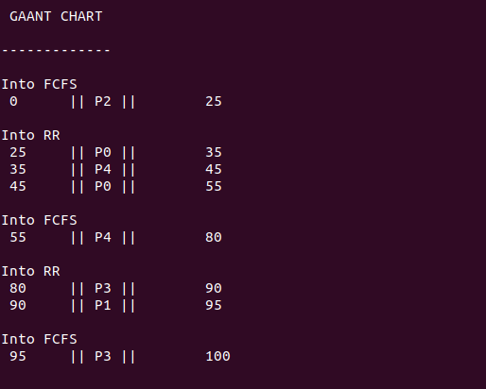

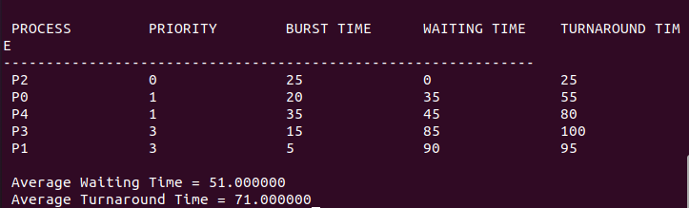

6. Multi-Level Feedback Queue Scheduling Algorithm Results with Time Quantums:
q1 = 10 (1st Queue)
q2 = 20 (2nd Queue)

