CCDR_KYR: Direct emissions from ruminants

**Over the past few decades, livestock emissions in Kyrgyzstan have risen sharply—from 3,165 ktCO₂e in 1995 to 5,590 ktCO₂e in 20221.** Today, they account for nearly 90% of all agricultural emissions and a similar share of the country’s methane emissions2. This growing footprint has made the livestock sector a central focus in Kyrgyzstan’s climate commitments. The Nationally Determined Contribution (NDC) outlines key strategies to curb emissions, including phasing out low-producing animals, improving manure management, and restoring degraded pastures.

**Ruminants—cattle, sheep, and goats—are at the heart of the challenge.** These animals alone contribute around 90-95% of total direct livestock emissions, primarily through methane (from enteric fermentation and manure management) and nitrous oxide (from manure management and manure left on pasture).

**Looking ahead, the pressure on the livestock sector is set to intensify.** Emissions from ruminants are projected to increase significantly—rising from 4.7 mil t CO2-eq in 2022 to 7.0 mil t CO2-eq in 2050, a 49% rise. These projections, based on IPCC Tier 2 calculations and validated national data, are driven by current growth trends in herd populations, resulting in a 50% increase in protein production with limited efficiency gains—reaching 221 thousand tons of meat and 2,036 million tons of milk per year by 2050.

**However, there is room for progress.** The sector has the potential to boost efficiency while also becoming moreresilient to climate shocks. Government-led initiatives, such as the IFAD-funded RRPCP project3, aim to do just that—improving animal health, breeding practices, and feed use, especially to curb overgrazing. These efforts could increase protein production by 32% and reduce emissions intensity (EI) by -18% compared to the current trajectory in 2050. Still, because overall production would continue to rise, total emissions are projected to grow to 7.5 million tCO2-eq—8% higher than in the current growth scenario.

**To curb rising emissions from the livestock sector, a strategic shift is necessary.** While targeted measures like improved manure management (biodigesters, composting), and methane-reducing feed additives can provide partial relief, the most effective approach is reducing herd size. By increasing output per animal, protein production can be maintained similar to current growth trends, while reducing the need for additional animals. This could lead to a -17% reduction in emissions by 2050 compared to current trends. Further reductions—up to -25%—could come from dietary shifts, such as replacing 15% of ruminant beef with broiler meat. In total, mitigation measures could reduce emissions by 1.8 million tCO₂-eq compared to the current growth pathway, potentially unlocking climate finance opportunities.

**But even with these efforts, emissions in 2050 would remain above 2022 levels.** To achieve a true net decrease in emissions, carbon sequestration through improved grazing land management will be essential— alongside further shifts in diets, potentially moving away from animal-source foods. Given the crucial role of livestock in rural livelihoods and the increasing demand for animal-source foods in the Kyrgyz Republic, a balanced, stepwise approach will be key. By integrating sustainable land use, improving productivity, phasing out inefficient livestock, and promoting dietary diversification, Kyrgyzstan can align its climate goals with economic and social realities—paving the way for a more resilient and sustainable future.

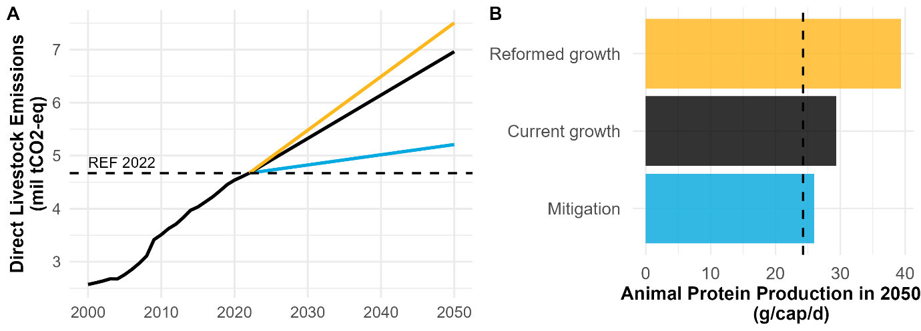

**Figure 1**.: Estimated direct ruminant emissions and protein production per capita per day in Kyrgyz republic under various adaptation and mitigation scenarios (2000-2050) (source: WB, and FAOSTAT).

**Table 1:** Estimated ruminant emissions, emissions intensity, and protein production under various adoption and mitigation scenarios for Kyrgyz republic.

|  |  |  |  |  |  |
| --- | --- | --- | --- | --- | --- |
|  | **Year** | **GHG (mil tCO2)** | **EI** | **Protein (ton)** | **Protein (g/cap/d)** |
| Reference year | 2022 | 4.7 | 66.2 | 71.0 | 28.0 |
| Current growth | 2050 | 7.0 | 65.2 | 106.7 | 30.3 |
| **% difference compared to current growth** | | | | | |
| Reformed growth | 2050 | 8% | -18% | 32% | 32% |
| Mitigation | 2050 | -25% | -17% | -10% | -10% |
|  |  |  |  |  |  |

 **Figure 2**.: Estimated direct ruminant emissions and protein production per capita per day in Kyrgyz republic under various adaptation and mitigation scenarios (2000-2050) (source: WB, and FAOSTAT).

**Table 2:** Estimated ruminant emissions, emissions intensity, and protein production under various adoption and mitigation scenarios for Kyrgyz republic.

|  |  |  |  |  |  |
| --- | --- | --- | --- | --- | --- |
|  | **Year** | **GHG (mil tCO2)** | **EI** | **Protein (ton)** | **Protein (g/cap/d)** |
| Reference year | 2022 | 4.7 | 66.2 | 71.0 | 28.0 |
| Current growth | 2050 | 7.0 | 65.2 | 106.7 | 30.3 |
| **% difference compared to current growth** | | | | | |
| Reformed growth | 2050 | 8% | -18% | 32% | 32% |
| +Herd control | 2050 | -17% | -17% | 0% | 0% |
| +Dietary shift | 2050 | -25% | -17% | -10% | -10% |