**Bluetooth-bc04**

Based on British CSR BlueCore4-Ext chip, follow V2.1 + EDR Bluetooth specification. The module supports UART, USB, SPI, PCM, SPDIF interface, and support for the SPP Bluetooth serial protocol, low cost, small size, low power consumption, send and receive sensitivity advantages, just with a few external components will be able to achieve its powerful. Feature:

* Bluetooth V2.1 + EDR
* Bluetooth Class 2
* Built-in PCB RF antenna
* Built-in 8Mbit Flash
* Support for SPI programming interface
* Support UART, USB, SPI, PCM interface
* 3.3V power supply
* REACH, ROHS certification

Application: The module is mainly used for short-range wireless data transmission field. Convenient and connected to the PC, Bluetooth devices can also data exchange between the two modules. Avoid cumbersome cable connections, direct replacement for the serial line.

* Bluetooth wireless data transmission;
* industrial remote control, telemetry;
* POS system, wireless keyboard, mouse;
* traffic, underground positioning, alarm;
* automated data acquisition system;
* wireless data transmission; banking system;
* wireless data acquisition;
* building automation, security, wireless monitoring room equipment, access control systems;
* smart home, industrial control;
* automotive testing equipment;
* television the interactive program vote Equipment;
* government street light energy saving equipment
* wireless LED display system
* Bluetooth joystick, Bluetooth gamepad
* Bluetooth printer
* Bluetooth remote control toy

Mechanical Features:

* Operating Frequency Band 2.4GHz -2.48GHz unlicensed ISM band
* Bluetooth Specification V2.1+EDR
* Output Power Class Class 2
* Operating Voltage 3.3V
* Host Interface USB 1.1/2.0 or UART
* Audio Interface PCM interface
* Flash Memory Size 8Mbit
* Dimension 27mm (L) x 13 (W) mm x 2mm (H)

Electric Features:

* Absolute Maximum Ratings
* Rating Min Max
* Storage temperature -40℃ +150℃
* Supply voltage: VBAT -0.4V 5.6V
* Other terminal voltages VSS-0.4V VDD+0.4V
* Recommended Operating Conditions
* Operating Condition Min Max
* Operating temperature range -40℃ +150℃
* Guaranteed RF performance range(a) -40℃ +150℃
* Supply voltage: VBAT 2.2V 4.2V(b)

Power Consumption:

* Operation Mode Connection Type UART Rate(kbps) Average Unit
* Page scan - 115.2 0.42 mA
* ACL No traffic Master 115.2 4.60 mA
* ACL With file transfer Master 115.2 10.3 mA
* ACL 1.28s sniff Master 38.4 0.37 mA
* ACL 1.28s sniff Slave 38.4 0.42 mA
* SCO HV3 30ms sniff Master 38.4 19.8 mA
* SCO HV3 30ms sniff Slave 38.4 19.0 mA
* Standby Host connection - 38.4 40 µA

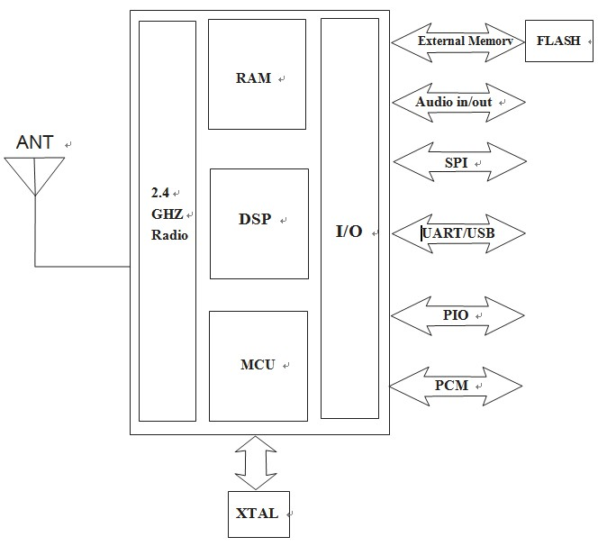

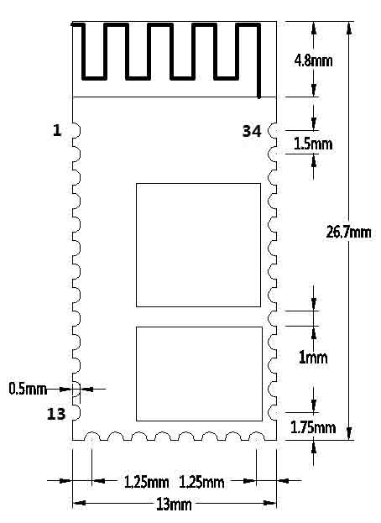Fig.1 – Function diagram

Fig.2 - Board dimension

### AT Commands

BC04-B Bluetooth serial module instruction is divided into Command (downlink command) and Indication (reporting instructions). (NOTE: AT commands are not case-sensitive, are carriage return, newline character at the end: \ r \ n AT instruction only in the state of the module is not connected to take effect once the Bluetooth module connected to the device, the Bluetooth module that entering data pass-through mode)  
See the full Command List on table.

|  |  |  |  |
| --- | --- | --- | --- |
| **Command Name** | **Command** | **Response** | **Parameter** |
| Check version | AT+VERSION | +VERSION=<Para1> | <Para1>: Firmware version number, the Bluetooth version number,  the local HCI version, HCI amendments,  LMP version number, LMP sub-version number |
| check help | AT+HELP | ... |  |
| Reset to default | AT+DEFAULT | OK | null |
| reset | AT+ RESET | OK | null |
| check/set device type | AT+COD  AT+COD< Para1>,<Para2> | OK or error | <Para1>: Local device type (length must be 6 bytes) from the mode is in effect,  the end retrieval <Para2>: Filtration equipment type effect in the main mode for filtering  search to equipment (if you set 000,000 returns all search equipment) default: 001f00, 000000 |
| check/set module SPP master/slave mode | AT+ROLE  AT+ROLE< Para1> | OK or error | <Para1>: 0 --- from the device;  1 --- master; Default: 0 from equipment |
| check/set GIAC | AT+IAC< Para1> | OK or Error | <Para1>: The query access code, default value: 9e8b33  specific settings, see Appendix 2: query access code Description |
| check/set remote bluetooth device name | AT+RNAME< Para1> | OK or Error | <Para1>: remote Bluetooth device address |
| check/set inquiry mode | AT+INQM<Para1>,<Para2>,<Para3> | OK or Error | <Para1>: Query mode: 0: inquiry_mode_standard,1: inquiry_mode_rssi,  2: inquiry_mode_eir, Length: 1 byte,  <Para2>: Up Bluetooth Device response, Length: 2 bytes,  <Para3>: Query timeout, Timeout range :1-30(Converted into time :1.28-61.44 seconds), Length: 2 bytes, Default: 1,9,30 (16 hex) |
| check/set connection mode | AT+CMODE< Para1> | OK or Error | <Para1>: 0: specified Bluetooth address connected mode  (specified Bluetooth address set by the BIND command)  1: Any Bluetooth address connection mode  (not the BIND command set address the constraints), the default value: |
| check/set bluetooth address | AT+BIND<Para1> | OK or Error | <Para1>:  Set binding Bluetooth address format: 11,22,33,44,55,66 Reply the Bluetooth address format: 11:22:33:44:55:66 Default: 00:00:00:00:00:00 |
| clear memory address | AT+CLEAR | OK | Null |
| check/set UART MODE | AT+ UARTMODE<Para1>,<Para2> | OK or Error | <Para1>: Stop bit: 0:1 stop bit, 1:2 stop bit  <Para2>: Parity: 0: no parity, 1: Odd, 2: Even parity, default value: 0,0 |
| check local BT address | AT+LADDR | +LADDR=<Para1> | <Para1>: Local Bluetooth address,  for example: 11:22:33:44:55:66 |
| checkt BT module working status | AT+STATE | +STATE=<Para1> | Example |
| check/set Remote Bluetooth device automatically search | AT+ AUTOINQ<Para1> | Ok or Error | 0=no, 1=yes |
| check remote bluetooth device | AT+INQ | Ok | null |
| cancel check remote bluetooth device | AT+INQC | Ok | null |
| check/set Whether to automatically connect to a remote Bluetooth device | AT+ AUTOCONN<Para1> | OK or Error | 0=Not Auto, 1= Auto |
| Connect to remote bluetooth device | AT+CONNECT<Para1> | OK or Error | <Para1>:  Set the remote bluetooth address format: 11,22,33,44,55,66 Reply Bluetooth address format: 11:22:33:44:55:66 |
| check/set Page scan and inquiry scan parameters | AT+IPSCAN<Para1>,<Para2>,<Para3>,<Para4> | OK or Error | <Para1>: Query interval  <Para2>: Query duration <Para3>: Paging time intervals <Para4>: Paging duration The above parameters are hexadecimal numbers. Default: 800,12,800,12 |
| check/set Encrypt mode | AT+SENM<Para1>,<Para2> | OK or Error | <Para1>: Safe mode, the following values ​​(1 byte):  0 - sec_mode0_off 1 - sec_mode1_non_secure 2 - sec_mode2_service 3 - sec_mode3_link 4 - sec_mode4_ssp <Para2>: Encryption mode, the following values ​​(1 byte): 0 - hci_enc_mode_off 1 - hci_enc_mode_pt_to_pt 2 - hci_enc_mode_pt_to_pt_and_bcast Default: 0,0 |
| Check/set low power Mode | AT+ LOWPOWER<Para1> | ok or error | 0=not support, 1=support, default =1 |
| check/set sniff energy save mode | AT+SNIFF<Para1>,<Para2>,<Para3>,<Para4> | ok or error | <Para1> - max time, <Para2> - min time, <Para3> - trial time, <Para4> - timeout time |
| check/set indication upward command | AT+ENABLEIND<Para1> | ok or error | 0= close, 1= open, default 1 |
| check Bluetooth pairing list | AT+LSP | LSP=<Para1>,<Para2>,<Para3>  …… LSP=E | <Para1>：number（0-7） <Para2>：bluetooth address code  <Para3>：name default feedback：LSP=E |
| Clear all bluetooth pairing list | AT+RESETPDL | Ok | - |
| clear selected bluetooth pairing record | AT+REMOVEPDL<Para1> | OK | <Para1>：number（0-7） |
| check/set linkloss checking time | AT+SUPERVISION<Para1> | Ok or error | <Para1> response time, unit in second (Hex), default 5 |

Source:

www.electrodragon.com  
www.martyncurrey.com

www.seeedstudio.com  
www.openimpulse.com  
www.suptronics.com

**Shahed University** summer-2019  
By: Mohammad Hossein Movasaghinia