**XBee**

XBees are hugely popular wireless transceivers for a number of reasons. They're flexible -- they send and receive data over a [serial port](https://learn.sparkfun.com/tutorials/serial-communication), which means they're compatible with both computers and microcontrollers (like [Arduino](https://learn.sparkfun.com/tutorials/what-is-an-arduino)). And they're highly configurable -- you can have meshed networks with dozens of XBees, or just a pair swapping data. You can use them to remotely control your robot, or arrange them all over your house to monitor temperatures or lighting conditions in every room.

The pair of XBees alone won't get you very far. In most cases you'll want a separate module to interface with the XBee. You can use an [XBee Shield](https://www.sparkfun.com/products/10854) to connect an XBee to your Arduino. Or you can use an [XBee Explorer](https://www.sparkfun.com/products/11812) to connect an XBee to your computer.

The focus of this tutorial is to explain how to use an XBee Explorer with an XBee. There are a variety of Explorer boards, all designed to achieve the same purpose: to create a communication gateway between your computer and the XBee.

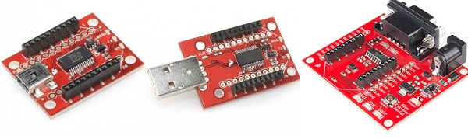

Fig.1 - The Explorers: [USB Explorer](https://www.sparkfun.com/products/11812), [Explorer Dongle](https://www.sparkfun.com/products/11697), and [Serial Explorer](https://www.sparkfun.com/products/13225)

With an XBee Explorer connected between your computer and your XBee, and with the help of the X-CTU software, you can easily configure XBees, test connections, and pass data between your computer and remote XBees.

XBee Explorer USB

The [XBee Explorer USB](https://www.sparkfun.com/products/11812) is the most popular of the Explorers. It's equipped with a mini-B USB connector, so you'll need the [proper USB cable](https://www.sparkfun.com/products/11301) to connect it to your computer.

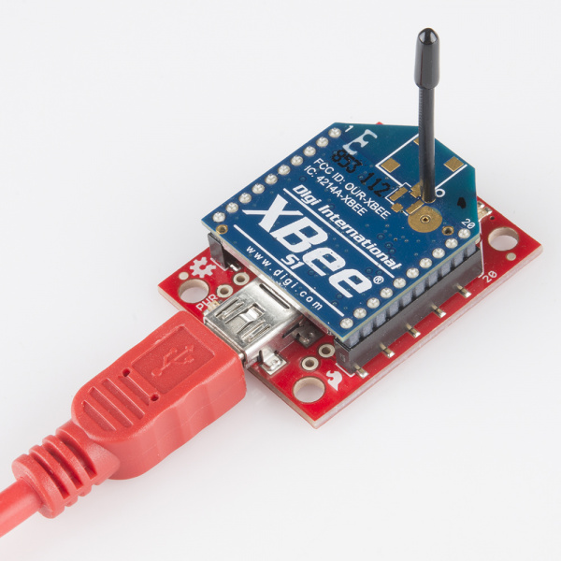Fig.2 - [XBee Explorer USB](https://www.sparkfun.com/products/11812)

The highlight of this board is an [FT231X USB-to-Serial converter](https://www.sparkfun.com/products/11736). That's what translates data between your computer and the XBee. There's also a **reset button**, and a voltage regulator to supply the XBee with plenty of power. In addition, there are four LEDs that'll help if you ever need to debug your XBee: RX, TX, RSSI (signal-strength indicator), and a power indicator.

This board also breaks out each of the XBee's I/O pins to a pair of breadboard-compatible headers. So if you want to make use of the XBee's extended functionality, you can solder some [header pins](https://www.sparkfun.com/products/116) into those, or even just solder some wire.

### XBee Explorer USB Dongle

The [XBee Explorer Dongle](https://www.sparkfun.com/products/11697) is an extension of the Explorer. In fact, the only real difference between this and its predecessor is the USB connector. The Dongle can be connected directly to your laptop or PC USB port.

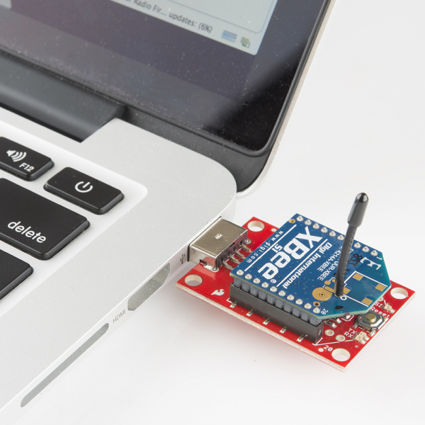

Fig.3 - [XBee Explorer USB](https://www.sparkfun.com/products/11812) Dongle

Or, if you need some distance from your computer, you can use a [USB extension cable](https://www.sparkfun.com/products/517).

### XBee Explorer Serial

Computers with an RS-232 serial port are becoming harder and harder to find, but if you do have one of those relics, the [XBee Explorer Serial](https://www.sparkfun.com/products/13225) is a viable option.

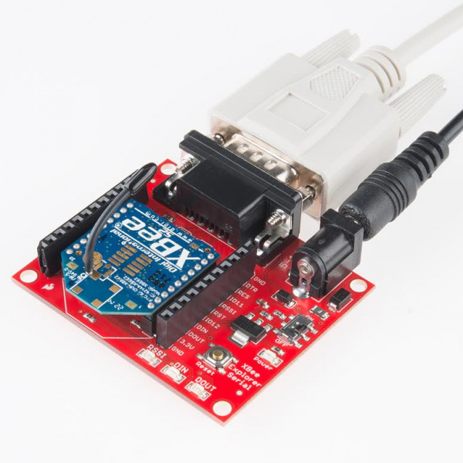

Fig.4 - [XBee Explorer Serial](https://www.sparkfun.com/products/11812)

The Serial Explorer has a bigger footprint than its USB-based brethren, but still shares most of the same features. There are RX and TX LEDs, reset button, break-out pins, and a voltage regulator. One additional feature that the Serial Explorer has is an On/Off switch on board. This enables the user to turn on or off the power supply to the XBee module.

One additional feature available on the Serial Explorer are two jumpers available near the DB9 connector. These allow the user to swap the configuration of the DB9 connector to work with either a straight through cable ([DCE](http://en.wikipedia.org/wiki/Data_circuit-terminating_equipment) configuration), or a switched cable ([DTE](http://en.wikipedia.org/wiki/Data_terminal_equipment) configuration). If you’re using our [Serial Cable](https://www.sparkfun.com/products/65), the default DCE configuration of the jumpers is fine.

Source:

www.learn.sparkfun.com

www.digi.com

www.spin.atomicobject.com

**Shahed University** summer-2019  
By: Mohammad Hossein Movasaghinia