## “Depression”

**Members**

**Navarro, Micah Guinevere P.**

**Minase, Desiree Rose**

**Alvarez, Marie Rhian Jaa**

**De Jesus, Daniel John**

**Christian Living Education  
Grade 9D  
Sir. Rainheart Pinuela**

**Project Proposal:   
- This project is created by group no. 7/26. Our study focuses on depression. It talks about their roots and some solutions.Our group has decided to cut down the parts of our project to deeper understand and gain more knowledge about the picked issue that affects a christian family.**

**- Our study focuses on raising awareness for depression. Our group has decided to cut down the parts and do some research. We have discovered that there are tons of roots but we have chosen only 3 of which are: Age, Loss, and Family/Marital problems.**

**- Our objectives is to educate,make known, and give possible solutions to people.**

**Introduction: (from Scaffold 3)  
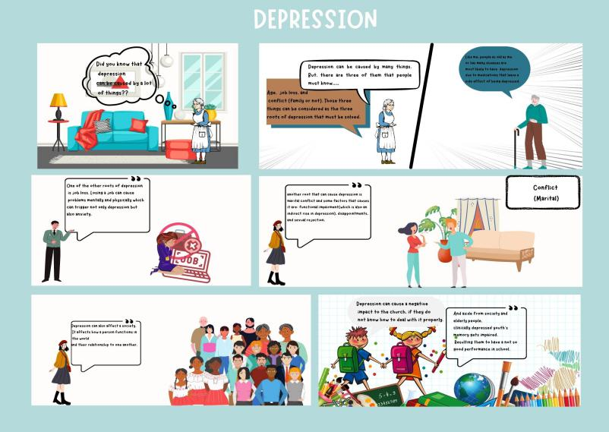**

**- Depression is a disorder that causes a feeling of sadness and loss of interest. Depression impacts an individuals daily life, it is caused by a chemical imbalance in neurotransmitters in the brain.   
- there are a lot of root causes in depression but we chose Age,Loss,and Family/Marital problems.   
- The stand of the church with regards to depression is very touching because they say that “whoever suffers mental illness always bears God’s image and likeness, and has an inalienable right to be considered a person and treated as such.**

**[https://www.google.com/url?sa=t&source=web&rct=j&url=https://lacatholics.org/mental-health-and-suicide/&ved=2ahUKEwj8of-OgZb2AhUVxzgGHSosBbgQFnoECFIQBQ&usg=AOvVaw3aMC16NcutJmqJ9UpOKnV5](https://www.google.com/url?sa=t&source=web&rct=j&url=https://lacatholics.org/mental-health-and-suicide/&ved=2ahUKEwj8of-OgZb2AhUVxzgGHSosBbgQFnoECFIQBQ&usg=AOvVaw3aMC16NcutJmqJ9UpOKnV5&fbclid=IwAR21k3DT5ocSV6uJ3Y1kpFSA7w9RluXFH5iwkfJasCyH8WNUrxdCIPN7xog" \t "https://www.facebook.com/_blank)**

**Rationale:  
- A lot of people suffers from depression, this project is really important because we need to take depression seriously.It does not only affect a person’s mental health but it also affects the physical well being of a person. We aim to address and educate people who does not know much about depression. Depression should be known properly because some people makes a laugh about it. It is important to know that there are a lot of possible root causes of depression. It isn’t just a family/marital problem or a loss of job/loved one. This project also wants people to know that a possible effect of depression is suicide.Knowing the signs of depression and learning about it can possible be a big help in the future.**

**Solutions:  
- Exercising and seeing a psychologist can be a solution to depression.**



**Exercising helps prevent and improve a number of health problems. Working out or doing other physical activities help ease symptoms of depression. It can also help preventing depression from coming back once you become better.**



**Seeing a psychologist when you have depression is highly advisable because they are highly trained mental health professionals with experience in helping patients recover from depression.**

**Prayer and Acknowledgement:**

**Prayer:**

**Lord God thank you for everything that you have done in the lives of these people. Thank you Lord because they are sill here and they are still trying to survive even though they are losing hope. Lord, I pray that you would touch them and heal them, I pray for them to feel your presence and know that they are not alone in this battle. Lord God we give you all the glory, honor and thanks. In Jesus name, Amen.**

**Acknowledgement:**

**I would like to acknowledge people who suffers depression. Though they feel like giving up, still they stay and choose to fight. They try to not lose hope and that is a very brave choice. Knowing that some people battles it alone breaks my heart into a thousand pieces.If ever you are battling depression alone, know that I am always here for you.**