Name : SUYASH SANJAY JADHAV Roll no. :32
Div : B Class :-SYBCA Batch:(B5)
Practical no:9 Developing a Personal Portfolio Website with React and Bootstrap.
App.js
import React from 'react';
import Navbar from './components/Navbar';
import Home from './components/Home';
import About from './components/About';
import Projects from './components/Projects';
import Footer from './components/Footer';
function App() {
return (
<div>
<Navbar />
<Home />
<About />
<Projects />
<Footer />
</div>
);
}
export default App;

Nvabar.js
import React from 'react';
function Navbar() {
return (
<nav className="navbar navbar-expand-lg navbar-dark bg-dark">
<div className="container">
<a className="navbar-brand">My Portfolio</a>
<div className="collapse navbar-collapse">
<ul className="navbar-nav ms-auto">
<li className="nav-item"><a className="nav-link" href="#home">Home</a></li>
<li className="nav-item"><a className="nav-link" href="#about">About</a></li>
<li className="nav-item"><a className="nav-link" href="#projects">Projects</a></li>
</ul>
</div>
</div>
</nav>
);
}
export default Navbar;

Home.js
import React from 'react';
function Home() {
return (
<section id="home" className="bg-dark text-center py-6">
<div className="container">
<h1>Hello, I’m Mahil</h1>
<p>Frontend Developer | React Enthusiast</p>
</div>
</section>
);
}
export default Home;

About.js
import React from 'react';
function About() {
return (
<section id="about" className="py-5">
<div className="container">
<h2>About Me</h2>
<p>I am a passionate web developer with skills in React, Bootstrap, and modern web
technologies.</p>
</div>
</section>
);
}
export default About;

Projects.js
import React from 'react';
function Projects() {
return (
<section id="projects" className="bg-light py-5">
<div className="container">
<h2>Projects</h2>
<ul>
<li>Portfolio Website</li>
<li>To-do App with React</li>
<li>Weather App using API</li>
</ul>
</div>
</section>
);
}
export default Projects;

Footer.js
import React from 'react';
function Footer() {
return (
<footer className="bg-dark text-white text-center py-3">
<p>© 2025 My Portfolio. All rights reserved.</p>
</footer>
);
}
export default Footer;
Index.js
import React from 'react';
import ReactDOM from 'react-dom/client';
import './index.css';
import App from './App';
import reportWebVitals from './reportWebVitals';

const root = ReactDOM.createRoot(document.getElementById('root'));
root.render(
<React.StrictMode>
<App />
</React.StrictMode>
);
// If you want to start measuring performance in your app, pass a function
// to log results (for example: reportWebVitals(console.log))
// or send to an analytics endpoint. Learn more: https://bit.ly/CRA-vitals
reportWebVitals();
Output:-
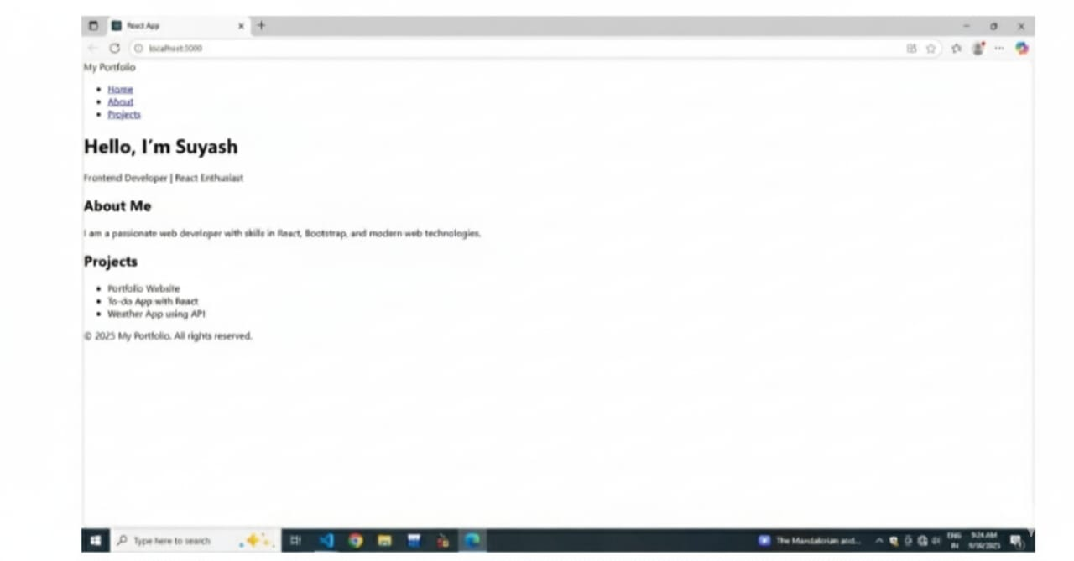
Name : SUYASH SANJAY JADHAV Roll no. :32
Div : B Class :-SYBCA Batch:(B5)
Practical No:10 Setting Up a Node.js and Express.js Development Environment: A Practical Guide. Server.js

const express = require('express');
const cors = require('cors');
const app = express();
const PORT = 5000;
app.use(cors());
app.use(express.json());
// Dummy API
app.get('/api/message', (req, res) => {
res.json({ message: "Hello from the backend!" });
});
app.listen(PORT, () => {
console.log(`Server running on http://localhost:${PORT}`);
});

OUTPUT:-

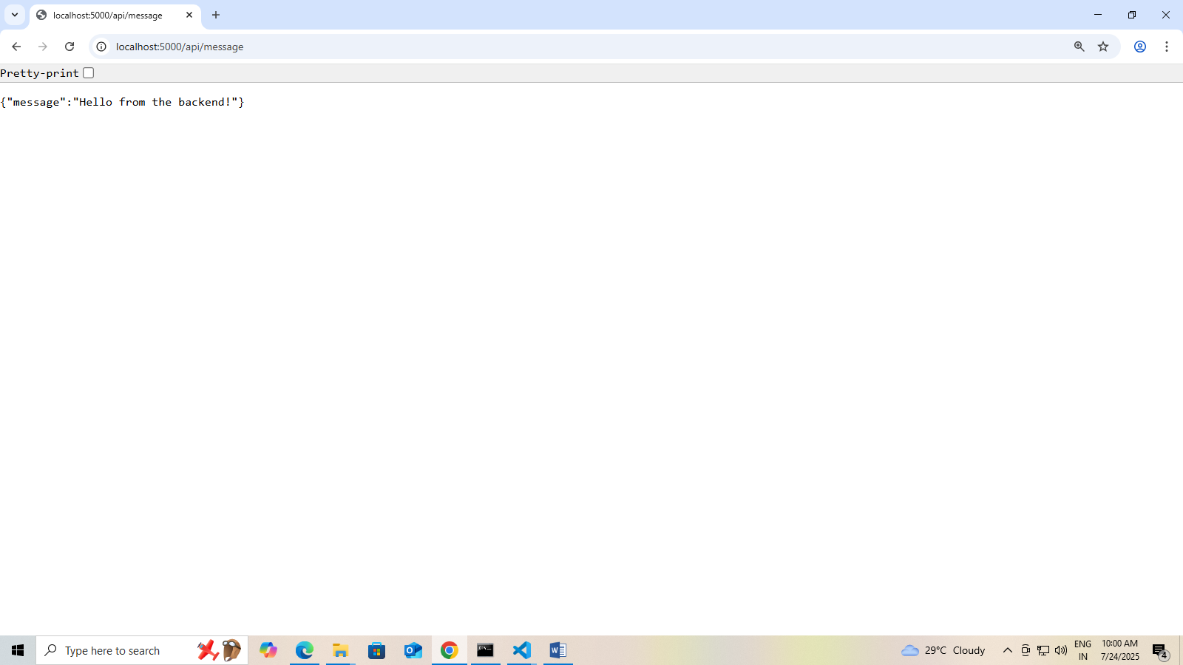

Name : SUYASH SANJAY JADHAV Roll no. :32
Div : B Class :-SYBCA Batch:(B5)
Practical No:11 Implementing Basic Routing in Express.js: Creating Multiple GET Endpointsconst

const express = require('express');
const app = express();
const port = 3000;
// Home Route
app.get('/', (req, res) => {
res.send('Welcome to my Home Page!');
});
// About Route
app.get('/about', (req, res) => {
res.send('This is the About my Page.');
});
// Contact Route
app.get('/contact', (req, res) => {
res.send('Contact us at contact jadhavsuyash@gmail.com');
});
// Services Route
app.get('/services', (req, res) => {
res.send('Here are our services: Web Development, App Development, SEO.');
});
// Start server
app.listen(port, () => {
console.log(`Server running at http://localhost:${port}`);
});

OUTPUT:-

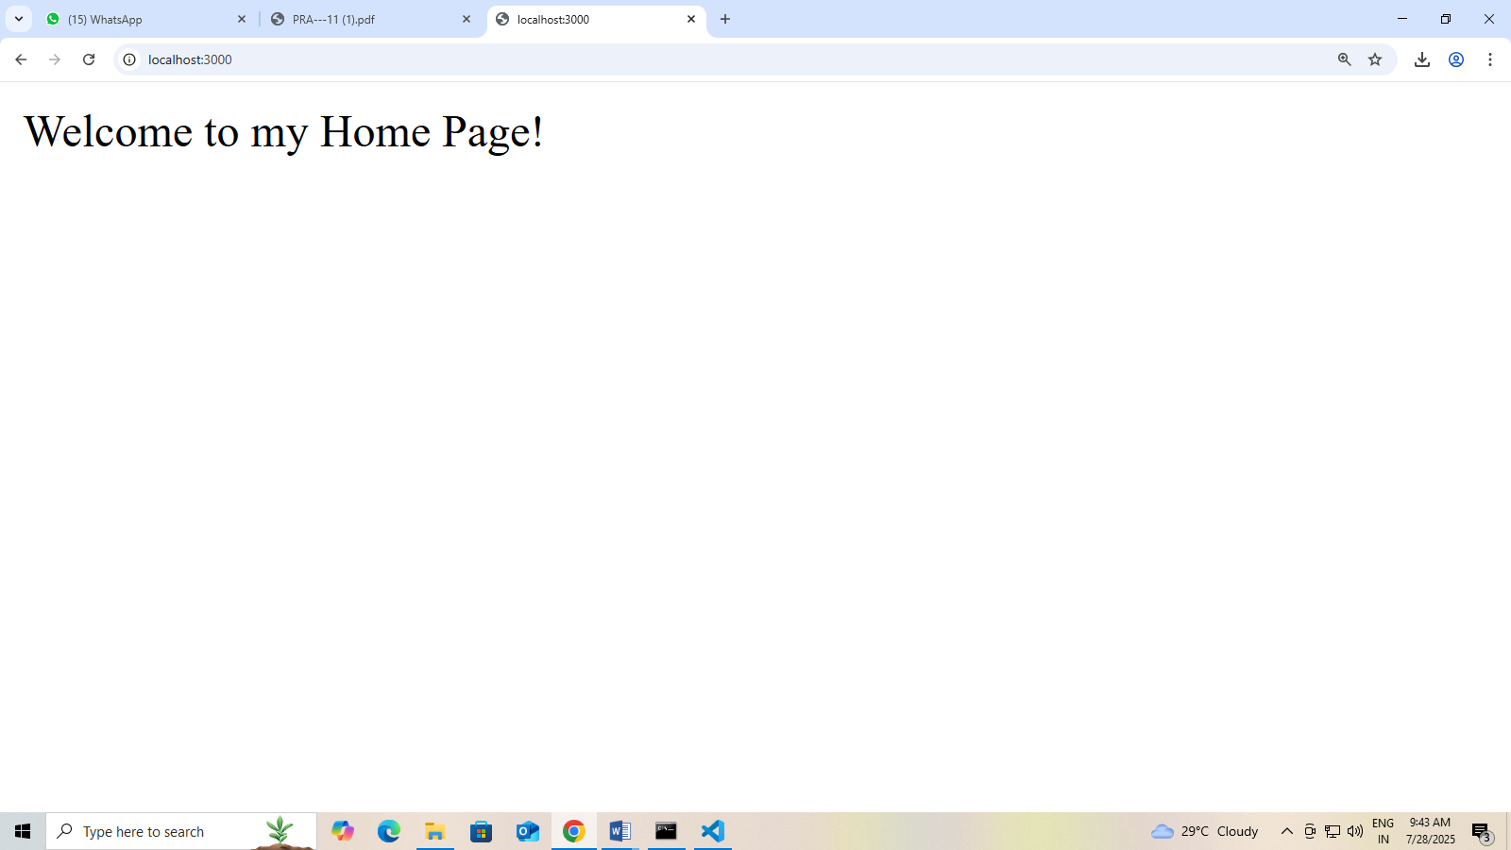
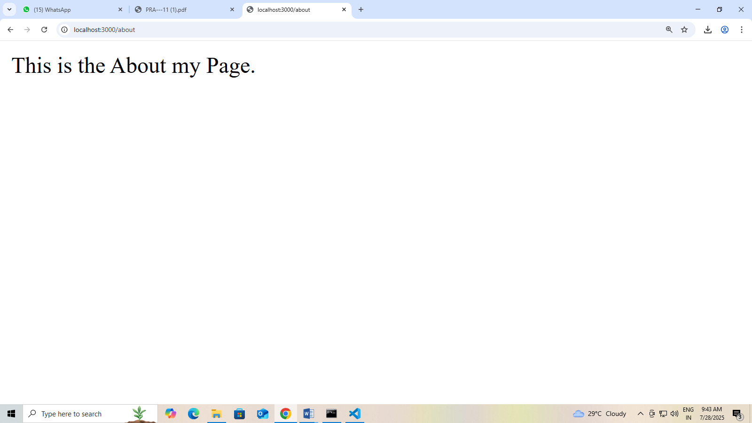

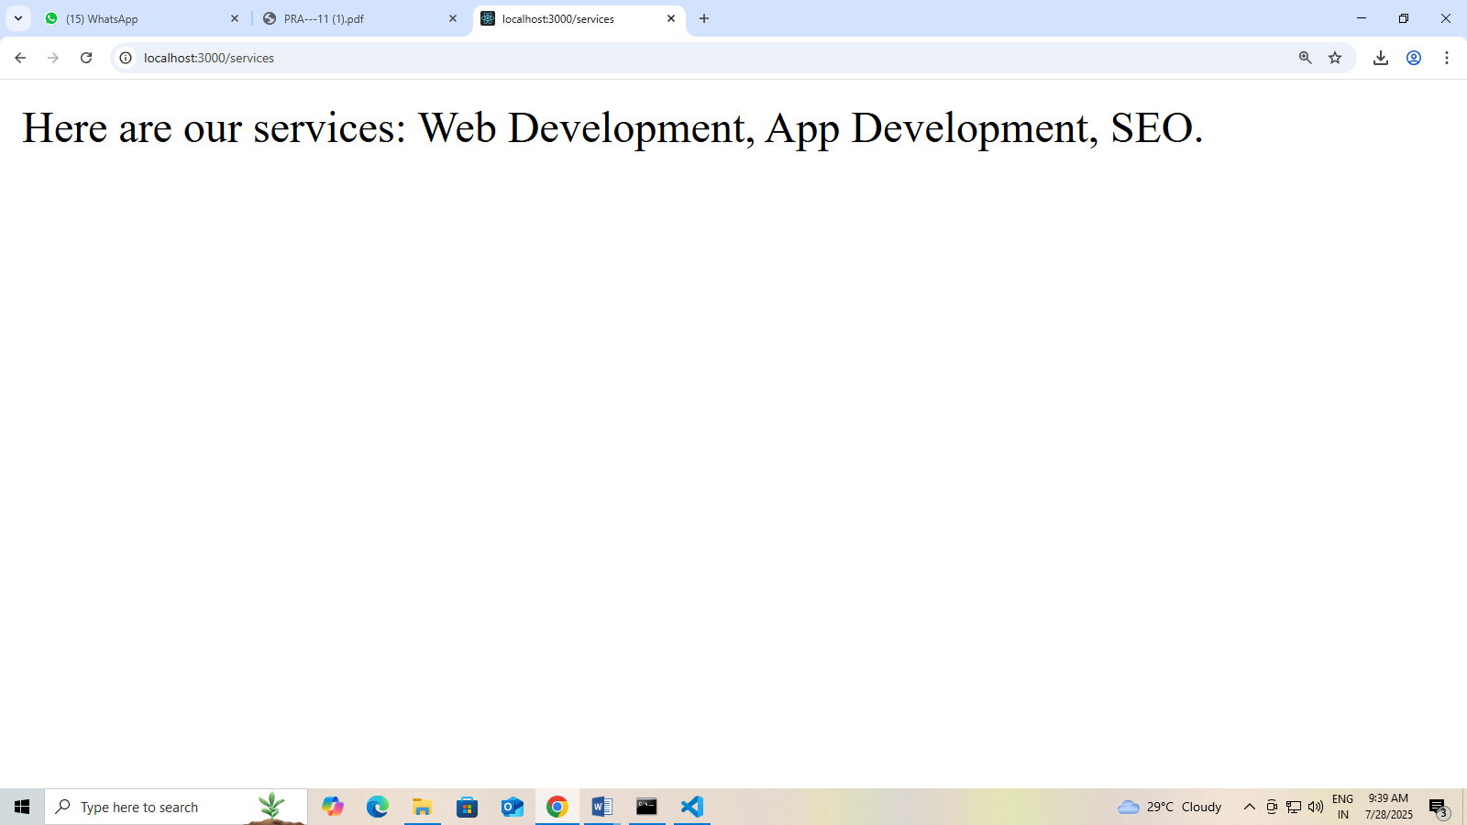

Name : SUYASH SANJAY JADHAV Roll no. :32
Div : B Class :-SYBCA Batch:(B5)
Practical No 12:- Building a RESTful API with Express.js: A Hands-On
Guide to HTTP Methods on (Customer details)
Index.js :-
const express = require('express');
const app = express();
const port = 3000;
app.use(express.json());
// Dummy in-memory customer data
let customers = [
{ id: 1, name: 'Harshu', email: 'Harshu@example.com' },
{ id: 2, name: 'Swati', email: 'Swati@example.com' }
];

// GET - List all customers list
app.get('/customers', (req, res) => {
res.json(customers);
});

// GET - Get a customer by ID
app.get('/customers/:id', (req, res) => {
const id = parseInt(req.params.id);
const customer = customers.find(c => c.id === id);
if (!customer) {
return res.status(404).send('Customer not found');
}
res.json(customer);
});

// POST - Add a new customer
app.post('/customers', (req, res) => {
const { name, email } = req.body;
const newCustomer = {
id: customers.length + 1,
name,
email
};
customers.push(newCustomer);
res.status(201).json(newCustomer);
});

// PUT - Update an existing customer
app.put('/customers/:id', (req, res) => {
const id = parseInt(req.params.id);
const customer = customers.find(c => c.id === id);
if (!customer) {
return res.status(404).send('Customer not found');
}
customer.name = req.body.name || customer.name;
customer.email = req.body.email || customer.email;
res.json(customer);
});

// DELETE - Remove a customer
app.delete('/customers/:id', (req, res) => {
const id = parseInt(req.params.id);
const index = customers.findIndex(c => c.id === id);
if (index === -1) {
return res.status(404).send('Customer not found');
}
const deletedCustomer = customers.splice(index, 1);
res.json(deletedCustomer);
});

// Start the server
app.listen(port, () => {
console.log(`Customer API is running at http://localhost:${port}`);
});
1.GET all customers
URL: http://localhost:3000/customers
Method: GET
Output:- 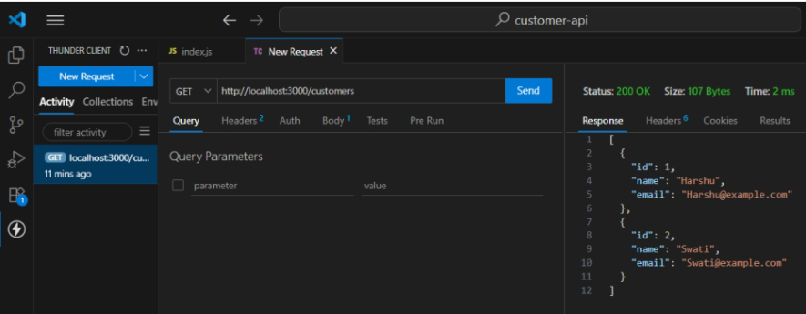

2.GET a customer by ID
URL: http://localhost:3000/customers/1
Method: GET
Output :-
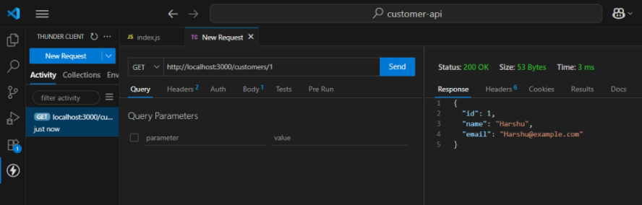

3.POST a new customer
URL: http://localhost:3000/customers
Method: POST
Output:-
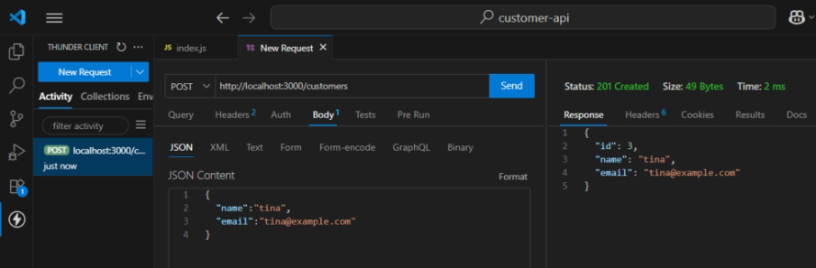

4.PUT(update) a customer
URL: http://localhost:3000/customers/3
Method: PUT
Output:- 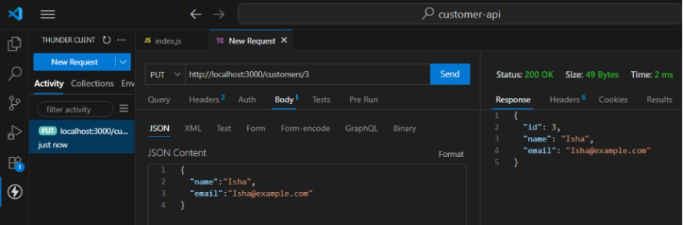

5.DELETE a customer
URL: http://localhost:3000/customers/3
Method: DELETE
Output:-
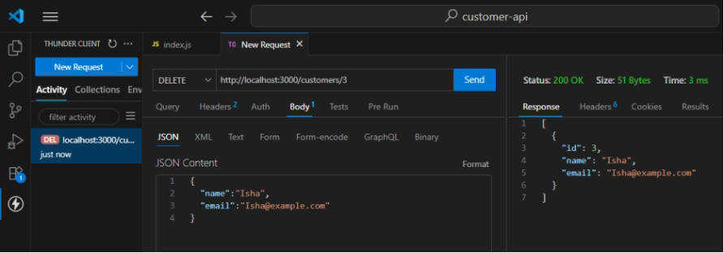

Name : SUYASH SANJAY JADHAV Roll no. :32
Div : B Class :-SYBCA Batch:(B5)
Practical No 13:Building RESTful APIs: Managing JSON POST Requests in Express.js (Employee Post Method).
const express = require('express');
const app = express();
const port = 3000;
// Middleware to parse JSON bodies
app.use(express.json());
// Sample data: Employees array
let employees = [
{ id: 1, name: 'Alice', role: 'Developer' },
{ id: 2, name: 'Bob', role: 'Designer' }
];
// GET endpoint to get all employees
app.get('/employees', (req, res) => {
res.json(employees);
});
// POST endpoint to add a new employee
app.post('/employees', (req, res) => {
const newEmployee = req.body;
// Simple validation
if (!newEmployee.name || !newEmployee.role) {
return res.status(400).json({ error: 'Name and role are required' });
}
// Assign a new id
newEmployee.id = employees.length + 1;
employees.push(newEmployee);
res.status(201).json(newEmployee);
});
// Start the server
app.listen(port, () => {
console.log(`Server running at http://localhost:${port}`);
});
OUTPUT:-
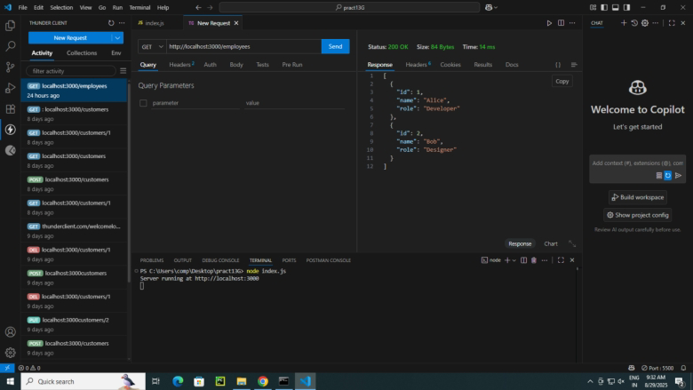

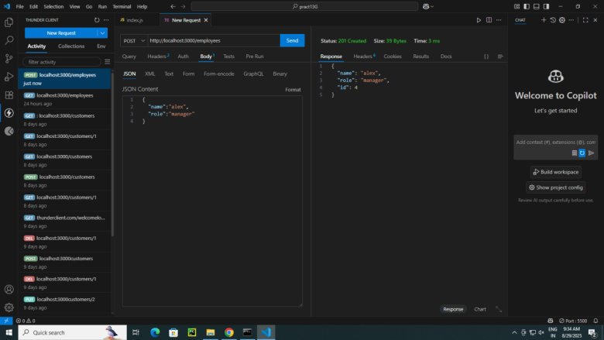

Name : SUYASH SANJAY JADHAV Roll no. :32
Div : B Class :-SYBCA Batch:(B5)
Practical No:14 Implementing CRUD Operations (Students)Using RESTful API and HTTP Methods
const express = require('express');
const app = express();
const port = 3000;
app.use(express.json());
// Fake in-memory database
let students = [];
let nextId = 1;
// CREATE - Add new student
app.post('/students', (req, res) => {
const student = { id: nextId++, ...req.body };
students.push(student);
res.status(201).json({ message: 'Student created', student });
});
// READ ALL - Get all students
app.get('/students', (req, res) => {
res.json(students);
});
// READ ONE - Get student by ID
app.get('/students/:id', (req, res) => {
const student = students.find(s => s.id == req.params.id);
if (!student) {
return res.status(404).json({ message: 'Student not found' });
}
res.json(student);
});
// UPDATE - Update student by ID
app.put('/students/:id', (req, res) => {
const index = students.findIndex(s => s.id == req.params.id);
if (index === -1) {
return res.status(404).json({ message: 'Student not found' });
}
students[index] = { id: students[index].id, ...req.body };
res.json({ message: 'Student updated', student: students[index] });
});
// DELETE - Delete student by ID
app.delete('/students/:id', (req, res) => {
const index = students.findIndex(s => s.id == req.params.id);
if (index === -1) {
return res.status(404).json({ message: 'Student not found' });
}
const removedStudent = students.splice(index, 1);
res.json({ message: 'Student deleted', student: removedStudent[0] });
});
app.listen(port, () => {
console.log(`Server running at http://localhost:${port}`);
});
Output:-