**SQL-CS-TASK**

**Code:**

CREATE DATABASE IF NOT EXISTS library_system;   
USE library_system;

**Result:**



**Code:**

CREATE TABLE books (

book_id INT PRIMARY KEY AUTO_INCREMENT,

title VARCHAR(100) NOT NULL,

author VARCHAR(100) NOT NULL,

publication_date DATE NOT NULL );

**Result:**

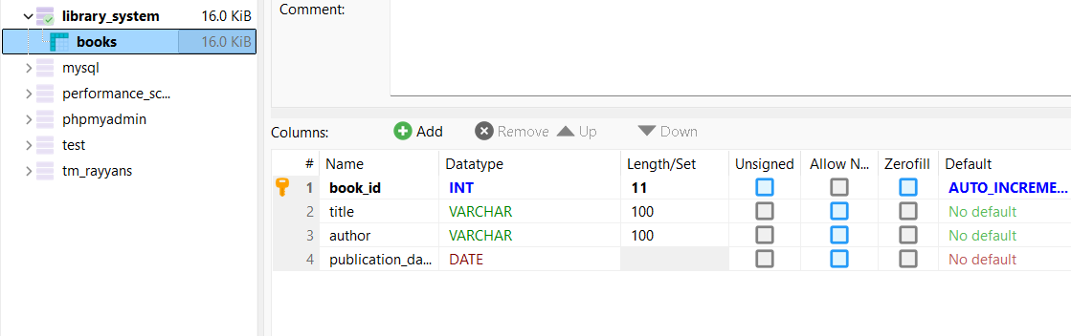

**Code:**

INSERT INTO books (title, author, publication_date)

VALUES ('The Great Gatsby', 'F. Scott Fitzgerald', '1925-04-10');

**Result:**

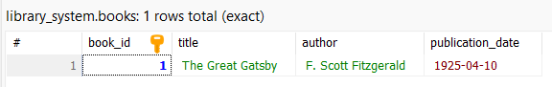

**Code:**

UPDATE books

SET publication_date = '1926-01-01'

WHERE book_id = 1;

**Result:**

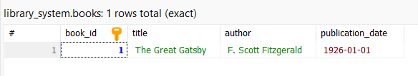

**Code:**

SELECT * FROM books

WHERE publication_date > '2000-01-01';

**Result:**

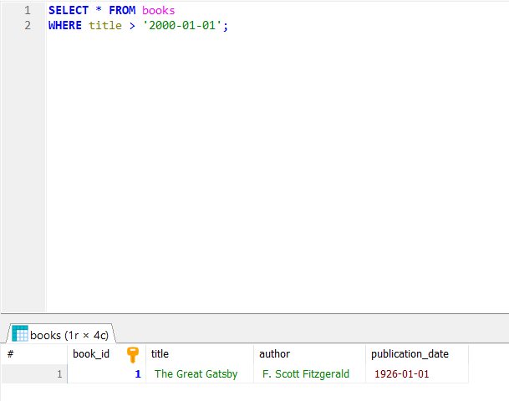

**Code:**

SELECT title, publication_date

FROM books

WHERE author = 'F. Scott Fitzgerald';

**Result:**

