What is Jiviz?

Jiviz as a social media on blockchain.

Smart Contract that will reward Token will reward users when coin is mined/or when a certain amount of blocks have been mined. The coins will be sent to this smart contract which will distribute coins to its users, automatically.

Users action will be recorded on blockchain, which will then be recorded on the side chain.

Road Map:

Identity Control

Artificial Intelligence for security safety and consistency in identities.

Abstract :

Jiviz is a decentralized platform that leverages the power of blockchain technology in empowering involved stakeholders to take full ownership of their content and finances. Our platform is built on a transparent Peer-to-Peer network powered by programmable smart contracts to enable fair remuneration for all social media activity done by peers.

Long Term Vision:

Source : https://gs.statcounter.com/social-media-stats



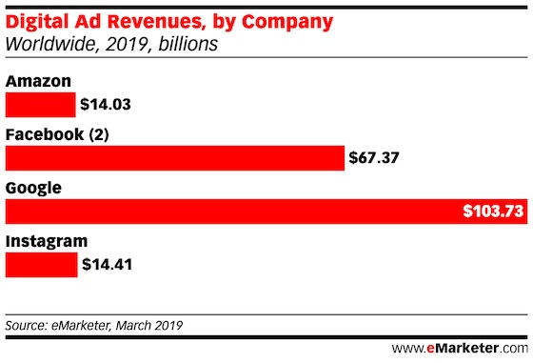

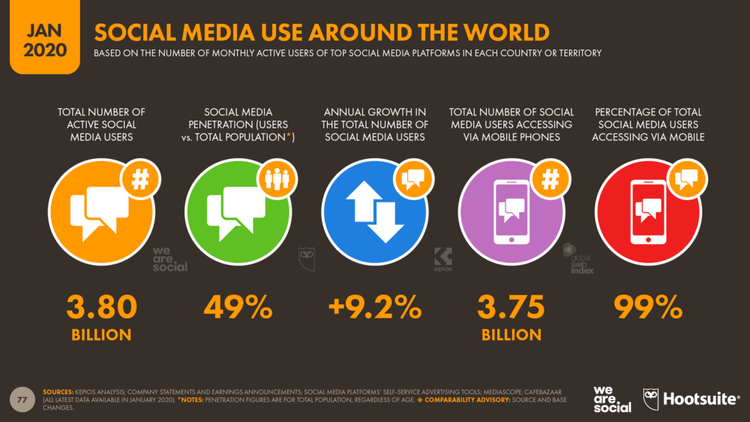

By the end of 2019 Around Half of the world’s population is using social media and sharing digital content worldwide. Some of this content is having a significant business value and this should be rewarded, so that more quality content. The growth potential is obviously very high.

Centralization:
Today a handful of companies own more than 95% of the market share and dictate the market rules that are most favorable to them. Often the charges for advertising on their platforms is highly unfair. Centralization of revenue adn power among social media is also susceptible to propagate unfair info in the

