A

Project Report

On

**Library Management System**

Submitted in partial fulfilment of the requirement for the IV semester

**Bachelor of Computer Science**

By

**MANOJ NATH GOSWAMI**

**POOJA JOSHI**

Under the Guidance of

**Mr. Devesh Pandey**

**Assistant Professor**

**Department of CSE**



# DEPARTMENT OF COMPUTER SCIENCE & ENGINEERING GRAPHIC ERA HILL UNIVERSITY, BHIMTAL CAMPUS

**SATTAL ROAD, P.O. BHOWALI, DISTRICT- NAINITAL-263132**

**2022- 2023**

## STUDENT’S DECLARATION

We, **Manoj Nath Goswami and Pooja Joshi** here by declare the work, which is being presented in the project, entitled “**Library Management System**” in partial fulfilment of the requirement for the award of the degree **B.Tech** in the session **2022-2023**, is an authentic record of my own work carried out under the supervision of “**Mr. Devesh Pandey”, Assistant Professor, Department of CSE, Graphic Era Hill University, Bhimtal.** The matter embodied in this project has not been submitted by us for the award of any other degree.

Date:

Manoj Nath Goswami

210111126

Pooja Joshi

210121622

**CERTIFICATE**

The project report entitled “Library Management System” being submitted by **Manoj Nath Goswami and Pooja Joshi** to Graphic Era Hill University Bhimtal Campus for the award of bonafide work carried out by them. They have worked under my guidance and supervision and fulfilled the requirement for the submission of report.

**(Mr. Devesh Pandey) (Dr. Ankur Bisht)**

**Project Guide (HOD, CSE Dept.)**

**ACKNOWLEDGEMENT**

We take immense pleasure in thanking Honourable **“Mr Devesh Pandey”** (**Assistant** **Professor,** **CSE, GEHU Bhimtal Campus**) to permit me and carry out this project work with his excellent and optimistic supervision. This has all been possible due to his novel inspiration, able guidance and useful suggestions that helped me to develop as a creative researcher and complete the research work, in time.

Words are inadequate in offering my thanks to GOD for providing me everything that we need. We again want to extend thanks to our President **“Prof. (Dr.) Kamal Ghanshala”** for providing us all infrastructure and facilities to work in need without which this work could not be possible.

Many thanks to Professor **“Dr. Manoj Chandra Lohani”** (Director Gehu Bhimtal),other faculties for their insightful comments, constructive suggestions, valuable advice, and time in reviewing this thesis.

Finally, yet importantly, we would like to express my heartiest thanks to our beloved parents, for their moral support, affection and blessings. We would also like to pay our sincere thanks to all our friends and well-wishers for their help and wishes for the successful completion of this research.

**Manoj Nath Goswami**

**Pooja Joshi**

**TABLE OF CONTENTS**

ABSTRACT 6

1. **INTRODUCTION** 
   1. PROJECT AIMS AND OBJECTIVES **7**
   2. BACKGROUND OF PROJECT  **7**
   3. OPERATION ENVIRONMENT **7**
2. **SYSTEM ANALYSIS**
   1. SOFTWARE REQUIREMENT SPECIFICATION **8**
   2. EXISTING VS PROPOSED **13**
   3. SOFTWARE TOOL USED 14
3. **SYSTEM DESIGN**
   1. TABLE DESIGN 17
   2. DATA FLOW DIAGRAM’S 18
4. **SYSTEM IMPLEMENTATION**
   1. SCREEN SHOTS 20
5. **SYSTEM TESTING**
   1. UNIT TESTING 23
   2. INTEGRATION TESTING 23
6. **CONCLUSION & FUTURE SCOPE** 25
7. **REFERENCES** 26

**Abstract:**

Online Library Management System is a system which maintains the information about the books present in the library, their authors, the members of library to whom books are issued, library staff and all. This is very difficult to organize manually. Maintenance of all this information manually is a very complex task. Owing to the advancement of technology, organization of an Online Library becomes much simple. The Online Library Management has been designed to computerize and automate the operations performed over the information about the members, book issues and returns and all other operations. This computerization of library helps in many instances of its maintenances. It reduces the workload of management as most of the manual work done is reduced.

For library users, the system provides a user-friendly interface to search and browse the library catalos, view availability status, place holds, and renew borrowed items. It may offer personalized features, such as creating user profiles, managing reading lists, and receiving notifications for upcoming due dates or new arrivals. Online access to digital resources, e-books, and e-journals can also be integrated into the system, enhancing the library's digital offerings.

In addition, the library management system generates reports and statistical analysis to support data-driven decision-making, including circulation statistics, resource usage trends, and user demographics. It aids in inventory management, budget planning, and collection development, enabling libraries to optimize their resources and services based on user needs.

Overall, the library management system serves as a comprehensive solution to efficiently manage library operations, improve user experience, and enhance the overall effectiveness and accessibility of library services.

**CHAPTER 1**

**INTRODUCTION**

This chapter gives an overview about the aim, objectives, background and operation environment of the system.

**1.1 PROJECT AIMS AND OBJECTIVES**

The project aims and objectives that will be achieved after completion of this project are discussed in this subchapter. The aims and objectives are as follows:

* Online book reading.
* A search column to search availability of books.
* Facility to download required book.
* Video tutorial for students.
* An Admin login page where admin can add books, videos or page sources • Open link for Learning Websites

### 1.2 BACKGROUND OF PROJECT

E-Library Management System is an application which refers to library systems which are generally small or medium in size. It is used by librarian to manage the library using a computerized system where he/she can add new books, videos and Page sources.

Books and student maintenance modules are also included in this system which would keep track of the students using the library and also a detailed description about the books a library contains. With this computerized system there will be no loss of book record or member record which generally happens when a non-computerized system is used.

**1.3 OPERATION ENVIRONMENT**

|  |  |
| --- | --- |
| PROCESSOR | INTEL CORE PROCESSOR OR BETTER PERFORMANCE |
| OPERATING SYSTEM | WINDOWS VISTA, WINDOWS7, UBUNTU |
| MEMORY | 1GB RAM OR MORE |
| HARD DISK SPACE | MINIMUM 3GB FOR DATABASE USAGE FOR FUTURE |
| DATABASE | MYSQL |

**CHAPTER 2**

**SYSTEM ANALYSIS**

In this chapter, we will discuss and analyse about the developing process of Library Management System including software requirement specification (SRS) and comparison between existing and proposed system. The functional and non-functional requirements are included in SRS part to provide complete description and overview of system requirement before the developing process is carried out. Besides that, existing vs proposed provides a view of how the proposed system will be more efficient than the existing one.

**2.1SOFTWARE REQUIREMENT SPECIFICATION**

### 2.1.1 GENERAL DESCRIPTION

**PRODUCT DESCRIPTION:**

Library Management System is a computerized system which helps

user(librarian) to manage the library daily activity in electronic format. It reduces the risk of paper work such as file lost, file damaged and time consuming. It can help user to manage the transaction or record more effectively and time- saving.

**PROBLEM STATEMENT:**

The problem occurred before having computerized system includes:

**• File lost:**

When computerized system is not implemented file is always lost because of human environment. Sometimes due to some human error there may be a loss of records.

• **File damaged:**

When a computerized system is not their file is always lost due to some accident like spilling of water by some member on file accidentally. Besides some natural disaster like floods or fires may also damage the files.

• **Difficult to search record:**

When there is no computerized system there is always a difficulty in searching of records if the records are large in number

**• Space consuming**

After the number of records become large the space for physical storage of file and records also increases if no computerized system is implemented.

• **Cost consuming**

As there is no computerized system the to add each record paper will be needed which will increase the cost for the management of library.

### 2.1.2 SYSTEM OBJECTIVES

* Improvement in control and performance

The system is developed to cope up with the current issues and problems of library.The system can add user, validate user and is also bug free.

* Save cost

After computerized system is implemented less human force will be required to maintain the library thus reducing the overall cost.

* Save time

Librarian is able to search record by using few clicks of mouse and few search keywords thus saving his valuable time.

* Option of online Notice board

Librarian will be able to provide a detailed description of workshops going in the college as well as in nearby colleges

* Lecture Notes

Teacher has a facility to upload lectures notes in a pdf file having size not more than 10mb

### 2.1.3 SYSTEM REQUIREMENTS

#### 2.1.3.1 NON-FUNCTIONAL REQUIREMENTS

Product Requirements: -

**EFFICIENCY REQUIREMENT**

When a library management system will be implemented librarian and user will easily access library as searching and book transaction will be very faster.

**RELIABILITY REQUIREMENT**

The system should accurately perform member registration, member validation , report generation, book transaction and search

**USABILITY REQUIREMENT**

The system is designed for a user-friendly environment so that student and staff of library can perform the various tasks easily and in an effective way.

**ORGANIZATIONAL REQUIREMENT IMPLEMENTATION REQUIREMNTS**

In implementing whole system, it uses html in front end with php as server-side scripting language which will be used for database connectivity and the backend i.e., the database part is developed using mysql.

**DELIVERY REQUIREMENTS**

The whole system is expected to be delivered in six months of time with a weekly evaluation by the project guide.

**2.1.3.2 FUNCTIONAL REQUIREMENTS**

1. **NORMAL USER**

**1.1 USER LOGIN**

##### Description of feature

This feature used by the user to login into system. They are required to enter user id and password before they are allowed to enter the system. The user id and password will be verified and if invalid id is there user is allowed to not enter the system.

##### Functional requirements

* user id is provided when they register
* The system must only allow user with valid id and password to enter the system
* The system performs authorization process which decides what user level can acess to.
* The user must be able to logout after they finished using system.

#### 1.2 REGISTER NEW USER

##### Description of feature

This feature can be performed by all users to register new user to create account. **Functional requirements**

* System must be able to verify information
* System must be able to delete information if information is wrong

#### 1.3 REGISTER NEW BOOK

##### Description of feature

This feature allows to add new books to the library

###### Functional requirements

* System must be able to verify information
* System must be able to enter number of copies into table.
* System must be able to not allow two books having same book id.

1**.5 SEARCH BOOK**

**DESCRIPTION OF FEATURE**

This feature is found in book maintenance part . we can search book based on book id , book name , publication or by author name.

**Functional requirements**

* System must be able to search the database based on select search type
* System must be able to filter book based on keyword enterd
* System must be able to show the filtered book in table view

* System should be able to add detailed information about events.
* System should be able to display information on notice board available in the homepage of site

### 2.1.4 SOFTWARE AND HARDWARE REQUIREMENTS

This section describes the software and hardware requirements of the system

#### 2.1.4.1 SOFTWARE REQUIREMENTS

* Operating system- Windows 7 is used as the operating system as it is stable and supports more features and is more user friendly

* Database MYSQL-MYSQL is used as database as it easy to maintain and retrieve records by simple queries which are in English language which are easy to understand and easy to write.

* Development tools and Programming language- HTML is used to write the whole code and develop webpages with css, java script for styling work and php for sever side scripting.

#### 2.1.4.2 HARDWARE REQUIREMENTS

* Intel core i5 2 nd generation is used as a processor because it is fast than other processors an provide reliable and stable and we can run our pc for long time. By using this processor, we can keep on developing our project without any worries.
* Ram 1 gb is used as it will provide fast reading and writing capabilities and will in turn support in processing.

**2.2 Existing System:**

* Early days Libraries are managed manually. It required lot of time to record or to retrieve the details. The employees who have to record the details must perform their job very carefully. Even a small mistake would create a lot of problems. Security of information is very less. Report generations of all the information is very tough task.
* Maintenance of Library catalogue and arrangement of the books to the catalogue is very complex task. In addition to its maintenance of member details, issue dates and return dates etc. manually is a complex task.
* All the operations must be performed in perfect manner for the maintenance of the library without any degradation which may finally result in the failure of the entire system.

**Proposed System:**

To solve the inconveniences as mentioned in the existing system, an **Online Library** is proposed. The proposed system contains the following features:

* The students will register them through Online.
* Individually each member will have his account through which he can access information he needs.
* Book details like authors, number of copies totally maintained by library, present available number of books, reference books, non-reference books etc. all this information can be made handy.
* Regarding the members designation, number of books was issued.Issue dates and returns of each member is maintained separately and fine charged if there is any delay in returning the book.
* Administrator can add, update the books.

#### 2.3 SOFTWARE TOOLS USED

The whole Project is divided in two parts the front end and the back end.

##### 2.3.1 Front end

The front end is designed using of html , Php ,css, Java script

**HTML**- **HTML** or**Hyper Text Markup Language** is the main markup language for creating web pages and other information that can be displayed in a web browser.HTML is written in the form of HTML elements consisting of *tags* enclosed in angle brackets (like <html>), within the web page content. HTML tags most commonly come in pairs like <h1> and </h1>, although some tags represent *empty elements* and so are unpaired, for example <img>. The first tag in a pair is the *start tag*, and the second tag is the *end tag* (they are also called *opening tags* and *closing tags*). In between these tags web designers can add text, further tags, comments and other types of text-based content. The purpose of a web browser is to read HTML documents and compose them into visible or audible web pages.

**CSS-** **Cascading Style Sheets**(**CSS**) is a style sheet language used for describing the look and formatting of a document written in a markup language. While most often used to style web pages and interfaces written in HTML and XHTML, the language can be applied to any kind of XML document, including plain XML, SVG and XUL. CSS is a cornerstone specification of the web and almost all web pages use CSS style sheets to describe their presentation.CSS is designed primarily to enable the separation of document content from document presentation, including elements such as the layout, colors, and fonts. This separation can improve content accessibility, provide more flexibility and control in the specification of presentation characteristics, enable multiple pages to share formatting, and reduce complexity and repetition in the structural content (such as by allowing for table less web design).

**JAVA SCRIPT**- **JavaScript**(**JS**) is a dynamic computer programming language. It is most commonly used as part of web browsers, whose implementations allow client side scripts to interact with the user, control the browser, communicate asynchronously, and alter the document content that is displayed. It is also being used in server-side programming, game development and the creation of desktop and mobile applications. JavaScript is a prototype-based scripting language with dynamic typing and has first-class functions. Its syntax was influenced by C. JavaScript copies many names and naming conventions from Java, but the two languages are otherwise unrelated and have very different semantics. The key design principles within JavaScript are taken from the Self and Scheme programming languages. It is a multiparadigm language, supporting object-oriented, imperative, and functional programming styles.

**PHP**- **PHP** is a server-side scripting language designed for web development but also used as a general-purpose programming language. PHP is now installed on more than 244 million websites and 2.1 million web servers. Originally created

by Rasmus Lerdorf in 1995, the reference implementation of PHP is now produced by The PHP Group. While PHP originally stood for *Personal Home Page*, it now stands for *PHP: Hypertext Preprocessor*, a recursive backronym. PHP code is interpreted by a webserver with a PHP processor module, which generates the resulting web page: PHP commands can be embedded directly into an HTML source document rather than calling an external file to process data. It has also evolved to include a command-line interface capability and can be used in standalone graphical applications. PHP is free software released under the PHP License. PHP can be deployed on most web servers and also as a standalone shell on almost every operating system and platform, free of charge.

**MYSQL**- **MySQL** ("My S-Q-L", officially, but also called "My Sequel") is (as ofJuly

2013) the world's second most widely used open-source relational database management system (RDBMS). It is named after co-founder Michael Widenius daughter, My. The SQL phrase stands for Structured Query Language. The MySQL development project has made its source code available under the terms of the GNU General Public License, as well as under a variety of proprietary agreements. MySQL was owned and sponsored by a single for-profit firm, the Swedish company MySQL AB, now owned by Oracle Corporation .MySQL is a popular choice of database for use in web applications, and is a central component of the widely used LAMP open source web application software stack (and other 'AMP' stacks). LAMP is an acronym for "Linux, Apache, MySQL,Perl/PHP/Python." Free-software-open source projects that require a full-featured database management system often use **MySQL**. For commercial use, several paid editions are available, and offer additional functionality. Applications which use MySQL **databases** include: TYPO3, MODx, Joomla, WordPress, phpBB, MyBB, Drupal and other software. MySQL is also used in many high-profile, large-scale websites, including Wikipedia, Google (though not for searches), Facebook, Twitter, Flickr, and YouTube .

**CHAPTER 3**

**SYSTEM DESIGN**

**3.1** **TABLE DESIGN**

VARIOUS TABELS TO MAINTAIN INFORMATION

**Library Table from Database**

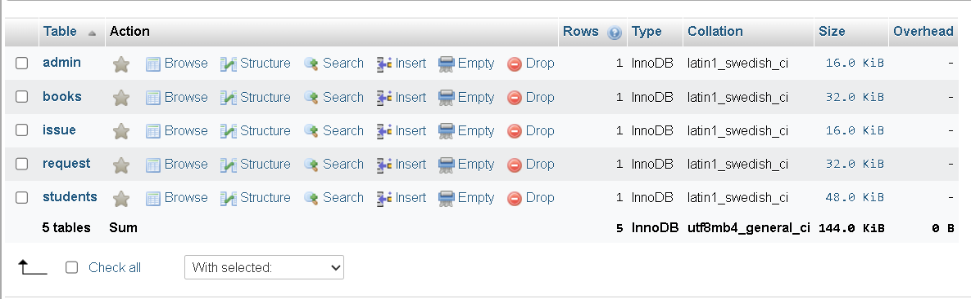

**Admin Table from Database** 

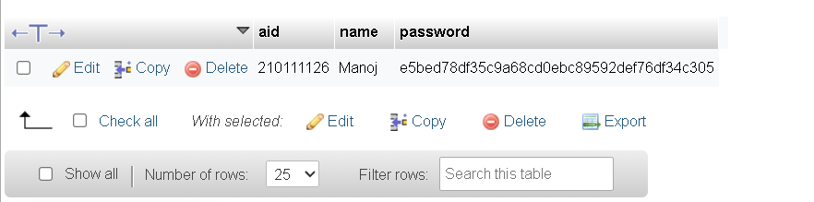

**Books Table from Database**

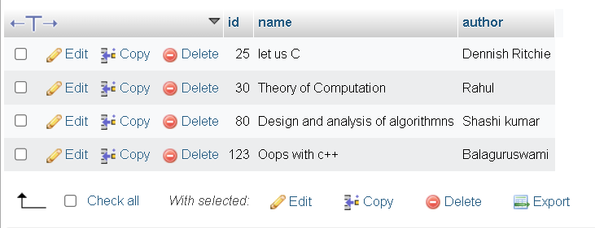

**Students Table from Database**

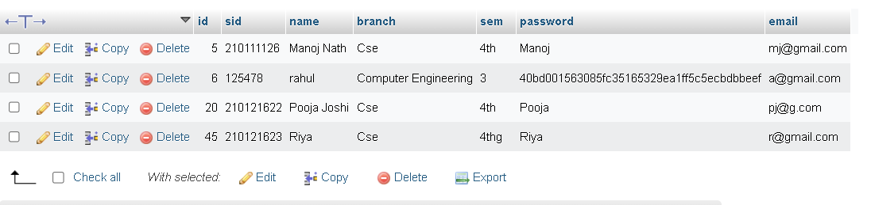

**3.2** **DATA FLOW DIAGRAMS**

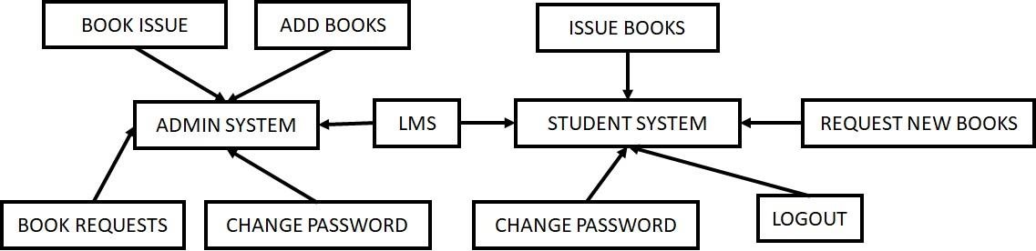

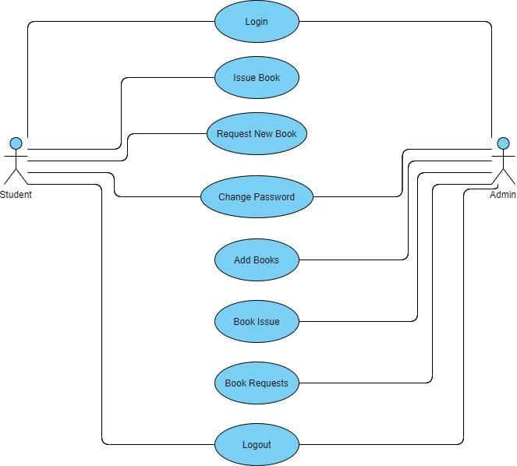

After entering to the home page of the website, Admin can choose the Admin Login option where they are asked to enter username & password , and if he/she is a valid user then a teacher login page will be displayed.

USER CASE DIAGRAM FOR ADMIN

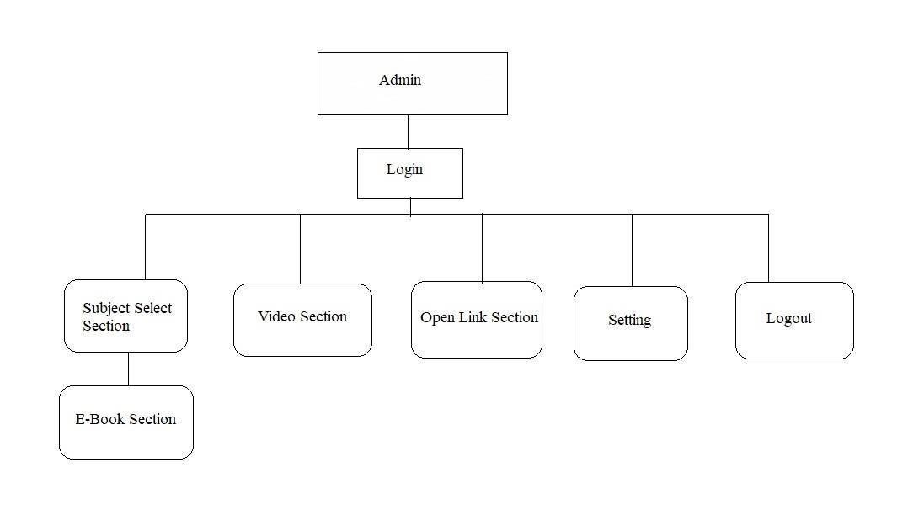

**CHAPTER 4**

## SYSTEM IMPLEMENTATION

### 4.1 Screenshot for homepage

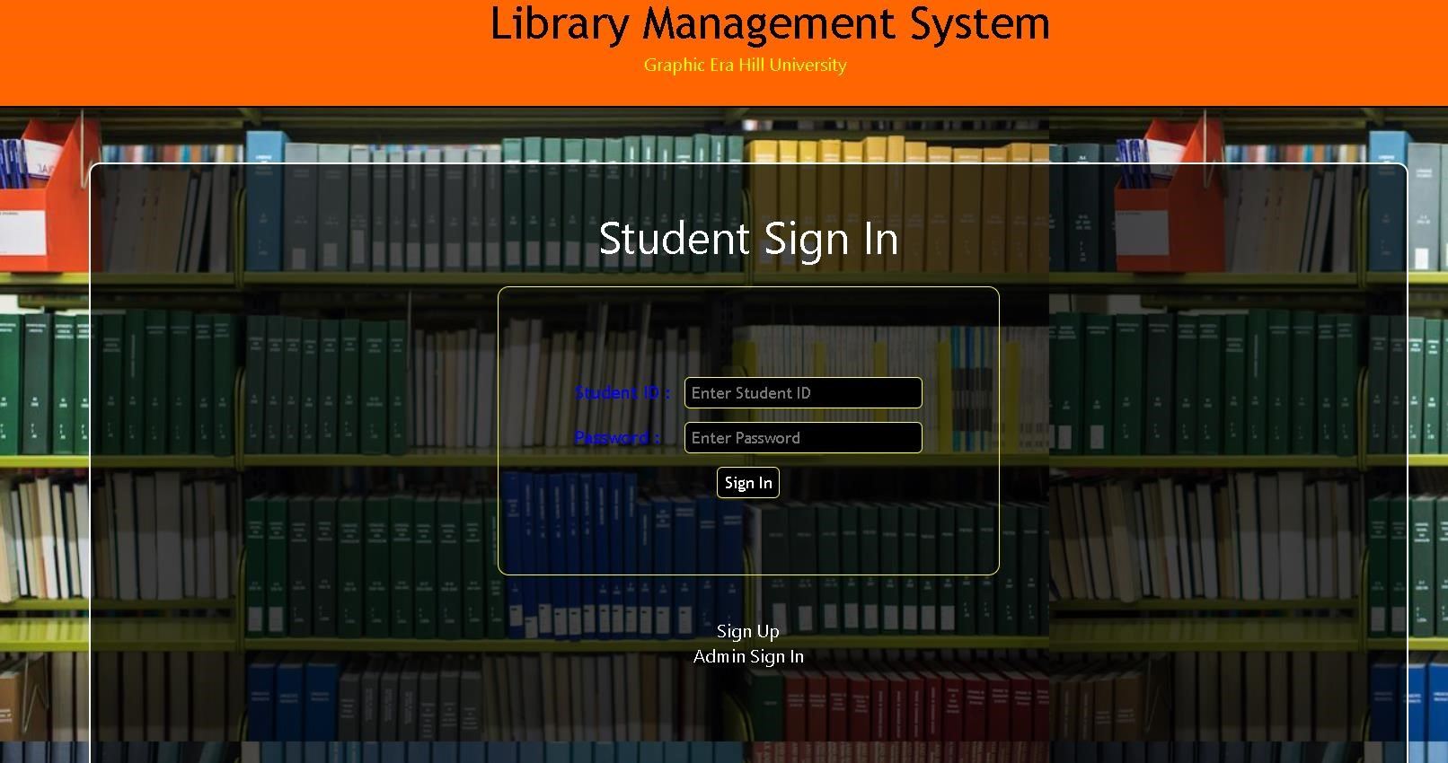

### 4.2 Screenshot for admin signup

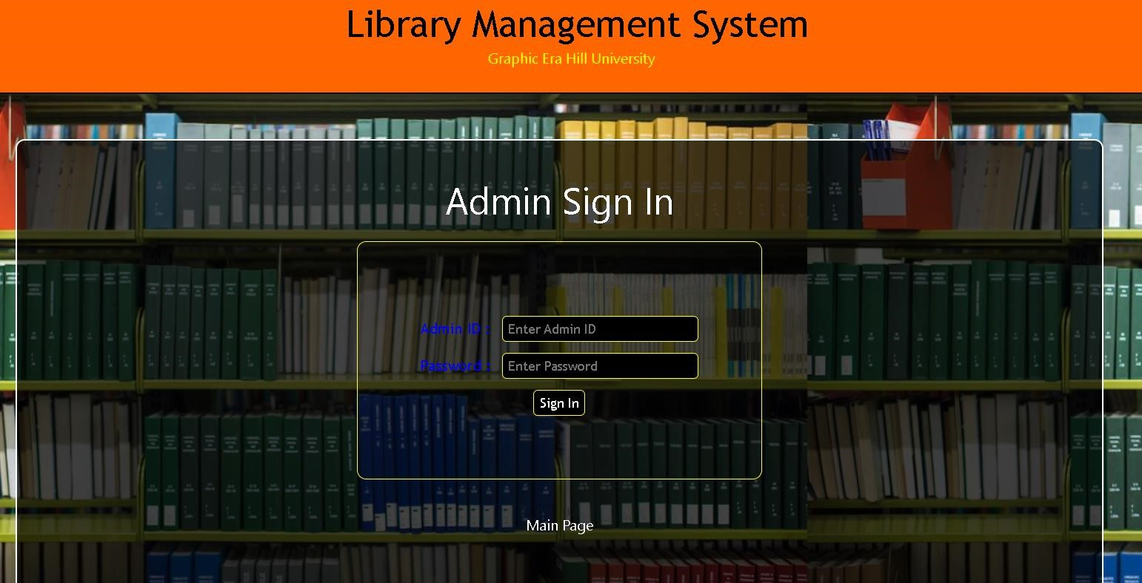

### 4.3 Screenshot for Student Registration

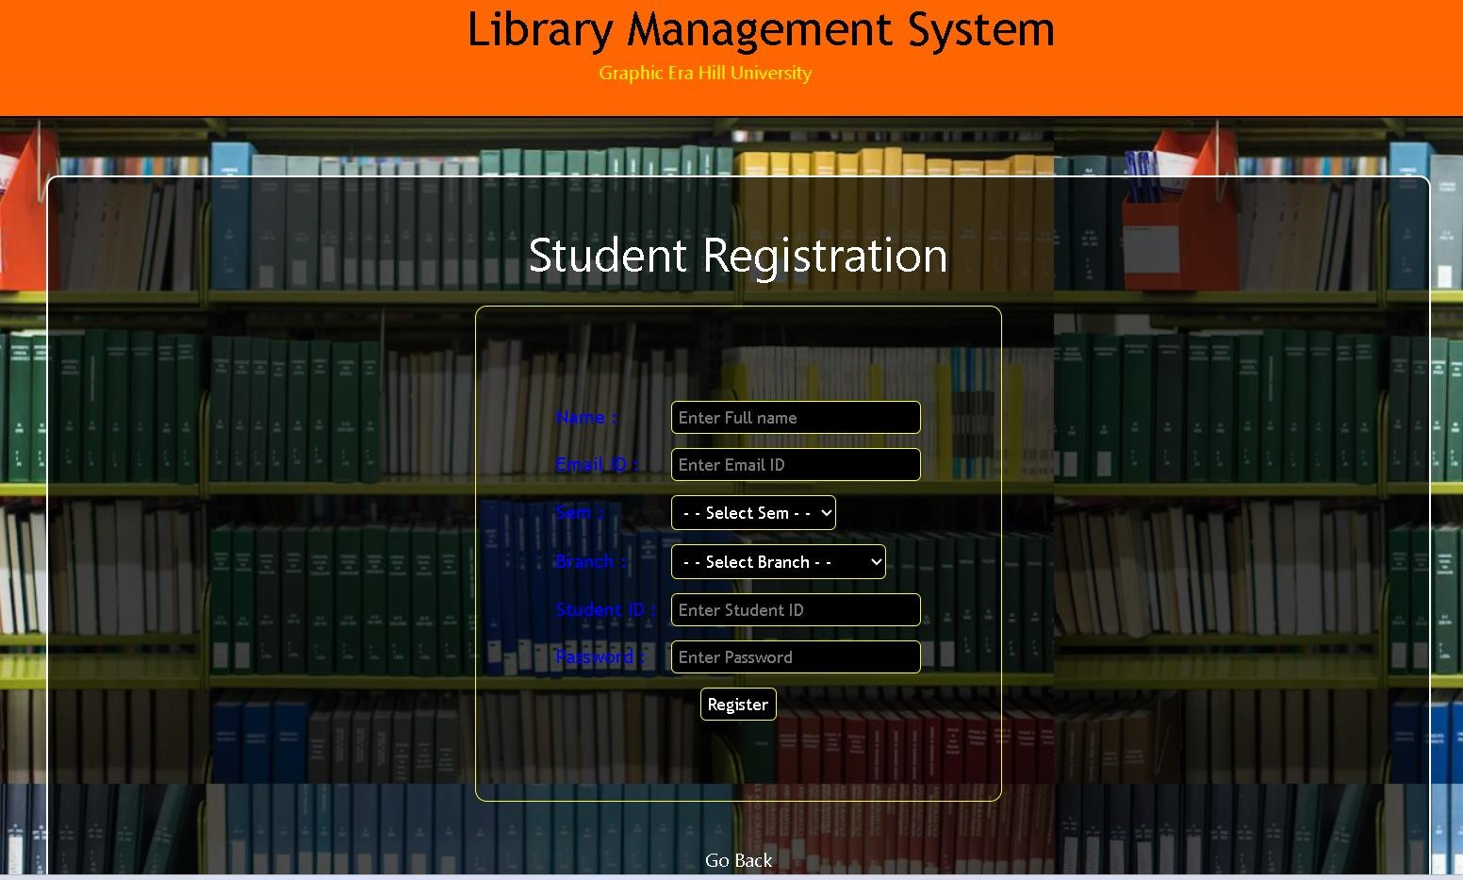

### 4.4 Screenshot for Student Page

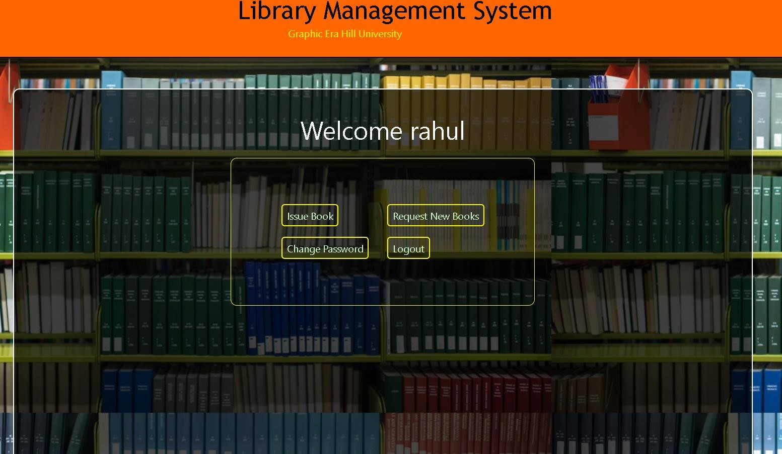

### 4.5 Screenshot for Admin Page

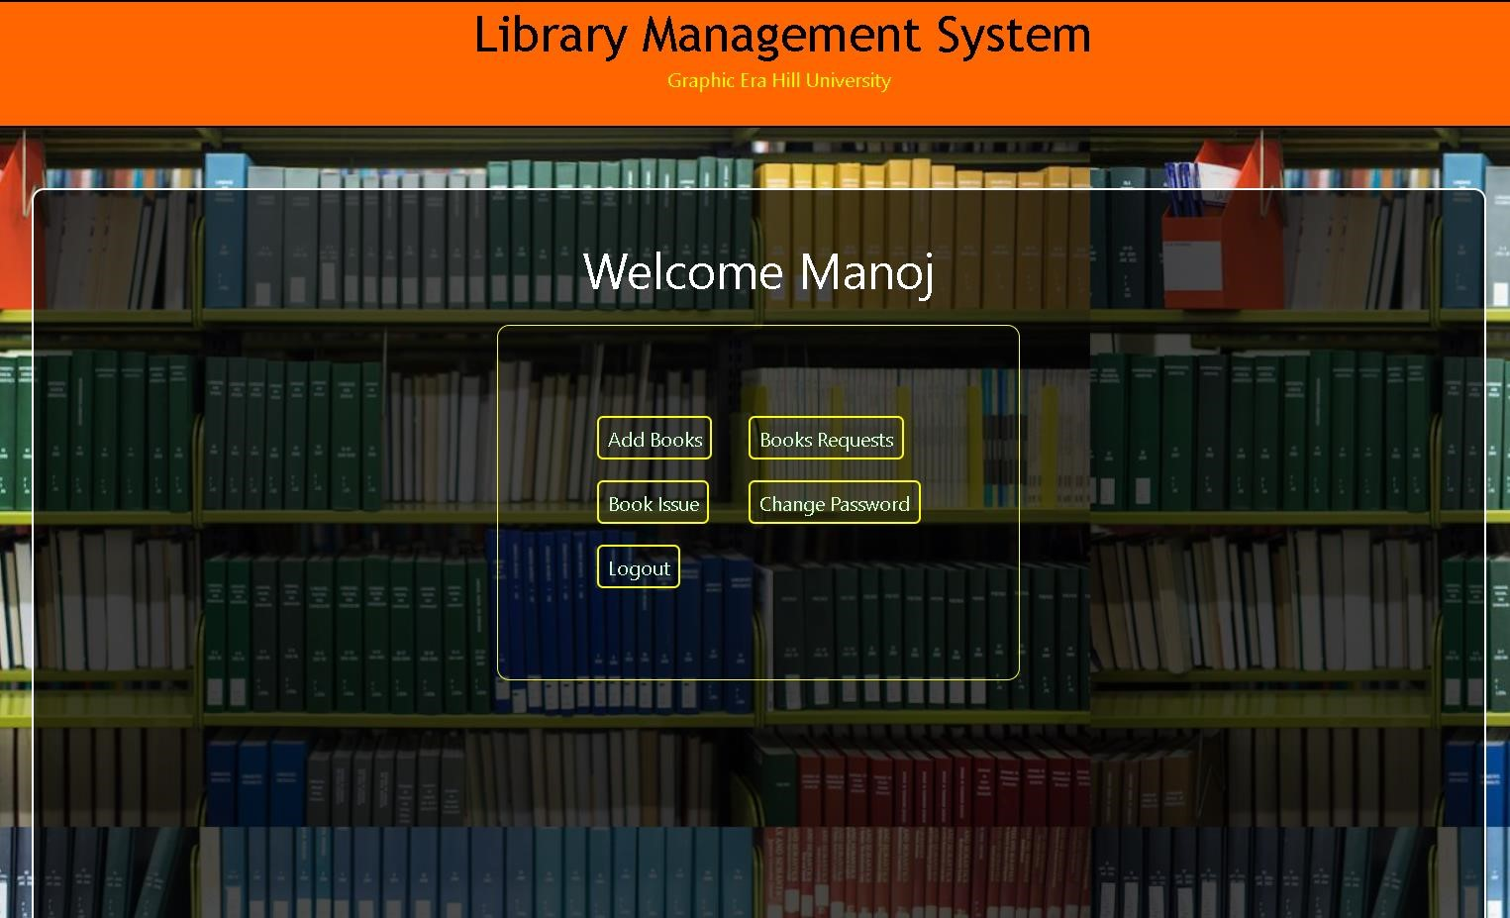

### 4.6 Screenshot for change password

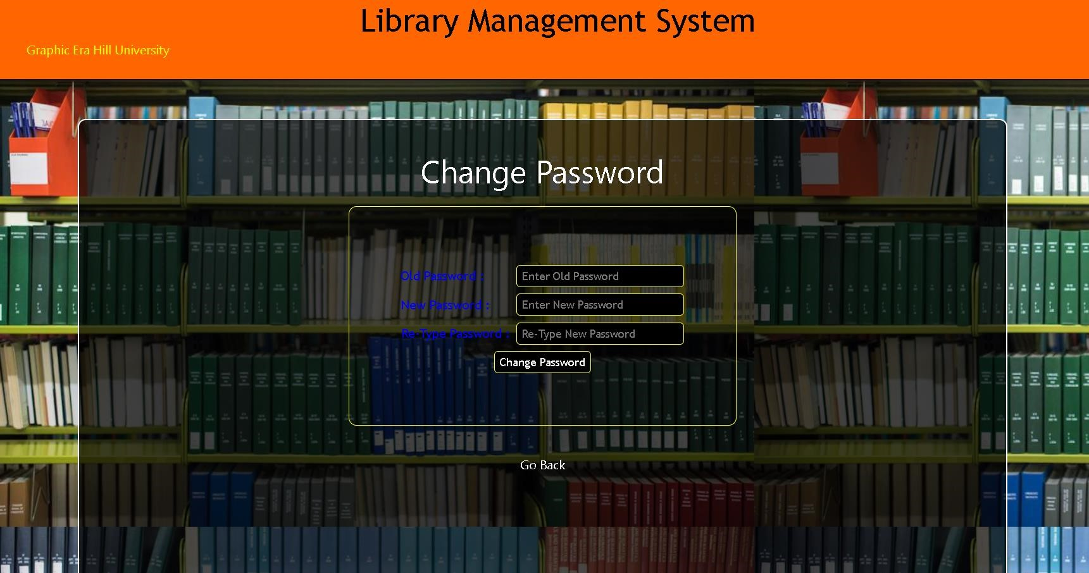

**CHAPTER 5**

**SYSTEM TESTING**

The aim of the system testing process was to determine all defects in our project. The program was subjected to a set of test inputs and various observations were made and based on these observations it will be decided whether the program behaves as expected or not. Our

Project went through two levels of testing

1.Unit testing

2.integration testing

### UNIT TESTING

Unit testing is undertaken when a module has been created and successfully reviewed .In order to test a single module we need to provide a complete environment i.e. besides the module we would require

* The procedures belonging to other modules that the module under test calls
* Non local data structures that module accesses

* A procedure to call the functions of the module under test with appropriate parameters

Unit testing was done on each and every module that is described under module description of chapter 4

1. Test For the admin module

* + Testing admin login form-This form is used for log in of administrator of the system. In this we enter the username and password if both are correct administration page will open otherwise if any of data is wrong it will get redirected back to the login page and again ask for username and password
  + Student account addition- In this section the admin can verify student details from student academic info and then only add student details to main library database it contains add and delete buttons if user click add button data will be added to student database and if he clicks delete button the student data will be deleted

* + Book Addition- Admin can enter details of book and can add the details to the main book table also he can view the books requests.

1. Test for Student login module

* + Test for Student login Form-This form is used for log in of Student. In this we enter the library id, username and password if all these are correct student login page will open otherwise if any of data is wrong it will get redirected back to the login page and again ask for library id, username and password.

* + Test for account creation- This form is used for new account creation when student does not fill the form completely it asks again to fill the whole form when he fills the form fully it gets redirected to page which show waiting for conformation message as his data will be only added by administrator after verification.

1. Test for teacher login module-

Test for teacher login form- This form is used for logg in of teacher. In this we enter the username and password if all these are correct teacher login page will open otherwise if any of data is wrong it will get redirected back to the login page and again ask for username and password.

**INTEGRATION TESTING**

In this type of testing, we test various integration of the project module by providing the input The primary objective is to test the module interfaces in order to ensure that no errors are occurring when one module invokes the other module.

**CONCLUSION & FUTURE SCOPE**

This website provides a computerized version of library management system which will benefit the students as well as the staff of the library. It makes entire process online where student can search books, staff can generate reports and do book transactions. It also has a facility for student login where student can login and can see status of books issued as well request for book or give some suggestions. It has a facility of teacher’s login where teachers can add lectures notes and also give necessary suggestion to library and also add info about workshops or events happening in our college or nearby college in the online notice board.

There is a future scope of this facility that many more features such as online lectures video tutorials can be added by teachers as well as online assignments submission facility, a feature of group chat where students can discuss various issues of engineering can be added to this project thus making it more interactive more user friendly and project which fulfils each user need in the best way possible.

**REFERENCES**

1. <http://www.w3schools.com/html/html_intro.asp>
2. <http://www.udemy.com/css/css_background.asp>
3. <http://www.w3schools.com/js/js_datatypes.asp>