INDEX
- Introduction
- Purpose Of The Project
- Project Requirement
- Scope Of The Project
- Flow Chart
- Coding
- Screenshot
- References

Project Requirement
The Project had required the following:-
- Hardware Requirements
- A PC with minimum 512 MB RAM and 100 GB Hard disc
- Windows XP or above

- Software Requirement
- Python IDLE 3.7
- MySQL Version 5.1
- Microsoft Word

- Used Module in Python Program
- MySQL.connector
- Prettytable
- Datetime

Introduction
As we all know that now-a-days all the works are done by the computer.
“School Admission System” is an application will be used for admission of new students in any school. It will store all the details of student in computerized manner in a single database.
This project contains two types of users.
- Admin: The admin is the super user of the system, which have the all the privileges of the system. The admin can.
  - Add New users
  - Add New Admin
  - Add New Student
  - View all the data
- User: The user is the teacher who can add the New Student and can view student data. User has limited access to the system.

Flow Chart of the application

Start
Login
ADMIN
Login Success
Login Failed

Admission
Add Users
View details

Purpose of the project
In the office of school we can see that the student records stored in the files. There are large size bundles of records of student data. So it is difficult to search details of any particular student. There is lot of paper wastage to keep record of them. But records in these files are not safe and secured.
With the help of this project we will overcome the drawbacks of existing system. Some of them are following.
- It will reduce paper wastage because the data will be store in a single database.
- It will provide fast accessing to data.
- Time saving
- Safe from data losses
- It can store data for a long time without damage

Scope of the project

This project is very useful for almost every colleges, schools or institutions to manage the data of students. It provides a user friendly interface so that the user can easily operate the system without having only basic computer knowledge.
There is the feature of login so the authenticated user can access the system, which provides security to data. It makes easy for any student or any other authenticated user to search his/her data. In future we can add some new features in this system as per the organization’s need.

PROJECT REPORT
On
School Admission System
Subject: Computer Science

AISSCE: 2020 - 2021



RAJIV GANDHI NAVODAYA VIDYALAYA
CHAUNALIYA, ALMORA

Submitted By:
Manoj Nath Goswami
Class:XII B
Roll No: 25601183
Submitted To:
Mr. Manoj Kr. Palariya
PGT (Comp. Sc.)

CERTIFICATION


This is to certify that Manoj Nath Goswami a student of class XIIth Science has successfully completed their project on School Admission System under the guidance of Mr. Manoj Kr. Palariya (Subject teacher) during the year 2020-21 in partial fulfillment of the requirement for Computer Science practical examination conducted by AISSCE, New Delhi.

Date:
Manoj Kr. Palariya
PGT Computer Science

ACKNOWLEGEMENT
I take this opportunity to thank all those who have been directly or indirectly related to my project.
I would like to thank to our subject teacher Mr. Manoj Kr. Palariya for his constant source of inspiration. I am grateful to our Respected Principal Sir Dr. T.C.Joshi for their encouragement and suggestion on my project. I sincerely thank to our entire teachers of our school for their continued support.
I once again extend my sincere thanks to all of them.

Manoj Nath Goswami
Class 12 & Section B
Roll No.25601183

DECLARATION
I hereby declare that project work entitled School Admission System”, submitted by me, is a bonofied work undertaken by me under the guidance of Mr. Manoj Kr. Palariya in the partial fulfillment of the requirement for Computer Science practical examination conducted by AISSCE, New Delhi.
The metter embodied in this project report is my original work and it has not been presented earlier in this manner.

Date: Manoj Nath Goswami

Connection:
import mysql.connector as cs

#The connector Function Connect Pythom TO SQL

def connection():
global con,cur
con=cs.connect(host = "localhost", user = "root", passwd="1234",
database = "cs_project" )
cur = con.cursor()
connection()

Menu:

#This Is Main Page from Where Application Start

from connect import *
import home as h
import login as l
print ("****************Welcome To School Admission System****************")
print("________________________________________________________________________")
print(" ")
l.login()

Login:
from connect import *
import home as

#To login user/Admin

def login():
global user_ty
print("admin press 1")
print(" ")
print("user press 2")
print(" ")
print("3 for help ")
design()
ch=input_user_choice()
design()
user_ty=ch
if ch==1:
ty="admin"
email_admin_check(ty)
admin()
elif ch==2:
ty="user"
email_admin_check(ty)
h.index(user_ty)
elif ch==3:
ch=help_u()
if ch==1:
login()
else:
login()
else:
design()
print("Invalid Input,Number has no funtion")
design()
login()

# Function To Check Email OF User

def email_admin_check(ty):
global e_a
e_a=input("E_mail Id : ")
print(" ")
p=input ("Password : ")
design()
t=(e_a,p,ty)
q='''select * from login where email = %s and passwrd =%s
and type_user = %s'''
cur.execute(q,t)
d=cur.fetchone()
r=cur.rowcount
print("...............................Processing................")
print(" ")
print("............................Wait for a min......................" )
design()
if r==1:
print(".....................Login Successful.............")
design()
return()
else:
print("incorrect e_mail or password")
design()
login()

# Function to Admin’s work

def admin():
global user
print("1 About students ")
print(" ")
print("2 add a new user ")
print(" ")
print("3 make another admin ")
print(" ")
print("4 help")
print(" ")
print("5 exit")
design()
ch=input_user_choice()
design()
if ch==1:
h.index(user)
elif ch==2:
new_user()
elif ch==3:
new_admin()
elif ch==4:
c=help_u()
if c==1:
admin()
elif c==2:
e=exit()
if e==1:
login()
elif e==2:
admin()
else:
admin()
elif ch==5:
e=exit()
if e==1:
print("Thankyou for Using ")
design()
login()
elif e==2:
admin()
else:
print("Enter valid number")
design()
admin()
else:
print("Invalid Number,Number has no funtion")
design()
admin()

#Function to add new user:

def new_user():
global nm
nm=input("enter new user's name: ")
print(" ")
e=check_email_user()
print(" ")
p=input ("enter password : ")
design()
c=new_user_choice()
if c==1:
new_user2(e,p,nm)
ch=new_admin4()
if ch==1:
new_admin3(e)
print(" ")
t1=(e_a,)
q1="select name from login where email = %s"
cur.execute(q1,t1)
d=cur.fetchone()
print(d[0]," from now You are our User only ")
design()
login()
elif ch==2:
admin_del()
elif ch==3:
admin()
else:
design()
print("Invalid Number")
design()
new_admin4()
else :
new_user2(e,p,nm)
print("New User Added")
design()
admin()

# Function TO Get New User Choice:

def new_user_choice():
while true:
print("1 make admin")
print(" ")
print("2 make user only")
design()
c_option = [1,2]
choice=input_user_choice()
if ch in c_option:
return ch
else:
design()
print("Invalid Input,Input Number has no funtion")
design()
continue

# 2 Function TO add new user

def new_user2(e,p,nm):
design
t=(e,p,nm)
q='''insert into login(email,passwrd,name)
values(%s,%s,%s)'''
cur.execute(q,t)
con.commit()
design()
return

# Function To get choice of previous Admin

def new_admin4():
print("1 Remain as a user : ")
print(" ")
print("2 Exit from Admission system:")
print(" ")
print("3 exit")
design()
c=input_user_choice()
return c

# Function to make new Admin:

def new_admin3(e_u):
t1=(e_a,)
q1='''update login
set type_user='user'
where email=%s'''
cur.execute(q1,t1)
con.commit()
t=(e_u,)
q2='''update login
set type_user='admin'
where email=%s'''
cur.execute(q2,t)
con.commit()
q3='''select name from login where email =%s'''
cur.execute(q3,t)
data=cur.fetchone()
print("Congratulations ",data[0],"You become our new admin")
design()
return

# Function to get E mail of new admin:

def new_admin2():
e_u=input("enter new admin's e_mail Id : ")
design()
t=(e_u,)
q='''select * from login where email = %s'''
cur.execute(q,t)
d=cur.fetchone()
r=cur.rowcount
if r==1:
new_admin3(e_u)
return
else:
print("E_mail id don't found")
new_admin2()

# Function to check E mail of new admin:

def check_email_user():
e=input("enter e_mail Id : ")
t=(e,)
q="select * from login where email = %s"
cur.execute(q,t)
d=cur.fetchone()
r=cur.rowcount
if r==1:
design()
print("Email_id alredy exits Try with different one")
design()
check_email_user()
else:
return e

#Function to Delete Previous Admin:

def admin_del():
new_admin2()
t1=(e_a,)
q='''select name from login where email =%s'''
cur.execute(q,t1)
d=cur.fetchone()
print(d[0]," from now You are Not our User ")
design()
print(" Thankyou for using")
q2="delete from login where email = %s"
cur.execute(q2,t1)
con.commit()
design()
login()
# Function To Add New Admin

def new_admin():
ch=new_admin4()
if ch==1:
new_admin2()
t1=(e_a,)
q1="select name from login where email = %s"
cur.execute(q1,t1)
d=cur.fetchone()
print(d[0]," from now You are our User only ")
design()
login()
elif ch==2:
admin_del()
elif ch==3:
admin()
else:
print("Invalid Number,Input Number has no funtion")
design()
new_admin()

#Function To Help Return From Help Menu:

def help_menu():
while True:
print("1 for main menu")
print(" ")
print("2 for exit")
design()
u_cho=[1,2]
ch=input_user_choice()
design()
if ch in u_cho:
return ch
else:
design()
print("Invalid Input")
design()
#Function to Help User:

def help_u():
f=open("help.txt","r")
print(" ")
f1=f.read()
print(f1)
f.close()
design()
c=help_menu()
return c

#This Function is used for Check User’s input:

def input_user_choice():
while True:
choice=input("enter your choice : ")
if choice.isdigit():
ch= int(choice)
return ch
else:
design()
print("Invalid Input")
design()
continue

#Function to store user’s choice:
def user():
user=user_ty
return user
#Function To Exit or Log out:

def exit():
print("press 1 for log out")
print(" ")
print("press 2 for cancel ")
design()
ch=input_user_choice()
design()
return ch

#Function to design Application:

def design():
print(" ")
print("*"*50)
print(" ")

Home:
from connect import *
import view as v
import add as a
import update as u
import login as l

#Function About Students related works:

def index(user):
print ("1 for Add new students ")
print(" ")
print ("2 for View students ")
print(" ")
print("3 for update any student data ")
print(" ")
print("4 for Previous menu ")
print(" ")
print("5 for exit")
l.design()
ch=l.input_user_choice()
l.design()
if ch==1:
a.add_student()
elif ch==2:
v.view_student()
elif ch==3:
u.update_student()
elif ch==4:
user=l.user()
if user==1:
l.admin()
else:
e=l.exit()
if e==1:
print("Thankyou for Using ")
l.design()
l.login()
elif e==2:
index(user)
else:
print("enter valid number")
l.design()
index(user())
elif ch==5:
e=l.exit()
if e==1:
print("Thankyou for Using ")
l.design()
l.login()
elif e==2:
index(user)
else:
print("enter valid number")
l.design()
index(user)

#Function TO Check S_r no Of Student:

def check(sr):
t=(sr,)
q="select * from student_data where sr_no=%s"
cur.execute(q,t)
data=cur.fetchone()
rc=cur.rowcount
return(rc)

#Function For doing more work related to Student

def more():
print("press 1 for fill further details : ")
print(" ")
print("press 2 for main menu : ")
print(" ")
print("press 3 for exit")
lst=[1,2,3]
ln=len(lst)
l.design()
while True:
ch=l.input_user_choice()
l.design()
if ch==1:
return ch
elif ch==2:
return ch
elif ch==3:
return ch
else:
print("Invalid Input,Given Number Has No Funtion")
Continue

ADD:
from connect import *
import home as h
import datetime as d
import update as u
import login as l

#Function to Add New Student Data:

def add_student():
print("FILL ALL THE DETAILS ABOUT STUDENT")
sr=findsr()
l.design()
print("Your SR_NO is ",sr)
l.design()
nm=input("Full name : ")
print(" ")
fn=input("Father name : ")
print(" ")
mn=input("Mother name : ")
print(" ")
ph=input_ph()
print(" ")
dob=input("DOB (YYYY-MM-DD): ")
print(" ")
g=get_gender()
print(" ")
ad=input_adhr()
print(" ")
re=input("Religion : ")
print(" ")
ct=input("Categary (gen/obc/sc/st) : ")
print(" ")
ho=get_house(g)
am=d.date.today()
t=(sr,nm,fn,mn,ph,dob,g,ad,re,ct,ho,am)
q='''insert into student_data (sr_no,name,father_name,mother_name,
contact_no,
dob,gender,aadhar,religion,catagery,house_id,
admission_date)
values(%s,%s,%s,%s,%s,%s,%s,%s,%s,%s,%s,%s)'''
cur.execute(q,t)
con.commit()
l.design()
print("YOU HAVE COMPLEATED ONE STAGE ")
l.design()
c=h.more()
if c==1:
add_2(sr)
elif c==2:
h.index(l.user())
elif c==3:
e=l.exit()
if e==1:
print("Thankyou for Using ")
l.design()
l.login()
elif e==2:
h.more()
else:
print("enter valid number")
l.design()
h.more()

else:
l.design()
print("Enter right choice : ")
l.design()
h.more

#Function To get new Student Aadhar
def input_user_adhr():
while True:
choice=input("Aadhar Number : ")
if choice.isdigit():
ch= int(choice)
return ch
else:
l.design()
print("Invalid Input")
l.design()
continue

#Function To Check new Student _Aadhar Number

def input_adhr():
ad=input_user_adhr()
ln=len(str(ad))
if ln==12:
t=(ad,)
q="select * from student_data where aadhar = %s"
cur.execute(q,t)
d=cur.fetchone()
r=cur.rowcount
if r==1:
l.design()
print("Invalid aadhar Number/Duplicate Aadhar number: ")
print(" ")
print("Please enter right aahar number")
l.design()
input_adhr()
else:
return ad
else:
l.design()
print("Enter a valid Aadhar Number (it must be of 12 digit ")
l.design()
input_adhr()

#Function to get new Student contact Number

def input_user_number():
while True:
choice=input("Contact Number : ")
if choice.isdigit():
return choice
else:
l.design()
print("Invalid Input")
l.design()
continue

#Function To Check new Student contact Number

def input_ph():
while True:
p=input_user_number()
m=len(p)
if m == 10:
return p
else:
l.design()
print("Invalid Number Please enter valid Number")
l.design()
continue

#Function to get new Student’s Gender

def get_gender():
while True:
ln=["m","M","f","F"]
gen=input("Gender (M/F) : ")
if gen in ln:
return gen
else:
l.design()
print("Invalid gender please enter (M/F) only ")
l.design()
continue

#Function to provide new Student a house:

def get_house(g):
t=(g,)
q='''SELECT house_id,count(sr_no) from student_data
where gender = %s
group by house_id
order by count(sr_no),house_id '''
cur.execute(q,t)
d=cur.fetchall()
if d[0][0]==10:
l.design()
print("You Have Allotted CORBETT HOUSE")
elif d[0][0]==20:
l.design()
print("You Have Allotted GANGOTRI HOUSE")
elif d[0][0]==30:
l.design()
print("You Have Allotted NANDA HOUSE")
elif d[0][0]==40:
l.design()
print("You Have Allotted RAJAJI HOUSE")
else:
l.design()
print("Something Went Wrong ")
l.design()
h.index(l.user())
ho=d[0][0]
return ho

#Function to find SR_NO for New Student:

def findsr():
q='select max(sr_no) from student_data'
cur.execute(q)
d=cur.fetchall()
if d[0][0]==0:
sr=1
return sr
else :
sr=d[0][0]+1
return sr

#Function to add New Student’s Address:

def add_2(sr):
print(" ")
sr_no=sr
vi=input("Village name : ")
print(" ")
po=input("Post office : ")
print(" ")
pin=input("Pin_code no : ")
print(" ")
bl=input("Block name : ")
print(" ")
dist=input("District name : ")
print(" ")
st=input("State name : ")
l.design()
t=(sr_no,vi,po,pin,bl,dist,st)
q='''insert into address (sr_no,village,post_office,pin_code,block,district,state)
values(%s,%s,%s,%s,%s,%s,%s)'''
cur.execute(q,t)
con.commit()
print("YOU HAVE COMPLEATED SECOND STAGE ")
l.design()
ch=h.more()
if ch==1:
u.check_2(sr_no)
elif ch==2:
h.index(l.user())
elif ch==3:
e=l.exit()
if e==1:
print("Thankyou for Using ")
l.design()
l.login()
elif e==2:
h.more()
else:
print("enter valid number")
l.design()
h.more()
else:
l.design()
print("Enter right choice : ")
l.design()
h.more

#Function to add New Student’s Bank related Details :

def add_3(sr):
print(" ")
sr_no=sr
bn=input("enter Bank name : ")
print(" ")
ac=input("enter Bank Account Number : ")
print(" ")
ifc=input("enter IFSC code : ")
print(" ")
t=(sr_no,bn,ac,ifc)
q='''insert into account (sr_no,Bank,Account_no,ifsc)
values(%s,%s,%s,%s)'''
cur.execute(q,t)
con.commit()
l.design()
print("YOU HAVE FILLED ALL DETAILS")
l.design()
h.index(l.user())

View
from connect import *
import home as h
from prettytable import PrettyTable
import login as l

#Function To View Students Information:

def view_student():
print("1 for view all student data")
print(" ")
print("2 for view indivisual student data")
print(" ")
print("3 for view Housewise student data")
print(" ")
print("4 for view blockwise student data")
print(" ")
print("5 for view addresswise(village) student data")
print(" ")
print("6 for main menu")
print(" ")
print("7 for exit")
l.design()
ch=l.input_user_choice()
l.design()
if ch==1:
q='''select Sr_no,Name ,Father_Name,Mother_Name,Contact_no,catagery
from student_data '''
cur.execute(q)
data=cur.fetchall()
x = PrettyTable(["Sr_no","Name ","Father_Name","Mother_Name","Contact_no",
"categary"])
for d in data:
x.add_row([d[0],d[1],d[2],d[3],d[4],d[5]])
print(x)
again_view()
elif ch==2:
sr=int_sr()
l.design()
t=(sr,)
q='''select Sr_no,Name ,Father_Name,Mother_Name,Contact_no,catagery
from student_data where sr_no=%s'''
cur.execute(q,t)
d=cur.fetchone()
r=cur.rowcount
y = PrettyTable(["Sr_no","Name
","Father_Name","Mother_Name","Contact_no",
"categary"])
if r==1:
y.add_row([d[0],d[1],d[2],d[3],d[4],d[5]])
print(y)
again_view()
else:
l.design()
print("Data not found,Something went wrong ")
print("please try again")
l.design()
view_student()
elif ch==3:
g=gen()
if g==1:
q=''' select h.house_name ,h.HOUSE_MASTER ,count(s.sr_no)
from student_data s,house h
where h.house_id = s.house_id and s.gender="m"
group by h.house_id'''
cur.execute(q)
data=cur.fetchall()
z = PrettyTable(["House Name","House Master Name","Total number of students ",])
for d in data:
z.add_row([d[0],d[1],d[2]])
print(z)
l.design()
again_view()
elif g==2:
q=''' select h.house_name ,h.HOUSE_MASTER ,count(s.sr_no)
from student_data s,house h
where h.house_id = s.house_id and s.gender="F"
group by h.house_id'''
cur.execute(q)
data=cur.fetchall()
z = PrettyTable(["House Name","House Master Name","Total number of students ",])
for d in data:
z.add_row([d[0],d[1],d[2]])
print(z)
l.design()
again_view()
elif g==3:
view_student()
elif g==4:
h.index(l.user())
elif g==5:
e=l.exit()
if e==1:
print("Thankyou for Using ")
l.design()
l.login()
elif e==2:
gen()
else:
print("enter valid number")
l.design()
view_student()
else:
print("input valid number")
view_student()
elif ch==4:
q='''select a.block ,count(s.sr_no)
from student_data s,address a
where s.sr_no = a.sr_no
group by a.block'''
cur.execute(q)
data=cur.fetchall()
m = PrettyTable(["Block Name","Total number of students ",])
for d in data:
m.add_row([d[0],d[1]])
print(m)
l.design()
again_view()
elif ch==5:
q='''select a.village ,count(s.sr_no)
from student_data s,address a
where s.sr_no = a.sr_no
group by a.village'''
cur.execute(q)
data=cur.fetchall()
n = PrettyTable(["Village Name","Total number of students ",])
for d in data:
n.add_row([d[0],d[1]])
print(n)
l.design()
again_view()
elif ch==6:
h.index(l.user())
elif ch==7:
e=l.exit()
if e==1:
print("Thankyou for Using ")
l.design()
l.login()
elif e==2:
view_student()
else:
print("enter valid number")
l.design()
view_student()

#Function To Check Sr_no Of Student

def int_sr():
while True:
choice=input("enter Sr_no : ")
if choice.isdigit():
ch= int(choice)
return ch
else:
design()
print("Invalid Input")
design()
continue

#Function To Give more Opportunities To user:

def again_view():
print("1 for again view menu ")
print(" ")
print("2 for main menu ")
print(" ")
print("3 for exit")
l.design()
ch=l.input_user_choice()
l.design()
if ch==1:
view_student()
elif ch==2:
h.index(l.user())
elif ch==3:
e=l.exit()
if e==1:
print("Thankyou for Using ")
l.design()
l.login()
elif e==2:
view_student()
else:
print("enter valid number")
l.design()
view_student()
else:
print("Invalid Choice : ")
l.design()
again_view()

#Function to Get Gender

def gen():
print("1 for Boys details ")
print(" ")
print("2 for Girls details")
print(" ")
print("3 for view menu")
print(" ")
print("4 for main menu")
print(" ")
print("5 for exit")
l.design()
ch=l.input_user_choice()
l.design()
return ch

Update:
from connect import *
import home as h
import add as a
import view as v
import login as l

#Function to Check SR-NO Of Student:

def check(sr):
t=(sr,)
q="select * from address where sr_no=%s"
cur.execute(q,t)
data=cur.fetchone()
rc=cur.rowcount
if rc==1:
check_2(sr)
else:
a.add_2(sr)
check_2(sr)

#Function to Check SR-NO Of Student:

def check_2(sr):
t=(sr,)
q="select * from account where sr_no=%s"
cur.execute(q,t)
data=cur.fetchone()
rc=cur.rowcount
if rc==1:
print("All Data already Inserted ")
l.design()
h.index(l.user())
else:
a.add_3(sr)

#Function To Check Student Data:

def check_row(sr):
t=(sr,)
q="select * from student_data where sr_no=%s"
cur.execute(q,t)
data=cur.fetchone()
rc=cur.rowcount
if rc==1:
q1='select name from student data where sr_no=%s'
cur.execute(q,t)
data=cur.fetchone()
print("Name :",data[1])
print(" ")
check(sr)
else:
print("No Student has sr_no",sr)
l.design()
h.index(l.user())
#Function To Update Student Data:

def update_student():
s=v.int_sr()
l.design()
check_row(s)

#Output
1. Login Output
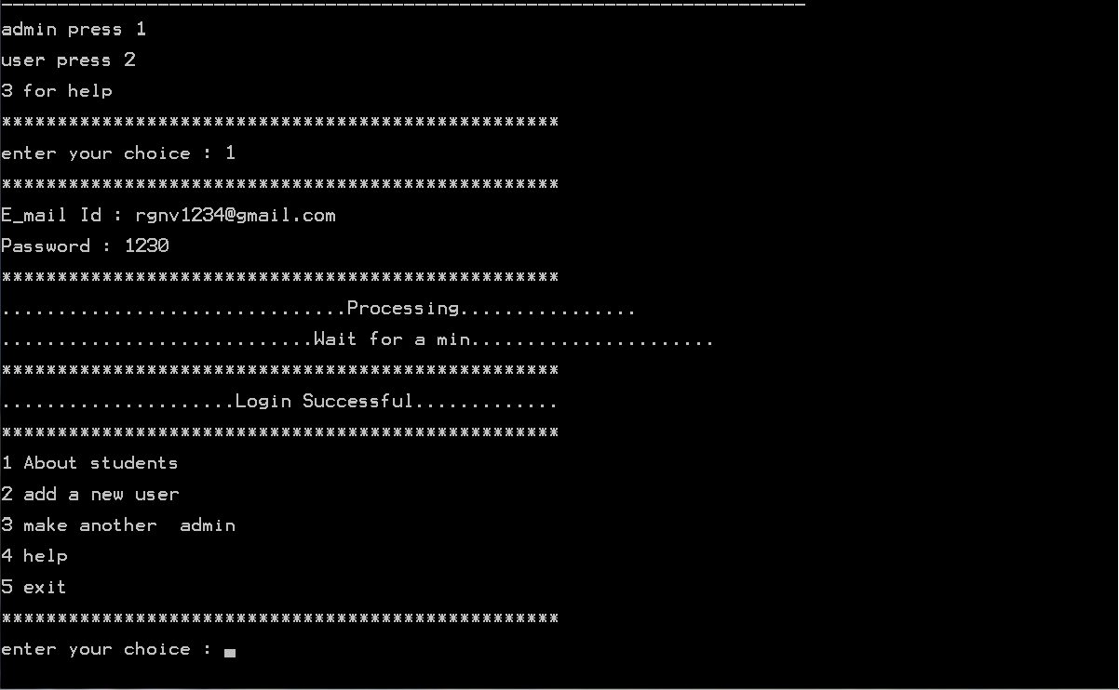

2. Student Related Output (Add New Student) Output

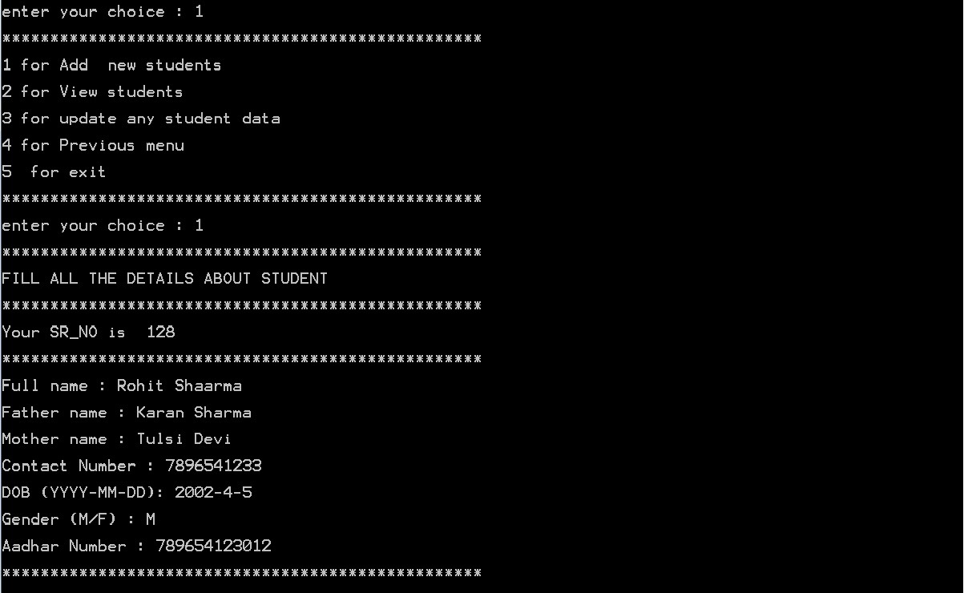
3. For Further Details or Previous Menu Output
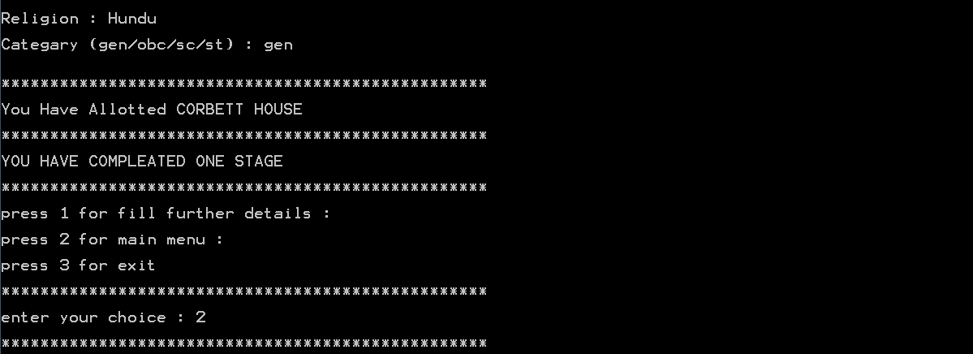
4. View Student Data Output
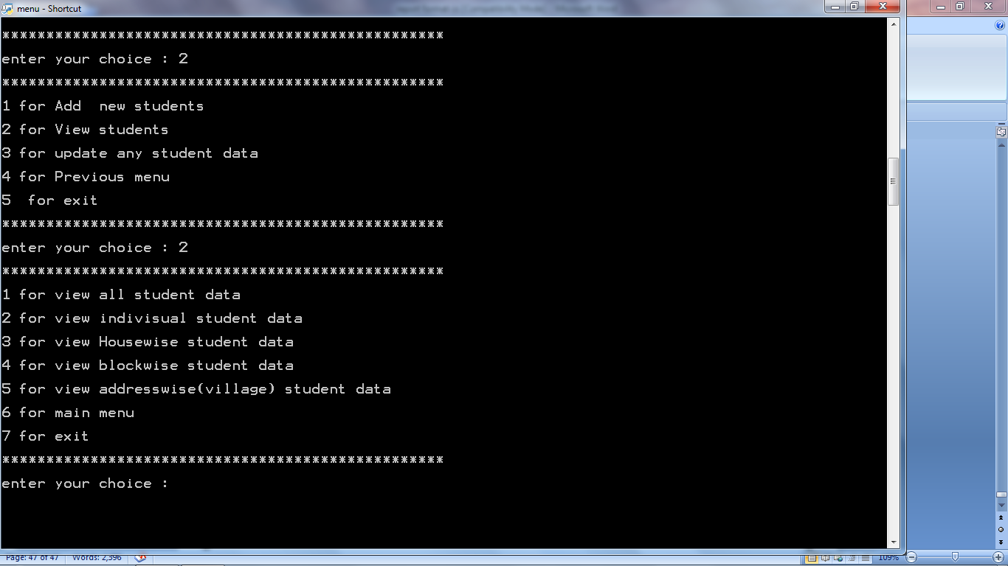
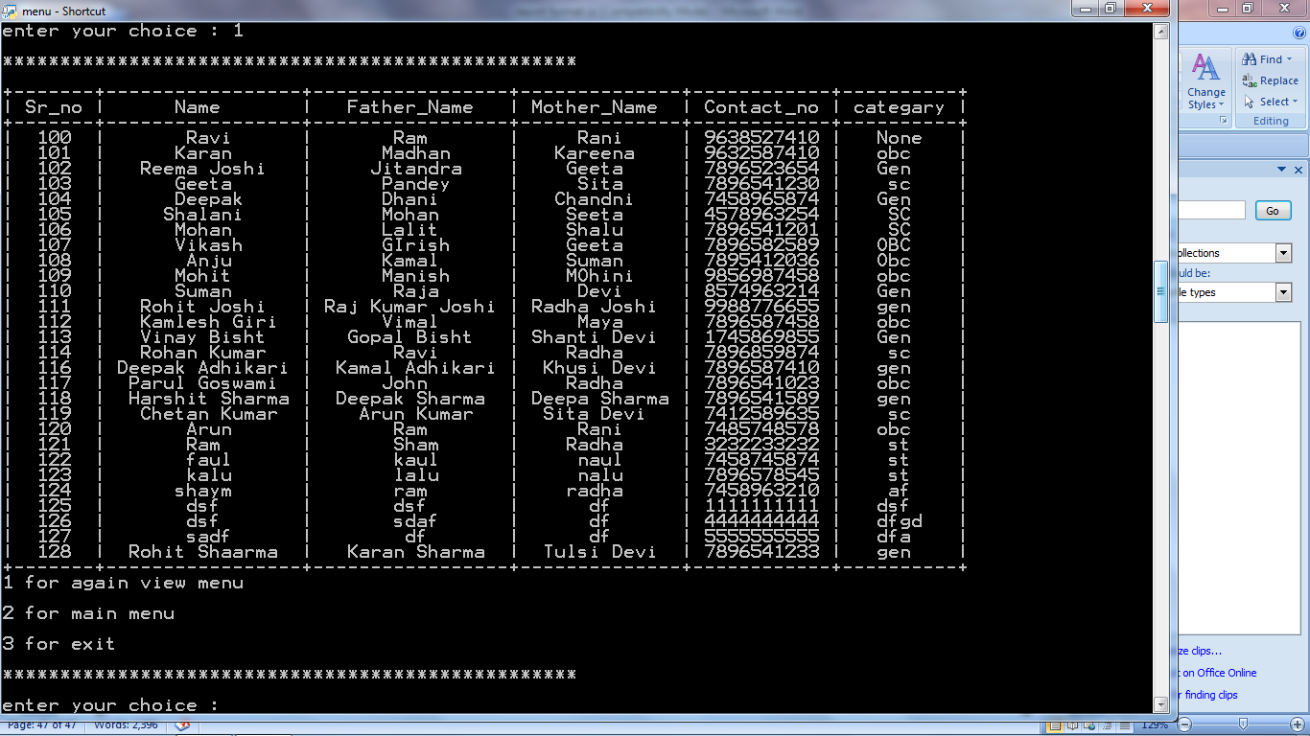
5. Individual Student Data Output
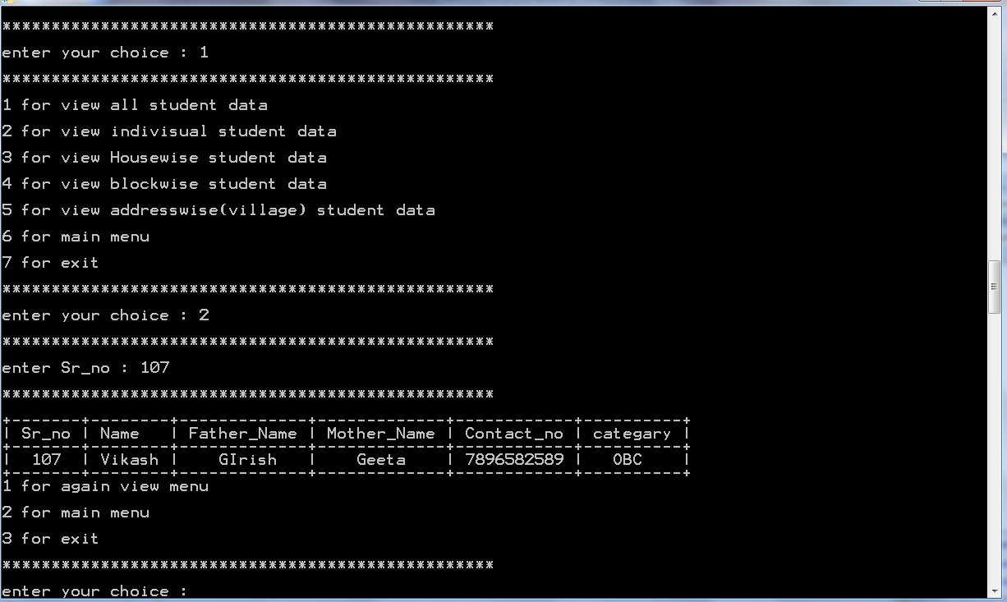
6. House Wise Student Data Output
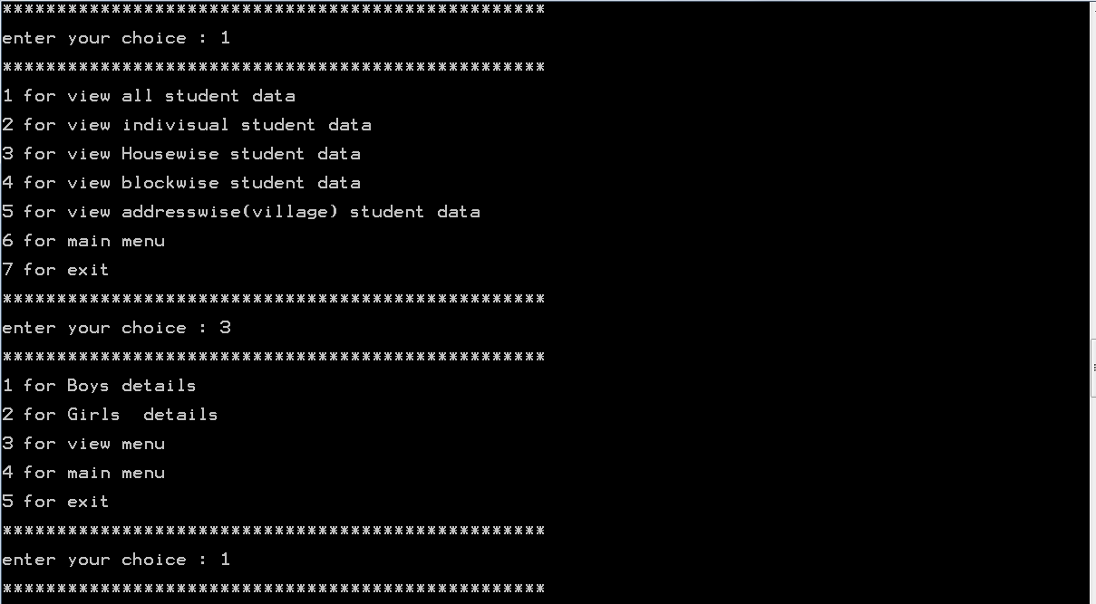

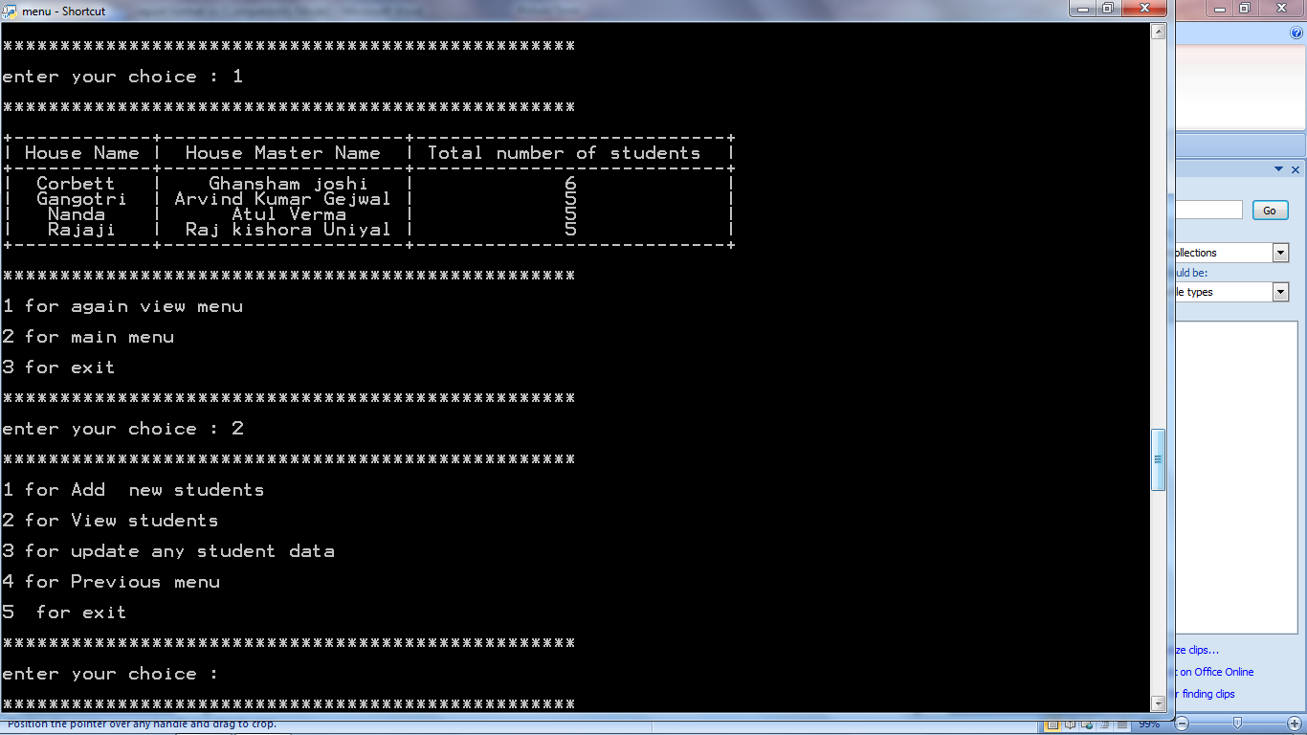
7. Update any Student Data Output
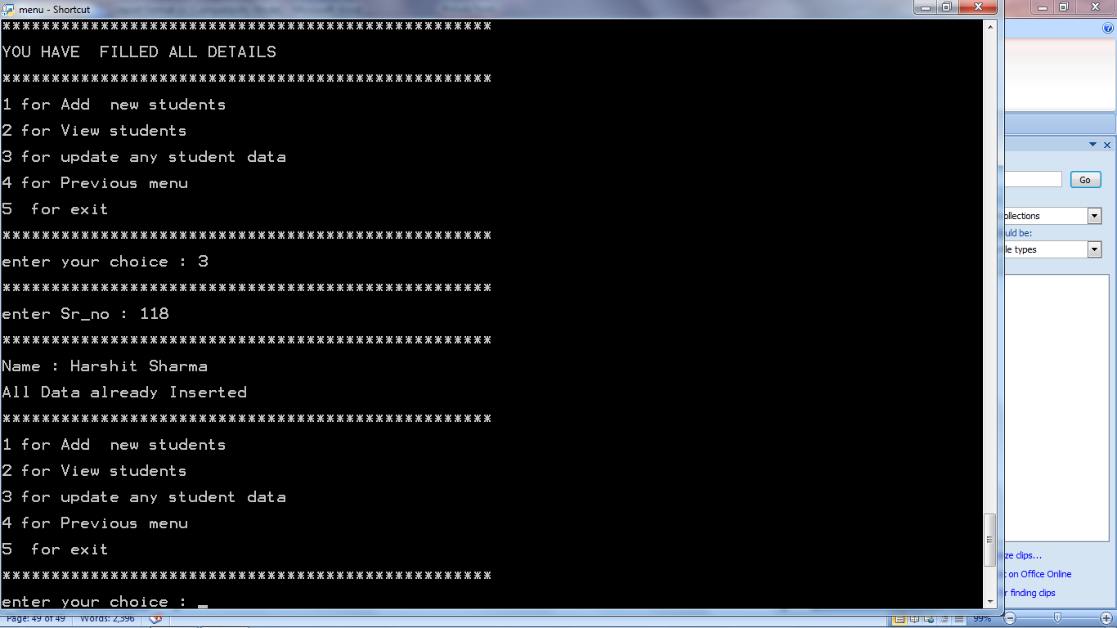
8. Logout Output
