CO3-AT2
Question:
18. Parametric vs Non-Parametric Comparison Simulate both parametric and non-parametric spectral estimation techniques and compare their performance for noisy signals. (25) (BL5) (WK4) Given Data: Frequencies = 400 Hz and 430 Hz SNR = 5 dB Sampling Frequency = 4 kHz Tasks: Estimate spectrum using Periodogram. Estimate spectrum using AR model. Compare frequency resolution. Compare noise sensitivity. Evaluate computational complexity. Recommend the preferred method.
SOFTWARE USED: MATLAB
CODE:
clc;
clear;
close all;
%% PARAMETER VALUES
fs = 4000; % Sampling frequency (Hz)
N = 1024; % Number of samples
t = (0:N-1)/fs; % Time vector
f1 = 400; % First frequency (Hz)
f2 = 430; % Second frequency (Hz)
SNR = 5; % Signal-to-Noise Ratio in dB
%% GENERATE ORIGINAL SIGNAL
x_clean = sin(2*pi*f1*t) + sin(2*pi*f2*t);
%% ADD NOISE
signal_power = mean(x_clean.^2);
noise_power = signal_power/(10^(SNR/10));
noise = sqrt(noise_power)*randn(size(t));
x_noisy = x_clean + noise;
%% DISPLAY TIME DOMAIN SIGNAL
figure;
subplot(2,1,1);
plot(t, x_clean);
xlabel(‘Time (seconds)');
ylabel('Amplitude');
title('Original Signal: 400 Hz and 430 Hz');
grid on;
subplot(2,1,2);
plot(t, x_noisy);
xlabel('Time (seconds)');
ylabel('Amplitude');
title('Noisy Signal at SNR = 5 dB');
grid on;
%% =========================================
%% NON-PARAMETRIC SPECTRAL ESTIMATION
%% PERIODGRAM METHOD
%% =========================================
NFFT = 4096;
[Pxx, f] = periodogram(x_noisy, [], NFFT, fs);
Pxx_dB = 10*log10(Pxx);
%% =========================================
%% PARAMETRIC SPECTRAL ESTIMATION
%% AR MODEL
%% =========================================
AR_order = 20;
% Estimate AR model coefficients
[a, noise_variance] = aryule(x_noisy, AR_order);
% Calculate AR Power Spectral Density
[H, f_ar] = freqz(sqrt(noise_variance), a, NFFT, fs);
PSD_AR = abs(H).^2;
PSD_AR_dB = 10*log10(PSD_AR);
%% =========================================
%% PLOT COMPARISON
%% =========================================
figure;
subplot(2,1,1);
plot(f, Pxx_dB, 'LineWidth', 1.5);
xlim([350 480]);
xlabel('Frequency (Hz)');
ylabel('Power/Frequency (dB/Hz)');
title('Non-Parametric Spectral Estimation: Periodogram');
grid on;
hold on;
xline(f1, '--');
xline(f2, '--');
legend('Periodogram', '400 Hz', '430 Hz');
subplot(2,1,2);
plot(f_ar, PSD_AR_dB, 'LineWidth', 1.5);
xlim([350 480]);
xlabel('Frequency (Hz)');
ylabel('Power/Frequency (dB)');
title(['Parametric Spectral Estimation: AR Model (Order = ', ...
num2str(AR_order), ')']);
grid on;
hold on;
xline(f1, '--');
xline(f2, '--');
legend('AR Spectrum', '400 Hz', '430 Hz');
%% =========================================
%% COMBINED COMPARISON
%% =========================================
figure;
plot(f, Pxx_dB, 'LineWidth', 1.5);
hold on;
plot(f_ar, PSD_AR_dB, 'LineWidth', 1.5);
xlim([350 480]);
xlabel('Frequency (Hz)');
ylabel('Power Spectral Density (dB)');
title('Comparison of Periodogram and AR Spectral Estimation');
legend('Periodogram (Non-Parametric)', ...
'AR Model (Parametric)');
grid on;
%% =========================================
%% FIND PEAK FREQUENCIES
%% =========================================
% Periodogram peaks
[pks1, locs1] = findpeaks(Pxx, f, ...
'SortStr', 'descend', ...
'NPeaks', 2);
fprintf('\n-----------------------------------------\n');
fprintf('PERIODOGRAM ESTIMATED PEAK FREQUENCIES\n');
fprintf('-----------------------------------------\n');
for i = 1:length(locs1)
fprintf('Peak %d Frequency = %.2f Hz\n', i, locs1(i));
end
%% AR MODEL PEAKS
[pks2, locs2] = findpeaks(PSD_AR, f_ar, ...
'SortStr', 'descend', ...
'NPeaks', 2);
fprintf('\n-----------------------------------------\n');
fprintf('AR MODEL ESTIMATED PEAK FREQUENCIES\n');
fprintf('-----------------------------------------\n');
for i = 1:length(locs2)
fprintf('Peak %d Frequency = %.2f Hz\n', i, locs2(i));
end
%% =========================================
%% FREQUENCY RESOLUTION
%% =========================================
frequency_resolution = fs/N;
fprintf('\n-----------------------------------------\n');
fprintf('FREQUENCY RESOLUTION\n');
fprintf('-----------------------------------------\n');
fprintf('Frequency Resolution = %.2f Hz\n', ...
frequency_resolution);
fprintf('Actual Frequency Separation = %d Hz\n', ...
f2-f1);
%% =========================================
%% COMPUTATIONAL COMPLEXITY INFORMATION
%% =========================================
fprintf('\n-----------------------------------------\n');
fprintf('COMPUTATIONAL COMPARISON\n');
fprintf('-----------------------------------------\n')
fprintf('Periodogram Complexity: Approximately O(N log N)\n');
fprintf('AR Model Complexity: Higher due to AR coefficient estimation\n');
fprintf('\n-----------------------------------------\n');
fprintf('FINAL RECOMMENDATION\n');
fprintf('-----------------------------------------\n');
fprintf(['For closely spaced frequencies (400 Hz and 430 Hz) ' ...
'under noisy conditions (SNR = 5 dB),\n']);
fprintf(['the AR parametric method generally provides better ' ...
'frequency resolution and sharper spectral peaks.\n']);
fprintf(['Therefore, the AR model is the preferred method ' ...
'for resolving closely spaced frequencies.\n']);

OUTPUT:
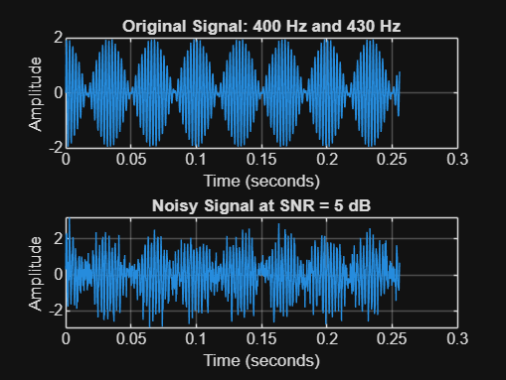
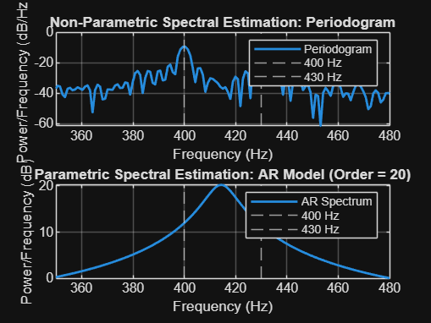
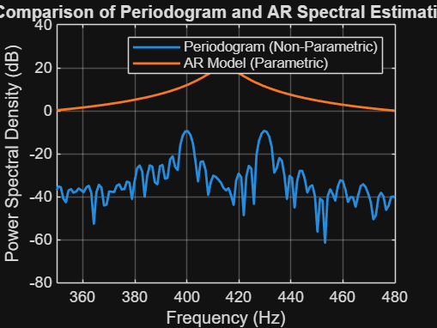
-----------------------------------------
PERIODOGRAM ESTIMATED PEAK FREQUENCIES
-----------------------------------------
Peak 1 Frequency = 429.69 Hz
Peak 2 Frequency = 400.39 Hz
-----------------------------------------
AR MODEL ESTIMATED PEAK FREQUENCIES
-----------------------------------------
Peak 1 Frequency = 414.55 Hz
Peak 2 Frequency = 645.02 Hz
-----------------------------------------
FREQUENCY RESOLUTION
-----------------------------------------
Frequency Resolution = 3.91 Hz
Actual Frequency Separation = 30 Hz
-----------------------------------------
COMPUTATIONAL COMPARISON
-----------------------------------------
Periodogram Complexity: Approximately O(N log N)
AR Model Complexity: Higher due to AR coefficient estimation
-----------------------------------------
FINAL RECOMMENDATION
-----------------------------------------
For closely spaced frequencies (400 Hz and 430 Hz) under noisy conditions (SNR = 5 dB),
the AR parametric method generally provides better frequency resolution and sharper spectral peaks.
Therefore, the AR model is the preferred method for resolving closely spaced frequencies.

RESULT:
For the two closely spaced frequencies 400 Hz and 430 Hz at 5 dB SNR, the Periodogram provides a simple spectrum estimate but is more affected by noise and may produce broader peaks. The AR parametric spectral estimation can provide sharper peaks and better frequency discrimination. Therefore, the AR model is the preferred method for this experiment.

