ERROR ANALYSIS TASK
DIGITAL SIGNAL PROCESSING (ECA09)
CO3-AT3

Problem Statement
“A sampling rate converter (L = 3, M = 2) gives an output sampling rate of 9 kHz from an input of 12 kHz. Identify the computational error.”
1. Objective
To identify the computational error in the given sampling rate conversion system, calculate the correct output sampling frequency, analyse the root cause of the error, and justify the corrected solution using multirate Digital Signal Processing concepts.
2. Given Data
- Input sampling frequency, Fs(in) = 12 kHz
- Interpolation factor, L = 3
- Decimation factor, M = 2
- Claimed output sampling frequency = 9 kHz

3. DSP Background
A sampling rate converter changes the sampling frequency of a discrete-time signal. In rational sampling-rate conversion, interpolation increases the sampling rate by an integer factor L, while decimation decreases the sampling rate by an integer factor M. The overall conversion ratio is L/M.
The general relationship is:
Fs(out) = Fs(in) × (L / M)
For correct implementation, the signal is typically interpolated, passed through an appropriate low-pass filter to suppress imaging and aliasing components, and then decimated.

4. Analysis of the Given Result
The claimed output sampling frequency is 9 kHz. The correct calculation must use the rational conversion factor L/M:
Fs(out) = 12 × (3 / 2) = 18 kHz
Therefore, the reported value of 9 kHz is computationally incorrect. Since L/M = 1.5 is greater than 1, the final sampling rate must be greater than the input sampling rate of 12 kHz.

5. Step-by-Step Correct Sampling Rate Conversion

Step 1: Interpolation by L = 3
Interpolation increases the sampling frequency by a factor of 3:
Fs(intermediate) = 12 × 3 = 36 kHz
Thus, after interpolation, the intermediate sampling rate is 36 kHz.

Step 2: Decimation by M = 2
Decimation reduces the intermediate sampling frequency by a factor of 2:
Fs(out) = 36 / 2 = 18 kHz
Hence, the correct conversion path is:
12 kHz → 36 kHz → 18 kHz
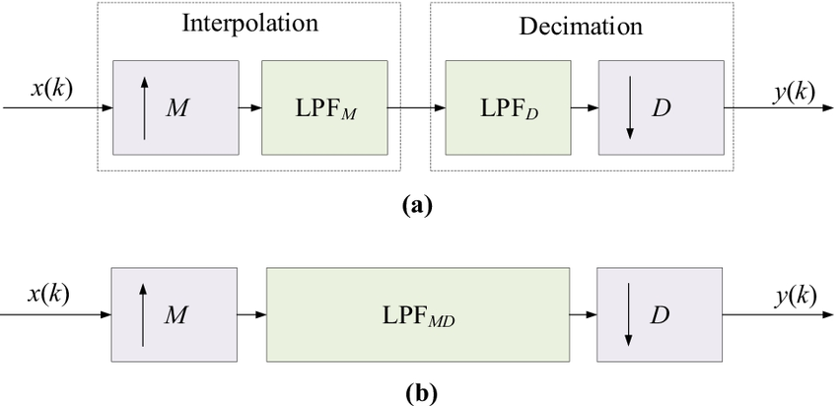

6. Identification of the Computational Error
The main error is the incorrect calculation or application of the interpolation and decimation factors. The factors must be applied as a ratio L/M, not as an arbitrary reduction. For L = 3 and M = 2, the correct net conversion factor is 3/2 = 1.5.
A result of 9 kHz would correspond to an overall factor of 9/12 = 0.75, which is inconsistent with the specified factor 3/2 = 1.5. Therefore, the reported output does not follow the given sampling-rate conversion parameters.

7. Error Calculation
Correct output sampling rate = 18 kHz
Incorrect reported output sampling rate = 9 kHz
Absolute Error = |18 − 9| = 9 kHz
Percentage Error = (|18 − 9| / 18) × 100 = 50%
Thus, the reported result has an absolute error of 9 kHz and a percentage error of 50% with respect to the correct output.

8. Root Cause Analysis
- Incorrect use of the conversion formula.
- Failure to apply interpolation and decimation in the correct ratio L/M.
- Possible confusion between the order of operations and the net sampling-rate conversion factor.
- Failure to verify whether the output should increase or decrease based on the value of L/M.
A simple reasonableness check would have detected the error: because L/M = 3/2 > 1, the output rate must be greater than 12 kHz. Therefore, 9 kHz cannot be the correct final sampling rate.

9. Corrected Solution and DSP Justification
The corrected sampling-rate converter must follow:
Fs(out) = Fs(in) × L/M = 12 × 3/2 = 18 kHz
The interpolation stage increases the rate from 12 kHz to 36 kHz. An interpolation low-pass filter should remove spectral images generated by zero insertion. The decimation stage then reduces the filtered signal from 36 kHz to 18 kHz. A suitable anti-aliasing filter is required before downsampling to prevent spectral overlap.

10. Comparison of Incorrect and Correct Results
Parameter | Incorrect Analysis | Correct Analysis
Input sampling rate | 12 kHz | 12 kHz
Interpolation factor | L = 3 | L = 3
Intermediate rate | Not correctly evaluated | 36 kHz
Decimation factor | M = 2 | M = 2
Output sampling rate | 9 kHz | 18 kHz
Net conversion factor | 0.75 implied | L/M = 1.5
Result | Incorrect | Correct

11. Practical Implementation Note
For efficient implementation, interpolation and decimation can be combined using multirate filtering techniques such as polyphase decomposition. Instead of computing filter outputs that will later be discarded during decimation, a polyphase structure performs only the required computations. This reduces computational cost while preserving the required sampling-rate conversion.

12. Final Conclusion
The claimed output sampling rate of 9 kHz is incorrect. For an input sampling rate of 12 kHz with interpolation factor L = 3 and decimation factor M = 2, the correct output sampling frequency 18 kHz
The computational error occurs because the sampling-rate conversion ratio was not correctly applied. The correct relation is Fs(out) = Fs(in) × L/M. Since 3/2 = 1.5, the sampling rate increases from 12 kHz to 18 kHz. The incorrect value of 9 kHz produces an absolute error of 9 kHz and a percentage error of 50%. Therefore, the corrected conversion process is 12 kHz → 36 kHz → 18 kHz.

13. Key Learning Outcome
This error analysis demonstrates the importance of correctly applying interpolation and decimation factors in multirate DSP. It also shows how mathematical verification and DSP concepts such as anti-imaging filtering, anti-aliasing filtering, and efficient polyphase implementation can be used to identify, correct, and justify sampling-rate conversion errors.

