**REPORT**

**MALAVIYA NATIONAL INSTITUTE OF TECHNOLOGY, JAIPUR**



**“FDI: SIGNIFICANCE OF FDI IN INDIA”**



**SUBMITTED BY :**

**NIDHI (2015ucp1684)**

**SAKSHI YADAV (2015ucp1683)**

**PREFACE**

FDI stands for the “FOREIGN DIRECT INVESTMENT”, and as the name

suggests it refers to the source of capital and investment involving foreign

control of production. The report is all about the detailed study of the very

meaning and significance of “FDI” ,the growth and current scenario of

different sectors of the country and the position of India and how is it

going to affect the nation.

**CONTENTS**

1. WHAT IS FDI??
2. OVERVIEW OF FDI
3. SECTOR WISE DISTRIB1UTION
4. TYPES OF ROUTES
5. BENEFITS OF FDI
6. WHAT IN INDIA ATTRACTS FDI
7. FDI IN DIFFERENT SECTORS

* RETAIL SECTOR
* MANUFACTURING SECTOR
* SERVICE SECTOR
* REAL ESTATE SECTOR
* AGRICULTURAL SECTOR
* TOURISM SECTOR

1. FDI POLICIES IN INDIA
2. MAKE IN INDIA
3. DISADANTAGES OF FDI
4. CRITICAL ANALYSIS

WHAT IS FDI??

Foreign direct investment (FDI) is an investment made by a company or individual in one country in business interests in another country, in the form of either establishing business operations or acquiring business assets in the other country, such as ownership or controlling interest in a foreign company. FDI is a measure of foreign ownership of productive

assets, such as factories, mines and land. Increasing foreign investment can be used as one measure of growing economic globalization. According to International Monetary Fund (IMF) definition, FDI has three components, viz., equity capital, reinvested earnings and other direct capital. A large number of countries, including several developing countries report FDI inflows in accordance with the IMF definition, which include reinvested earnings and other direct capital flows, besides equity capital.

OVERVIEW OF FDI

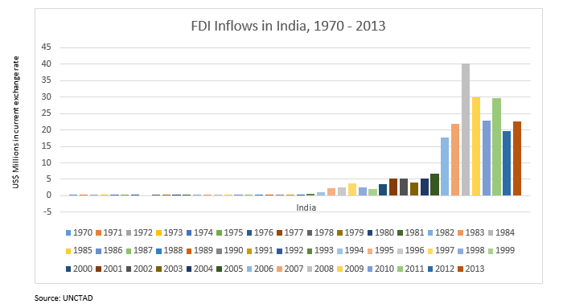

FDI has a host of benefits to provide to developing countries like India especially in terms of job creation, improved technology, enhanced quality of goods and services, better customer experience etc. Also we should remember that FDI inflows are mostly on a long term basis with intent of reaping profits on a perpetual basis. This, in turn leads to creation of assets like land and building, heavy machinery, R&D centers etc. Ever since India embarked on policy reforms in 1991 under the leadership of then Prime Minister Shri. P V Narasimha Rao, the FDI inflow to the country has been steadily increasing. It is estimated that around 1 crores jobs were created in the nation during the period 1991-2015 mainly due to establishment of foreign MNC’s in India.

**SECTOR WISE DISTRIBUTION**

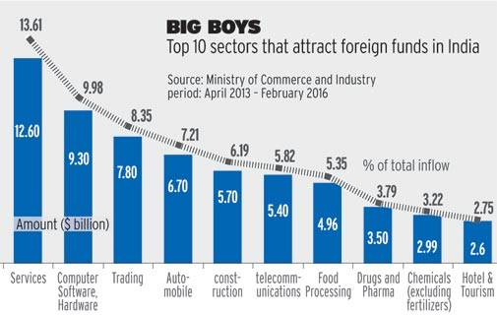

FDI is now considering as an important input for development of economy, it is permitted in a country in systematic manner **,** it comes through different route. The policy for FDI in different sector is different, and government of India is changing this policy in time to time basis.

India is a one of the most liberal country in context of transparent policies on FDI among the emerging economies.

FDI up to 100% is allowed under the automatic route in all activities/sectors except the following, which require prior approval of the Government:-

1. Sectors prohibited for FDI

2. Activities/items that require an industrial license

3. Proposals in which the foreign collaborator has an existing financial/technical collaboration in India in the same field

4. Proposals for acquisitions of shares in an existing Indian company in financial service sector and where Securities and Exchange Board of India (substantial acquisition of shares and takeovers) regulations, 1997 is attracted)

5. All proposals falling outside notified sectoral policy/CAPS under sectors in which FDI is not permitted.

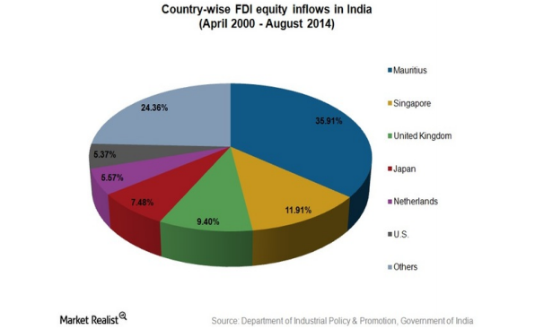

**TYPES OF ROUTES**

FDI in India can be done through 2 ways which are

(i) Automatic route: There is large number of sectors where FDI is permitted without any prior approval from government and/or RBI. It is known as the automatic route. However, the investors should file the required documents with regional office of RBI within 30 days after issuing shares to foreign investors. Also they need to inform the respective regional office of the receipt of any inward remittance within 30 days.

(ii) Government approved route: Sectors where FDI is not approved through the Automatic route require prior approval from the government of India.

Foreign Investment Promotion Board (FIPB), a body constituted by the government specifically looks into such cases and provides clearance wherever the required terms and conditions have been complied with.

The approval in granted by Foreign Investment Promotion Board (FIPB). In few sectors, FDI is not allowed.

After the grant of approval for FDI by FIPB or for the sectors falling under automatic route, FDI could take place after taking necessary regulatory approvals form the state governments and local authorities for construction of building, water, environmental clearance, etc.

**BENEFITS OF FDI**

**1. Promotion of investment in key areas:**

By allowing FDI, we can promote investment in key areas such as infrastructure development as a result of which there will be more production of capital goods. For example, investment in power generation can generate more electric power which will enable the growth of more industries.

**2. New technologies:**

FDI can bring in more new technologies which were not adopted in the country till now. Examples are the recent developments in the Communications System. The launching of satellites with the help of other countries has enabled the growth of communication system in the country. Nokia has come to India for promoting India’s communication system.

**3. Increase in Capital inflow:**

FDI promotes more capital inflow into the country especially in key and core sectors. We have a shortage of capital not only in the form of money but also in the form of material. FDIs will bridge this gap by which there will be speedy economic growth in the country.

**4. Increase in Exports:**

With the help of FDI, the exports of many underdeveloped countries have increased. The creation of Economic Zones and promotion of 100% export oriented units have helped FDIs in increasing their exports from other countries. Certain consumer products produced by them have world-wide markets. There is a change in the composition of exports and direction of exports with the presence of FDI.

### 5. Promotion of Employment opportunities:

The advent of FDI in developing countries has promoted the service sector. This has resulted in a change in the advertising and marketing technologies. This provides more scope for employment opportunities. Educated unemployment to some extent is reduced by the FDI as they could absorb some of Indian work force.

### 6. Promotion of financial services:

FDI strengthens financial services of a country by not only entering its banking industry but also by extending other activities such as merchant banking, portfolio investment, etc., which has resulted in the promotion of more new companies. It has also helped the capital market in the country.

### 7. Exchange rate stability:

Reserve Bank of India has been maintaining the exchange rate in the country through its exchange control measures. But the constant and continuous supply of foreign exchange is a must for continuing exchange rate stability. With more FDIs coming into the country, this is made possible and today RBI is having a comfortable foreign exchange reserve position of more than 1 billion dollars.

### 8. Development of backward areas:

Foreign direct investments are in a way responsible for the development of backward areas. There are so many industries started by them in far reaching and backward areas, as a result of which these areas have developed into industrial centres. Some of the backward regions have utilized the services of FDIs for starting industries in backward areas. Examples are Hyundai and Ford car units started at Sriperumbadur and Maraimalainagar in India.

### 9. Utilization of natural resources:

The natural resources in the country is put to better use by the FDls which otherwise would have remained un utilised. The examples are Saint Gobain glass company and manufacture of paper and newsprint.

### 10. Change in the lifestyle of people:

The presence of FDIs has no doubt changed the life-style pattern of people. The purchase of [consumer goods](http://accountlearning.com/consumer-goods-meaning-classification-characteristics/) such as TV, fridge, automobiles are made possible as these goods are made available through hire purchase system. The increasing number of automobiles in most of  
the cities is a standing example for the change in the life-style.

**WHAT IN INDIA ATTRACTS FDI??**

1. One of the fastest developing economies around the world.
2. Availability of cheap labour and abundant natural resources.
3. High potential of domestic market.
4. Access to highly qualified workforce.
5. Demand driven growth model.
6. Leading location for manufacturing facilities.
7. Political stability.
8. Support for innovation.

**FDI IN DIFFERENT SECTORS**

**1.RETAIL SECTOR**

* The part of the country’s economy that is made up of businesses that sell goods through stores , on internet , etc to the public.
* To achieve optimality in retail sector ,filling the gap between the organized and unorganized Indian retail is required.

If this gap could be filled even to a small extent, it would represent a huge revolution in the retail industry.

* Until 2011,Indian central govt denied FDI in multi brand Indian retail, forbidding foreign groups from any ownership in any retail outlets.
* After 2011,
  + India allowed foreign groups to own up to 51% in “ multibrand retailers", in the most radical pro-liberalisation reform passed by an Indian cabinet in years.
  + Single brand retailers can own 100% of the Indian stores(Up from the previous cap of 51%).
  + Both multibrand & single brand stores in India will have to source nearly a third of the goods from small and medium sized Indian suppliers .

**WHY THERE SHOULD BE FDI IN RETAIL SECTOR?**

1.Major contribution to GDP: the retail sector in India is hovering around 33-35% of GDP as compared to around 20% in USA.

2.High Growth Rate: the retail sector in India enjoys an extremely high growth rate of approximately 46%.

3. High Potential: since the organised portion of retail sector is only 2-3%, thereby creating lot of potential for future players.

4. High Employment Generator: the retail sector employs 7% of work force in India, which is rite now limited to unorganised sector only. Once the reforms get implemented this percentage is likely to increase substantially.

**ARGUMENTS IN FOR FDI IN RETAIL SECTOR**

1. FDI shifts the burden of risk if an from domestic to foreign investors.

2. Repayments are linked to profitability of the underlying investment

3. FDI is the only capital inflow that has been strongly associated with higher GDP growth since 1970.

4. FDI contributes to economic growth as it raises the ratio of FDI flow to domestic investment.

5. FDI has led to potential gains through technology transfer.

6.FDI has generated large employment opportunities in a number of countries.

7.FDI has led to the growth of the international trade.

**ARGUMENTS IN AGAINST FOR FDI IN RETAIL SECTOR**

1. Entry of global giants will force the Indian Traditional Kiryana Stores to shut down their business.

2. Profit will be distributed, investment ratios are not fixed.

3. An economically backward class person will suffer from price rise.

4. Market places will be located too far which will increase the travelling expenses.

5. There will be cross-culture conflicts

6. Exploitation of natural resources by foreign players

7. Inflation may be increased.

**2. MANUFACTURING SECTOR**

* Agglomeration of industries engaged in chemical, mechanical or physical transformation of materials, substances or components into consumer or industrial goods.
* This sector includes secondary processing of raw materials and all the braches of human activities that transform raw materials into products/goods.
* Also known as production sector.
* Cumulative FDI inflows into the electronics sector including computer hardware and software increased at a CAGR of 13.56%, with a value increasing from 9.8 billion US $ in FY10 to 21.02 billion US $ in FY16.
* Demand growth, supply advantages plus policies support have been instrumental in attracting FDI in this sector.

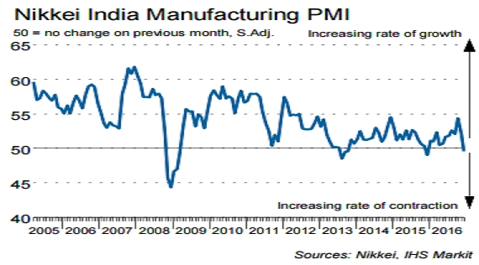

**3. SERVICE SECTOR**

* It is the portion of economy that produces intangible goods, more precisely services.
* Also called as a tertiary sector, and classified as the third economic sector, it is responsible for the largest portion of the economy’s business activities.
* Includes housekeeping , nursing , teaching , technical and scientific services, securities and investment services, information sector services ,etc.

**CURRENT ISSUES WITH SERVICE SECTOR**

* Very weak linkages of service sector with the Indian economy (only few cities).
* Requires highly skilled workers.
* Employee Welfare in time of crisis.

**4. REAL ESTATE SECTOR**

* Real estate is property comprised of land and buildings on it as well as the natural resources of the land.
* In India, this sector is the second largest employer after agriculture.
* This comprises of 4 subsectors : housing, retail, hospitality and commercial.

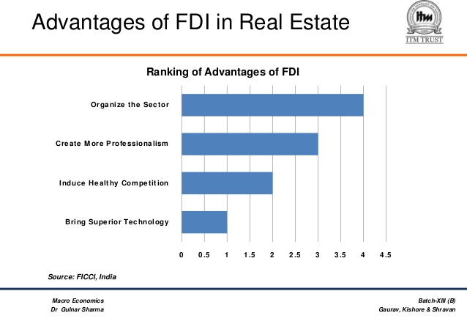

With the incoming FDI , the sector gets more organized with incoming big companies.

 >>the construction development sector in India has received Foreign Direct Investment (FDI) equity inflows to the tune of US$ 24.28 billion in the period April 2000-December 2016.

>>The growing flow of FDI into Indian real estate is encouraging increased transparency. Developers, in order to attract funding, have revamped their accounting and management systems to meet due diligence standards.

**5. AGRICULTURAL SECTOR**

* This sector composes the science, art and business of cultivating soil, producing crops, farming and raising livestock.
* It is the primary sector of economy that provides employment to two-third of the total workforce though it contributes only 17% to the GDP.

**ARGUMENTS FOR NEED OF FDI IN ARGO SECTOR**

* Farmers benefited through direct marketing and

contract farming programme.

* Improves farm production through modern techniques.
* Increasing availability of low interest credit for farmers.
* Increase in services related to agro and allied sectors.

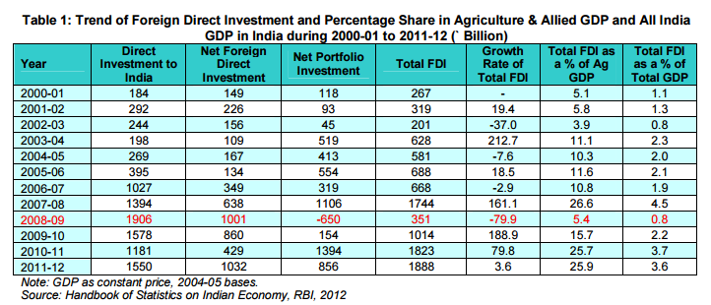

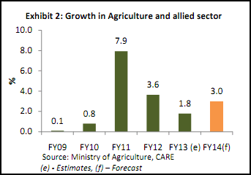

**6. TOURISM SECTOR**

* Tourism is the business of attracting, accommodating and entertaining tourists and the business of operating tours.
* It is the major source of income and affects the economy of both the source and host countries.
* It brings in large amounts of income into a local economy in form of payments for goods and services needed by the tourists.
* The tourism and hospitality sector is among the top 10 sectors in India to attract the highest Foreign Direct Investment (FDI). During the period April 2000-December 2016, the hotel and tourism sector attracted around US$ 9.93 billion of FDI, according to the data released by Department of Industrial Policy and Promotion (DIPP).
* With the rise in the number of global tourists and realising India’s potential, many companies have invested in the tourism and hospitality sector.

**CURRENT SECENRIO**

* 7.5% contribution to GDP.
* India is 16th most visited country and positioned 42th globally.
* Domestic tourism contributes to ¾ of the tourism economy with 6.97 million foreign tourist arrivals in 2013.
* Due to economic and political and social stability this industry is increasing approx at the rate of 15% yearly making it a promising sector for FDI.

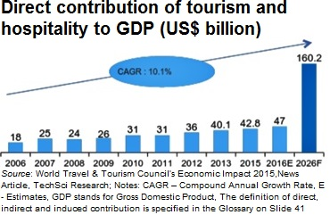

>>In India, it accounts for 7.5 per cent of the GDP and is the third largest foreign exchange earner for the country

>>The tourism and hospitality sector’s direct contribution to GDP in 2016, is estimated to be US$47 billion

>>The direct contribution of travel and tourism to GDP is expected to grow at 7.2 per cent per annum, during 2015 – 25, with the contribution expected to reach US$160.2 billion by 2026

**FDI POLICIES IN INDIA**

* In the period 1951-91, India adopted Inward looking policy , i.e. closed economy by putting restrictions on FDI and controls in the form of licences , permits, quotas and high complex tax rates.
* After economic reforms in 1991, India has liberalized its foreign policy and took series of measures to attract in FDI by adopting Outward-looking trade policy ,i.e. Open economy and globalisation.
* There were removal of restrictions of FDI , other controls and regulations for the entry of MNCs that caused Export-led industrialization.

**MAKE IN INDIA**

The Make in India initiative was launched by Prime Minister in September 2014 as part of a wider set of nation-building initiatives. Devised to transform India into a global design and manufacturing hub, Make in India was a timely response to a critical situation: by 2013, the much-hyped emerging markets bubble had burst, and India’s growth rate had fallen to its lowest level in a decade. The promise of the BRICS Nations (Brazil, Russia, India, China and South Africa) had faded, and India was tagged as one of the so-called ‘Fragile Five’. Global investors debated whether the world’s largest democracy was a risk or an opportunity. India’s 1.2 billion citizens questioned whether India was too big to succeed or too big to fail. India was on the brink of severe economic failure.

**ADVANTAGES OF MAKE IN INDIA**

1. Manufacturing sector led growth of nominal and per capita gdp. While India ranks 7th in terms of nominal GDP, it ranks a dismal 131st in terms of per capita GDP.  
  
2. Employment will increase manifold. This will augment the purchasing power of the common Indian, mitigate poverty and expand the consumer base for companies. Besides, it will help in reducing brain drain.  
  
3. Export-oriented growth model will improve India's Balance of Payments and help in accumulating foreign exchange reserves (which is very important given the volatility in the global economy with multiple rounds of Quantitative Easing announced by major economies).  
  
4. Foreign investment will bring technical expertise and creative skills along with foreign capital. The concomitant credit rating upgrade will further woo investors.  
  
5. FIIs play a dominant role (relative to FDI) in the Indian markets. However, FIIs are highly volatile in nature and a sudden exodus of hot money from India can effect a nosedive in the bellwether indices. Make in India will give an unprecedented boost to FDI flows, bringing India back to the global investment radar.

India emerged, after initiation of the programme in 2015 as the top destination globally for [foreign direct investment](https://en.wikipedia.org/wiki/Foreign_direct_investment), surpassing the [United States of America](https://en.wikipedia.org/wiki/United_States_of_America) as well as the [People's Republic of China](https://en.wikipedia.org/wiki/People's_Republic_of_China).

With the demand for electronic hardware expected to rise rapidly to US$400 billion by 2020, India has the potential to become an electronic manufacturing hub. The government is targeting to achieve net zero imports of electronics by 2020 by creating a level playing field and providing an enabling environment.

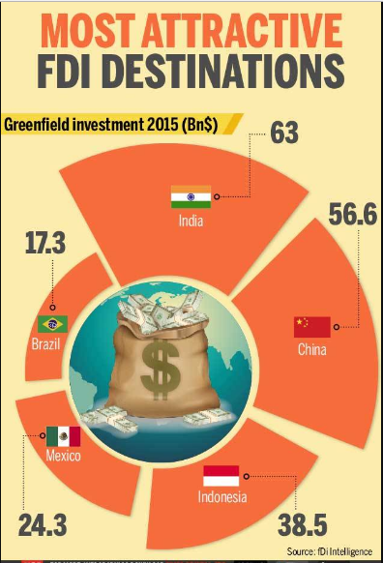

**DISADVANTAGES OF FDI**

1. **Disappearance of cottage and small scale industries:**

Some of the products produced in cottage and village industries and also under small scale industries had to disappear from the market due to the onslaught of the products coming from FDIs. Example: Multinational soft drinks.

**2. Contribution to the pollution:**

Foreign direct investments contribute to pollution problem in the country. The developed countries have shifted some of their pollution-borne industries to the developing countries. The major victim is automobile industries. Most of these are shifted to developing countries and thus they have escaped pollution.

**3. Exchange crisis:**

Foreign Direct Investments are one of the reason for exchange crisis at times. During the year 2000, the Southeast Asian countries experienced currency crisis because of the presence of FDls. With inflation contributed by them, exports have dwindled resulting in heavy fall in the value of domestic currency. As a result of this, the FDIs started withdrawing their capital leading to an exchange crisis. Thus, too much dependence on FDls will create exchange crisis.

**4. Cultural erosion:**

In all the countries where the FDls have made an inroad, there has been a cultural shock experienced by the local people, adopting a different culture alien to the country. The domestic culture either disappears or suffers a setback. This is felt in the family structure, social setup and erosion in the value system of the people. Importance given to human relations, hither to suffers a setback with the hi-fi style of living.

**5. Political corruption:**

In order to capture the foreign market, the FDIs have gone to the extent of even corrupting the high officials or the political bosses in various countries. Lockheed scandal of Japan is an example. In certain countries, the FDIs influence the political setup for achieving their personal gains. Most of the Latin American countries have experienced such a problem. Example: Drug trafficking, laundering of money, etc.

**6. Inflation in the Economy:**

The presence of FDIs has also contributed to the inflation in the country. They spend lot of money on advertisement and on consumer promotion. This is done at the cost of the consumers and the price is increased. They also form cartels to control the market and exploit the consumer. The biggest world cartel, OPEC is an example of FDI exploiting the consumers.

**7. Trade Deficit:**

The introduction of TRIPs (Trade Related Intellectual Property Rights) and TRIMs (Trade Related Investment Measures) has restricted the production of certain products in other countries. For example, India cannot manufacture certain medicines without paying royalties to the country which has originally invented the medicine. The same thing applies to seeds which are used in agriculture. Thus, the developing countries are made to either import the products or produce them through FDIs at a higher cost. WTO (World Trade Organization) is in favour of FDIs.

**CRITICAL ANALYSIS**

* After taking into consideration both pros and cons of FDI, one can safely say that although there are certain apprehensions about FDI in India but all these fears are unfounded.
* FDI can also be considered to be the sea for the sailor who wishes to travel in the deeper waters. Let’s look at it this way, when you know that your parents are there to back you up economically, you can freely think about new perspectives. Same goes for an entrepreneur where there is FDI to back him up. He can think about solving the next issue in front of him.
* Although there is a possibility that FDI has the potential to destroy small entrepreneurs, small Kirana shops because it brings stiff competition.

But there is hardly any truth in this fact , rather it will be beneficial to both the consumers and the farmers of India. So , one can believe that the future of India lies in FDI and the government must proceed in that direction if it wants to make the Indian economy a developed economy.