# W2D2 Homework

# Question 1

Table emp, order by ename increasing，which one or more are correct?

A.select ename , salary from emp   order by ename asc

B.select ename , salary from emp   order by ename desc

C.select ename , salary from emp   order by salary asc

D.select ename , salary from emp   order by ename  ;

# Question 2

Table EMPLOYEES

EMPLOYEE_ID        NUMBER          Primary Key

FIRST_NAME             VARCHAR2(25)

 LAST_NAME              VARCHAR2(25)

Which one insert one record to the table correctly?

A. INSERT INTO employees(employee_id) VALUES (1000);

B. INSERT INTO employees (first_name,last_name) VALUES (‘John’,’Smith’);

 C. INSERT INTO employees VALUES(1000,’John’,’NULL’);

D. INSERT INTO employees VALUES (‘1000’,’John’);

# Question 3

SELECT name, rank, serialNo FROM employee.

Which one to get the value of first column of rs?

A. rs.getString(0);

B. rs.getString("name");

C. rs.getString(1);

D. rs.getString(“ename”);

# Question4

At first in database, create a table Employee, id is primary key.

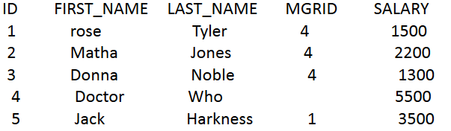

1. Create a table, and insert a record to the table, and print out all the data in the table

(6 Alex Lee 1 4500)

1. Modify the last_name to “Tate” , and save it to database. And print out all the data in the table.

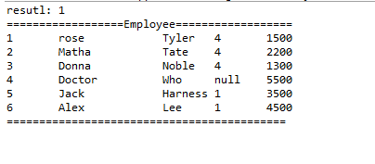

# Question 5

Why we use Class.forName?

We use **Class.forname()** to load a JDBC driver implementation, usually a JDBC driver must contain a static intializer that registers an instance of the driver implementation. It also give control over where exactly the first attempt to load the specified class. Lastly It is a way to get around potential compile-time restrictions.

# Question 6

What’s the difference between Statement and Prepared Statement?

**Statement** SQL query sent to the database pre-executes  Parse the incoming SQL query ,compile the SQL queryPlan/optimize the data acquisition path and Execute the optimized query / acquire and return data while **Prepared Statement**can only pre-executes  Parse the incoming SQL query ,compile the SQL and queryPlan/optimize the data acquisition path.

# Question 7

How to close the resultset, statement and connection after we finished the database operation? Write the codes.

Connection.close ();

pstmt.close();

rs.close();