Homework

Answer the questions by SQL.

1. **List all the employees whose salaries are more than 3000.**

SELECT A.* FROM EMP A WHERE A.SAL >3000;



1. **List all the employees whose names begin with “S”.**

SELECT A.* FROM EMP A WHERE ENAME like 'S%'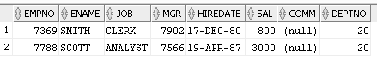

1. **List the employees whose name is “SMITH”, “ALLEN” or “FORD”.**

SELECT A.ENAME, A.* FROM EMP A WHERE A.ENAME IN ('SMITH', 'ALLEN', 'FORD');

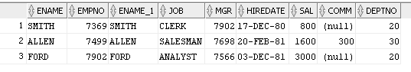

1. **List all the employees whose department is “SALES”.**

SELECT A.* FROM EMP A, DEPT B WHERE A.DEPTNO= B.DEPTNO AND DNAME='SALES';

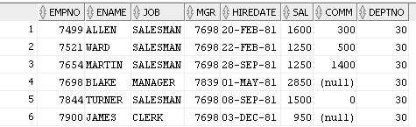

1. To get the value of average, biggest, smallest and total of each department, and order by department number.

SELECT AVG(A.SAL) , MAX(A.SAL) , MIN(A.SAL) , SUM(A.SAL) FROM EMP A, DEPT B WHERE A.DEPTNO = B.DEPTNO GROUP BY B.DEPTNO;

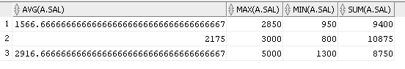

1. To get the total number of employees, whose salary is more than 3000 for each department.

SELECT COUNT(ename) AS "NUM OF EMPLOYEES", sal, deptno FROM emp WHERE sal >= 3000 GROUP BY deptno, sal;

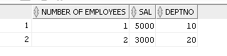

1. TO get the number of the average salary for each department, according to the department name in ascending order.

SELECT AVG(A.SAL) , B.DNAME FROM EMP A, (SELECT DNAME, DEPTNO FROM DEPT ORDER BY DNAME ASC) B WHERE A.DEPTNO = B.DEPTNO GROUP BY B.DEPTNO , B.DNAME;

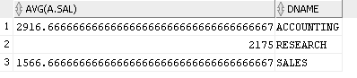

1. List the statistics of employees who have the same salary in each department, list their department number, salary, and number of employees

SELECT c.dname, a.sal, count(a.ename) FROM emp A , emp B , DEPT C WHERE a.DEPTNO=C.DEPTNO AND A.SAL=B.SAL AND A.EMPNO != B.EMPNO group by c.dname, a.sal ;

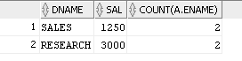

1. List the number of department with more than 2 employees in the same department, showing the name of the Department, the name of the area, and the number of the employees in the same department.

SELECT DISTINCT DNAME, LOC

FROM DEPT WHERE DEPTNO IN (SELECT DEPTNO FROM EMP HAVING COUNT(ENAME) > 2 GROUP BY DEPTNO);

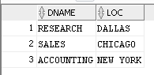

1. List the name and salary of employees whose salaries is higher than the average salary of the entire firm

SELECT A.ENAME , A.SAL FROM EMP A WHERE A.SAL> (SELECT AVG(SAL) FROM EMP) ;

