Vergara, John Benedict D.

W2D1 Homework

1 What’s character of these Collection, Collections, List, Set and Map? ArrayList and LinkedList? HashMap and TreeMap?

* Collection - Is the root interface in the collection Hierarchy. Moreover, it represents a group of elements.
* Collections – utility method class for doing certain operations. It provides useful operations for handling the collections.
* List – A collection of elements that has a particular index. A list has size and the index of its always starts with 0 and ends with size – 1.
* Set – A collection of elements that are unique. The elements it contain will not duplicate, if ever the same element was added, it will just overwrite the existing element.
* Map – A collection of elements that has Values and Keys. Each Keys which are unique pertains to a certain Value.
* ArrayList and LinkedList
  + The advantage of LinkedList is that it can continuously insert and delete element in the List without reassigning another values to the deleted index or element. While the advantage of ArrayList is the ease of access to the different element of the List through the use of its index. But when you delete an element in the ArrayList, you need to move the next element or adjust the size or add another element to the empty or deleted element or index. In LinkedList, when you delete an element, it automatically adjust or moves the next element to the place of the deleted element.
* HashMap and TreeMap
  + The TreeMap is the order of the keys can be sorted and will retain in order. While The order of the keys can be sorted but is in definite if it will retain the order.

2.

Requirement:

1. Write the output of the code.

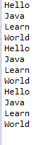

1. Where and how to modify if change Arraylist with LinkedList?

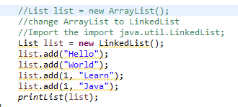

1. Where and how to modify if change Arraylist with Vector? What’s the difference between ArrayList and Vector?

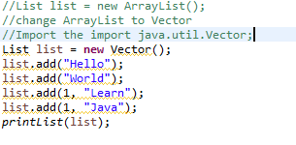

Vector is also a collection of elements but it is not good to use when searching, adding, delete and update of its elements because it is synchronized.

3. （List）Write the output of the program.

**import** java.util.*;

**public** **class** TestList {

**public** **static** **void** main(String args[]) {

List list = **new** ArrayList();

list.add("Hello");

list.add("World");

list.add("Hello");

list.add("Learn");

list.remove("Hello");

list.remove(0);

**for**(**int** i = 0; i < list.size(); i++) {

System.***out***.println(list.get(i));

}

}

}

Answer:



4. Select the right one?

1. Compile with error
2. Compile correctly, but throw exception when running.
3. ***Compile and run well, and output 3***
4. Compile and run well, and output 4

***Answer: Compile and run well, and output 3***