# W2D2 Homework

Vergara, John Benedict D.

# Question 1

Table emp, order by ename increasing，which one or more are correct?

***A.select ename , salary from emp   order by ename asc***

B.select ename , salary from emp   order by ename desc

C.select ename , salary from emp   order by salary asc

***D.select ename , salary from emp   order by ename  ;***

***Answer:***

* ***A.select ename , salary from emp   order by ename asc;***
* ***D.select ename , salary from emp   order by ename  ;***

# Question 2

Table EMPLOYEES

EMPLOYEE_ID        NUMBER          Primary Key

FIRST_NAME             VARCHAR2(25)

 LAST_NAME              VARCHAR2(25)

Which one insert one record to the table correctly?

**A. INSERT INTO employees(employee_id) VALUES (1000);**

B. INSERT INTO employees (first_name,blast_name) VALUES (‘John’,’Smith’);

***C. INSERT INTO employees VALUES(1000,’John’,’NULL’);***

D. INSERT INTO employees VALUES (‘1000’,’John’);

Answers:

* **A.INSERT INTO employees(employee_id) VALUES (1000);**
* ***C. INSERT INTO employees VALUES(1000,’John’,’NULL’);***

# Question 3

SELECT name, rank, serialNo FROM employee.

Which one to get the value of first column of rs?

A. rs.getString(0);

***B. rs.getString("name");***

***C. rs.getString(1);***

D. rs.getString(“ename”);

***Answers:***

* ***B. rs.getString("name");***
* ***C. rs.getString(1);***

# Question4

At first in database, create a table Employee, id is primary key.

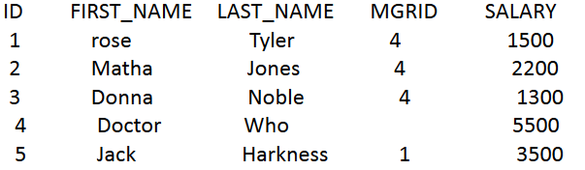

1. Create a table, and insert a record to the table, and print out all the data in the table

(6 Alex Lee 1 4500)

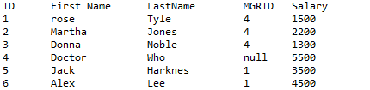

1. Modify the last_name to “Tate” whose last_name is “Jones” , and save it to database. And print out all the data in the table.

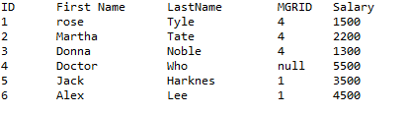

# Question 5

Why we use Class.forName?

* We use Class.forName because it causes the Class to be loaded dynamically at runtime.

# Question 6

What’s the difference between Statement and PreparedStatement?

* PreparedStatement is more efficient to use because you can manipulate the values of your statement from user input parameters, while statement cannot accept input parameters.

# Question 7

How to close the resultset, statement and connection after we finished the database operation? Write the codes.

* resultset.close();
* statement.close();
* connection.close();