# W2D2 Homework

Answers are in red.

# Question 1

Table emp, order by ename increasing，which one or more are correct?

A.select ename , salary from emp   order by ename asc

B.select ename , salary from emp   order by ename desc

C.select ename , salary from emp   order by salary asc

D.select ename , salary from emp   order by ename  ;

# Question 2

Table EMPLOYEES

EMPLOYEE_ID        NUMBER          Primary Key FIRST_NAME             VARCHAR2(25) LAST_NAME              VARCHAR2(25)

Which one insert one record to the table correctly?

A. INSERT INTO employees(employee_id) VALUES (1000);

B. INSERT INTO employees (first_name,last_name) VALUES (‘John’,’Smith’);

 C. INSERT INTO employees VALUES(1000,’John’,’NULL’);

D. INSERT INTO employees VALUES (‘1000’,’John’);

A will insert but with no first_name and last_name, C will insert a NULL as the last_name,

B will give an error because employee_id is a primary key, unless you are using a sequence/auto increment, D will also give an error because of missing value for last_name.

# Question 3

SELECT name, rank, serialNo FROM employee.

Which one to get the value of first column of rs?

A. rs.getString(0);

B. rs.getString("name");

C. rs.getString(1);

D. rs.getString(“ename”);

# Question4

At first in database, create a table Employee, id is primary key.

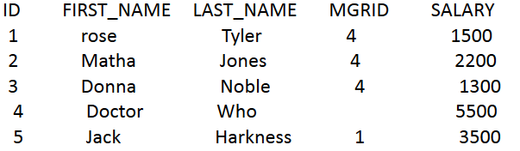

1. Create a table, and insert a record to the table, and print out all the data in the table

(6 Alex Lee 1 4500)

1. Modify the last_name to “Tate” , whose last_name is “Jones”and save it to database. And print out all the data in the table.

# Question 5

Why we use Class.forName?

We use the Class.forName to load the specified Class/driver (for example: oracle.jdbc.driver.OracleDriver) using the classloader so that we can use it to create a Connection object.

# Question 6

What’s the difference between Statement and PreparedStatement?

Statement is a static SQL Statement, only one ResultSet per Statement object can be open at the same time. As per java documentation, all execution methods in the Statement will close the current ResultSet object if an open one exists.

PreparedStatement is an object that represents a pre-compiled statement, we can then use this object to execute that statement multiple times. It is a Subclass of Statement. PreparedStatement allows us to parameterize the values in the query.

# Question 7

How to close the resultset, statement and connection after we finished the database operation? Write the codes.

pstmt.close();

conn.close();

As per java documentation, all execution methods in the Statement will close the current ResultSet object if an open one exists.

rs.close();

