**1)Test Action (Test power trip):-**

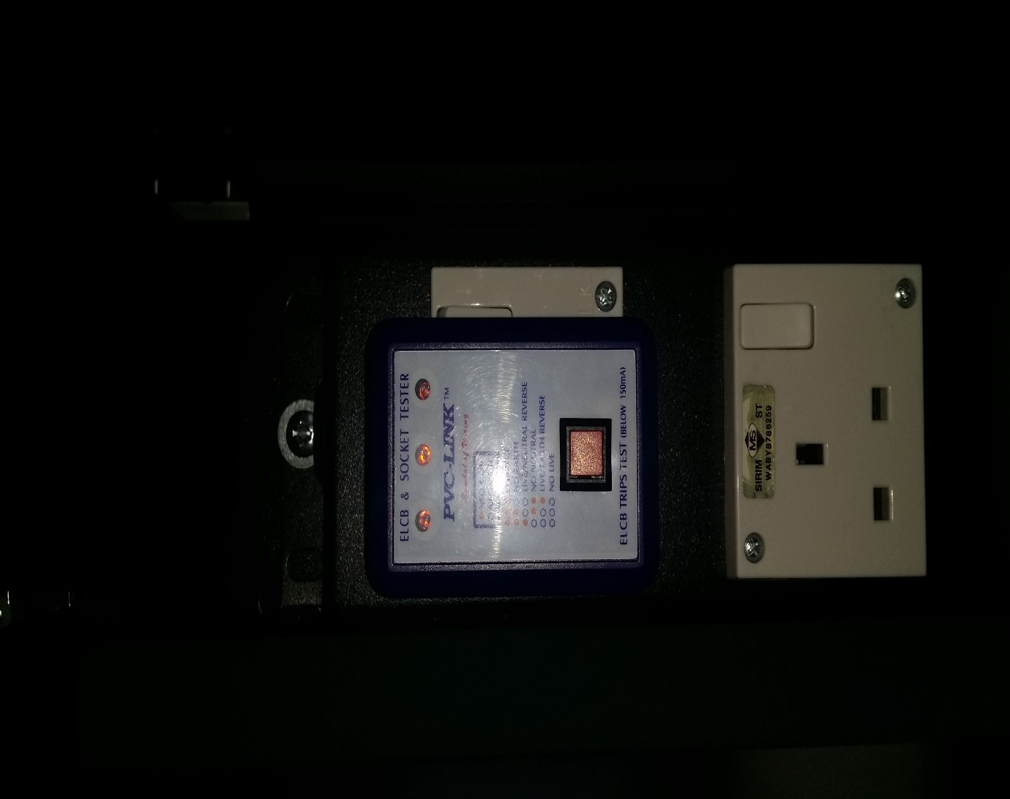

1. Test all ‘3 pin plug socket’ at 2 rows with ‘ELCB & Socket tester’.
2. 3 lights will show in ‘ELCB & Socket tester’.

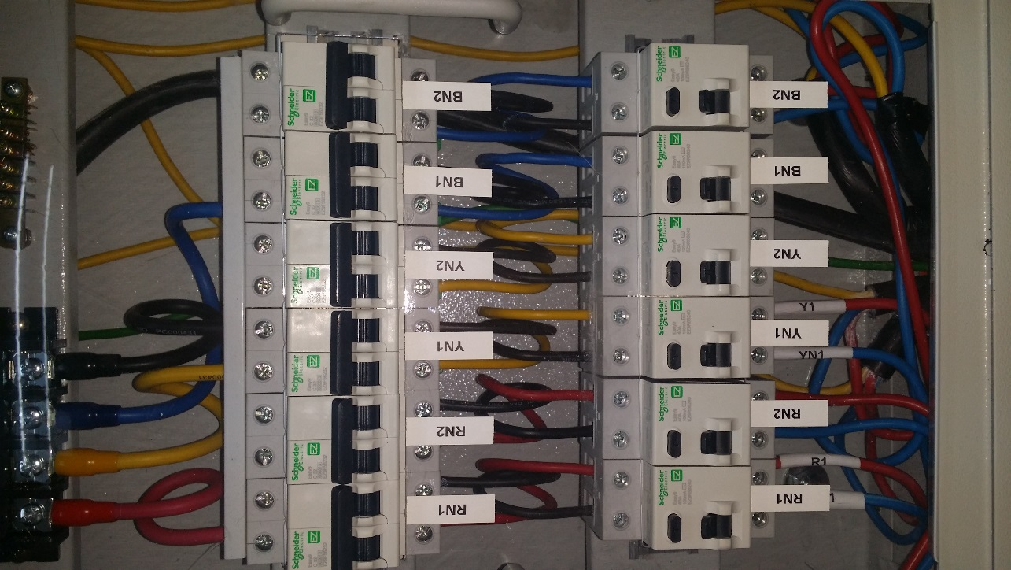 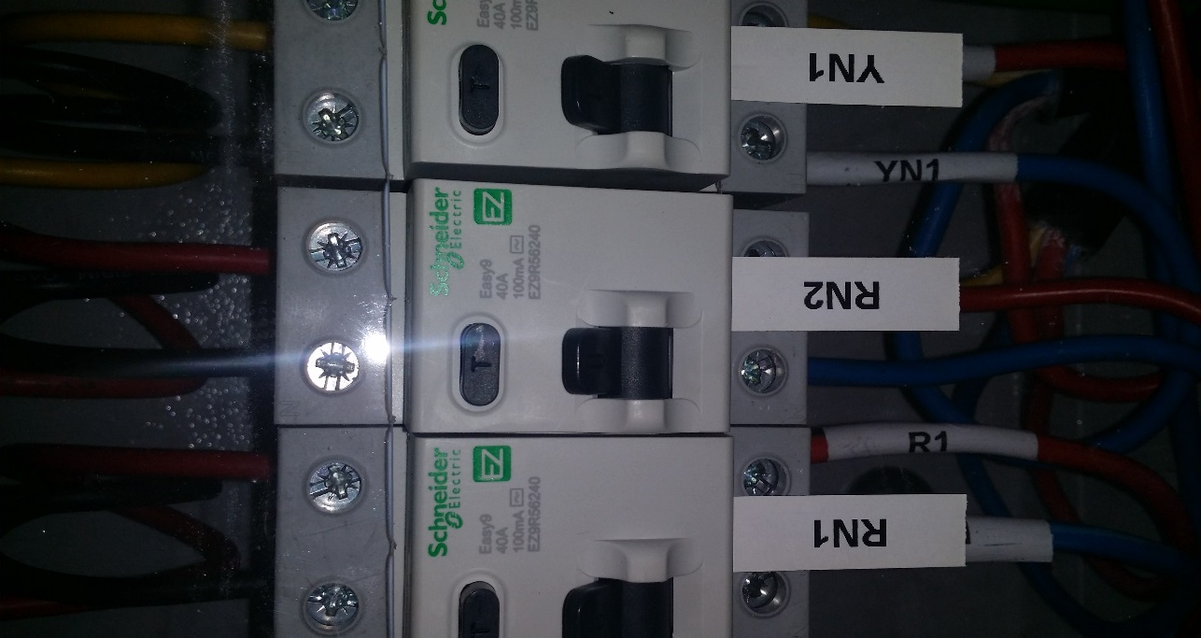

1. Turn ON ELCB switch RN2 & BN2 to run the test.

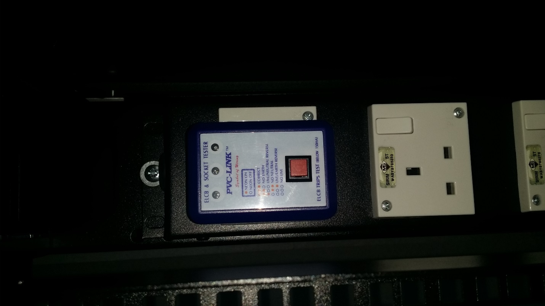

1. Test power trip by press the red button.

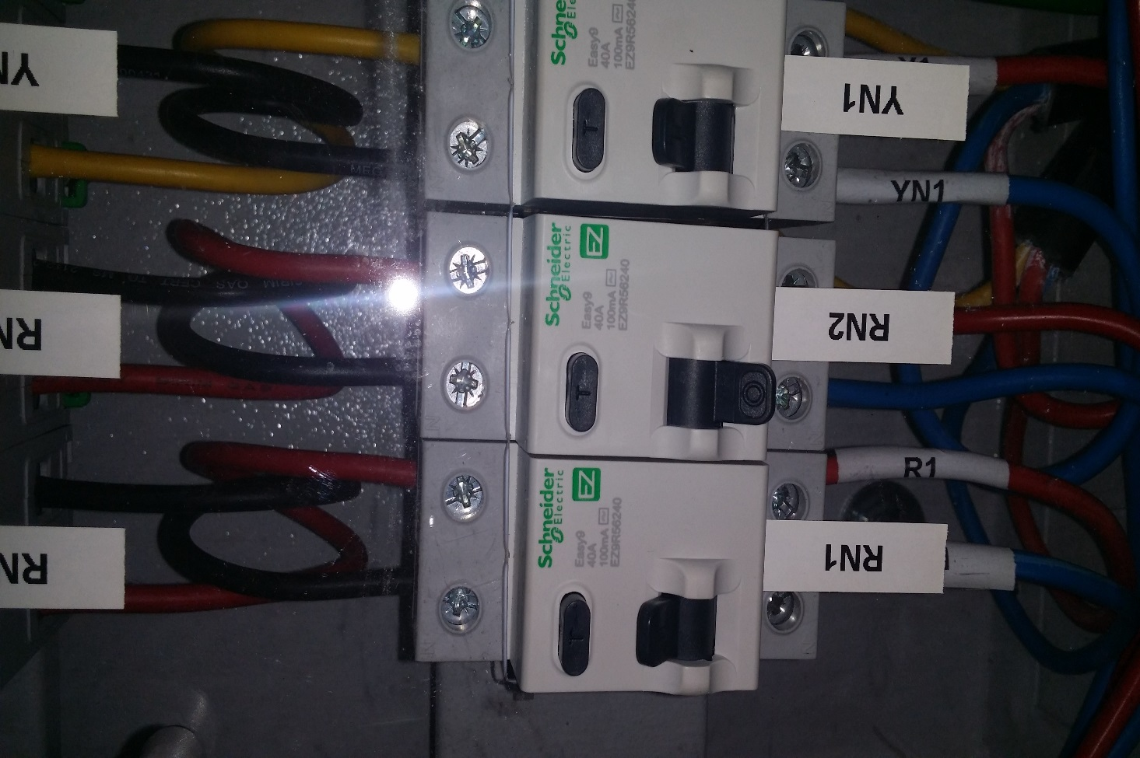

1. ELCB switch at RN2 will triggered and switch OFF.
2. That’s mean ELCB switch is Ok.

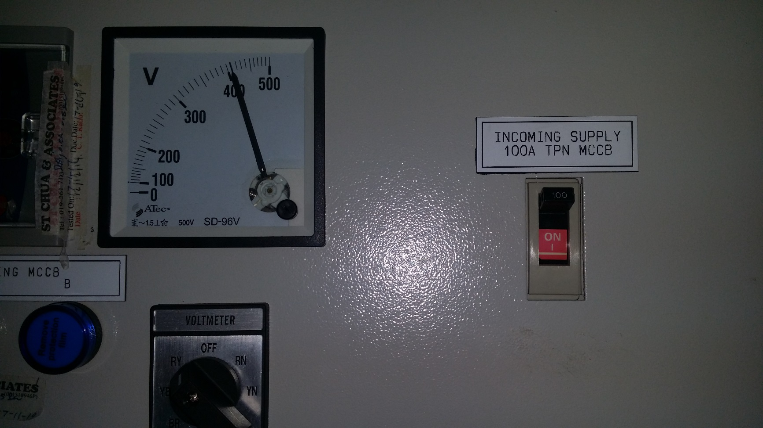

1. Incoming DB is still switch ON.
2. No power trip at Incoming DB during this exercise.

**2)Test Action (Check power load):-**

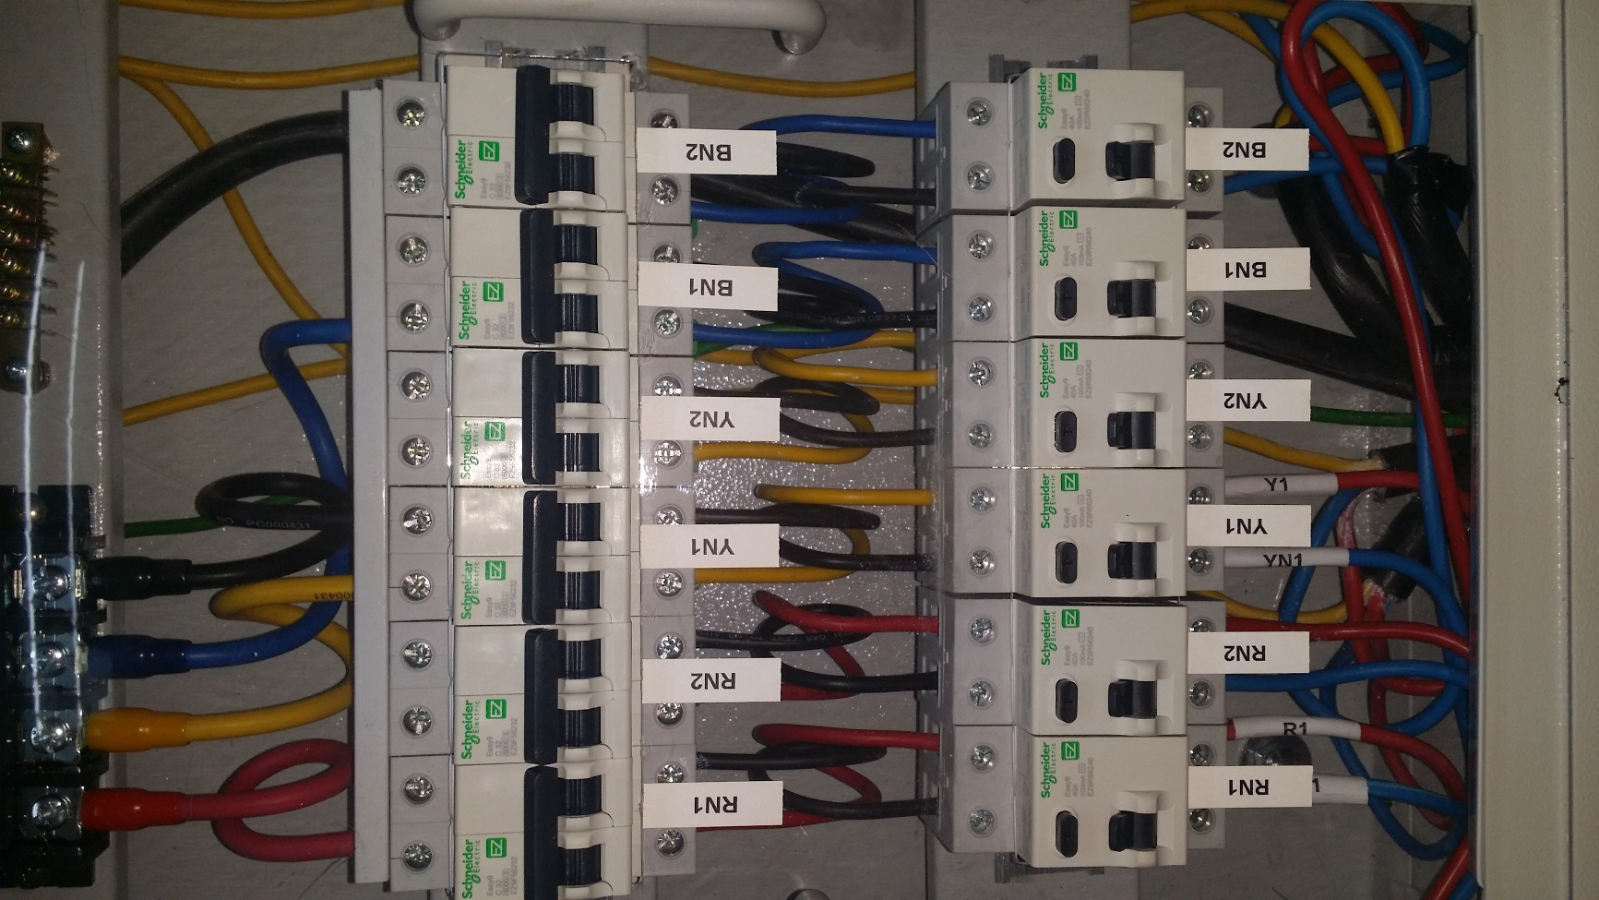

1. Plug power commando cable to rack.
2. Turn ON ELCB switch RN2 & BN2.

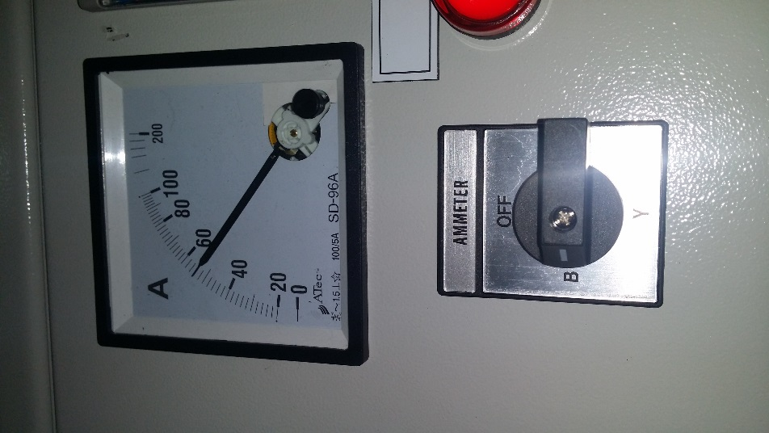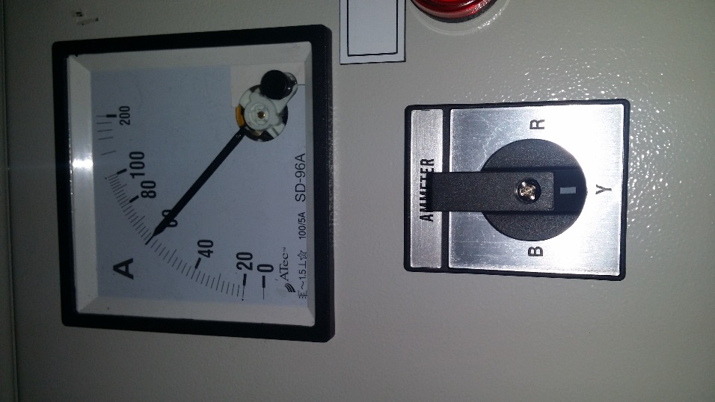 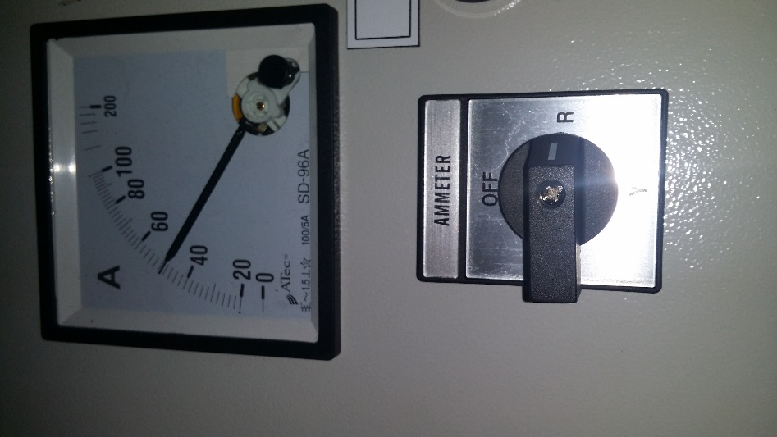

1. No power load in AMMETER (Blue/Yellow/Red) after plug in power commando to the power rack.
2. That’s mean the rack has not used any power due to no equipment running on it.