Output
- Using mobile stand (stability->only additional icons are highlighted)
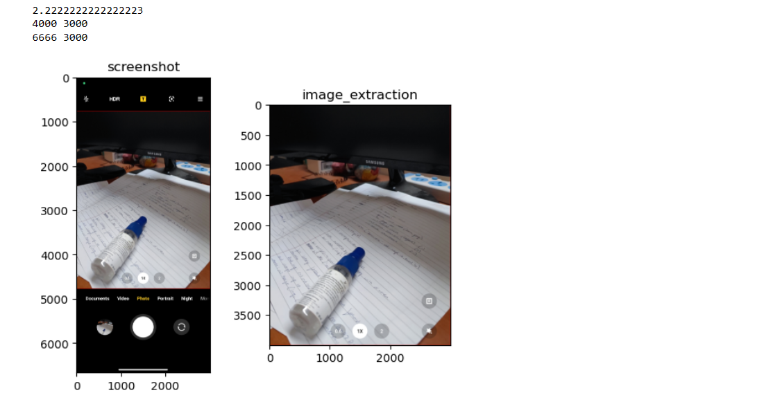
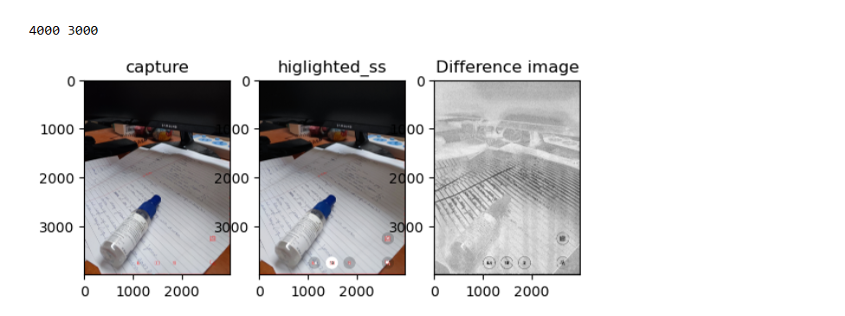

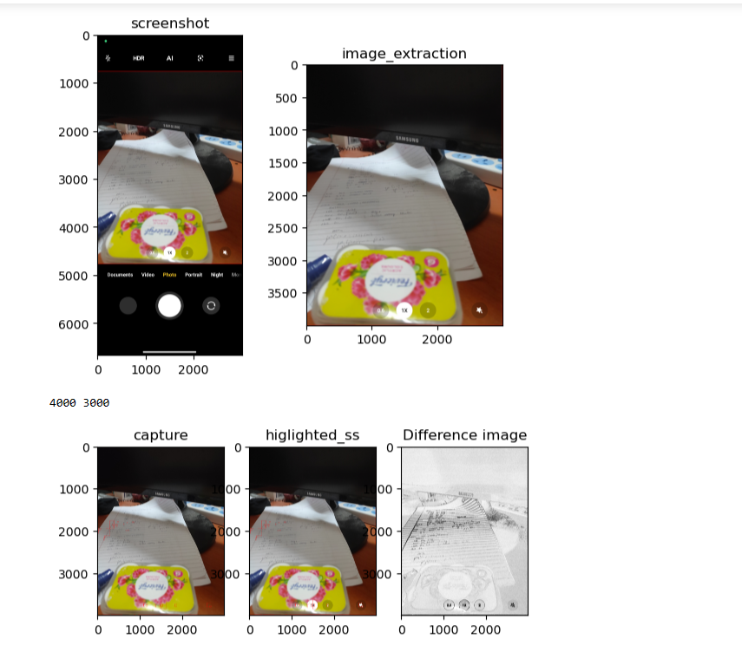

- Without using mobile stand (due to handshake whole image is highlighted)
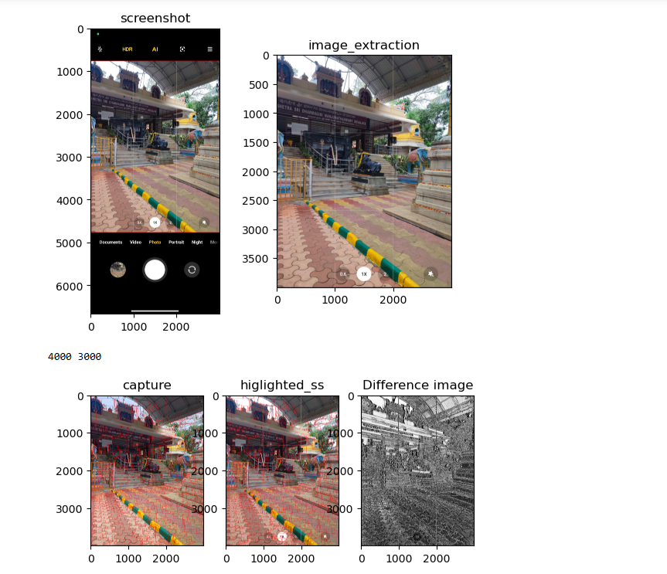

- Screenshot vs photo(in gallery only black area and icons are extra, so they are highlighted)
