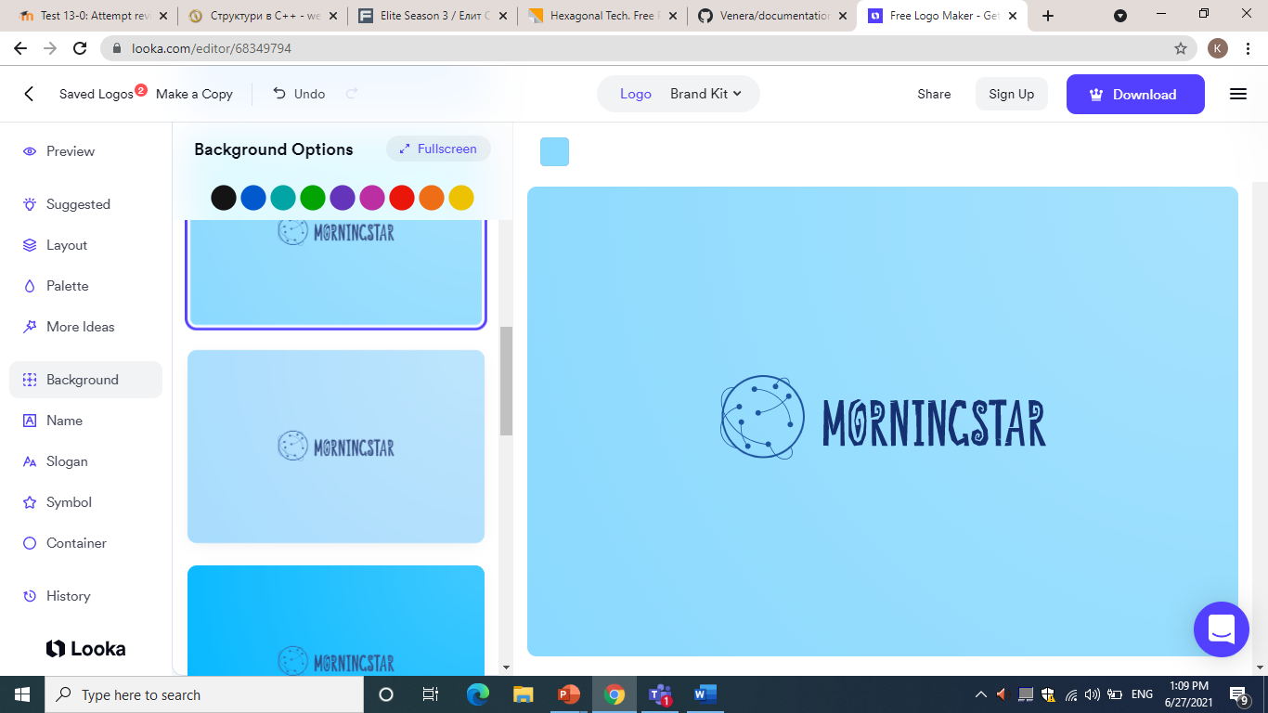

* ***Content***

*1.* Information 3

1.1. About us 3

1.2. Roles 3

*2.* For Game 4

**Information**

# **About us**

Participants:

* Mario Slavov 10a;
* Iliya Marinov 10g;
* Miriam Georgieva 9g;
* Kameliya Yaneva 9g;
* Stanislav Yordanov 8a;
* Konstantin Dinev 8v;

# **Roles**

* Mario Slavov– Scrum Trainer
* Iliya Marinov– Back-End Developer
* Kameliya Yaneva– Front-End Developer
* Miriam Georgieva– Front-End Developer
* Stanislav Yordanov– Front-End Developer
* Konstantin Dinev– Front-End Developer

**For Game**

The game we created is called Word spy, it is a scrambled letter, between which there are words that need to be found. Once the word is found, it must be selected in the marked fields, if it is correct it will be colored green. But if it is wrong it will be colored red.