**# REQUIREMENTS**

**#INTRODUCTION:**

The TNEB Bill calculator is a calculation oriented project which is used to calculate the electricity bill of the Tamilnadu Electricity Board Consumer. This takes the input such as previous month reading current month reading consumer Number etc. The tool used for writing the code to build this project is Code Blocks. The project is built using multi file approach and can run in multiplatform.

**#RESEARCH**:

In current days calculating electricity bills have become a hectic process. It is because most of the people are not aware of the subsidy that are available for the users. Moreover the cost of each unit varies for different type of users and even for same type of user it varies based on the units they consumed.

The feature of the TNEB bill calculator includes

Total Units consumed

Bill calculation for:

Domestic Users

Commercial Users

Agricultural Users

Commercial Users are further classified as

Industries

Railway Traction

Government Educational Institutions

Private Educational Institutions

Temporary Construction sites

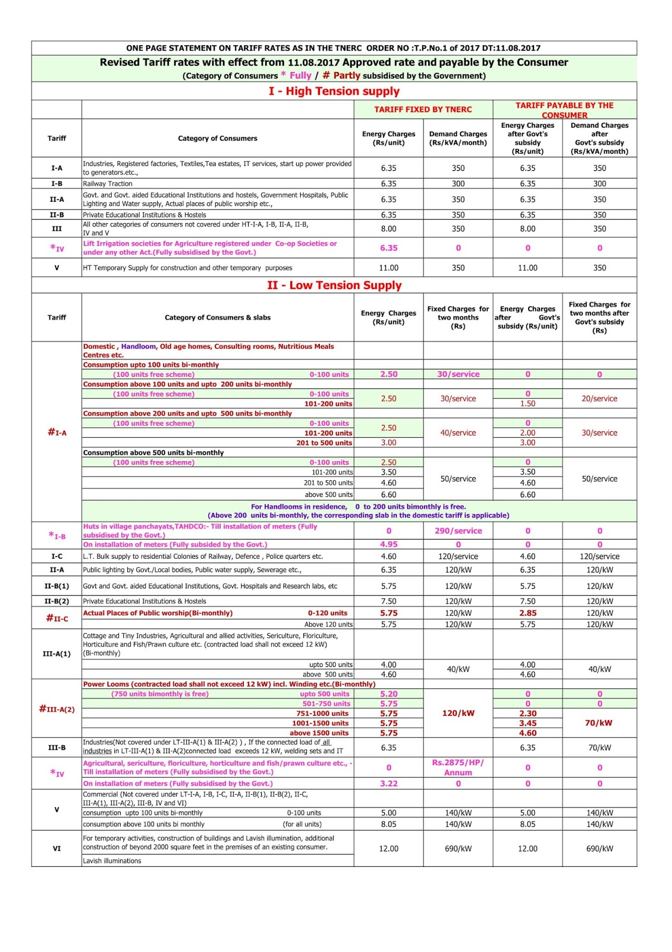

**SWOT Analysis:**

**Strength**: Creative, Easy to use.

**Weakness**: Everybody should learn to use this.

**Opportunities**: Still in most places we use paper and pen for calculation. So there is a great market for this product.

**Threats**: Convincing the customers who already got used to paper pen method.

**4’W and 1’H**

**What**: TNEB Bill Calculator

**Where**: Schools, Industries, Houses etc.

**When**: Electricity bill Calculation.

**Who**: TNEB Consumers

**How**: Calculates from the user input and gives as output.

Low level Requirements:

|  |  |  |
| --- | --- | --- |
| ID | Description | Status |
| LL01 | Calculates bill for Low tension users | Implemented |
| LL02 | Calculate bill for high tension users | Implemented |
| LL03 | Calculate bill for Agricultural users | Implemented |

High Level Requirements:

|  |  |  |
| --- | --- | --- |
| ID | Description | Status |
| LL01_HL01 | Bill for <100 units users | Implemented |
| LL01_HL02 | Bill for <200 units users | Implemented |
| LL01_HL03 | Bill for <500 units users | Implemented |
| LL01_HL04 | Bill for >500 units users | Implemented |

|  |  |  |
| --- | --- | --- |
| ID | Description | Status |
| LL02_HL01 | Bill for Industrial Users | Implemented |
| LL02_HL02 | Bill for Government Educational institutions | Implemented |
| LL02_HL03 | Bill for Private Educational institutions | Implemented |
| LL02_HL04 | Bill for Railway Traction | Implemented |
| LL02_HL05 | Bill for Temporary Construction Sites | Implemented |