GIT-HOL ASSIGNMENT-3 (3 pages)

Branching in Git
Branching in Git allows you to create a separate line of development, isolated from the main branch (usually main or master). This helps in working on features or fixes without affecting the stable code.

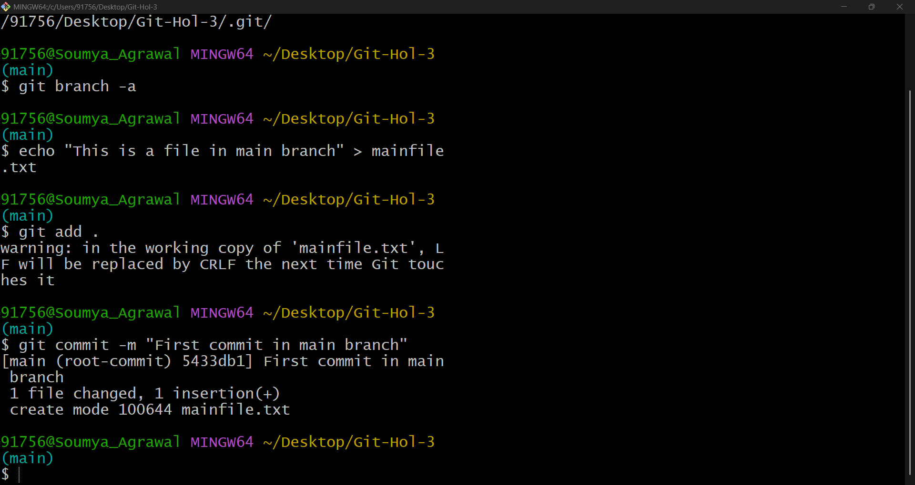
Figure 1: Commit in main branch

Merging in Git
Merging is the process of integrating changes from one branch into another.

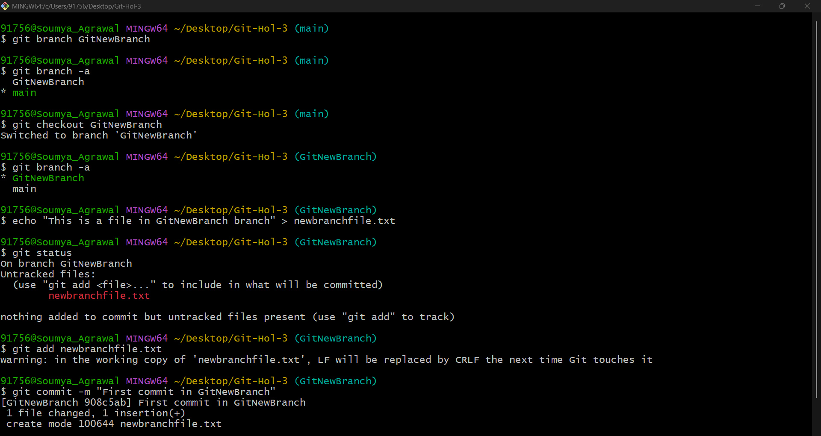
Figure 2: Commit in new branch GitNewBranch

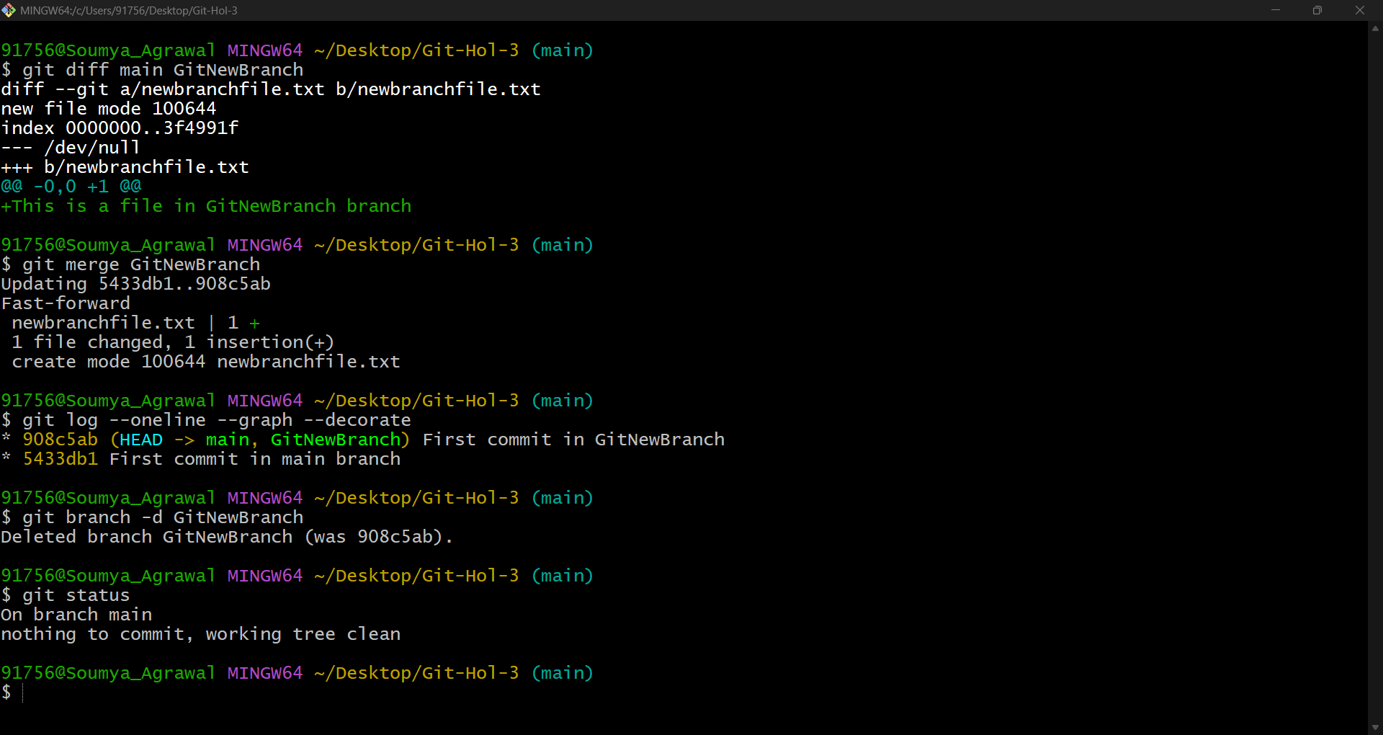
Figure 3: Difference between two branches, merged differences and deleted the newly created branch GitNewBranch.

