CloseDesk update: reading attachments correctly and search by meaning
September 30, 2026

Summary
This update makes Ask CloseDesk more reliable when answering from attachments. PDFs, spreadsheets, Word files and slides are now read accurately, including tables with empty cells. Reference numbers in answers open the file they cite. CloseDesk can also show which files are indexed for search by meaning, and you can index your mail with one button.

1. Attachments are read correctly
Before this update, some PDFs came through garbled. Names could appear with spaces between the letters (“J o n a t h a n”), and in tables exported from Excel a blank cell made the following values shift into the wrong columns. The assistant then gave confident but wrong answers.
- Whole words: PDF text is read from each character’s exact position on the page, so letter-spaced text comes out as normal words.
- Tables keep their columns: every value stays under its own column heading. An empty cell is shown as “not listed” instead of being skipped.
- Labelled rows: each table row reads like “Employee: Jonathan Reyes | Department: not listed | Manager: Priya Raman”, so the assistant can’t mix up columns.
- All file types: the same treatment applies to Word tables (including merged cells), PowerPoint tables, Excel workbooks and CSV files.
Example from testing: asked about an employee in a PDF staff list, the old version answered with another person’s department and phone number. The new version correctly said the department and phone were not listed and named the right manager.

Clickable references in answers
- Clicking a reference number such as [1] in an Ask CloseDesk answer now opens the attachment it refers to.
- PDFs open at the cited page. Other files open in CloseDesk’s text view, scrolled to the cited section with the cited value highlighted.
- Files on emails flagged as possible payment fraud still don’t open.

2. Search by meaning: see what’s indexed and index on demand
Search by meaning lets Ask CloseDesk find emails and file sections that say the same thing in different words. For example, a question about a “team trip to Portugal” can find a memo about the “Lisbon offsite”. It needs an embedding model loaded in LM Studio (for example nomic-embed-text), and your mail must be indexed first. Before this update there was no way to tell whether that had happened.

Setup page
A new Search by meaning box shows which model is used, how many emails and file sections are indexed, and when indexing last ran. The Index all mail now button indexes everything in the background with a progress bar. When everything is indexed, the button is replaced by “✓ Everything is indexed”.
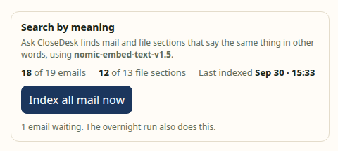
The Search by meaning box on the Setup page

Each email’s attachments
Every attachment shows whether it is indexed. If any file isn’t, an Index for search button appears in the Attachments header. Once indexed, the file shows a green “✓ Indexed” badge and the button disappears. If a file’s text changes later, it shows “Changed since indexed”.
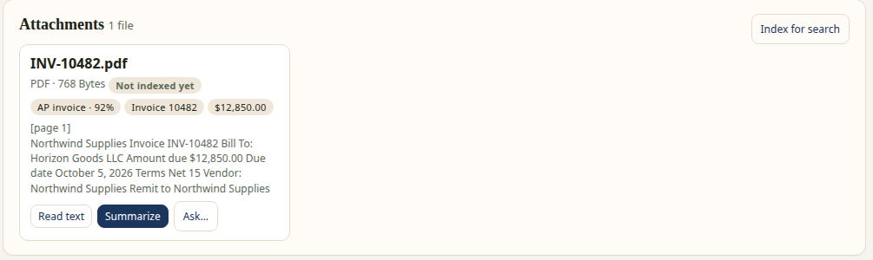
Before: “Not indexed yet”, with the Index for search button
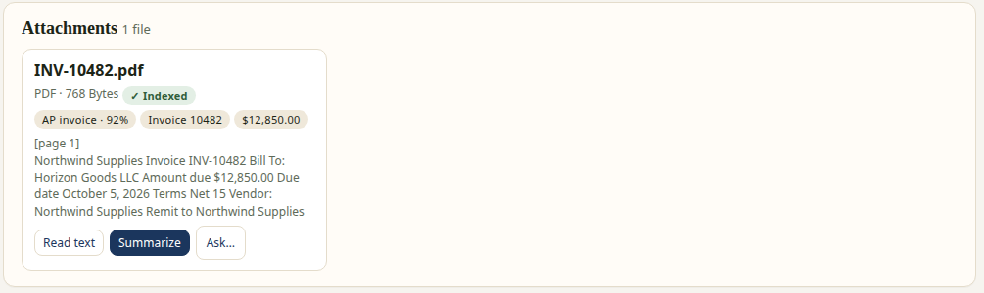
After: a green “✓ Indexed” badge, and the button is gone

Ask CloseDesk shows its work
The steps shown under each answer now say how the mail was searched and how much of each file was read:
- “Searched your mail by words and meaning (nomic-embed-text-v1.5): 1 email found by meaning”
- “Searched your mail by words only: it isn’t indexed for meaning yet (Setup → Index all mail now)”
- “Read Q4 budget.xlsx in full (3 sections)”
- “Read 6 of 31 sections of Audit report.pdf (picked by words and meaning)”

Better answers from long files
- When a file is too long to read whole, the assistant now picks the sections to read by meaning as well as by matching words, so questions worded differently from the file still reach the right page.
- Every attachment with text is indexed section by section: PDF pages, Excel sheets, PowerPoint slides and Word sections.
- Indexing runs whenever an embedding model is available, even when no chat model is loaded.

3. Safety and privacy
- Everything stays on your computer. Indexing uses the local model in LM Studio.
- Files on emails flagged as possible payment fraud are never indexed, opened or given to the assistant.
- Bank account numbers stay masked when attachments are re-read.

4. How to get the update
- Pull the latest version of CloseDesk (main branch).
- Start CloseDesk as usual with CloseDesk.bat (Windows) or CloseDesk.command (Mac). It installs the new PDF reader package automatically.
- Existing attachments are re-read with the improved reader on the next Process new mail or overnight run.
- In LM Studio, load an embedding model such as nomic-embed-text. Then go to Setup → Search by meaning → Index all mail now.

Testing
All 215 automated tests pass on Windows, Mac and Linux. The PDF fix was checked with a real local model on a letter-spaced staff list. Search by meaning was checked with the nomic-embed-text model: indexing covered all 19 sample emails and 13 file sections.

