Crowd Funding ETH DAPP

Introduction
Crowd Funding ETH DAPP is a Decentralized Application which tries to harness the power of social networks and the internet to give people the means to raise funds, help others overcome hardship, and meet inspirational goals.

Overview
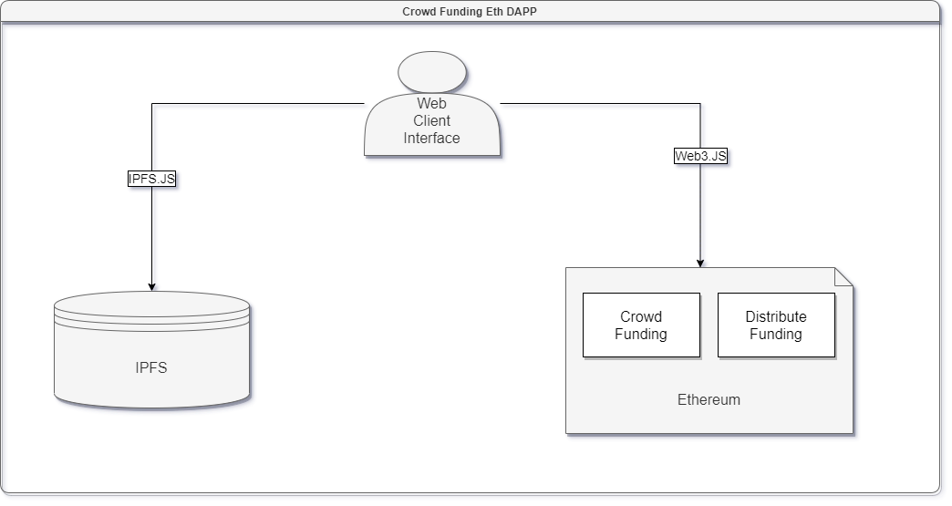
Crowd Funding ETH is an application that is mostly decentralized.
Here I will present all the aspects of the application that may be decentralized.
- Front End (Web Client Interface)
The Client Side Layer uses standard web technologies.
My choice of tools is Standard HTML, CSS, JavaScript and React Framework.
The Frond End is linked to Ethereum via web3.js JavaScript Library.

- Back End (Ethereum Blockchain)
The Business Logic of the Application is stored in Ethereum Smart Contracts.
The Smart Contracts used for this application are Crowd Funding and Distribute Funding.
Crowd Funding shall allow Contributors to Transfer or Withdraw Ether till Funding Target is not reached.
After Funding Target is reached the Owner of Crowd Funding can Transfer the Sum to Distribute Funding Contract.
Distribute Funding will share the Sum to Beneficiary/Beneficiaries.
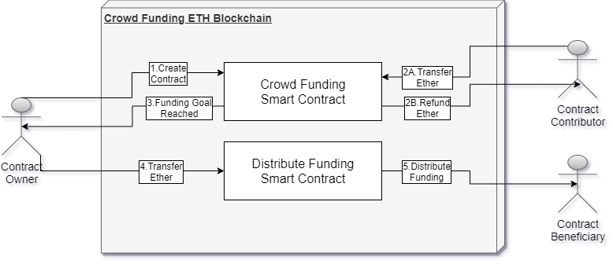
- Data Store (IPFS)
Due to high costs and the currently low block gas limit, Smart Contracts are not well suited to storing or processing large amounts of data.
Hence, Crowd Funding ETH DAPP utilizes a decentralized data storage service: Inter-Planetary File System (IPFS).
IPFS is ideal for storing and distributing large static assets such as:
- Images and Videos of Users and Funding Contracts
- Member’s Data
- Funding’s Data
- User’s Reviews and Funding History
- Success Stories
- Funding Contracts Categories
- “How It Works” Application Info

Application Use-Case
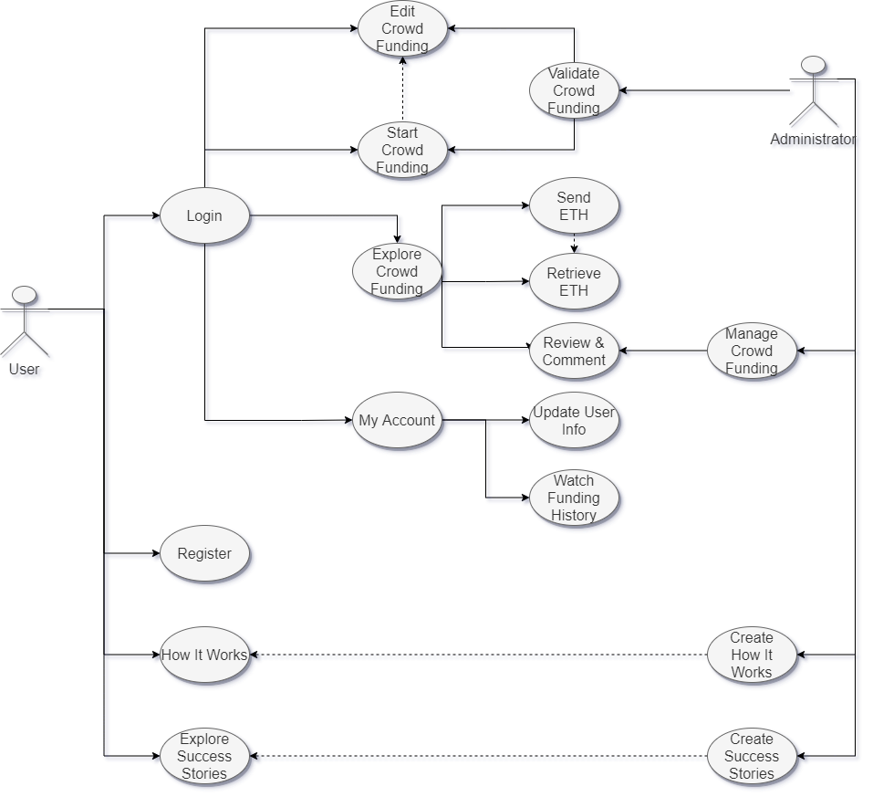
Main Roles of Crowd Funding ETH DAPP are:
- Register – Create User’s Membership
- How It Works – Application How To that should be created and updated by any Administrator
- Explore Success Stories – Stories about successful funding contracts that should be created and updated by any Administrator
- Login – Allow User to Create/Edit Crowd Funding, Explore and Contribute to other Crowd Fundings (Transfer/Refund Ether, Review and Comment)

