Assignment 1: One-Way ANOVA in R
Matthew Naughton
Northeastern University
ALY 3015: Intermediate Statistics for Data Analytics
Sergiy Shevchenko, PhD
September 29, 2026

Question 1: PlantGrowth Data
For this question I used the built-in PlantGrowth dataset, which comes bundled with R, so it loads with data(PlantGrowth) rather than being imported from a file. It records the dried weight of plants under a control condition and two treatments.
data(PlantGrowth)
str(PlantGrowth)
fit <- aov(weight ~ group, data = PlantGrowth)
summary(fit)
boxplot(weight ~ group, data = PlantGrowth)
TukeyHSD(fit)

(i) How many groups are there?
There are three groups: ctrl, trt1, and trt2, with 10 observations in each group.
(ii) Test the ANOVA – are the means equal?
The one-way ANOVA returned an F-value of 4.85 with a p-value of 0.0159. Because the p-value is below 0.05, I reject the null hypothesis that all the group means are equal. In other words, the means are not all equal – at least one group differs from the others.
(iii) Box plot – which two groups appear most similar?
Looking at the box plot below, ctrl and trt1 appear the most similar. Their boxes overlap a great deal and their group means are the closest (about 5.03 for ctrl and 4.66 for trt1). The trt2 group sits clearly higher than the other two.
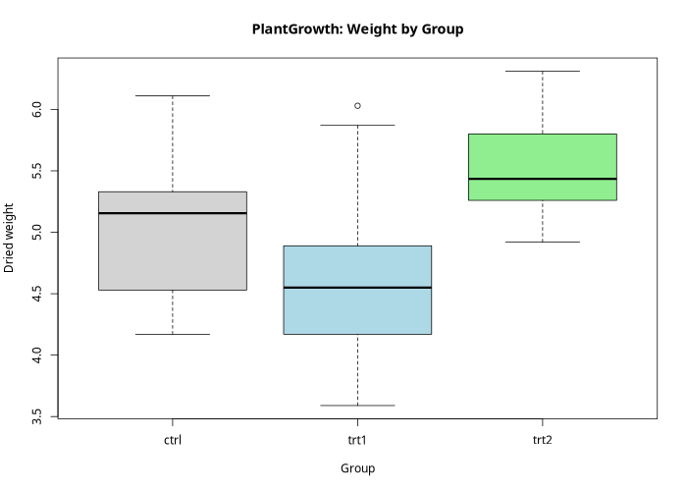
(iv) Which pairs are significantly different?
I used Tukey's HSD to compare each pair of groups. The only pair that was significantly different was trt1 vs. trt2 (adjusted p = 0.012). The other two comparisons – trt1 vs. ctrl (p = 0.39) and trt2 vs. ctrl (p = 0.20) – were not significant. So the significant difference the ANOVA detected is coming from the gap between the two treatments.
(v) Are all the ANOVA assumptions satisfied?
The main assumptions for a one-way ANOVA are independent observations, normally distributed residuals, and equal variances across groups. Independence is reasonable given the study design. For normality, the Shapiro-Wilk test gave p = 0.44, and for equal variances the Bartlett test gave p = 0.24. Both p-values are well above 0.05, so neither assumption is violated. Overall, the assumptions appear to be satisfied and the ANOVA result can be trusted.

Question 2: Regional Sales Data
For this question I started from the regionalsales Excel file, saved it as a CSV, and imported it into R with read.csv(). The data came in a wide layout with one row per year and separate columns for reg1, reg2, and reg3. ANOVA needs one column of values and one column of group labels, so I reshaped it into a long format using stack() before running the test.
sales_wide <- read.csv("regionalsales.csv")
long <- stack(sales_wide[, c("reg1", "reg2", "reg3")])
names(long) <- c("sales", "region")
boxplot(sales ~ region, data = long)
fit <- aov(sales ~ region, data = long)
summary(fit)
TukeyHSD(fit)

(i) Box plot and ANOVA result
The box plot below shows the three regions at clearly different levels, with reg2 highest, reg3 in the middle, and reg1 lowest. The group means back this up: about 111 for reg1, 296 for reg2, and 174 for reg3.
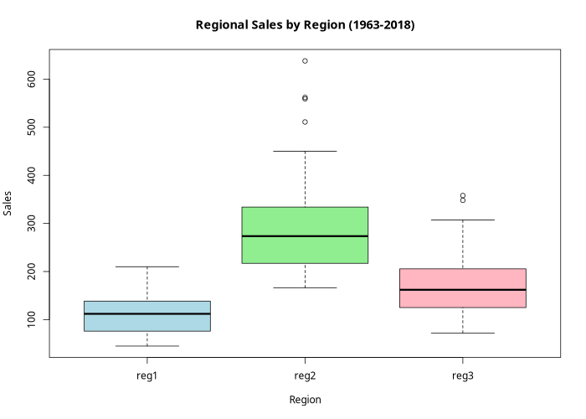
The one-way ANOVA returned F = 87.52 with a p-value below 2 × 10⁻¹⁶, which is far smaller than 0.05. My result is that I reject the null hypothesis: the average sales are not the same across the three regions.
(ii) Which pairs are significantly different?
Because the ANOVA was significant, I followed up with Tukey's HSD to see which specific regions differed. Every pair came back significant (all adjusted p-values below 0.05):
- reg2 vs. reg1: difference of about +185 (p ≈ 0)
- reg3 vs. reg1: difference of about +63 (p ≈ 0.00005)
- reg3 vs. reg2: difference of about −122 (p ≈ 0)
So all three regions differ significantly from one another, with the ordering reg2 > reg3 > reg1. The tests I used were a one-way ANOVA to establish that a difference exists, followed by Tukey's HSD to identify which pairs were responsible for it.

