Using Visual Studio 2019.

Make sure that the “Office/SharePoint development” module is installed in Visual Studio.  
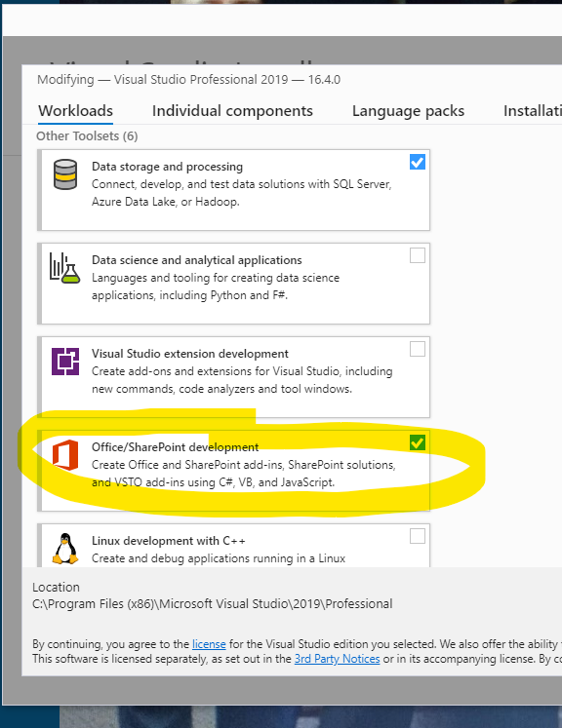

Create a new solution and add a new project of type Excel VSTO Add-in.  
