Analog clock

Html

Make division for clock container and

Make divisions for hour min sec

Attach css and js

Css

For the clock container

Position relative for responsive

We will not get image if we directly made url

So for thar make a dark background and then make background image and no repeat

To make it total fit make background size 100%

To make it centre set margin auto

Set height weidth accordingly

For common h,m,s container

Make position absolute to maintain fixed distance between center and walls of clock

Make background color black

And boarder radius 10% for the curve at top and bottom of hands of clock

For hour

Make height

Weidth Top ,left

in inspect better do these things patiently by keeping other 2 display as none

for minute

Make height

Weidth Top ,left

in inspect better do these things patiently by keeping other 2 display as none

for second

Make height

Weidth Top ,left

in inspect better do these things patiently by keeping other 2 display as none

***note : the hands will move in zig zag way so make it horigin centernew property transform origin: bottom;***

java script

setinterval function is used setInterval() is a function in JavaScript that is used to repeatedly execute a given function at a specified interval. It takes two arguments: the first argument is the function to be executed, and the second argument is the time interval (in milliseconds) between each execution.

Give 1000 it changes for every 1000 milli seconds

Now get time in hours and minutes and seconds

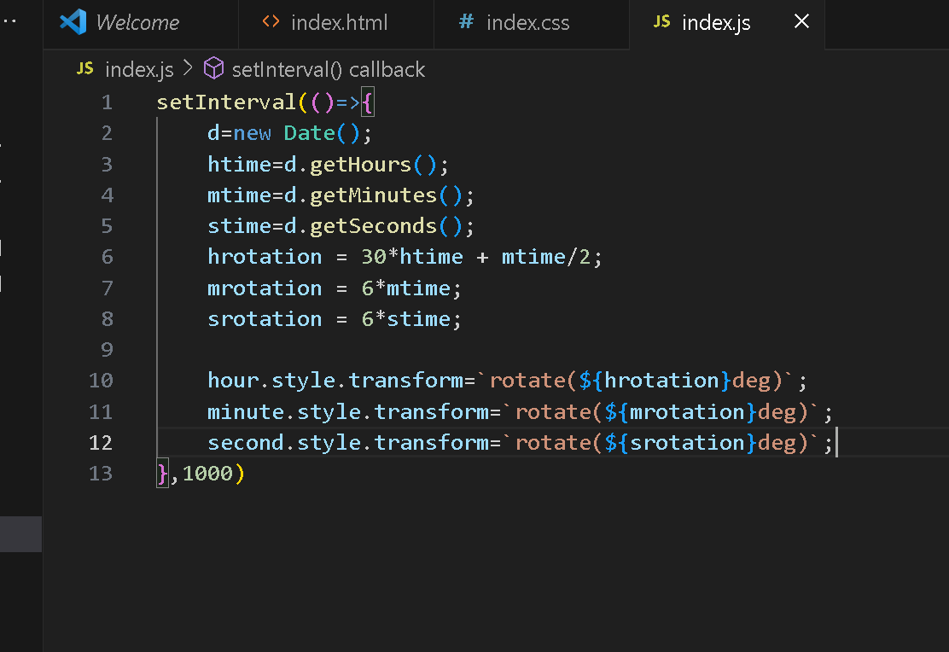

The rotation logic come by logic key point to js program

To make it rotate use ***hour.style.transform***

***Description. The transform property applies a 2D or 3D transformation to an element. This property allows you to rotate, scale, move, skew, etc., elements.***