---Download the react-scripts ; axios ; import useState

---get the images for background

---in App.js make divisions as we have a pattern of 3 sections

---search

--container

--top

1.Location

2.temp

3.temp in caliculus

--bottom

1.feels

2.humidity

3.wind

In index.css

Do styling using .className

The z-index property in CSS is used to control the stacking order of positioned elements. Negative values for z-index will place the element behind other elements, while positive values will bring the element forward.

In this specific case, the value z-index: -1 is used for the background image to ensure that it is placed behind all other elements on the page. This creates a subtle parallax effect, where the background image appears to move more slowly than the foreground elements as the user scrolls. It also ensures that the input field and other elements are easily readable and accessible on top of the background image.

Yes, that's correct! If you use a positive value for z-index on the background image, it will be placed in front of other elements on the page. This could cause issues with readability and accessibility, as other elements may be covered up by the image.

Using a value of 0 or a positive value for z-index on other elements on the page can also cause the background image to be covered up, as those elements would be placed in front of the background image.

By using a negative value for z-index on the background image, you ensure that it is placed behind all other elements on the page, allowing those elements to be easily readable and accessible.

  const searchLocation = (event) => {

    if(event.key === 'Enter'){

      axios.get(url).then((response)=>{

        setData(response.data)

        setCelsiusTemp((response.data.main.temp - 32) * 5/9)

        console.log(response.data)

      })

    }

  }

Here, we define a function search_location that takes an event object as an argument. We check if the key pressed during the event is the "Enter" key using event.key == 'Enter'. If it is, we construct the API URL using an f-string and make a GET request to the URL using requests.get(url).

We then parse the JSON response using response.json() and extract the temperature data using data['main']['temp']. We convert the temperature from Fahrenheit to Celsius using the formula (temp - 32) * 5/9.

Finally, we print the data using print(data). Note that in the original JavaScript code, the data is stored in state variables using the useState hook, but in Python, we simply print the data for demonstration purposes.

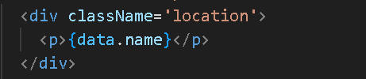

Data.main means we r accessing name of place from the api

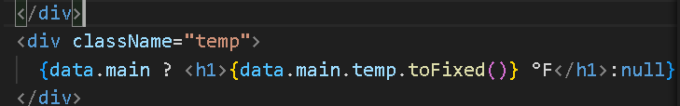

Here we r taking temperature from the api that is there in another place and **toFixed()** indicates temperature is fixed numeric without any decimal places

Similarly we acces the humidity and weather atmosphere type like clouds/mist/haze as those are part of arrays we use **weather[index]**

--***THE END***