Exp.No: 10 Creation of VHD on Windows and restoring on different host
Date: 26.09.26

Aim:
To create a VHD on windows and restore the same in different host
Steps:
Create a VHD on Windows
- Press Win + R, type diskmgmt.msc, and press Enter
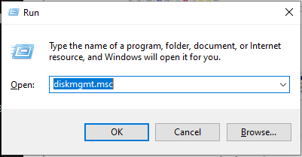
- In Disk Management, go to the Action menu → Create VHD
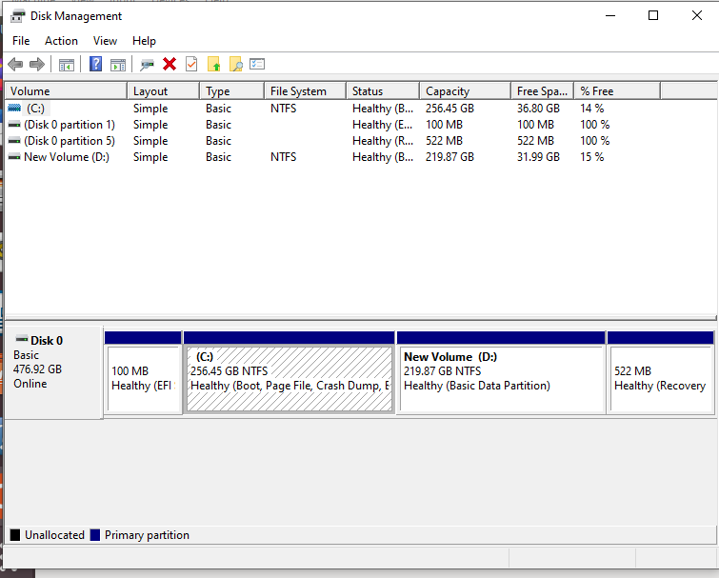

- Location → Browse and select where to save the .vhd or .vhdx file.
- Virtual Hard Disk Size (decide based on what you need).
- VHD format:VHD (compatible with older systems, max 2TB).
- Type: Fixed size → Pre-allocates the full size. Faster runtime, but uses disk space upfront.
- Dynamically expanding → Grows as data is added. Saves space initially.
- Click OK → The VHD will be created and appear in Disk Management as "Not Initialized".
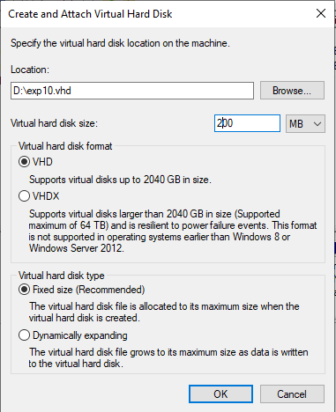
- Right-click the new disk → Initialize Disk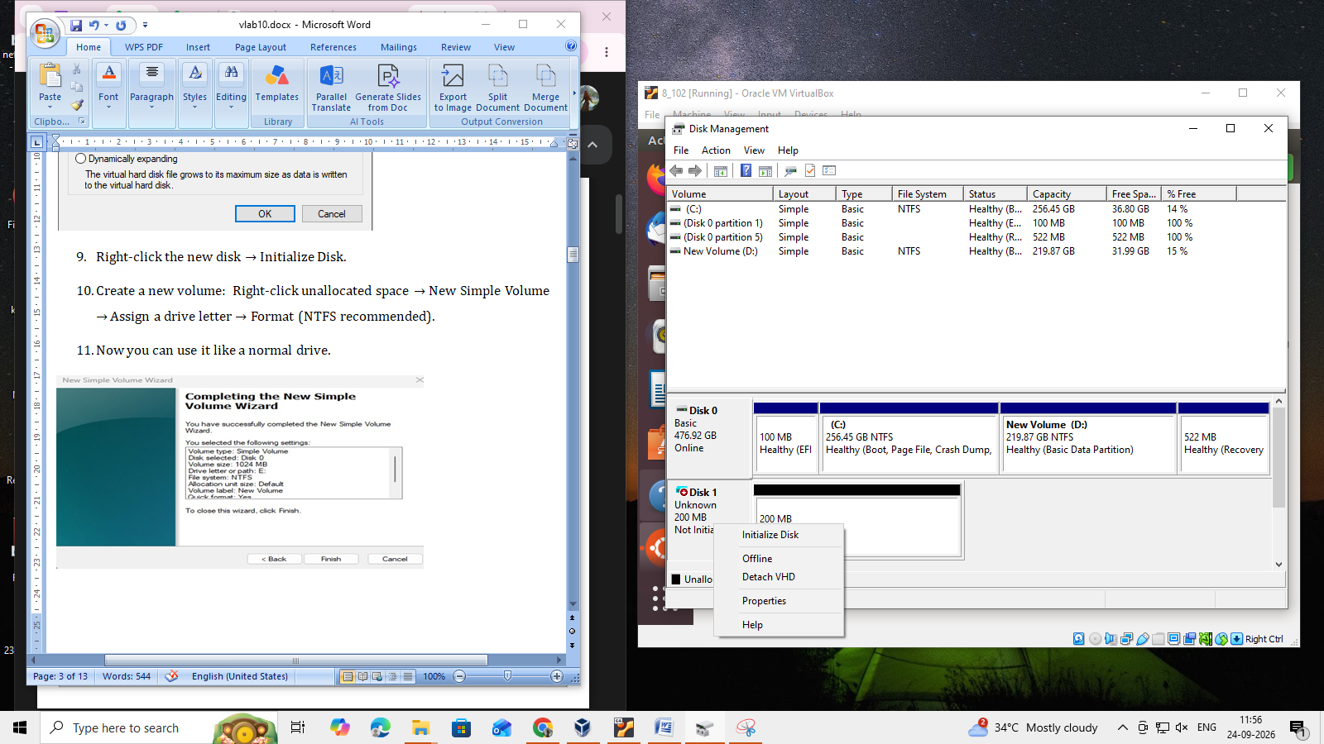
- Create a new volume: Right-click unallocated space → New Simple Volume → Assign a drive letter → Format (NTFS recommended).
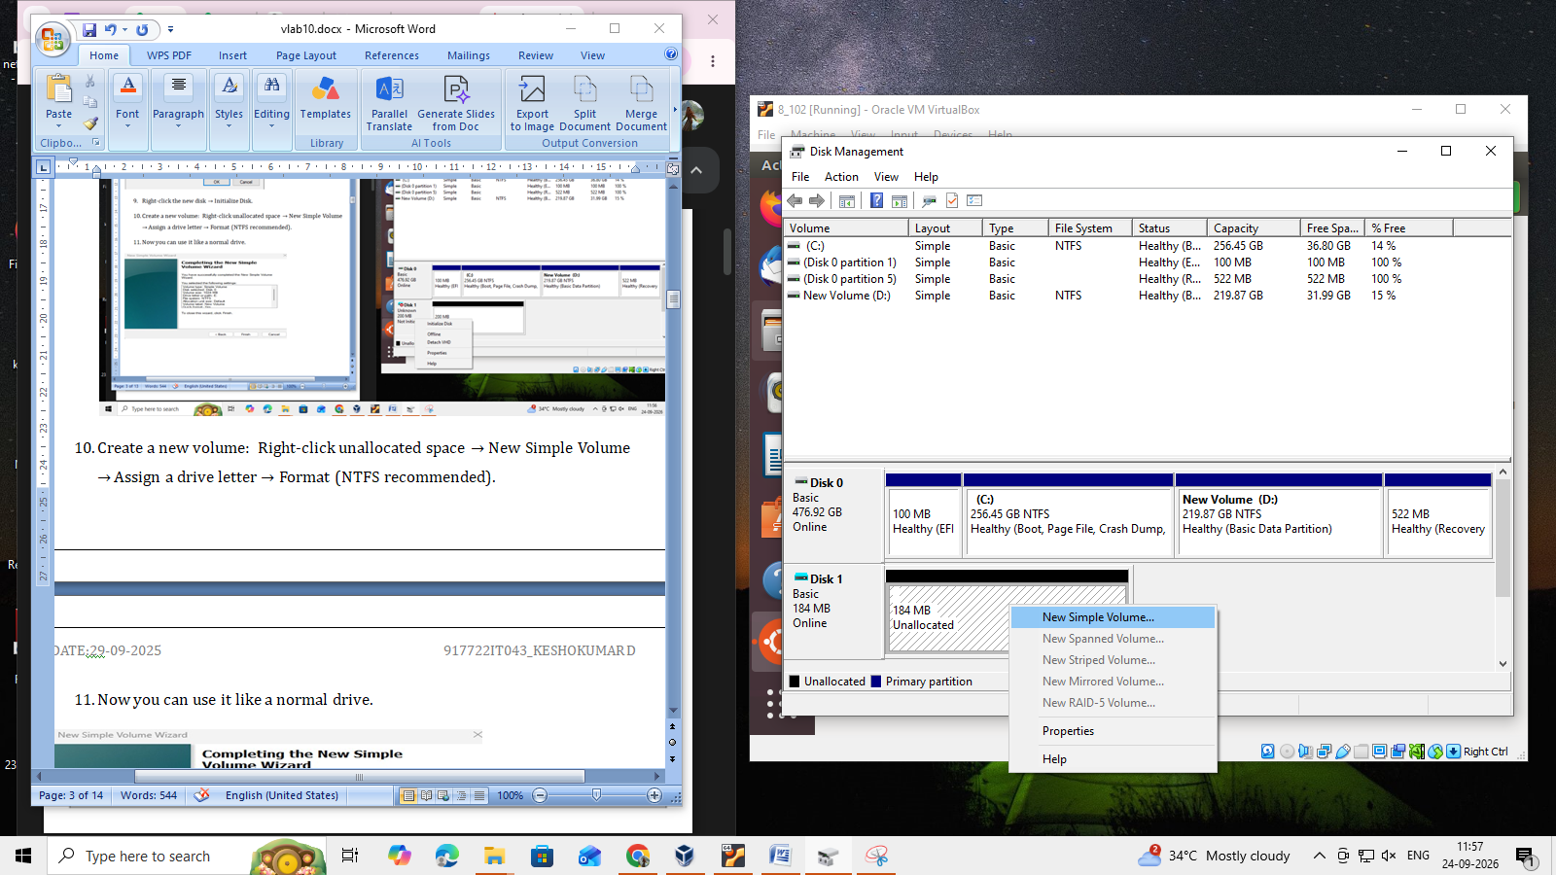
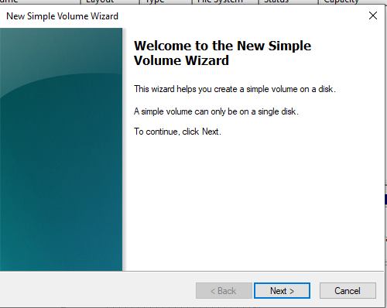
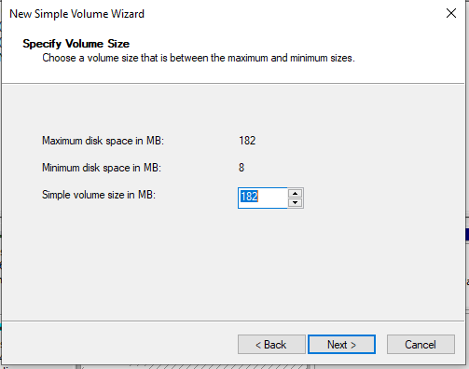
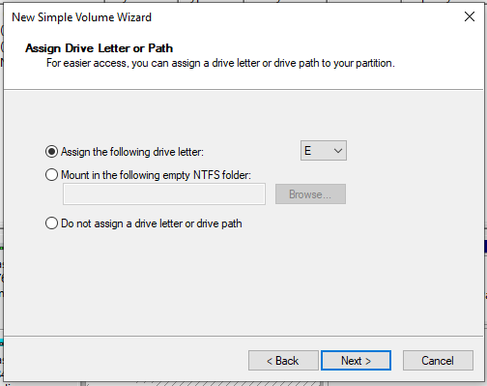
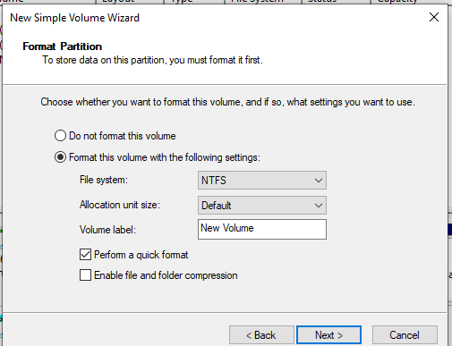
- Now you can use it like a normal drive.
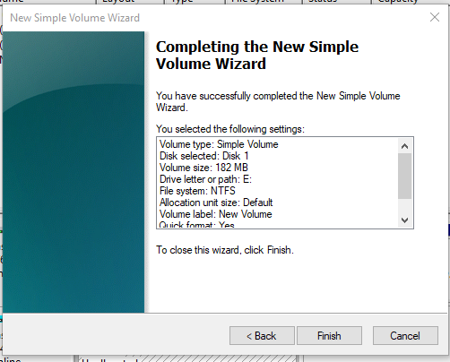
Steps to Use on Another Host
- Copy your .vhd or .vhdx file to the new machine (via external HDD, network, or cloud).
- On the new host:Open Disk Management → Action → Attach VHD.
- Browse to the .vhd file and click OK.
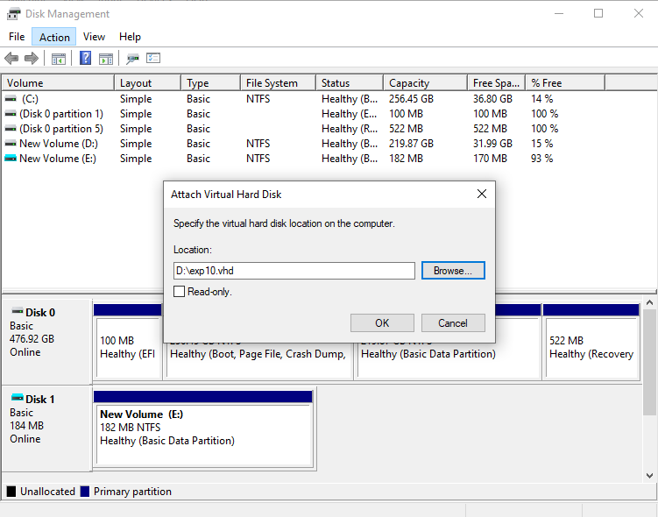
- The VHD will appear as a new drive (with the same partitions/data).
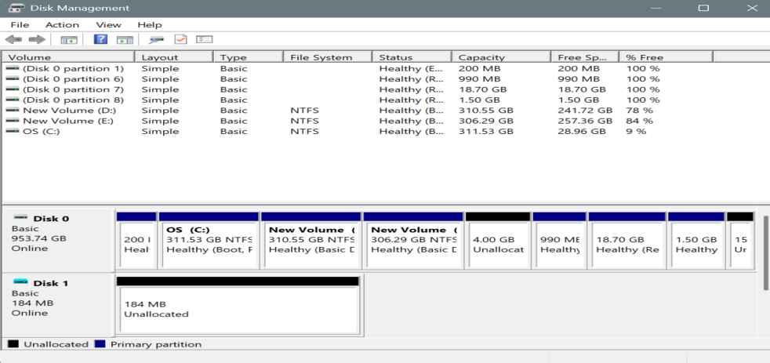

- If needed, assign a drive letter:Right-click the partition → Change Drive Letter and Paths → Assign a letter.
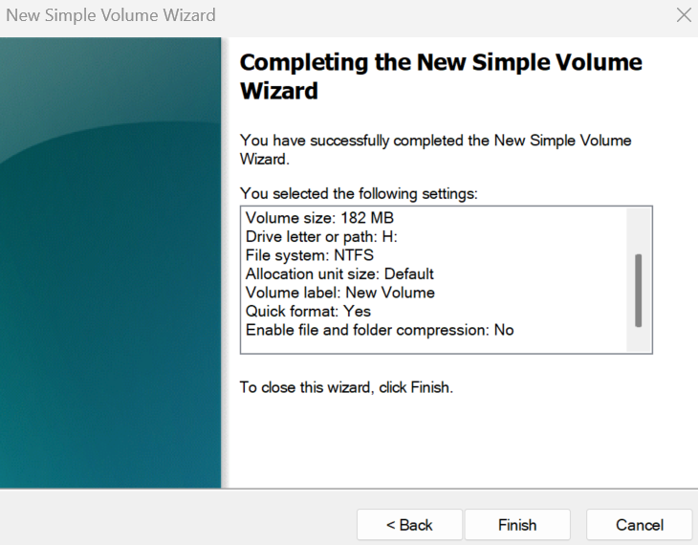
- Now you can access files just like a normal disk.
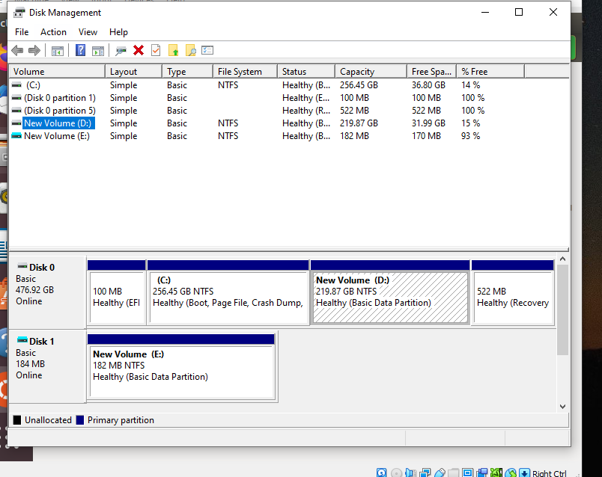
STORAGE VIRTUALIZATION:
Step 1: Create a VM and Add Additional Storage
- Create a Linux VM
  - Open VirtualBox → Click New → Enter VM Name, Type = Linux, Version = ubuntu.
  - Allocate RAM (e.g., 2–4 GB).
  - Hard Disk: Select “Use an existing virtual hard disk file”.
  - Browse and select your VDI file.
  - Click Finish.
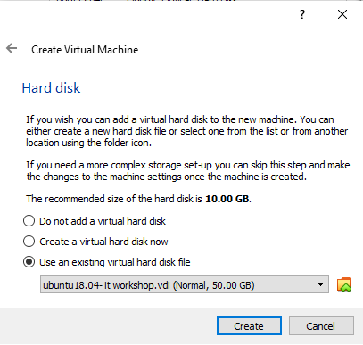

- Add an Additional Virtual Disk
- This disk will be used for extending storage via LVM.
- In VirtualBox:
  - Select the VM → Settings → Storage.
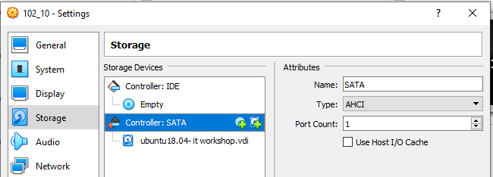

  - Click the Controller: SATA → Add Hard Disk → Create New Disk.
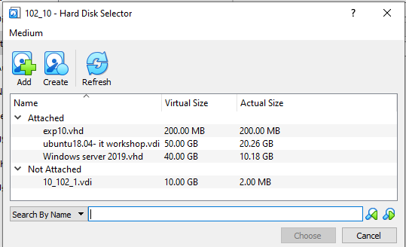
  - Choose VDI (VirtualBox Disk Image), Dynamically allocated, size = 7 GB
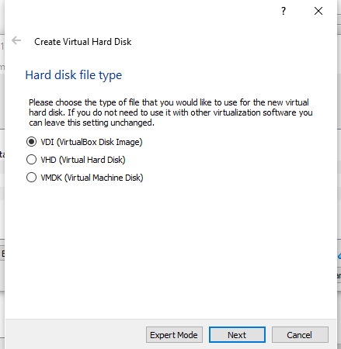

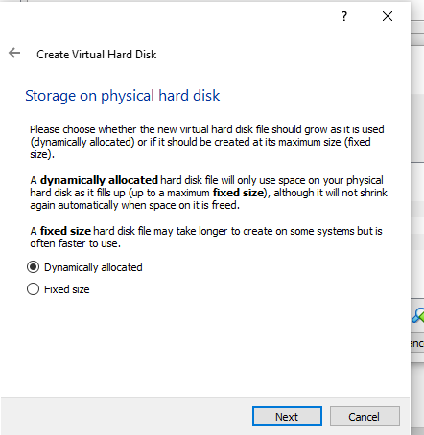
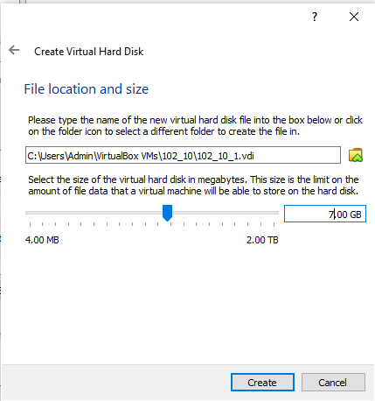
  - Click Finish. Now the 7gb additional disk is added
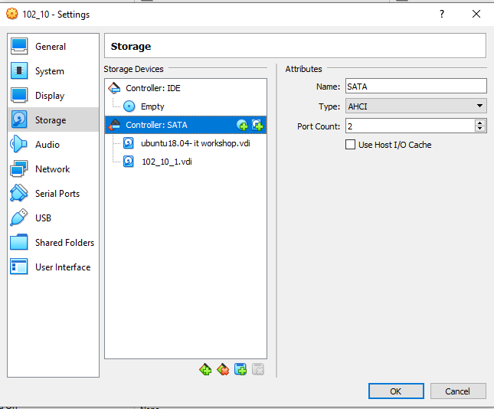
Step 2: Start the VM and Login as Root
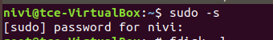
Step 3: Check Existing Disks and LVM
# List all disks fdisk -l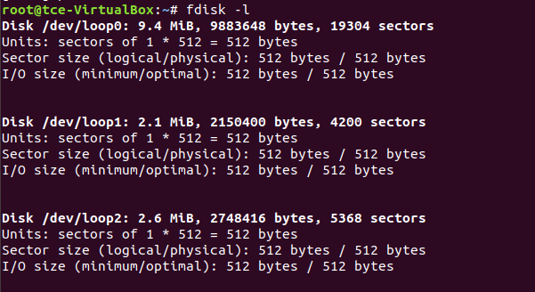

# List physical volumes
pvdisplay
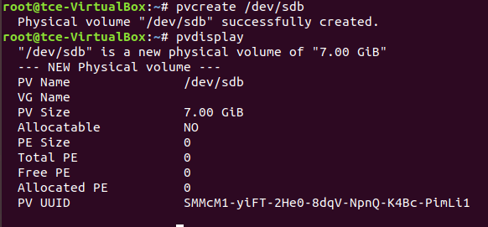
# List volume groups
vgdisplay
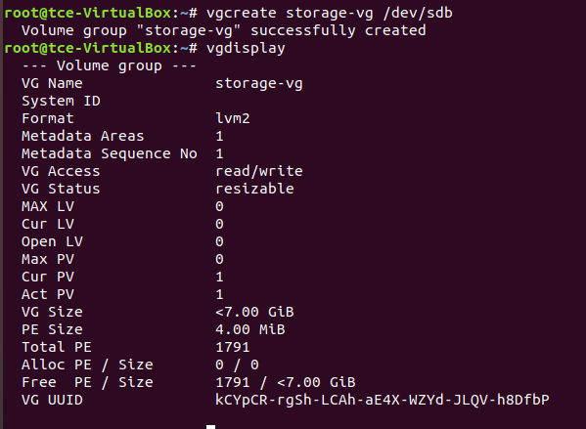
# List logical volumes
lvdisplay
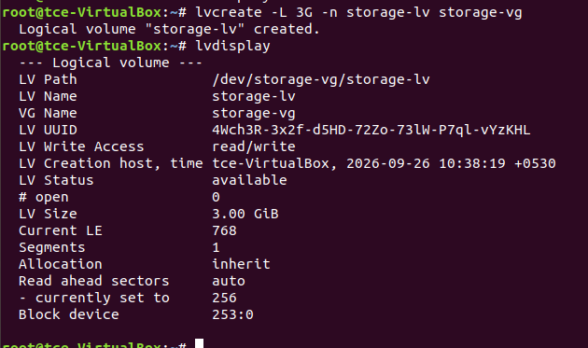
Step 4: Create Physical Volume
pvcreate /dev/sdb
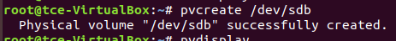
Initializes the new disk for LVM.
Step 5: Extend the Volume Group
vgextend ubuntu-vg /dev/sdb
If the above cmd gives error try running pvs, vgs, lvs, df –h /mnt/storage
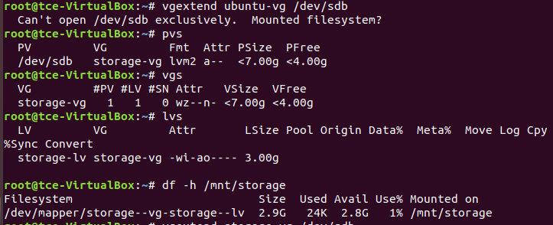
Replace cloud-vg with your existing Volume Group name.
This adds the new PV to your VG.
Step 6: Extend the Logical Volume (Root)
lvresize --size +3G /dev/ubuntu-vg/root
- +3G → amount of space to add
- /dev/cloud-vg/root → your logical volume
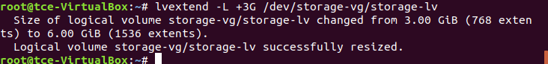
Alternative:
lvextend -L +3G /dev/ubuntu-vg/root
Step 7: Check Current Disk Usage
df -h
Shows current available space on /.
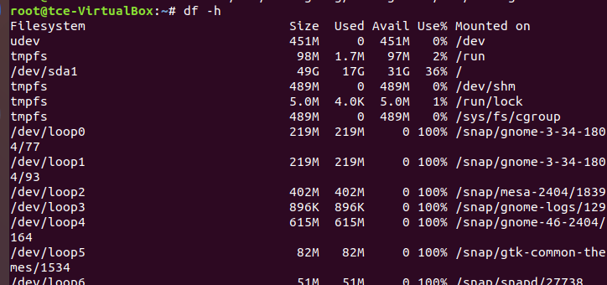
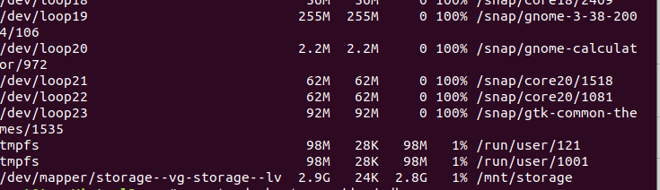

Step 8: Resize the Filesystem
resize2fs /dev/mapper/cloud--vg-root
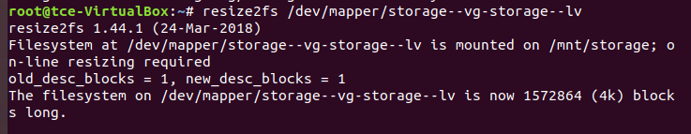
Resizes the filesystem to use the newly added space.
Step 9: Verify Disk Space
df -h
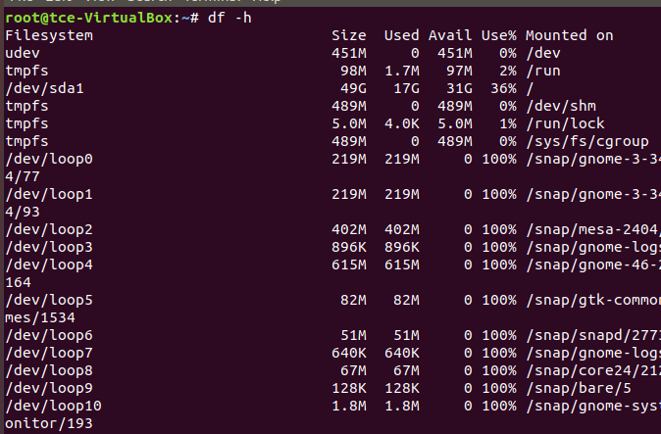
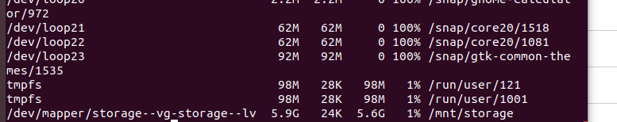
Confirm that the root filesystem now has additional 3 GB.

Result:
Thus we have created VHD on windows and restored it on another machine successfully.

