

**Safe She: Strengthening Women Safety**

Date: 16/10/2024

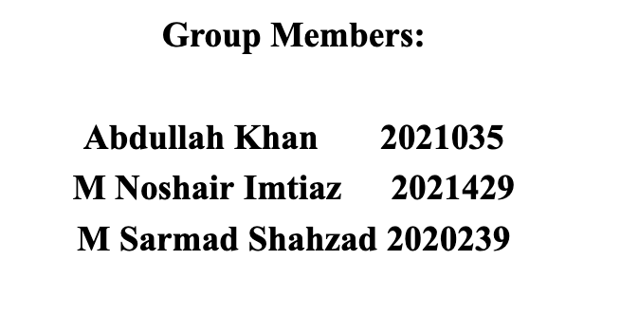

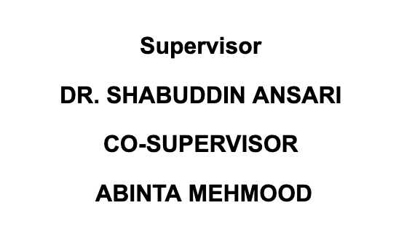

**Revision History:**

|  |  |  |
| --- | --- | --- |
| ***Revision History*** | ***Date*** | ***Comments*** |
| 1.00 |  |  |
| 2.00 |  |  |
|  |  |  |

**Document Approval:**

The following document has been accepted and approved by the following:

|  |  |  |
| --- | --- | --- |
| ***Signature*** | ***Date*** | ***Name*** |
|  |  |  |
|  |  |  |

List of Contents

List of Tables 4

1 INTRODUCTION 5

1.1. PROBLEM STATEMENT 5

1.2. PURPOSE 6

1.3. PRODUCT SCOPE 6

2 OVERVIEW 7

2.1 PRODUCT PERSPECTIVE 7

2.2. PRODUCT FUNCTIONS 8

2.3. USER CHARACTERISTICS 8

2.4 CONSTRAINTS 9

2.5 ASSUMPTIONS AND DEPENDENCIES 9

3 STATE OF THE ART 9

4 USER/SYSTEM REQUIREMENTS 11

4.1 External Interface Requirements 11

4.1.1 User Interfaces 11

4.1.2 Hardware Interfaces 12

4.1.3 Software Interfaces 12

4.1.4 Communication Interfaces 12

5 Functional Requirements 12

5.1 Functional Requirements with Traceability information 12

5.1.1 User Authentication 13

5.1.2 SOS Alert System **14**

5.1.3 Real Time Location Sharing 14

5.1.4 Safezone Identification **15**

5.1.5 Voice Command Activation 16

5.1.6 Settings and Configuration 16

5.1.7 Privacy and Data Security 17

5.1.8 Incident Reporting **18**

6 Nonfunctional Requirements & Software System Attributes 18

6.1 Performance Requirements 18

6.2 Nonfunctional Requirements 19

Project Design/Architecture 20

List of Figures

Figure 1 Use case 21

Figure 2 ER Diagram 22

Figure 3 Class Diagram **23**

Figure 4 Development view 24

Figure 5 Sequence Diagram 25

Figure 6 Context Diagram 26

Figure 7 Process view 26

Figure 8 Component Diagram 27

Figure 9 Physical view 28

Figure 10 User Interface/Launching page 29

Figure 11 User Interface/Login page 30

Figure 12 User Interface/Register page 30

Figure 13 User Interface/Homepage 31

Figure 14 Flowchart 1 31

Figure 15 Flowchart 2 32

## List of Tables

Table 1: Terms used in this document and their description………………………….06

Table 2: Table for Functional Requirement 1………………………………………....13

Table 3: Table for Functional Requirement 2…………………………………………14

Table 4: Table for Functional Requirement 3 ………………………………………...14

Table 5: Table for Functional Requirement 4…………………………………………15

Table 6: Table for Functional Requirement 5…………………………………………16

Table 7: Table for Functional Requirement 6…………………………………………16

Table 8: Table for Functional Requirement 7…………………………………………17

Table 9: Table for Functional Requirement 8…………………………………………18

# 1 INTRODUCTION

In a time when concerns about personal safety is constantly rising for women, especially, the focus today is on creating technology driven solutions. What sets apart these is that the idea of having a complete women's safety app that is a game changer that could help women in a lot of cases be safe in many different cases. This project aims to provide a dynamic and integrated safety solution through speech recognition, emergency response systems, and then real time location monitoring that allows women to feel more at ease in their everyday lives.

The Project is a modern Android application series that brings a strong safety apparatus by integrating modern technology into simple user interfaces. The software provides the ability for users to get straight and quick help, discreetly when required through the features of SOS alert system, real time location sharing, Safe Zone identification and voice command activation. Thanks to the integration of Google Firebase for real time data management and communication the users and their emergency contacts may chat instantaneously. It gives high reliability and speed for when situations are concerned.

It is a stitch that brings modern technological advancement to its ends and means. Unlike simple emergency notifications, Safe Zones combine location tracking with real time whereabouts information and direct users and trusted contacts to safe areas. With speech recognition, users can activate app hands free, meaning even when they are unable to use their phones manually the app functions to give users access to safety features.

In response to the rising demand for more efficient personal safety solutions tailored to women’s needs, who are still at great risk in public as well as in private, we created this Project. This software is to give women the ability to report things, and get help immediately and to get into safe areas without fear of that risk. The aim of this initiative is to reduce the vulnerabilities faced by women daily through the provision of a complete, user friendly and technologically advanced safety platform.

This paper describes the scope, goals, technological architecture and expected social effect of this Project along with the full system requirements and specifications needed to build it. Taking this as we start the project, we ask developers, safety advocates and stakeholders to join us as we build a future in which women can use this new technology to move about the world ever more securely and with more confidence.

* 1. **PROBLEM STATEMENT**

Women continue to face significant safety risks in both public and private spaces, with limited access to efficient, real-time safety solutions that can respond to emergencies. Traditional safety tools often fall short in providing timely assistance, discreet communication, or precise location tracking when it’s most needed. There is a clear need for an integrated, technology-driven solution that empowers women to respond quickly in dangerous situations, ensuring their well-being through features like real-time location monitoring, emergency alerts, and voice-activated controls.

In response to this gap, our project aims to address the vulnerabilities women encounter by providing an easy-to-use, comprehensive mobile application. This solution will enable women to discreetly signal for help, share their location with trusted contacts, and navigate toward safe zones — all while ensuring high reliability and speed through modern technologies like speech recognition and Google Firebase for real-time data management. The goal is to reduce safety risks and enhance women’s sense of security and confidence in their daily lives.

## PURPOSE

The idea of the Women’s Safety App initiative is to transform personal safety management by providing a rich and interactive tool for real time tracking, emergency response, and preventative safety measures. With the help of cutting edge technology such as voice activated alarms, location monitoring and real time data sharing, the app provides women more security and confidence to move about their surroundings. This creative approach ensures more rapid and individualized safety measures are possible and will lead to a safer, more empowered society, in which women can quietly and quickly get assistance when they need it.

## PRODUCT SCOPE

The project aimed to develop a comprehensive mobile application using state of the art technology that includes voice activated commands, SOS warning systems, and real time location monitoring, that will improve women's personal safety. It’s standard scope for the project to integrate with necessary safety features like voice recognition activated SOS, live communication with contacts in case of emergency, a Safe Zone and all of this provides users an opportunity to get a signal of help in case of emergency. What your set out to do is create a dependable and simple platform so that women can take control of their own safety both in public and in private.

The objective of this project is to develop a highly intuitive Android application dedicated to serving women. The app will allow users to share where they are currently, send out distress signals rapidly, and get directions to save locations within their surroundings. Once with its emergency contacts, the app will also allow these contacts to know the user’s location and respond immediately and efficiently. By using all the functions on the app, the user is able to go around their environment with more security and surety, knowing that if they need help, they are able to obtain help quickly. Raising awareness, ensuring personal safety, and creating a platform making the society safer for women wherever they are around the world is the goal of the project.

Table 1: Terms used in this document and their description.

|  |  |
| --- | --- |
| Name | Description |
| SOS Alert | Instant emergency function to send distress signal and to immediately send user’s position through pre-selected emergency contacts in real time. |
| Safe Zones | The app's map highlights certain safe places, such police stations or hospitals, to help users find their way in an emergency. |
| Real-Time Location Sharing | A function that allows them to broadcast their current location in real time to trusted contacts so they can keep an eye on the user’s movement in case of emergency. |
| Voice Recognition | When users are unable to physically access the app, they may use voice commands to trigger the SOS alert thanks to a hands-free feature. |
| Google Firebase | It is a backend platform which takes care of user authentication, synchronizing real time data in between devices, as well as a communication mechanism between user and user emergency contact. |
| Push Notifications | Victims of a crisis can send out alerts to their emergency contacts, and in turn those contacts receive alerts when the SOS is activated. |
| Incident Reporting | The function allows users to record and report safety issues sending information and media files through the app but for use later. |
| GPS Tracking | With accurate tracking and emergency support, the real time location tracking features make the application useful. |

# 2 OVERVIEW

**THE OVERALL DESCRIPTION**

The Women’s Safety App Safe-She is a state-of-the-art smartphone app, using state of the art features such as voice recognition, real time location monitoring and SOS warning systems to improve women’s personal safety. Its primary goal is to enable women to have a simple, readily available way to feel confident about their surroundings and to act fast in emergency situations. Putting GPS and Google Firebase together works to provide the software when it’s most needed; critical support that allows users to share their positions in real time, send instant distress signals and locate Safe Zones which are close by.

Providing features like configurable emergency contact settings, ability to set up hand’s free emergency call activation, and voice activated SOS notifications, this tool gives women the ability to do something about situations that they would normally not be able to. But women traveling alone, in public, or in a situation where their personal safety is a concern will find the app to be very useful. Women's Safety App's real time data sharing features mean emergency contacts can follow the user's movements and receive quick notifications.

By having this real time information into the user’s safety status, the Women’s Safety App provides a quicker reaction and reduces risks by making the information easy to use, through simple user interfaces and functional smoothly. User privacy and data integrity are given priority while taking away the ability to have dependable performance in emergency scenarios. The software endeavors to empower women in various aspects of their daily lives and advance personal safety management with a lot of safety features.

## PRODUCT PERSPECTIVE

The Women’s Safety App is intended to be a comprehensive safety app with its real time emergency response capabilities and preventative safety measures aimed at achieving its mission to empower women. It provides users with valuable personal security companion features such as identifying Safe Zone, sharing real time location and SOS notifications. This app uses Google Firebase for real time data storage, Android system integration for smooth communication with emergency contacts.

Not only does the software ensure user privacy, but it also ensures their personal safety by only sharing where they are and personal info with trusted contacts in an emergency. Scalability, user friendliness and dependability are key attributes of the product's viewpoint that help meet changing safety requirements as its user base keeps growing. The app prioritizes real-time responsiveness and user friendliness and frequent updating to stay relevant in many types of settings. Important factors when it comes to optimizing the influence of this around women’s safety are, secure communication methods, ethical data usage, working together with community services as well as law enforcement.

## PRODUCT FUNCTIONS

The Women’s Safety App is a thorough platform to make emergency response and personal security more convenient. Along with real time location sharing, the app has SOS alerts where users can share instant distress messages with pre-configured emergency contacts. But it also offers an interactive map to help users to identify Safe Zones, including nearby hospitals, police stations, which will guide them to safety if an emergency occurs. Instructions are voice activated and can be initiated hands free for emergency situations.

Powered by Google Firebase, the software promises users – and their emergency contacts – can communicate and synchronize in real time with strong authentication to protect user privacy. Real time information is sent to users and their contacts when an SOS alert is triggered or when they are close to a Safe Zone using push notifications. In addition, incident reporting tool enables users to record and report safety related incidents to enhance regional safety protocols.

The app apart from supplying users with the safety advice and self defense techniques that the users need to keep themselves educated also offers the users the ability to customize the user profiles that have the ability to let users choose the type of privacy and emergency contacts. At the same time, there is a kind of feedback and support system, so you can report if something is not correct or you required help. For example, the app was built with a mobile friendliness in mind and with real time updates that notifies users when new features and improved security get added. The Women’s Safety App is a vital tool in helping you to keep safe thanks to its user friendly layout and strong communication.

## USER CHARACTERISTICS

The Women’s Safety app was made to fulfill all demands for people and organizations concerned with emergency response and personal safety. The system's target audience is defined by the following user attributes:

**Women in Public Spaces:**

Real time location sharing and SOS notifications are great safety features to help women who are travelling alone or are using public spaces be in touch and safe with their emergency contacts.

**Safety Advocates:**

The app’s community support, education, and incident reporting functions can be used by groups and people committed to women’s safety and wellbeing to expand awareness and encourage regionally consistent safety protocols..

**Law Enforcement:**

Using the app’s real time location monitoring as well as its Safe Zone identification, police and all other emergency services can arrive to crisis areas more quickly and provide help to those in need.

**Family and friends:**

Emergency contacts who are reliable with answers and who need real time location updates and urgent alerts in case of emergencies.

**Technological Administrators:**

Technological administrators are in charge of keeping the app's backend systems up to date and making sure real-time data interchange and security features—especially those that use Google Firebase—run well.

**Security Consultants:**

An app aimed at security consultants are experts in personal or business security and may be used to help evaluate and improve the security measures, advise customers on how to reduce risk and encourage use of safety technology.

## CONSTRAINTS

Various limitations exist while developing the Women’s Safety App, such as data security and privacy that must be considered, and in order to preserve the user’s data, including the location and personal information, it is important to follow a privacy law. Real time monitoring and communication is highly reliant on reliable GPS and network connectivity which may not be trivial to find in distant areas. The app works with Android smartphones only and thus has to be optimized for the same. In addition, since it is built on Google Firebase for backend, it cannot rely on other cloud services. Battery life and resource efficiency are key because the software must be work for the software to function properly without depriving the user’s smartphone of battery life.

Keeping speech recognition and SOS activation operational in a highly stressful situation means the app needs to be designed as useful but as simple as possible. Together with emergency services and police, the app’s performance needs to be guaranteed in real life. This, of course, will depend on the budget and the resources available that will determine how much of the app's features you may need to extend or add with relation to the updates or new features. To continue to deliver and secure the platform moving forward will require regular upgrades and long term up keep.

* 1. **ASSUMPTIONS AND DEPENDENCIES**

The Women’s Safety App can only be built successfully and will be used effectively if there are several crucial presumptions and dependencies.

**Assumptions:**

The Women's Safety App was developed on the following presumptions: need for network and GPS connectivity, data privacy laws, enough money spent on development and upkeep. Precise location data at hand, cooperative with emergency and local authorities, able to fund continuous upgrades and improvements of them, and to solve a couple technical problems like battery life or speech recognition accuracy are the prerequisites. The project also rely on validation and maintenance frequency, privacy and security requirements and a nice interaction with Google Firebase to guarantee the app’s dependability and performance in real terms. These presumptions and dependencies are critical to the project's successful planning and is required to be carried out.

# 

# 

# 3 STATE OF THE ART

**3.1 LITERATURE REVIEW:**

**"Women’s Safety Apps: A Comprehensive Overview"**

In this review paper, the whole investigation of several women’s safety applications includes the integration of the systems of emergency response, location monitoring and real time communication with authorities and trusted contacts. The study points out that it is simply not acceptable to not have key features like GPS and SOS buttons in your safety solution for women. In addition, the papers stress the need for user friendly interfaces and assure that women can use the app easily during emergency time.

***"Ensuring prompt responses during emergencies can be revolutionized by combining precise location tracking with easily accessible SOS features."***

**"Technological Advancements in Personal Safety: Addressing Women’s Security Challenges"**

This research explores the future of women’s safety apps based on how advancements in technology like speech recognition, safe zones, and community alerts are shaping what the future of these apps will look like. We look into how predictive analytics may be used to identify potential threats and create safe spaces. The study analyzes the application of AI and machine learning for trend identification of risky circumstances or behaviors.

***"Technology must be used to anticipate and stop dangerous situations before they happen, in addition to responding to emergencies."***

**"Community Engagement and Law Enforcement in Women’s Safety Apps"**

The effectiveness of women's safety applications in bridging the divide between users, local communities, and law enforcement is examined in this article. It examines the possibilities of applications that allow for immediate event reporting as well as the function of crowdsourced data in locating dangerous locations. To speed up reaction times and better integrate applications into local security systems, the authors recommend more cooperation between law enforcement and app developers.

***"The efficacy of women's safety apps, especially in guaranteeing prompt interventions, depends on fostering trust among users, communities, and authorities."***

**"Validation and Accuracy in Women’s Safety Apps: Challenges and Strategies"**

We agree with this essay because the validating women safety app is required to make these apps dependable in such situation. Its mainly about testing procedures to validate the data integrity, timely SOS notification, accuracy of the location tracking. The authors argue that it is required because the goals of such applications and any technological problems are hard to handle without user-based trials and real time simulation. Although the most sophisticated safety apps were not yet ready to work, especially without validation, 'there was still work to do'.

**3.2 EXISTING SYSTEMS:**

Here are some instances of current applications for women's safety:

With location sharing, an SOS button and fake phone calls, the personal safety software bSafe deters any threats. Users may form the basis of a network of reliable contacts and will be notified in case of an emergency.

With **Shake2Safety**, by just shaking their phone users can share location information, capture videos, and send SOS warnings. At an emergency it negates the need for an intricate procedure.

Though useful, most of these applications still lack features such as seamless connection with law enforcement, real time danger identification and full community engagement. Furthermore, response accuracy would be further increased, user privacy should be protected, and emergency usage should be made much easier by additional research and development.

**4 USER/SYSTEM REQUIREMENTS**

**4.1 External Interface Requirements**

Individual users and trusted contacts are essential user roles for the women's safety app along with secure authentication for privacy, location sharing, safe zone notifications, SOS alerts, and role to personalize alert settings and emergency contacts. And for that you need to support users, get their input, and make sure there are no holes for breaching privacy and data protection regulations. For the system to work, there should be scalability to contend with a growing number of users, strong security measures for our private information, seamless integration with the communication network, real time location tracking, running performance optimizing for timely alerts, round-the-clock technological support, and alert-based monitoring for anything that could be a tech problem. Together, all these specifications ensure that we do have an app that helps users feel personal safety solutions without compromising privacy or pleasure.

### 4.1.1 User Interfaces

Our Women’s Safety App is built keeping in mind security, usability, as well as real time accessibility. These are elemental and also easy to use dashboard to peak into effortless navigation, verification of user authentication in order to safeguard private data, seamless sharing of location and SOS alerts for instant access to emergency functions. Features on the interface also include Real time tracking for dynamic location updates, Safe zone mapping to help the users to determine a safe places and Emergency contacts that can be customized for quicker help. As an additional feature, the app also features extensive Community Support, and notifications to help users feel informed and engaged. Taken together, these specifications provide an intuitive user interface that allows women to easily and with confidence improve their personal safety.

### Hardware Interfaces

The women’s safety app does not require specific hardware, it is designed for usual Android smartphones. The main hardware requirements include a GPS enabled smartphone for precision positioning tracking, working internet for on time data transfer to distress center and SOS notifications and simple sensors like a microphone for voice recognition. There is no need for specialist hardware or other external devices for the software to work properly.

### Software Interfaces

The women's safety app will use several libraries and software elements to ensure smooth operation:   
  
To serve as Android compatible front end, Java, Kotlin, and Android SDK will be used for the development of front end. Features such as location tracking and mapping (mapping through Google mapping API) will include several third party libraries.

For cloud messaging, authentication and real time database service, the backend will rely on Firebase, another Google offering. Firebase will handle SOS alarms, user data storage, real time location tracking and much more. These software components together make sure the app works safe and well.

### Communication Interfaces

To guarantee smooth data flow and interactions between various components, the women's safety app will make use of a variety of communication interfaces:  
  
**HTTP Communication:** HTTP requests will be used by the application’s front-end to connect with Firebase to share real time data (SOS notifications, location tracking, updating) to share.

**Firebase Realtime Database:** Firebase's real time database will be utilising that data is saved and retrieved through application instead of more traditional database call XMTP. This ensures real time updates about user location, notifications during user emergencies, communication with the user to contact an emergency.

# Functional Requirements

### **Functional Requirements with Traceability information**

User Registration and Authentication

SOS Alert System

Real-Time Location Sharing

Safe Zone Identification

Voice Command Activation

Settings and Configuration

Privacy and Data Security

Incident Reporting

### 5.1.1 User Authentication

User authentication must be given in the system to guarantee that only the authorized users can use the app’s features such as sending a SOS warning, tracking user location, and managing user safety settings.

Table 2: Table for Functional Requirement 1

|  |  |  |  |  |  |  |  |  |  |  |  |  |  |  |  |  |  |  |  |
| --- | --- | --- | --- | --- | --- | --- | --- | --- | --- | --- | --- | --- | --- | --- | --- | --- | --- | --- | --- |
| **Requirement ID** | FR-01 | | | | **Requirement Type** | | | | Functional | | | | | **Use Case #** | | | | | UC-01 |
| **Status** | ***New*** | X | ***Agreed-to*** | | | | - | ***Baselined*** | | | | - | ***Rejected*** | | | | | - |  |
| **Parent Requirement #** | PR-01 | | | | | | | | | | | | | | | | | | |
| **Description** | User registration and authentication using Firebase. | | | | | | | | | | | | | | | | | | |
| **Rationale** | Ensures only authenticated users access the system. | | | | | | | | | | | | | | | | | | |
| **Source** | User | | | | | | | | **Source Document** | | | | | | - | | | | |
| **Acceptance/Fit Criteria** | |  | | --- | |  |  |  |  |  | | --- | --- | --- | | |  | | --- | |  |  |  | | --- | | Successful registration and login | | | | | | | | | | | | | | | | | | | | |
| **Dependencies** | |  | | --- | | Firebase Authentication |  |  | | --- | |  | | | | | | | | | | | | | | | | | | | |
| **Priority** | ***Essential*** | | | High | | ***Conditional*** | | | | - | ***Optional*** | | | | | - |  | | |
| **Change History** | Initial draft, no changes | | | | | | | | | | | | | | | | | | |

### SOS ALERT SYSTEM

The system will allow authorized users to send and receive SOS notifications via the system and include real time location information, emergency contact information, and safety information.

Table 3: Table for Functional Requirement 2

|  |  |  |  |  |  |  |  |  |  |  |  |  |  |  |  |  |  |  |  |  |  |
| --- | --- | --- | --- | --- | --- | --- | --- | --- | --- | --- | --- | --- | --- | --- | --- | --- | --- | --- | --- | --- | --- |
| **Requirement ID** | FR-02 | | | | **Requirement Type** | | | | |  | | --- | |  |  |  | | --- | | Functional | | | | | | **Use Case #** | | | | | UC-02 |
| **Status** | ***New*** | X | ***Agreed-to*** | | | | - | ***Baselined*** | | | | - | ***Rejected*** | | | | | - |  |
| **Parent Requirement #** | PR-02 | | | | | | | | | | | | | | | | | | |
| **Description** | SOS alert system sends emergency alerts to contacts with location data. | | | | | | | | | | | | | | | | | | |
| **Rationale** | Provides immediate response to emergencies. | | | | | | | | | | | | | | | | | | |
| **Source** | User | | | | | | | | **Source Document** | | | | | | - | | | | |
| **Acceptance/Fit Criteria** | SOS alert sent and received within 2 seconds. | | | | | | | | | | | | | | | | | | |
| **Dependencies** | GPS module, Notification system | | | | | | | | | | | | | | | | | | |
| **Priority** | ***Essential*** | | | High | | ***Conditional*** | | | | - | ***Optional*** | | | | | - |  | | |
| **Change History** | Updated, priority set | | | | | | | | | | | | | | | | | | |

### 5.1.3 Real-Time Location Sharing

The system employs ultra-modern algorithms to track and display movements of users on its platform allowing for real time location sharing for improved safety and emergency response.

Table 4: Table for Functional Requirement 3

|  |  |  |  |  |  |  |  |  |  |  |  |  |  |  |  |  |  |  |  |
| --- | --- | --- | --- | --- | --- | --- | --- | --- | --- | --- | --- | --- | --- | --- | --- | --- | --- | --- | --- |
| **Requirement ID** | FR-03 | | | | **Requirement Type** | | | | Functional | | | | | **Use Case #** | | | | | UC-03 |
| **Status** | ***New*** | X | ***Agreed-to*** | | | | - | ***Baselined*** | | | | - | ***Rejected*** | | | | | - |  |
| **Parent Requirement #** | PR-03 | | | | | | | | | | | | | | | | | | |
| **Description** | Real-time location sharing with trusted contacts. | | | | | | | | | | | | | | | | | | |
| **Rationale** | Keeps emergency contacts informed about the user’s whereabouts. | | | | | | | | | | | | | | | | | | |
| **Source** | Trusted Contacts | | | | | | | | **Source Document** | | | | | | - | | | | |
| **Acceptance/Fit Criteria** | |  | | --- | |  |  |  |  |  | | --- | --- | --- | | |  | | --- | |  |  |  | | --- | | Location shared accurately and updated in real time. | | | | | | | | | | | | | | | | | | | | |
| **Dependencies** | GPS module, Google Maps API | | | | | | | | | | | | | | | | | | |
| **Priority** | ***Essential*** | | | High | | ***Conditional*** | | | | - | ***Optional*** | | | | | - |  | | |
| **Change History** | Initial draft, no changes | | | | | | | | | | | | | | | | | | |

### Safe Zone Identification

Geofencing technology will enable this space where the system will be able to alert users to where they are able to travel safely by alerting them to

places they deem are secure, which will assuage their fear of such situations.

Table 5: Table for Functional Requirement 4

|  |  |  |  |  |  |  |  |  |  |  |  |  |  |  |  |  |  |  |  |
| --- | --- | --- | --- | --- | --- | --- | --- | --- | --- | --- | --- | --- | --- | --- | --- | --- | --- | --- | --- |
| **Requirement ID** | FR-04 | | | | **Requirement Type** | | | | Functional | | | | | **Use Case #** | | | | | UC-04 |
| **Status** | ***New*** | X | ***Agreed-to*** | | | | - | ***Baselined*** | | | | - | ***Rejected*** | | | | | - |  |
| **Parent Requirement #** | PR-04 | | | | | | | | | | | | | | | | | | |
| **Description** | Safe Zone identification with nearby location data. | | | | | | | | | | | | | | | | | | |
| **Rationale** | Helps users identify safe locations in emergencies. | | | | | | | | | | | | | | | | | | |
| **Source** | Users & Authorities | | | | | | | | **Source Document** | | | | | | - | | | | |
| **Acceptance/Fit Criteria** | Safe Zones appear on map based on real-time location. | | | | | | | | | | | | | | | | | | |
| **Dependencies** | Google Maps API | | | | | | | | | | | | | | | | | | |
| **Priority** | ***Essential*** | | | Medi-um | | ***Conditional*** | | | | - | ***Optional*** | | | | | - |  | | |
| **Change History** | Updated dependencies | | | | | | | | | | | | | | | | | | |

### Voice Command Activation

The system will have voice command functionality and SAFE features that will allow users to request an SOS alert and access safety features hands free in emergency situations, to help ensure prompt, effective responses in emergencies.

Table 6: Table for Functional Requirement 5

|  |  |  |  |  |  |  |  |  |  |  |  |  |  |  |  |  |  |  |  |
| --- | --- | --- | --- | --- | --- | --- | --- | --- | --- | --- | --- | --- | --- | --- | --- | --- | --- | --- | --- |
| **Requirement ID** | FR-05 | | | | **Requirement Type** | | | | Functional | | | | | **Use Case #** | | | | | UC-05 |
| **Status** | ***New*** | X | ***Agreed-to*** | | | | - | ***Baselined*** | | | | - | ***Rejected*** | | | | | - |  |
| **Parent Requirement #** | PR-05 | | | | | | | | | | | | | | | | | | |
| **Description** | |  | | --- | |  |  |  | | --- | | Voice command to activate SOS alert in hands-free scenarios. | | | | | | | | | | | | | | | | | | | |
| **Rationale** | Allows user to trigger emergency alert without accessing the phone manually. | | | | | | | | | | | | | | | | | | |
| **Source** | User | | | | | | | | **Source Document** | | | | | | - | | | | |
| **Acceptance/Fit Criteria** | SOS alert activated through voice command. | | | | | | | | | | | | | | | | | | |
| **Dependencies** | Voice recognition module | | | | | | | | | | | | | | | | | | |
| **Priority** | ***Essential*** | | | Low | | ***Conditional*** | | | | - | ***Optional*** | | | | | - |  | | |
| **Change History** | Added voice feature | | | | | | | | | | | | | | | | | | |

### Settings and Configuration

The system should have settings and configuration choices that can improve the user experience and improve user efficacy as well as people can personalize their preferences like their emergency contact details and notification settings and their personal safety measure.

Table 7: Table for Functional Requirement 6

|  |  |  |  |  |  |  |  |  |  |  |  |  |  |  |  |  |  |  |  |  |  |
| --- | --- | --- | --- | --- | --- | --- | --- | --- | --- | --- | --- | --- | --- | --- | --- | --- | --- | --- | --- | --- | --- |
| **Requirement ID** | FR-06 | | | | **Requirement Type** | | | | |  | | --- | |  |  |  | | --- | | Functional | | | | | | **Use Case #** | | | | | UC-06 |
| **Status** | ***New*** | X | ***Agreed-to*** | | | | - | ***Baselined*** | | | | - | ***Rejected*** | | | | | - |  |
| **Parent Requirement #** | PR-06 | | | | | | | | | | | | | | | | | | |
| **Description** | User-configurable settings for contacts and notifications. | | | | | | | | | | | | | | | | | | |
| **Rationale** | Customization of emergency contacts and notification preferences. | | | | | | | | | | | | | | | | | | |
| **Source** | Authorities & Users | | | | | | | | **Source Document** | | | | | | - | | | | |
| **Acceptance/Fit Criteria** | Settings saved and modified successfully. | | | | | | | | | | | | | | | | | | |
| **Dependencies** | User Profile, Notification system | | | | | | | | | | | | | | | | | | |
| **Priority** | ***Essential*** | | | Medi-um | | ***Conditional*** | | | | - | ***Optional*** | | | | | - |  | | |
| **Change History** | Initial draft, no changes | | | | | | | | | | | | | | | | | | |

### Privacy and Data Security

Such a system must have strong features for privacy and data security to ensure that user data — including user location and personal information – be kept and transmitted safely to comply with applicable data protection laws and ensure user confidentiality.

Table 8: Table for Functional Requirement 7

|  |  |  |  |  |  |  |  |  |  |  |  |  |  |  |  |  |  |  |  |  |  |
| --- | --- | --- | --- | --- | --- | --- | --- | --- | --- | --- | --- | --- | --- | --- | --- | --- | --- | --- | --- | --- | --- |
| **Requirement ID** | FR-07 | | | | **Requirement Type** | | | | |  | | --- | |  |  |  | | --- | | Non-Functional | | | | | | **Use Case #** | | | | | UC-07 |
| **Status** | ***New*** | X | ***Agreed-to*** | | | | - | ***Baselined*** | | | | - | ***Rejected*** | | | | | - |  |
| **Parent Requirement #** | PR-07 | | | | | | | | | | | | | | | | | | |
| **Description** | Ensures privacy and secure data handling using Firebase encryption. | | | | | | | | | | | | | | | | | | |
| **Rationale** | Protects sensitive user data during transmission and storage. | | | | | | | | | | | | | | | | | | |
| **Source** | Administration | | | | | | | | **Source Document** | | | | | | - | | | | |
| **Acceptance/Fit Criteria** | Data securely stored and transmitted using encryption. | | | | | | | | | | | | | | | | | | |
| **Dependencies** | Firebase Encryption, User profile module | | | | | | | | | | | | | | | | | | |
| **Priority** | ***Essential*** | | | High | | ***Conditional*** | | | | - | ***Optional*** | | | | | - |  | | |
| **Change History** | |  | | --- | |  |  |  | | --- | | Security added | | | | | | | | | | | | | | | | | | | |

### Incident Reporting

With the incident reporting tool of the system in country users will be able quickly and simply to report the safety issues or crises, while the incident’s location, type, etc. are to be mentioned as much as possible regarding the prompt reaction and support.

Table 9: Table for Functional Requirement 8

|  |  |  |  |  |  |  |  |  |  |  |  |  |  |  |  |  |  |  |  |  |  |
| --- | --- | --- | --- | --- | --- | --- | --- | --- | --- | --- | --- | --- | --- | --- | --- | --- | --- | --- | --- | --- | --- |
| **Requirement ID** | FR-08 | | | | **Requirement Type** | | | | |  | | --- | |  |  |  | | --- | | Functional | | | | | | **Use Case #** | | | | | UC-08 |
| **Status** | ***New*** | X | ***Agreed-to*** | | | | - | ***Baselined*** | | | | - | ***Rejected*** | | | | | - |  |
| **Parent Requirement #** | PR-08 | | | | | | | | | | | | | | | | | | |
| **Description** | Allows users to report incidents, upload media, and submit details. | | | | | | | | | | | | | | | | | | |
| **Rationale** | Facilitates timely reporting and documentation of incidents. | | | | | | | | | | | | | | | | | | |
| **Source** | Users | | | | | | | | **Source Document** | | | | | | - | | | | |
| **Acceptance/Fit Criteria** | Incident report submitted with attached media. | | | | | | | | | | | | | | | | | | |
| **Dependencies** | Firebase Realtime Database | | | | | | | | | | | | | | | | | | |
| **Priority** | ***Essential*** | | | Medi-um | | ***Conditional*** | | | | - | ***Optional*** | | | | | - |  | | |
| **Change History** | Initial draft, no changes | | | | | | | | | | | | | | | | | | |

# Nonfunctional Requirements & Software System Attributes

# Performance Requirements

**Response Time:** Responsible for safe zone identification, real time location sharing, the Women Safety App is responsive so as to secure quick action on the part of safe zone identification, real time location sharing and SOS warnings. Users should be able to come in quickly through the most essential functions to resource notifications, so they receive help as soon as possible.

**Scalability:** The program must be able to grow the user count and have many queries at the exact same time without performance issues. It should efficiently balance load and manage resource in order to scale to serve a growing user population and uninterrupted service delivery in peak hours.

**Concurrency:** The app has to support multiple users interacting with the system at simultaneous time. This must do without lag or interference a mass of SOS notifications and live location queries, and include a few tour around senseless creature who search for the wildlife.

**Logging and Monitoring:** To check how well an app works, spot problems, and make it run better before issues pop up, make sure to add detailed tracking and watching features. You should be able to look at logs to make customers happier and the system more reliable.

**Load Testing:** Ensure your performance requirements are meet, by performing complete load testing for a variety of scenarios. The simulation must include heavy user activity and lots of SOS alarms, to uncover all bottlenecks while also correlating the other problems in order to ensure robustness & dependability.

**Real-Time Location Tracking:** The app must generate a prompt to share the real time location of the user to their trusted contacts so they can keep track of the users movements and provide assistance. You should be able to actively locate the user using the location notification.

## Nonfunctional Requirements

1. **Performance:**

**Requirement:** Users will be able to access safety features without major delays because of the system's real-time or almost real-time performance for location sharing and SOS notifications.

**Rationale:** Since human life and time related to user interaction Matters in getting emergency help ASAP.

1. **Security and Data Privacy:**

**Requirement:** ensures the privacy, availability and integrity of user data including location so that it can be stored with secure applications,data security structure standers on all bases.

**Rationale:** Data privacy and user data protection are very important, especially in safety applications.

1. **Scalability:**

**Requirement:** System should be scale so that a bunch of users can use our systems and even though thousands of SOS event queue it to process, performance will not drop significantly.

**Rationale:** Scalability (the program can be scalable based on the volume of customers asking for a change, provide reliable service basically to offer all high usage period)

1. **Reliability and Availability:**

**Requirement:** The system should have high reliability, minimal maintenance downtime for critical emergency / safety alerts.

**Rationale:** One of the primary concerns in safety applications are having working dependability and availability because with potential lives on the line, a quick response to information or help is vital.

1. **Usability:**

**Requirement:** We need the user interface to be usable so that our users can essentially open the program and start using it with minimal training or technical know-how.

**Rationale:** When usability is important to ensure the overall success of an app, especially in use and emergencies.

1. **Interoperability:**

**Requirement:** To activate effective responses during large-scale disasters, the collectives system must be compatible to interoperability standards in order to interact seamlessly with additional stated or adjacent safety and emergency services.

**Rationale:** One of the most important reasons for building interoperable applications is to make it more beneficial than just a stand-alone app that can easily connect with other places and security resources

1. **Compliance with Ethical Guidelines:**

**Requirement:** Personal safety applications shall respect ethical standards in the use of user data and safety information, as required by this Policy.

**Rationale:** Ethical standard — the program is only as good as it acts and plays out in accordance with which users can trust/confidence.

In order for the Women Safety App to work, it must meet several non-functional requirements. This is from my which define safety are performance, security, scalability, reliability and usability interoperability and ethical issue.

**Software System Attributes:**

**Reliability:** Till now, the episodes have been dropping from time to time but same should not be happening in case of app and it also has good performance using Firebase.

**Scalability:** Firebase cloud option allows scaling up the number of users effortlessly.

**Security:** Security, with encryption of the whole conversation and an extra layer for user authentication data.

**Usability:** Quick, clickable icons to use emergency features with voice command.

**Performance:** Prompt SOS notification actions to save both battery and data.

**Maintainability:** More modules add more continuation of update and specify the problem after development.

**Portability:** Based on the Android platform and can be ported to other platforms later.

**Project Design/Architecture**

4+1 ARCHITECTURE VIEW MODEL

* + Use Case View
  + Logical View:
  + Development View
  + Process View
  + Physical View
  + User Interface Design
  + Context Diagram

**1-Use Case View:**

Use Case View of the Women Safety App featuring key interactions like SOS Alert Activation to notify authorities and emergency contacts with real-time location sharing. It also features Voice Command Activation that guarantees hands-free activation of SOS warnings, and Safe Zone Identification to locate other close, safe areas. That includes a mobile app that supports incident reporting at the local level, notifies enforcement of suspect behavior and ensures an immediate & effective emergency response.

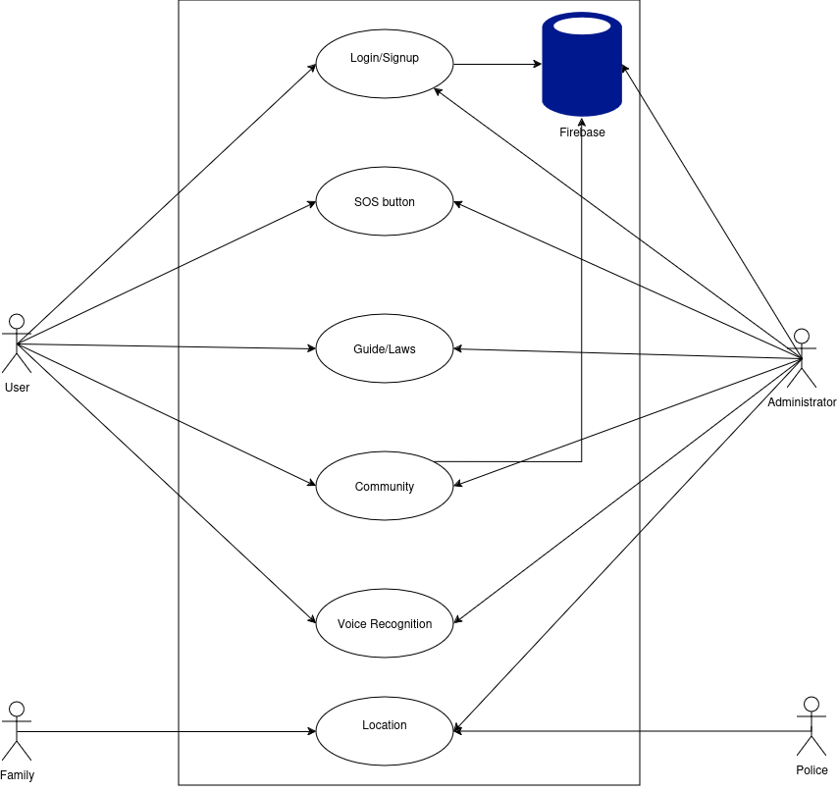

**Figure 1: Use case view**

**2-Logical View:**

In view of logic, the women's safety application highlights its inner structure this time and does not have much to say of the module that goes ahead real time with the location of the user and as well the SOS alert system that executes emergency messages. It possesses an incident reporting tool that records and saves reports and also marks the safe zone identification engine, that detects safe locations. The Voice Command Module activates most emergency situations hand-free and establishes proper communications for most emergencies.

**Figure 2: ER diagram**

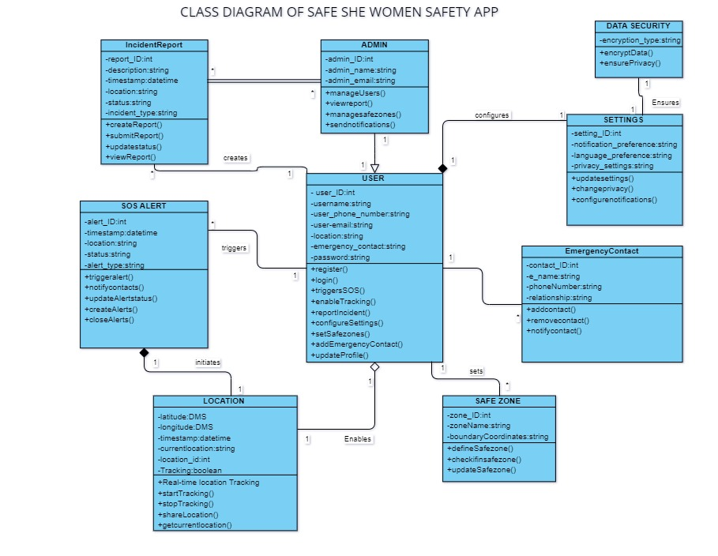

**Figure 3: Class diagram**

**3-Development View**:

In view of development, software architecture focuses on how the system’s components are organized and built from a developer’s perspective. It details the structure of the software in terms of its source code, the organization of modules, libraries, and packages, and how they interact during the development process. This view also covers aspects like version control, build processes, and the assignment of responsibilities within the development team. In essence, the Development View helps ensure that the system’s codebase is maintainable, scalable, and can evolve as needed, supporting efficient collaboration and long-term development goals.

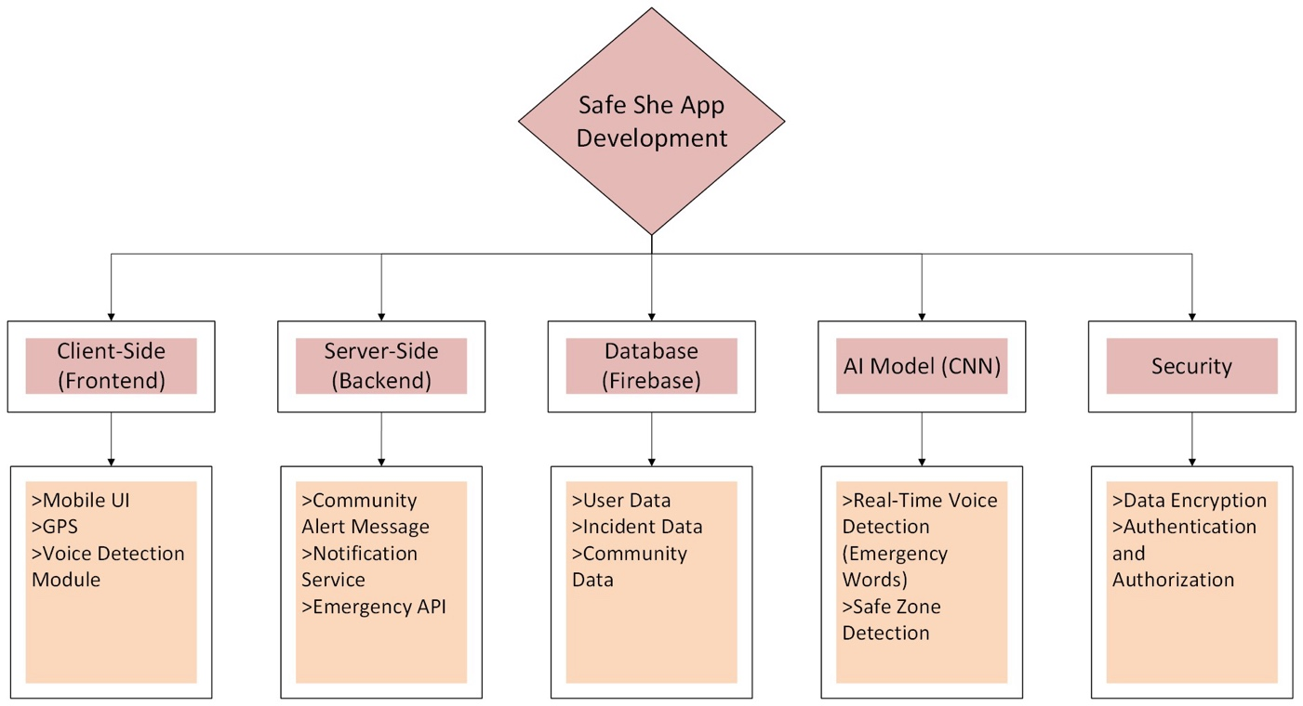

**Figure 4: Development View**

**Sequence Diagram:**

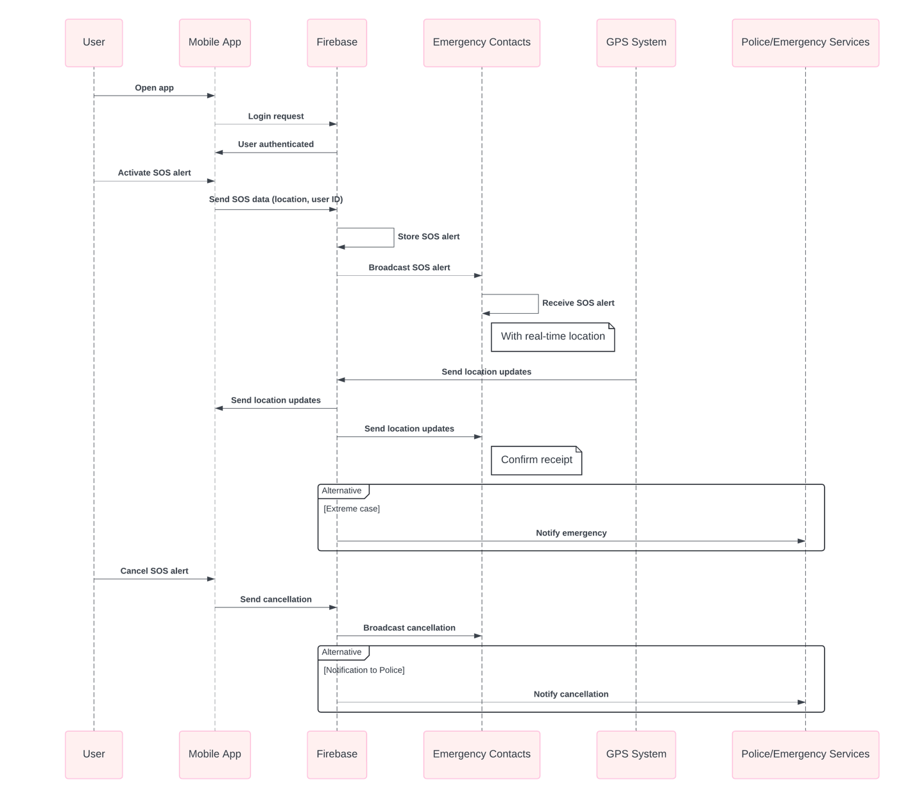

**Figure 5: Sequence Diagram**

**Figure 6: Context Diagram**

**4-Process View:**

The Process View focuses on how the system behaves during runtime. It looks at the interactions between different components and how they communicate and process tasks. This view helps in understanding how the system handles concurrency, performance, and scalability, making sure everything runs smoothly and efficiently when multiple processes or users are involved.

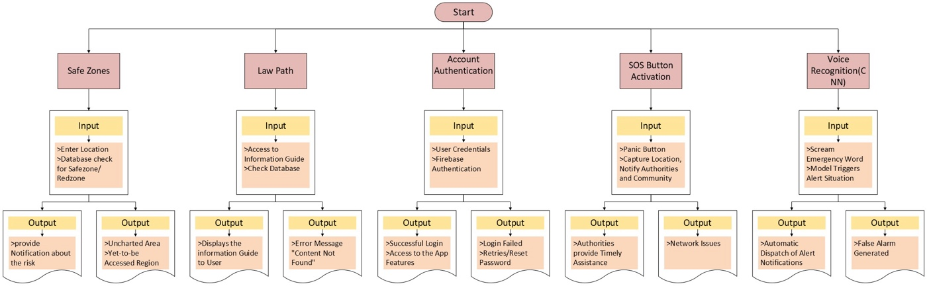

**Figure 7: Process View**

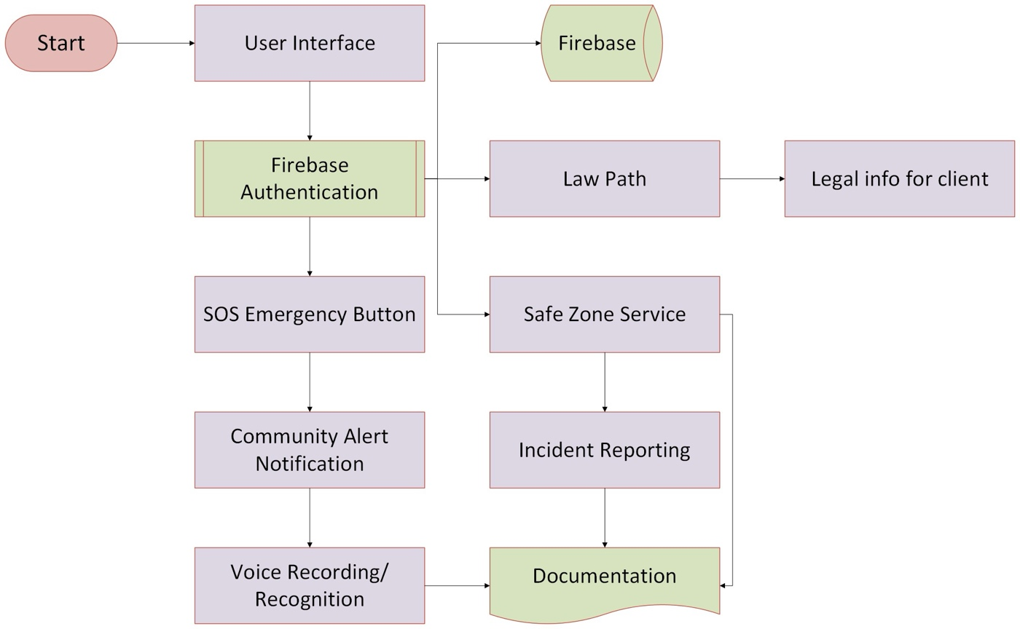

**Figure 8: Component Diagram**

**5-Physical View:**

The physical view of the Women Safety App describes infrastructure design and its deployment, such as cloud servers intended for processing real-time data like share location and reporting events as well as mobile devices that access the application via. It uses secure communication networks to send warnings and updates and communicates with GPS devices to track to the exact position. It also interfaces other systems, such as safe zone monitoring systems, and in fact law enforcement databases; it ensures that it operates smoothly across a wide range of mobile devices.

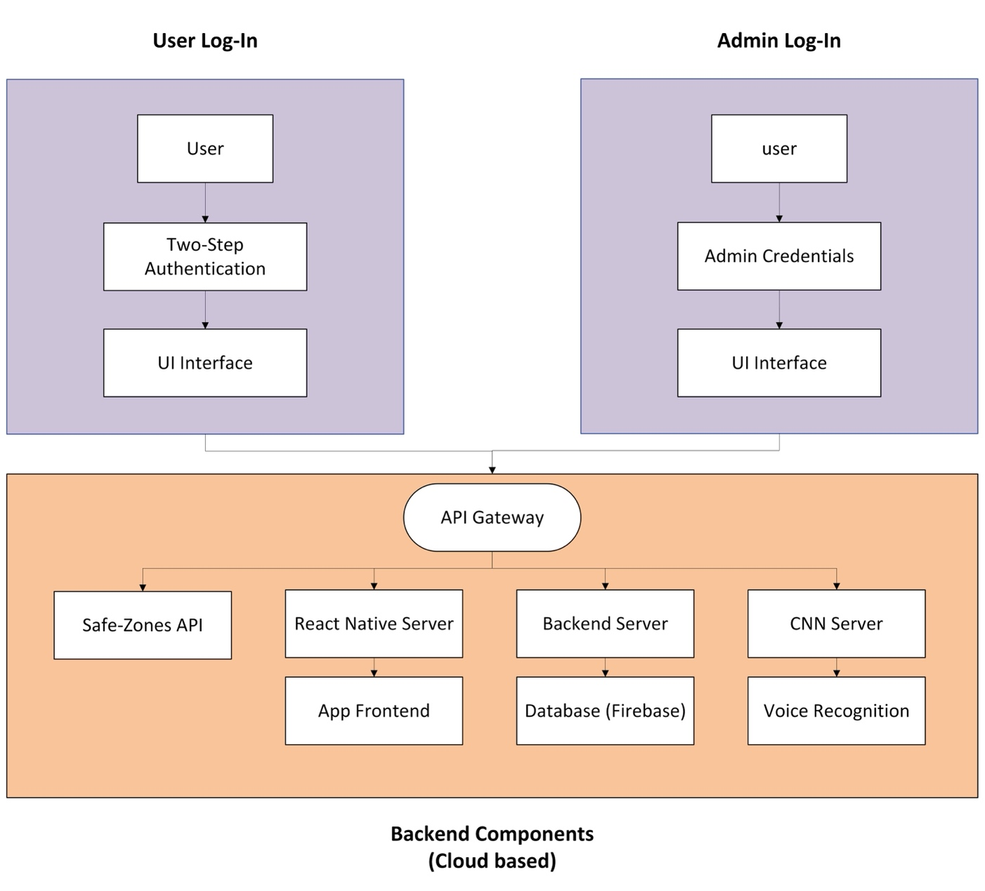

**Figure 09: Physical View**

**6-User Interface Design:**

The interface of the Women Safety App is very intuitive interaction that's easy to use and very easy to navigate through. There's a great big SOS button placed on the home screen for rapid warning by emergencies. Real-time location sharing with readable maps and safe zone markers is included in the design. Even though settings allow the user to change their alert preferences and contacts, voice commands can be used for hands-free emergency circumstances. The interface is very user-hostile, though a secured and responsive design would be necessary to allow access to such functions as incident reporting, identification of safe zones, and access to privacy settings quickly.

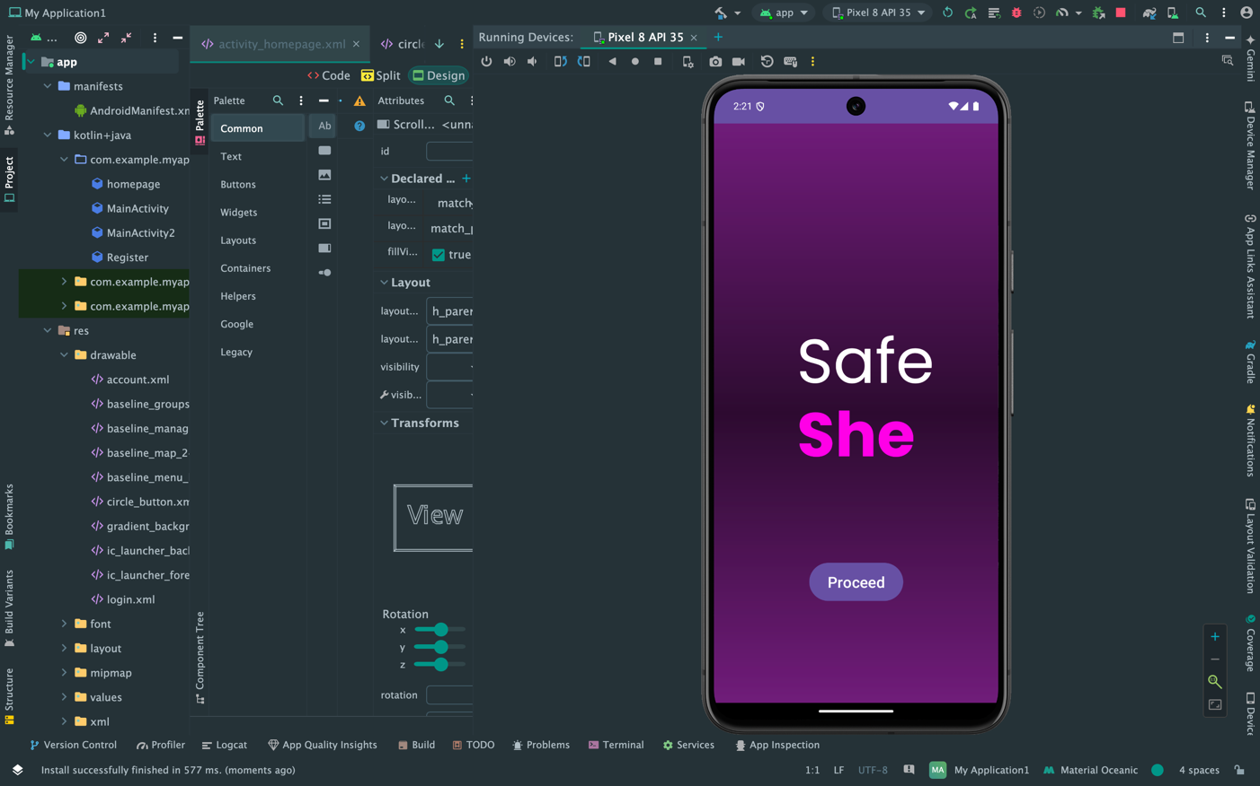

**Figure 11: User Interface/Launching page**

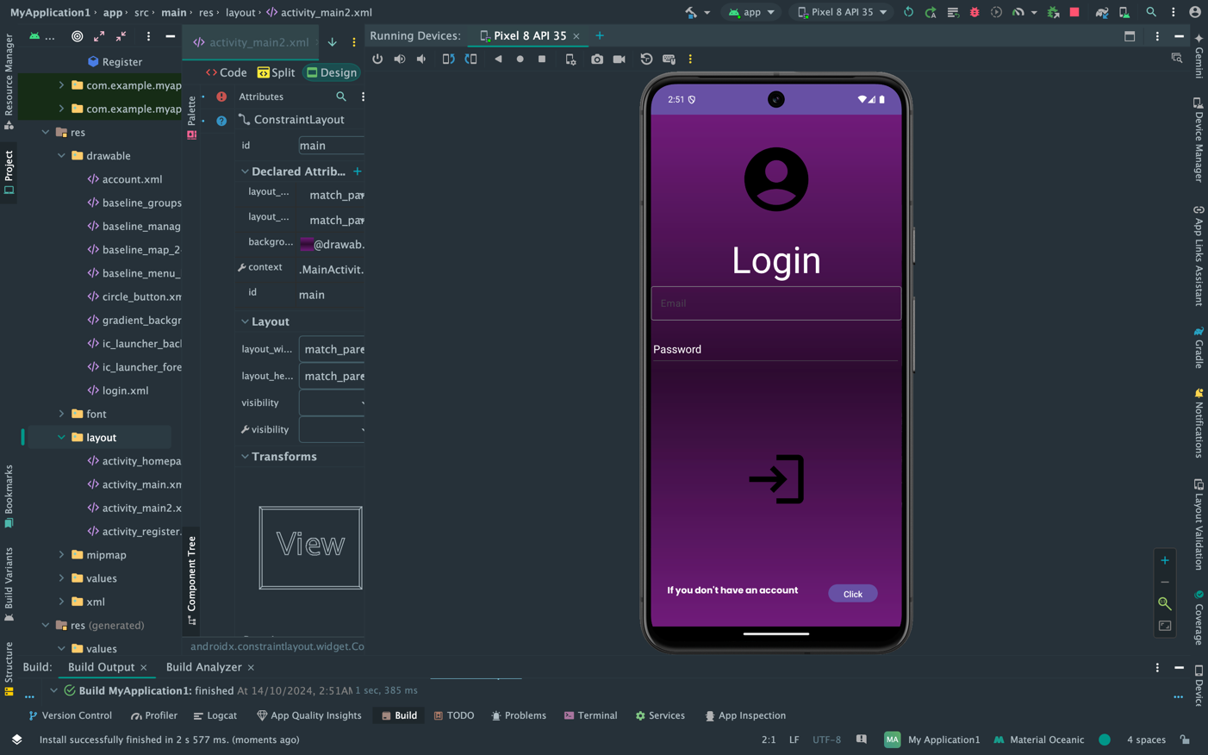

**Figure 12: User Interface/Login Page**

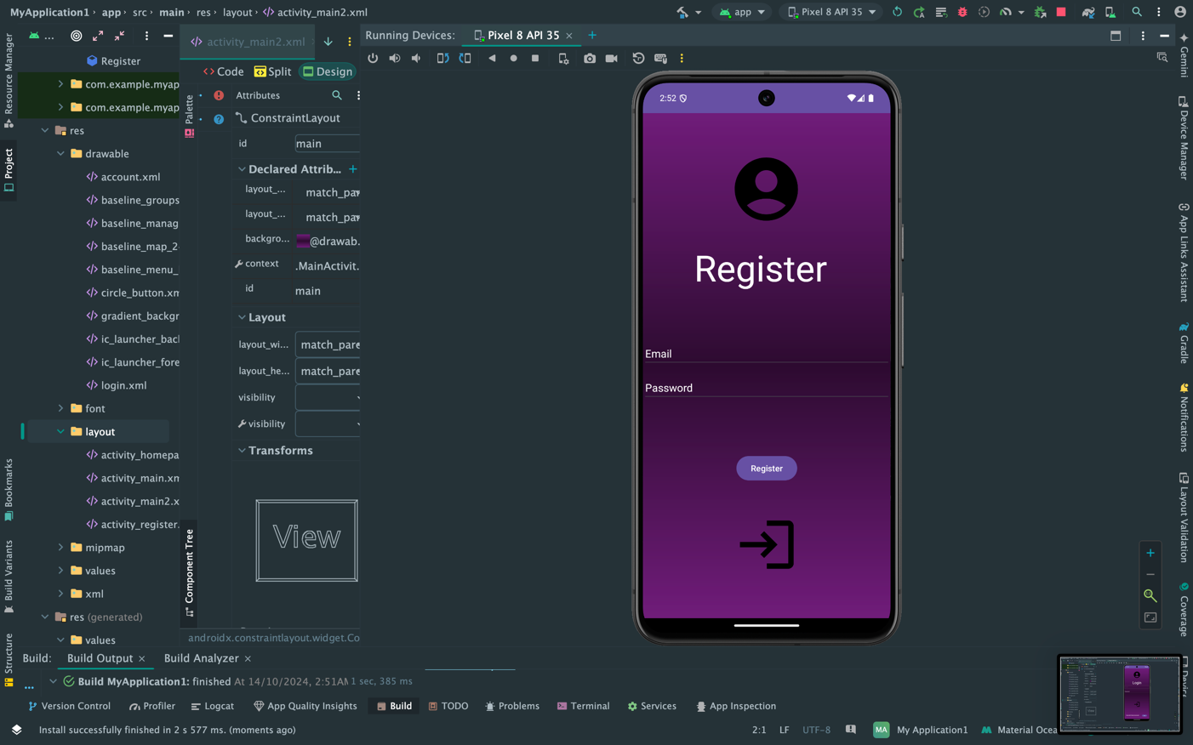

**Figure 11: User Interface/ Register Page**

**Figure 11: User Interface/Home Page**

1. **Flowchart**

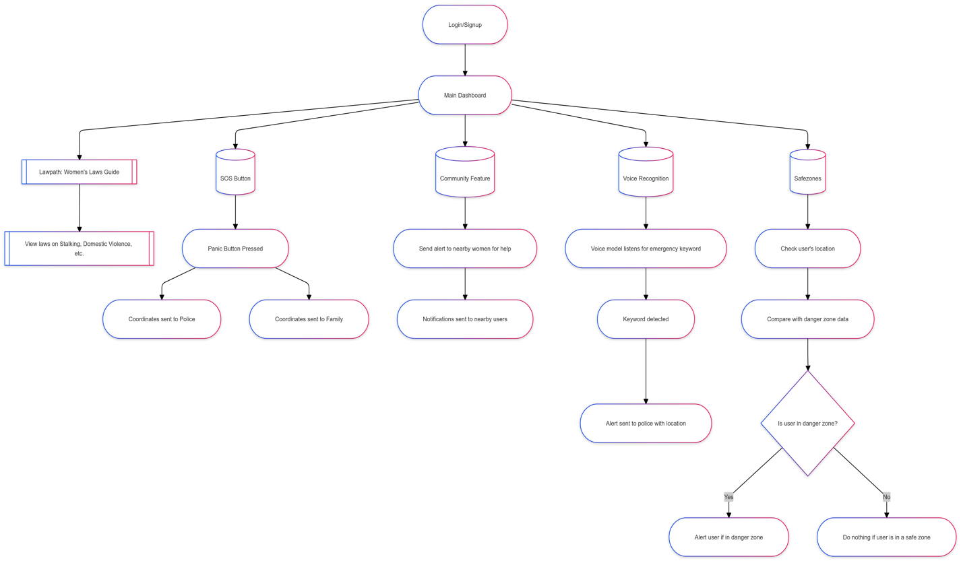

**Figure 12: Flowchart 1**

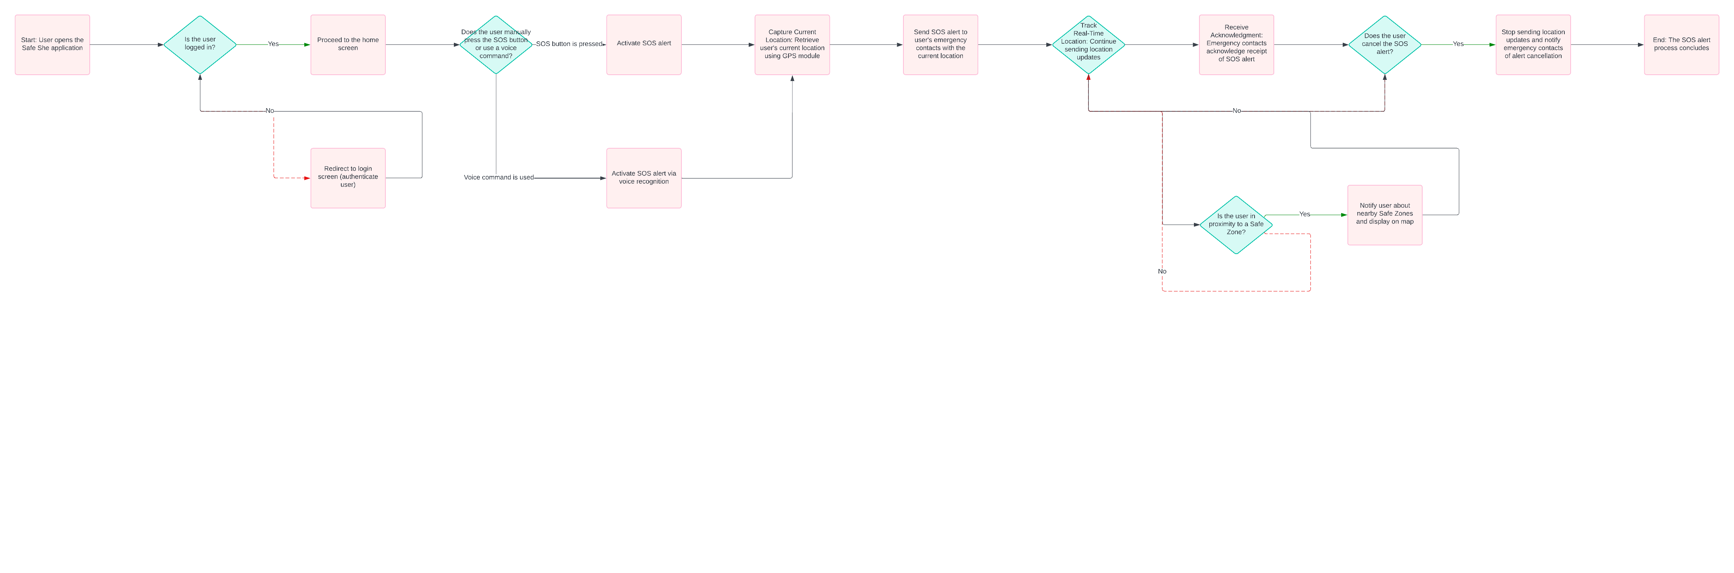

**Figure 13: Flowchart 2**