Third Party Audit & License Validation Jenkins Plugin (TPALVU) Configuration

To Install the plugin:
- Click to “Jenkins” in the dashboard and select the "Manage Jenkins" menu from the left panel.
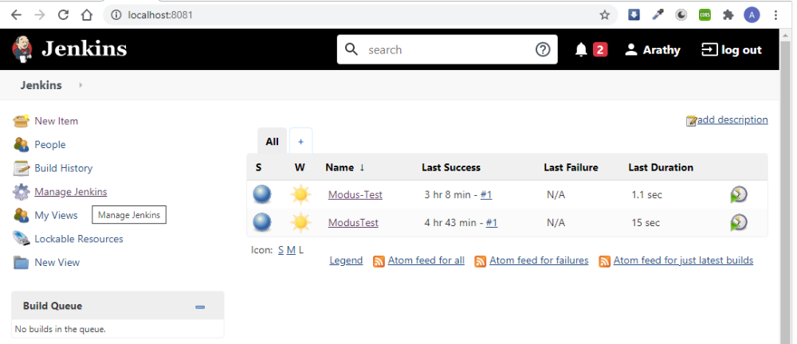

- Select the "Manage plugins" from the “System configuration”.
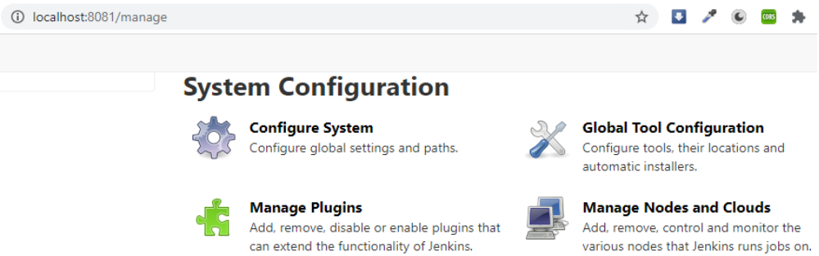
- Click on "Advanced" tab and from the “Upload Plugin” section select "Choose file" .
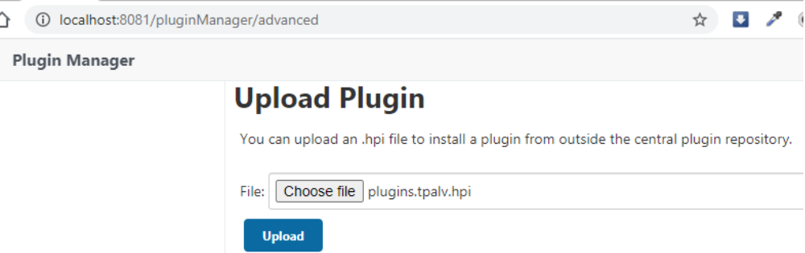
Here select the “plugins.tpalv.hpi” file from the “target folder” and click the “upload” button.
And after installed the file restart the Jenkins using the checkbox "Restart Jenkins when installation is complete and no jobs are running" or directly run the url http://localhost:8080/restart/

If there is no existing project, then
To create a project:
From the dashboard click on “New Item” from the left panel and Enter a Item name and select “Freestyle project” to enable the OK button to continue.
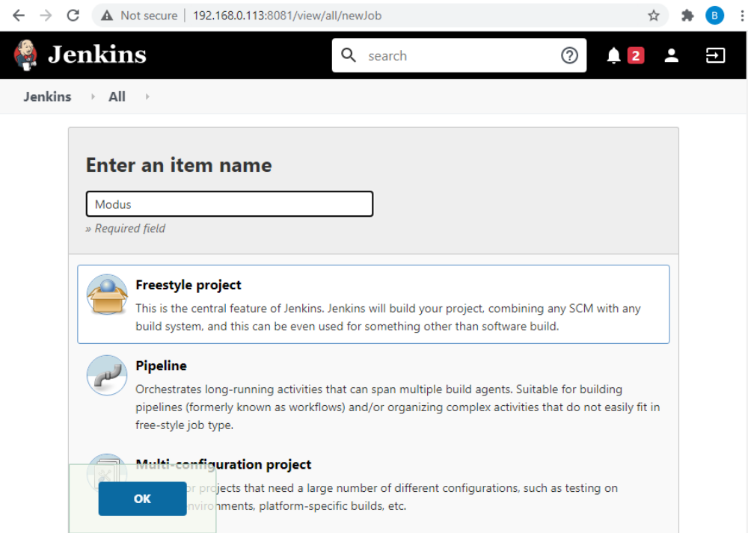
Click on Save button to show the created job in the dashboard.

Select your project:
After login, select the project from the dashboard,
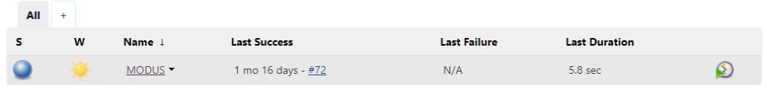
and click "Configure" menu from the left panel.
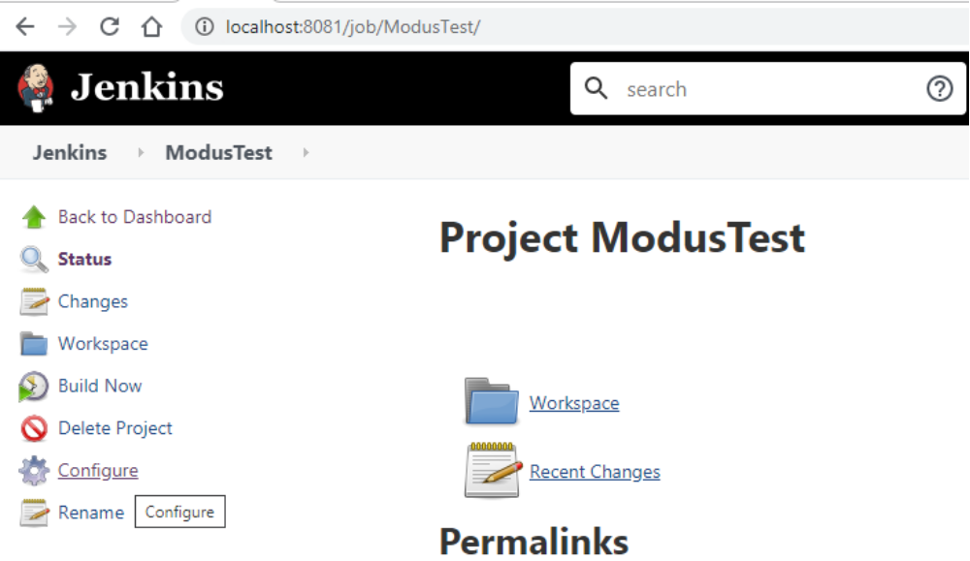

On the "Build" tab, click on "Add build step" drop down and select "Third Party Audit & License Validity" from the drop down.
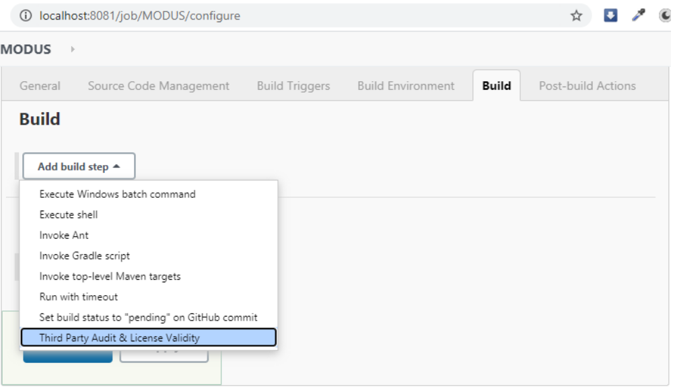

Fill all the properties in the shown fields and click on “Save” or “Apply” button.
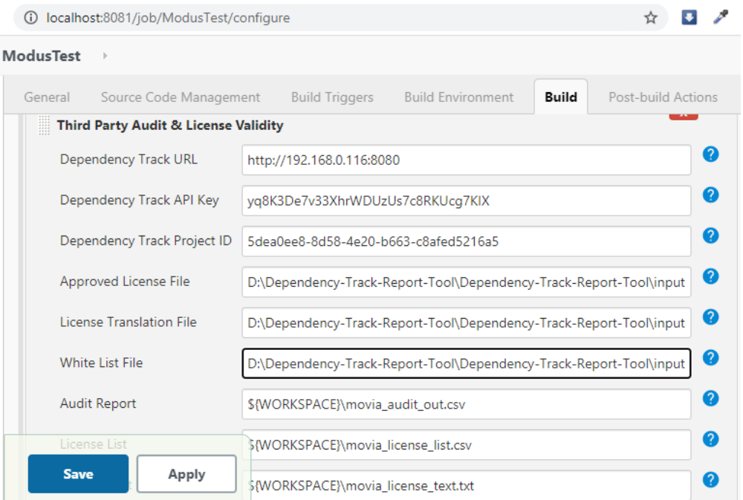
Build:
Click the "Build Now" menu from the left panel to audit the result in the output folder.
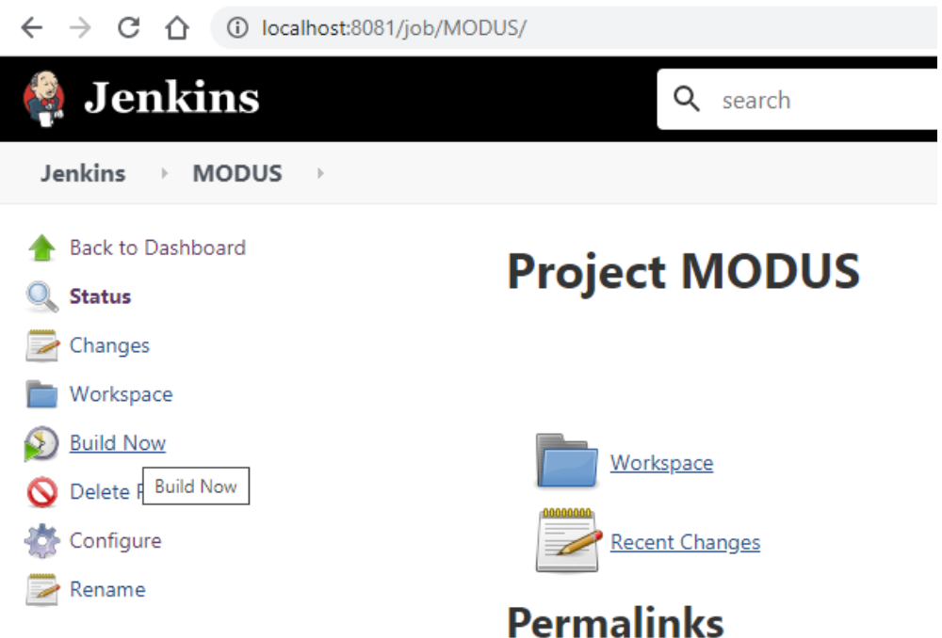

From the “Build History”, click on the latest build, and select "Console Output" menu from the left panel to display the console log.

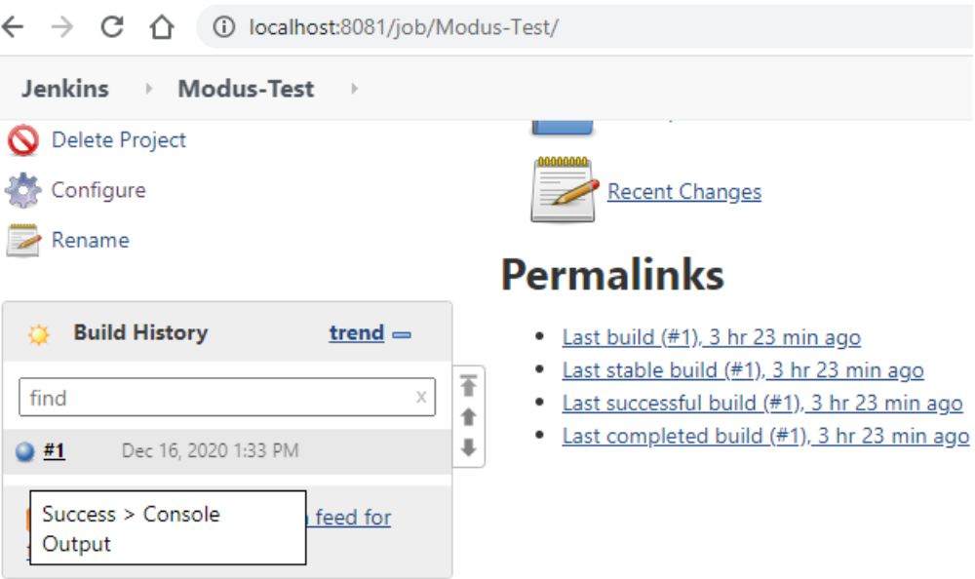

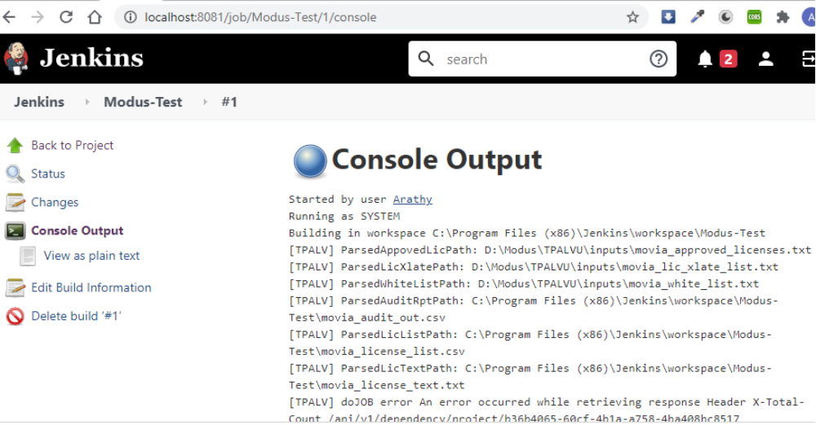
You may find the README doc for Jenkins plugin at
https://github.com/MO-Movia/Dependency-Track-Report-Tool/tree/master/jenkins-plugin#third-party-audit--license-validation-jenkins-plugin-tpalvu

