1. Steps to open the file

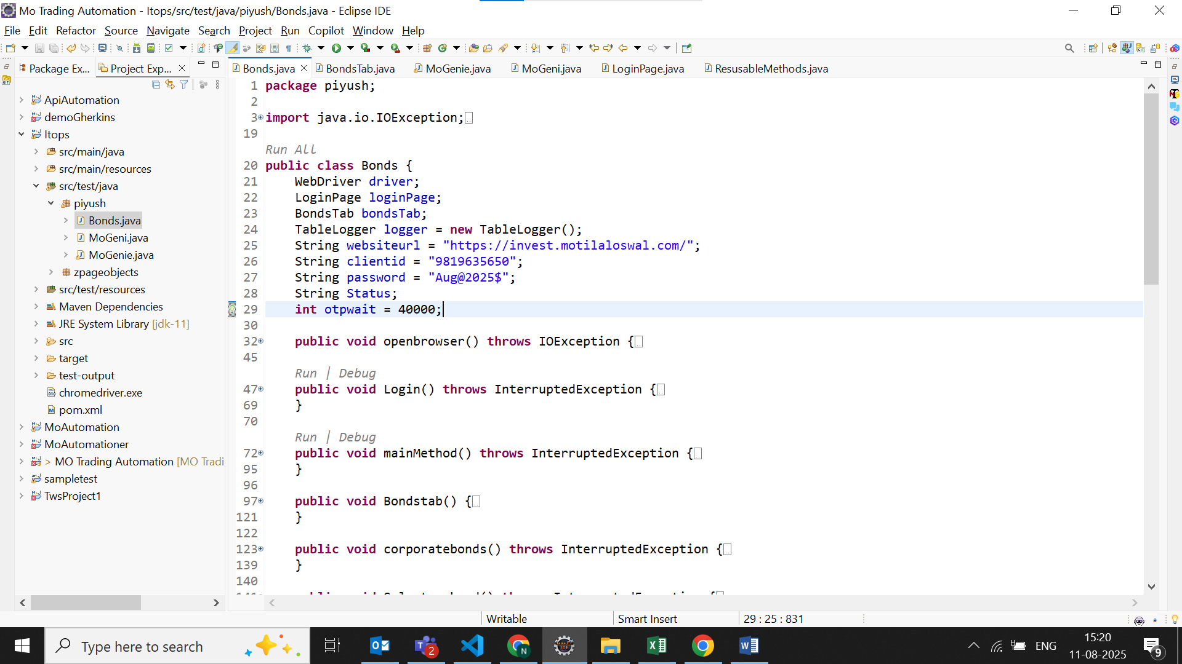

Double click and open src/test/java then open Piyush folder than open Bonds.java file

1. 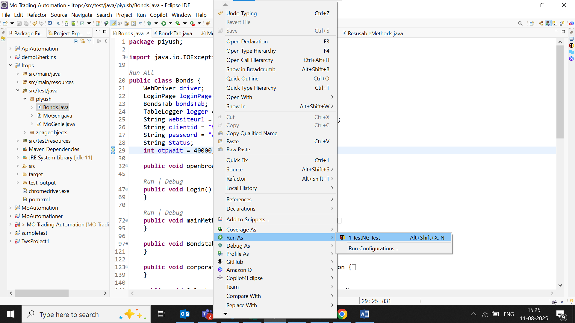Steps to run the file

Right click in the file than select Run as then select TestNg

1. Steps to view execution report

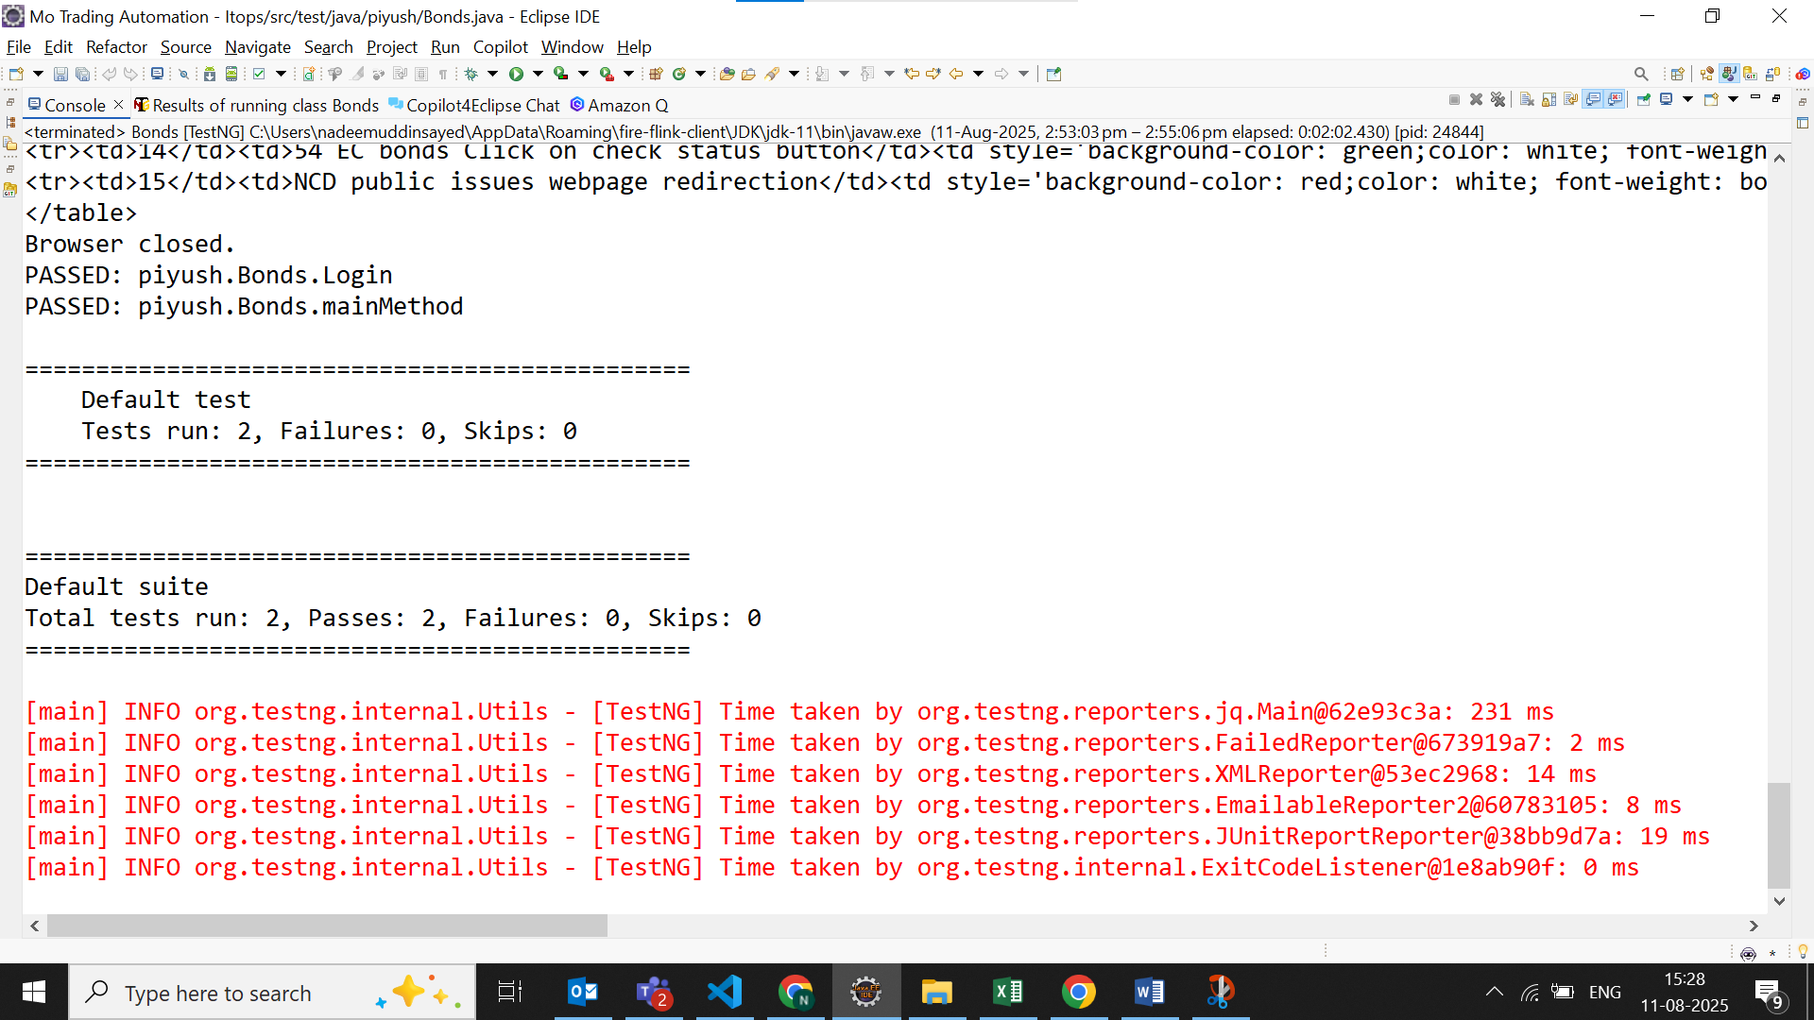

Once the execution is completed you will see this window click on this minimize icon

`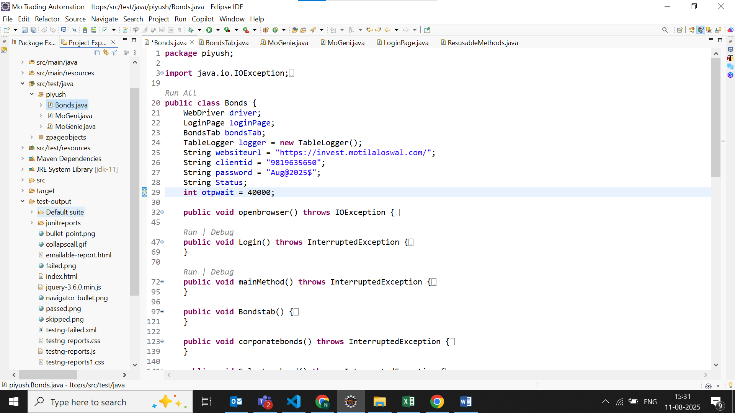

Right click on index.html file than open with select open with web browser

Open test output folder

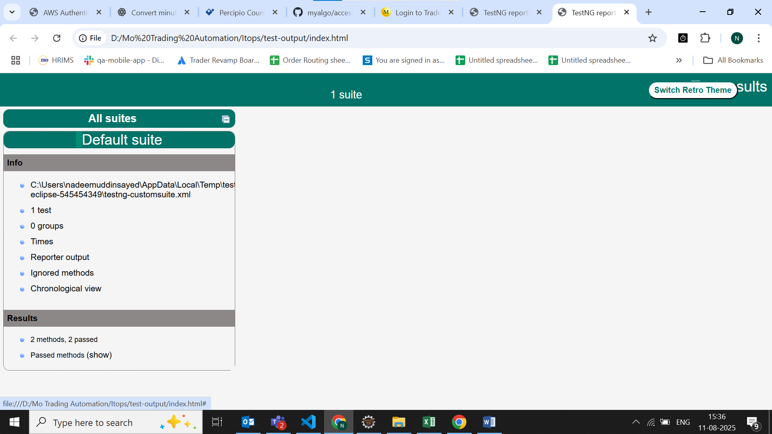

Click reporter output method to view detailed report