|  |
| --- |
| Chapter 1  Introduction |

**1.1Overview:**

ASPS is a system for administrating and securing institutions that aims to secure the entrances from the illegal entry of persons who are not authorized to enter through two-factor authentication password, and Ai. Through the camera, we will be able to make face recognition to know if this person is authorized or not. And to Manage It all, ASPS provides a Control Panel which makes it easy for admins to Control Authentications directly - According to the permission of each admin - and follow attendance and Departure times for each employee in the institution.

It is known that all major institutions have visitors, so there is a mobile application, through which the visitor can obtain a temporary password for a certain period to allow entry.

On the other hand, people will be tracked within the organization using LIFI technology through which create an internal network for the organization so that any data will be transmitted over the place in a safer and faster way than its counterparts from existing technologies for data transfer, such as WIFI technology Which is considered less fast as it provides standard date transform only 150 Mbps and Bluetooth provides standard data transform only 800 Kbps while LIFI provides 1 Gbps. safer in transferring data, and that is made this technology -LIFI- the subject of consideration and interest from us to use it such as its high data speed, high security, electricity saving, and can work in high dense environments.

**1.2 Problem Definition:**

Many institutions suffer from difficulty in securing and managing their entrances in terms of:

* Entry of unauthorized persons.
* Lack of control over the presence of people inside institution.
* Record the attendance of employees and members who enter the institution.
* Track people within the institution and follow their whereabouts and movements.
* Do not restrict visitor movement permissions within the institution.

We seek to solve the above problems through:

Based on the idea of two-factor authentication, which is keypad code, and the second factor using AI, which is Face Recognition using the camera to ensure that the person who will enter the place is authorized to do so, in addition to a way to track people within the institution using LIFI technology.

**1.2.1 Motivations:**

* Determining the entry and exit permit for people, including employees and visitors within the institution.
* Restricting unauthorized persons from being in certain places.
* Facilitate the presence of visitors within the institution and determine the validity of their presence in certain places.
* Track the location of each employee in the institution.
* Record the attendance of employees within the institution.

**1.3 Objectives:**

The project ASPS system is aim to secure company or houses or any place need to be secured for the entry of authorized person and Goals to be achieved in this project are:

* **High security and assurance.**
* User Experience –Convenient and fast.
* Everyone has access to a unique set of biometrics by password and face recognition.
* Spoof proofBiometrics are hard to fake or steal.
* To develop a hassle-free smart system to enhance security by technology.
* To create a simple and cost-effective product in a short period so that it can applicable and affordable to the average people and can compete in the present market.
* Develop a smartphone application to control the system.
* Efficient because templates take up less storage.
* Track the location of each employee in the company in a high-quality manner.
* Reducing the human factor in controlling the management or insurance of the institution in general.

**1.4 Contributions**

Biometric verification has become increasingly popular in corporate and public security systems, consumer electronics and point-of-sale applications. In addition to security, convenience has been the driving force behind biometric verification.

The idea of ​​this project is that it combines biometrics with personal uses, which include the following:

* As for the software part, it is a dashboard that controls our hardware, and who will control it directly is the super admin, which has different powers, such as adding new admins and controlling the powers of each of them to follow up the employees of the institution or see their data and work reports,

use face recognition and password to detect person who require login he have access or not.

* And in mobile application when any visitor come to company asked him for permission to authorized who inside company.

**1.5 Scope:**

The project provides a hardware product to verify user authentication and software that includes Dashboard and Mobile Application for all major institutions like banks, military facilities, hospitals, and software companies.

**1.6 Project Outline:**

This project consists of six chapters in addition to one appendix and references.

These chapters are organized to reflect the scientific steps toward our Main objective, that will be explained in the following lines.

Chapter 1: Introduces the project objectives, the motivation of the Project, the approach used in this project, the contribution of this Project, the scope of the work, and project layout.

Chapter 2: Literature Review, provides the reader with an overview of the previous related work, common technologies used, and the relation Between our work and the relevant work.

Chapter 3: System Analysis, includes the analysis of existing system, System requirements, use requirements, system architecture, Development methodology using UML, the tools, and languages used in our system.

Chapter 4: System Design, provides the system design including class Diagram, database design and interface design.

Chapter 5: System Implementation, shows the process of mapping Design into implementation, sample application code, system testing, Results of the investigation, and goals achieved.

Chapter 6: Conclusion and Future Work, summarizes the entire Research, and addresses the suggested improvements for the system. Appendix contains information about the contents of the project DVD and how to use them.

|  |
| --- |
| Chapter 2  Literature Review |

**2.1 Introduction**

Security describes protection of life and property. There are doors to keep people out, Key locks and chains reinforce the mode of security. Doors are being made of metals not just wood anymore. Influential persons in our society have bullet proof doors to ensure a good measure of security of self and family. The security sector is experiencing diversification as it has never seen before. This has brought about the need to review the reliability of already existing systems and look into the possibility of creating better systems that are smarter and more secure.

The door lock is one of the major necessities of the companies as it is widely used to protect their companies from any intruders from gaining unauthorized access. After understanding the necessity of smart door lock to company and taking their problems into the consideration this Several projects have been established. But these projects have a percentage of errors, and they used RFID, passwords, Bluetooth, etc. to facilitate access to the institution or company. Without the intervention of a human factor in this project, we explain the solutions to some of these errors.

In this chapter is about the details of the background of a project that includes About the Literature review, a Similar system. The critical comparison with similar systems is also discussed in this chapter.

**2.2 Similar System**

We will cover three projects based on the idea of the Door Lock to protect companies, which are the following:

* Smart Home Security Using RFID System.
* Automatic Door Locking System Using Bluetooth Module.
* Electronic Door Lock using RFID and Password-Based on Arduino.
* Guards Pro.
* ACRE's Access Control Portfolio.

**2.2.1 Smart Home Security Using RFID System**

This Door Lock system is a magnetic door lock that allows users to easily lock and unlock the doors. It contains an RFID reader, relay, and magnetic door lock, and the user is provided with a passive RFID tag to lock or unlock the door. This system uses the PIC (16F877A) microcontroller for controlling the whole system. Moreover, in this system, an LCD was used to display the door status. The components included in this system are simple and uses only an RFID technology to develop a door lock and consist of an LCD to give an output message.

**Disadvantages:**

This door locking system is simply an RFID Based system that needs an RFID tag to unlock the door.

* lacks security features like alert function
* This door lock system does not have batteries for failsafe which creates problems during the power cut.

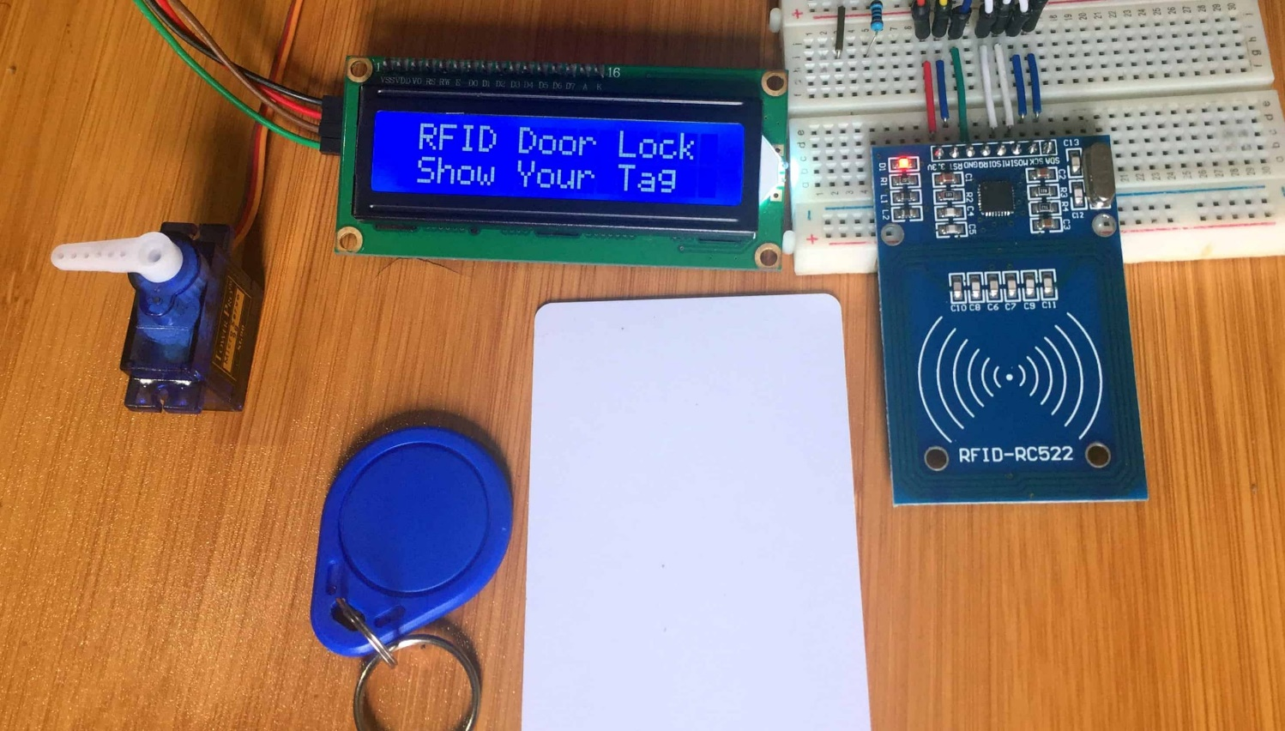

Figure1: Smart-Home-Security-Using-RFID-System

**2.2.2 Automatic Door Locking System Using Bluetooth Module**

This is a Bluetooth-based door locking system that uses the servo motor to lock or unlock the door. Bluetooth module in this system works as a command agent and a smartphone application is used for controlling the motion of the servo motor. The overall system of this door lock is controlled by Arduino Uno. The ideal purpose of this system is to lock and unlock the door by using a smartphone.

**Disadvantages:**

This system is simply only controlled by smartphones and needs a smartphone to unlock or lock the door by enter password if password ture open the door otherwise not open Similarly:

* This door lock system uses a servo motor for controlling the motion of the door lock which is less secure
* lacks security features like alert function

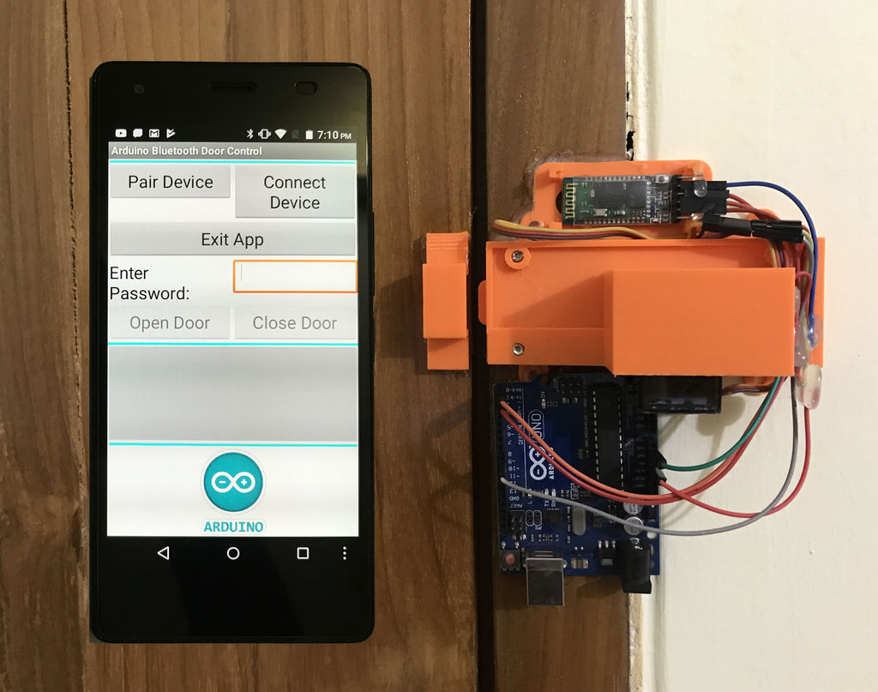

Figure2: locked system using Bluetooth.

**2.2.3 Electronic Door Lock using RFID and Password-Based on Arduino**

This electronic door lock uses RFID and password-based technology. This door lock system can be used on doors and cupboards as electronic lock and so on. Like other projects, this door lock system uses an RFID tag and password to unlock or lock the door. The extra password function of this project makes the door lock more secure and helps to enhance the security. Similarly, this door lock system is also controlled by using a microcontroller Arduino Uno.

**Disadvantages:**

Although the extra password function of this project makes the door lock more secure. but:

* not have any battery backup.
* 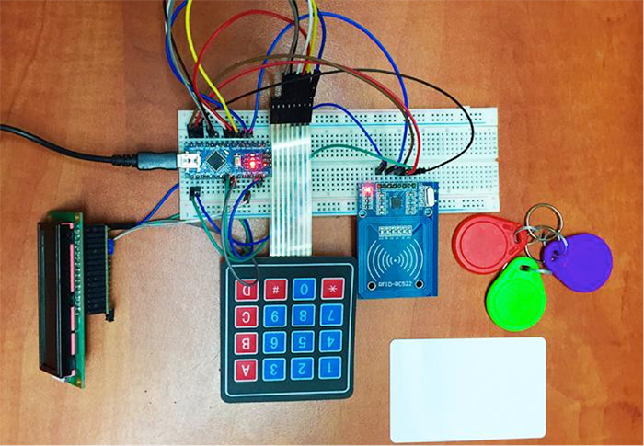this system has a voltage regulator is relatively big then comparing to our system.

Figture3: using RFID and Password-Based on Arduino.

**2.2.4ACRE's Access Control Portfolio:**

ACRE’s multiple access control systems control the movement of staff and visitors within a building’s structure. This provides many functions aside from access control, including visitor management and health and safety issues. This vast arsenal includes door access with face recognition, access control QR code readers, mobile credentials for access control, and Bluetooth access control card readers.

**Disadvantage**

Using Bluetooth has many problems with security, and in this kind of system, security is necessary, so we replace it with LIFI which has a lead at this point.

**LIFI has additional features that make it distinct from Bluetooth and other technologies:**

* LIFI is more secure than Bluetooth and other technologies.
* Providing a standard data transform of 1 Gbps while Bluetooth provides a standard data.
* transform of only 800 Kbps.
* LIFI can work in highly dense environments while Bluetooth not.

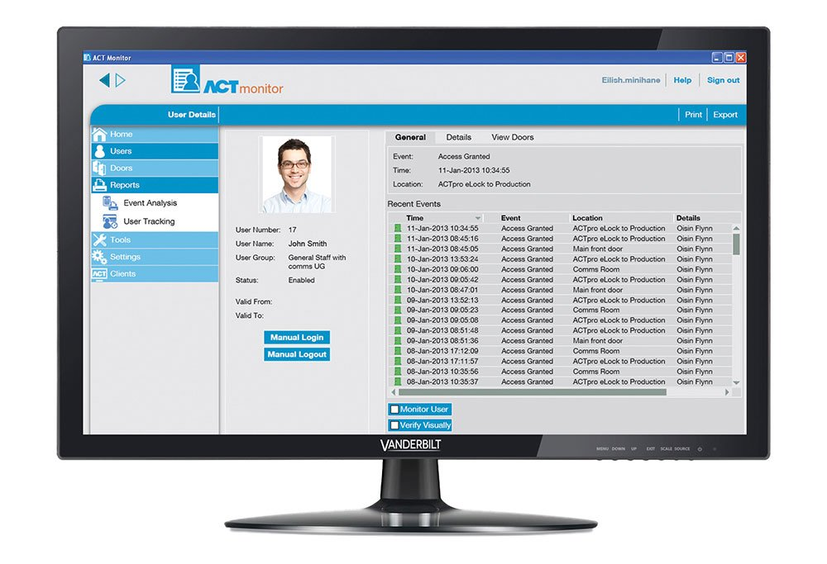

Figture4: ACRE’s Dashboard.

**2.2.5 Guards Pro:**

Guards Pro Guard App is intuitive mobile app for security guard which is part of Guards Pro Physical Security Platform. It is designed to streamline security operations at every level of private patrol company. Security guards can use Guards Pro Guard App to submit reports, log hours using time clock, access their schedule, create pass-downs, confirm post orders, communicate with their security team and much more. Guards Pro Guard App allows the security guards to provide excellent security guard services and guard their post sites effectively. It gives security guards the right tools they need to do the job right, while increasing guard’s performance. Guards Pro Guard App allows security guards to confirm shifts, swap shifts, view time log, view their payroll, work closely with other security guards to submit reports, and communicate effectively.

**Access Tasks:**

Assign tasks to your on-field security teams effortlessly and make them instantly available on the mobile app for guards hassle-free.

**Disadvantage:**

This application is not user friendly. If you forget to log out then it will not send the client the report. It updates once month and that is cumbersome and causes guards unfamiliar with the application problems.

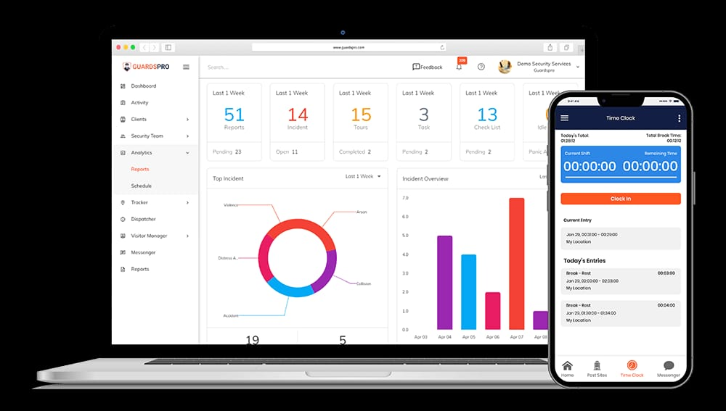

Figture5: Guards Pro.

**2.3 Summery**

Generally, there are so many factors that are needed for consideration while building and designing a smart door locking system. The system is designed to be cost-effective, versatile, hassle-free, and more user-friendly so that these modern devices can be integrated into everyone's system. The main goal of such a system is to maintain and to enhance the strength of security.

**There are some scholars who have presented research and development in these systems, some of which are as follows:**

* (Ralph Ting, 2014) proposed an RFID door lock that is based on security and access control. It is designed to create a convenient way to unlock the door than the traditional key. The components included in this system are simple and uses only an RFID technology to develop a door lock. This system lacks the important security features as it has no any alerting system. This system suggests adding additional features such as buzzer for alerting purpose, SMS alert, and so on.
* (Ni-Ni San Hlaing, 2019), in his research on RFID door lock system suggests the use of keypad to secure the system by adding a password after scanning the RFID tag. The extra password function in the system makes the door lock more secure.
* (Lia Kamelia, 2014) in her research on smart door lock recommends that to be able to unlock the door using smartphone helps the users to interact more easily than other door locking system. The proposed door lock is the combination of different technologies in which an android smartphone works as a task handler, Bluetooth module as command agent, Arduino Uno as controlling and data processing unit, and solenoid as the output.

As compared with these doors locking system proposed by different authors, our project has extra features and uses more technology to build a door lock. The two-way authentication feature of this project add extra security to the system and the use of smartphone makes it more user-friendly.