# Project idea

My project is that users exchange books instead of buying a new book and discover new books and get to know each other.

## List of functions

1. My book page: The users must add books that want to swap it.
2. Trading Page: This page users search for books or titles that they want.
3. Registe Page: This page must the user create an account on this website.
4. Login Page: Login Page: After creating an account, you must log in with the newly created account
5. Contact Page: Information about me
6. Home page: information about books and something attractive to users
7. Feedback: Users are allowed to give feedback about books.

### Recommended Solution

Many users have books they have finished reading and they want to replace them. However, they face difficulty in looking for people interested in books, and it takes time. Here is my site to solve this problem. My site helps them search for specific books or specific topics that they like, and people who love books, making the swap process faster and easier.

Benefits my platforms

* Reduce Costs: Instead of buying a new book, users can exchange books to save money.
* Discover New Topics or Titles: When trading, the page will display books that others are offering to swap.
* Meet New People: When swapping a book, you connect with the person offering it.
* Save Time: No need to search for people interested in books—the platform helps you find them easily.
* Security: Information about security improvements remains unchanged.

#### Storyboards

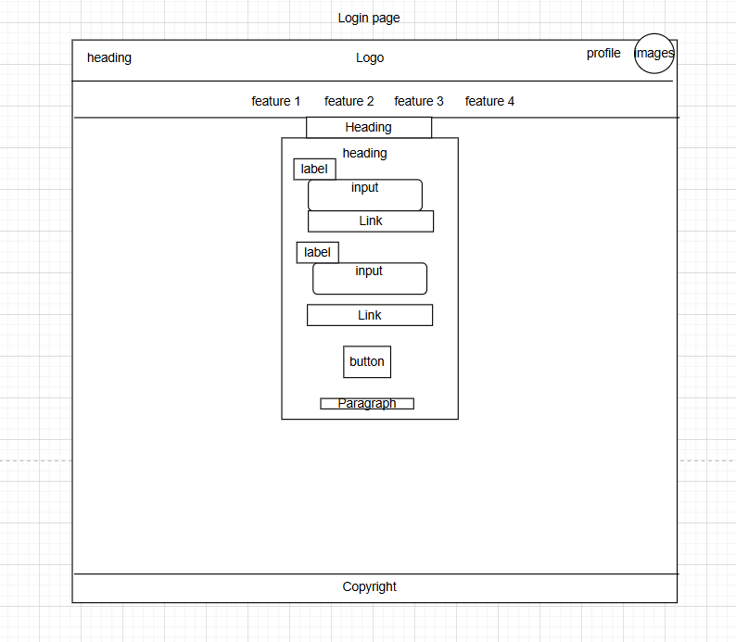

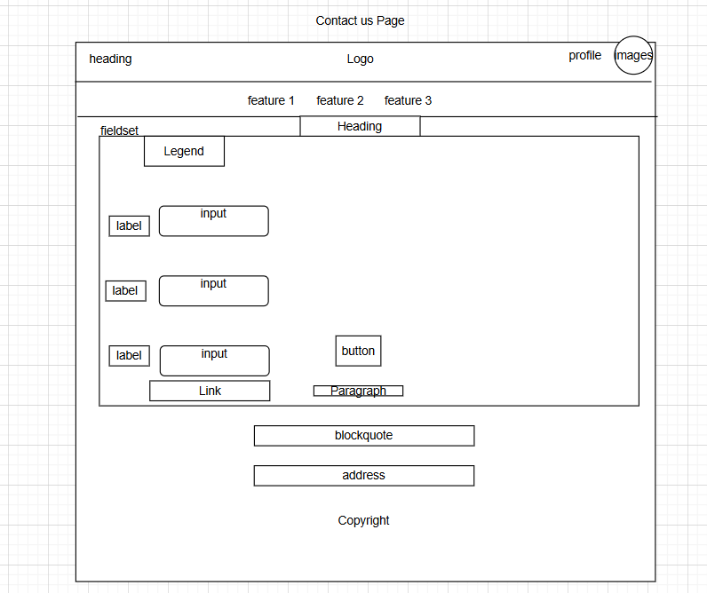

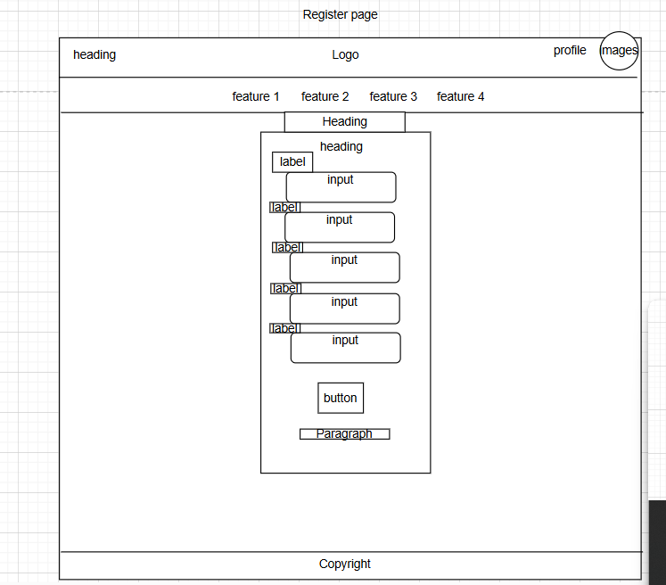

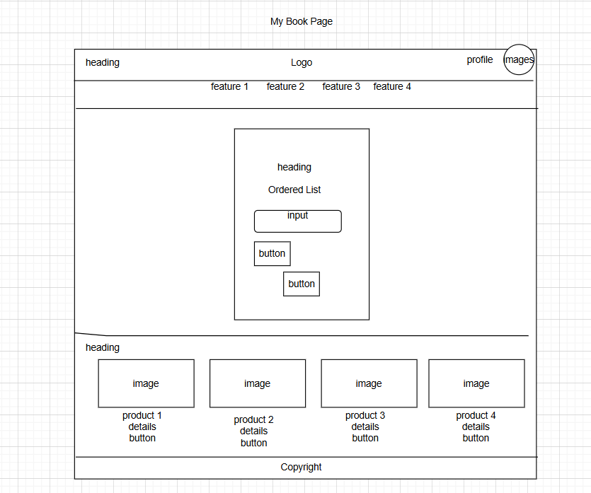

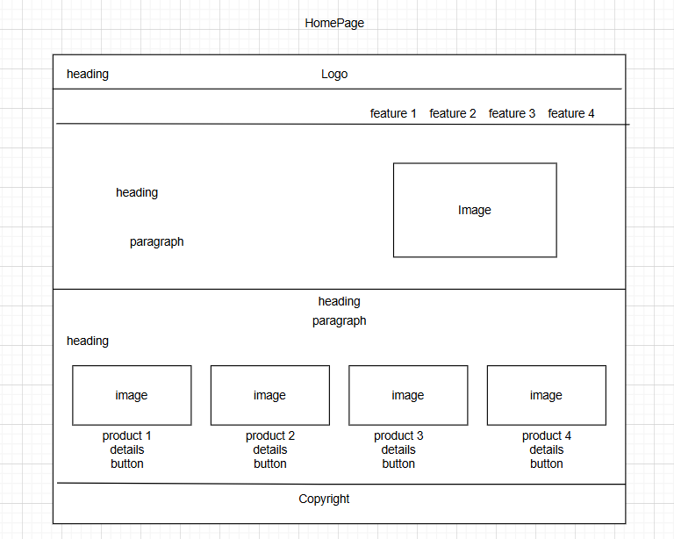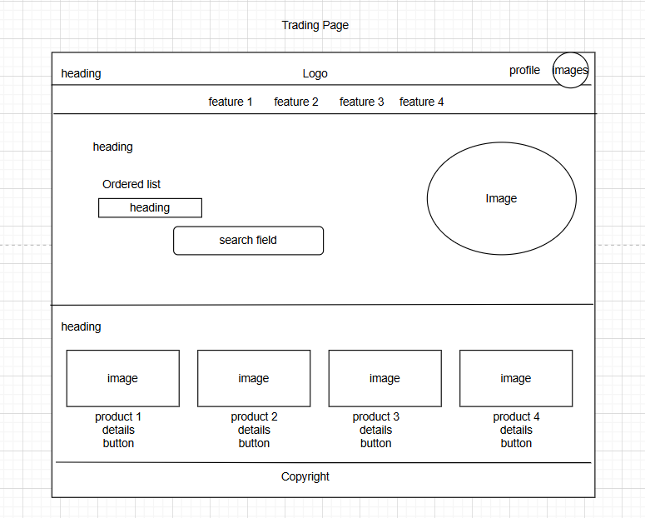

##### Site Map

