Project Description

Name: Mohammed KHALED ABUASBEH

Dataset(s):
Brief Description of the Dataset:
The dataset contains detailed records of 100,000 employees across various departments in an organization. It captures employee demographics, job-related details, performance metrics, and other key factors that influence productivity and satisfaction. The dataset is structured with 20 columns, which include the following types of data:

- Employee_ID: Unique identifier for each employee.
- Department: The department in which the employee works (e.g., Sales, HR, IT).
- Gender: Gender of the employee (Male, Female, Other).
- Age: Employee's age (between 22 and 60).
- Job_Title: The role held by the employee (e.g., Manager, Analyst, Developer).
- Hire_Date: The date the employee was hired.
- Years_At_Company: The number of years the employee has been working for the company.
- Education_Level: Highest educational qualification (High School, Bachelor, Master, PhD).
- Performance_Score: Employee's performance rating (1 to 5 scale).
- Monthly_Salary: The employee's monthly salary in USD, correlated with job title and performance score.
- Work_Hours_Per_Week: Number of hours worked per week.
- Projects_Handled: Total number of projects handled by the employee.
- Overtime_Hours: Total overtime hours worked in the last year.
- Sick_Days: Number of sick days taken by the employee.
- Remote_Work_Frequency: Percentage of time worked remotely (0%, 25%, 50%, 75%, 100%).
- Team_Size: Number of people in the employee's team.
- Training_Hours: Number of hours spent in training.
- Promotions: Number of promotions received during their tenure.
Employee_Satisfaction_Score: Employee satisfaction rating (1.0 to 5.0 scale).
- Resigned: Boolean value indicating if the employee has resigned.
Project Scoping Document

Business Problem
Human Resources (HR) is a crucial part of any organization, focusing on managing and optimizing the workforce. HR is essential for creating a cohesive and efficient organization, acting as a bridge between management and employees to achieve both short-term and long-term goals.
I aim to enhance employee growth, reduce workplace stress, and identify employee issues within the workplace.

Business Impact
Identify hidden issues that employees and companies may not be aware of, as well as the problems they face in the workplace.

Dataset(s)

Methods
1. Understand the Dataset
- Inspect the Data: Review structure, columns, and data types.
- Clean the Data: Handle missing, duplicate, or inconsistent values if any.
- Summarize Key Metrics: Calculate descriptive statistics for numeric columns (e.g., mean, median, range).

2. Performance Analysis
- Identify High/Low Performers: Analyze the distribution of Performance_Score and factors affecting it (e.g., training, satisfaction).
- Correlations: Explore relationships between Performance_Score, Projects_Handled, and other metrics like Training_Hours or Overtime_Hours.

3. Employee Satisfaction
- Satisfaction Trends: Study the distribution of Employee_Satisfaction_Score across departments, job roles, and other demographics.
- Impact Analysis: Examine correlations of satisfaction with factors like salary, workload, and training hours.

4. Resignation Analysis
- Turnover Trends: Identify patterns among employees who resigned (Resigned = True).
- Key Factors: Investigate links between resignations and metrics like Sick_Days, Remote_Work_Frequency, or Years_At_Company.

5. Department-Level Insights
- Compare Departments: Analyze differences in performance, workload, and satisfaction across departments.
- Identify Outliers: Detect departments or teams with extreme values (e.g., highest overtime or lowest satisfaction).

6. Visualization and Reporting
- Create clear visualizations (e.g., histograms, heatmaps, scatterplots) to illustrate trends and correlations.

Dashboard

*Dashboard mockup here*
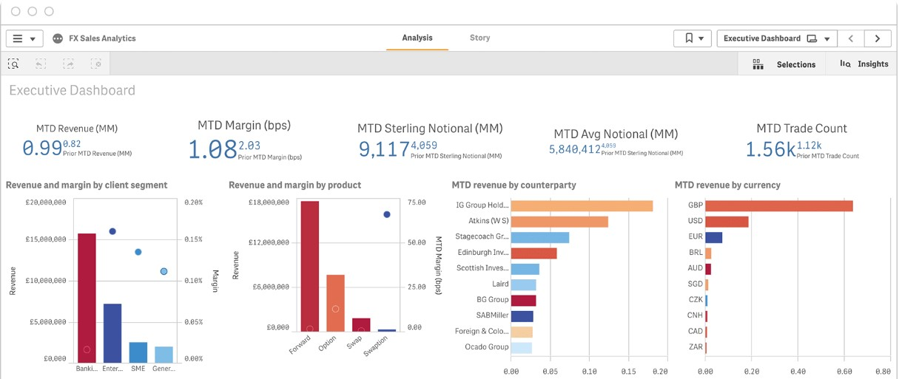

Milestones
- What do you expect to do to achieve success in your project?
- The first milestone is usually EDA, and your final milestone should be achievable only if everything goes perfectly.

1.Find the suitable Dataset
2.Data Cleaning and Validation
3.Create Data Visualization
4.Write Final Report

Timeline
- When do you expect to have each component of your project completed? You can use the due dates in this document as a guideline.

Week | Tasks
Week 1 | Search about dataset and identify business requirements
Week 2 | Process data and clean
Week 3 | Create Dashboard, Write Final report

