# Project Scope -- Vision Zero: MV104 Injury Severity project

### MODA:

* Deena Patel – analysis; Mitsue Iwata – data transfer and MOU

### Partners:

* Lawrence Fung: City Research Scientist, Bureau of Environmental Disease and Injury Prevention DOHMH
* Rob Viola: Director of Safety Policy and Research DOT

### Analytics Question:

Can crash injury severity be more accurately predicted using variables available in NYPD crash reports (MV104) beyond the KABCO score?

### Impact

Vision Zero is the NYC initiative to reduce traffic fatalities to zero. A better understanding of where severe injuries occur will allow DOT to more accurately prioritize street safety improvement projects.

DOT currently uses the MV104 crash report data on fatal and serious injuries (K or A from KABCO) to identify Vision Zero priority intersections, corridors, and areas. These geographies were identified using crash reports from 2009-2013. They will be redrawn by the end of 2018 based on 2012-2016 data. DOT would like to understand if there is a more accurate way to account for injury severity to inform the priority geographies.

### Data

MV104 crash data contains information on vehicles, crash types, persons involved, time, weather, and road conditions. Information on injury severity is limited to the KABCO injury score, based on police observation at the time of the crash. Hospital records contain more accurate information on injury outcomes, including the Injury Severity Score (ISS) which is assessed by medical professionals.

In 2016 DOHMH linked crash and hospital data to better understand crash injury outcomes (<https://www.ncbi.nlm.nih.gov/pubmed/28226252>). They probabilistically matched 5 years of data (2009-2013) from NYPD crash reports (MV104) to NYC hospital records (SPARCS). About half the hospital records were able to be matched to a crash report (145,003 linked records). Linkage results indicate that KABCO injury determination do not perfectly align with injury severity scores calculated from hospital record data (Fig. 1). However, the general pattern of ISS against KABCO follows an expected severity gradient, most severe injuries coded in KABCO are also coded as high severity injury in ISS.

DOHMH will transfer select variables from the linked dataset via DOITT to DataBridge. The linked dataset cannot be shared outside this project.

* MV104 – NYPD report for crashes causing fatality, injury, or property damage over $1000.
* SPARCS subset – contains select variables from hospital records: discharge status, level of service (e.g., admitted or emergency department visit), and injury severity score.

### Deliverable

The deliverable is a new formula that can be applied to MV104 crash reports to identify serious injuries. In comparison to the current KABCO formula, this new formula will more consistently identify serious injuries that align with the serious injuries as defined using hospital records.

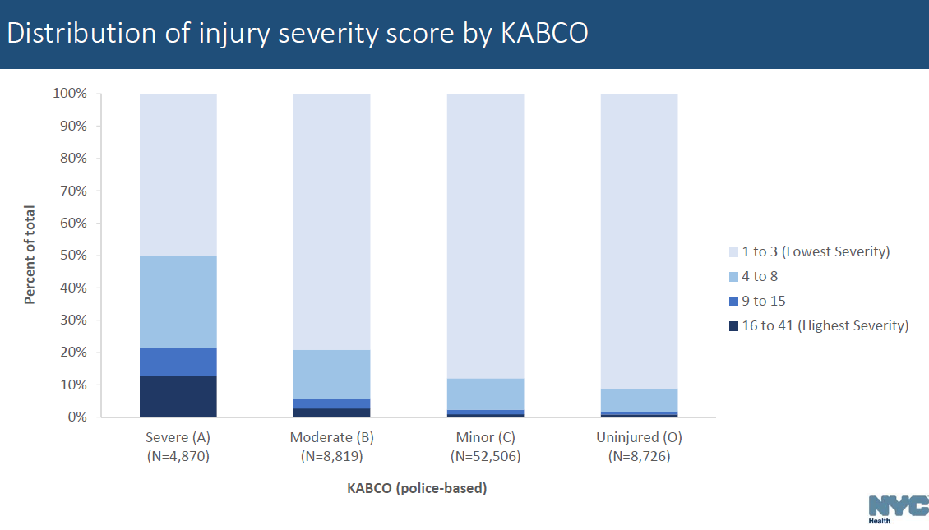

Figure 1. Injury Severity Score (ISS) from hospital records vs KABCO score from police reports. Graph from DOHMH.

### Potential Secondary Use

NYPD has a Collision Investigation Squad that does an in depth investigation of fatal crashes, they would like to know what non-fatal crashes to also include. This type of analysis could be used to inform their team on how to choose the types of crashes to investigate.