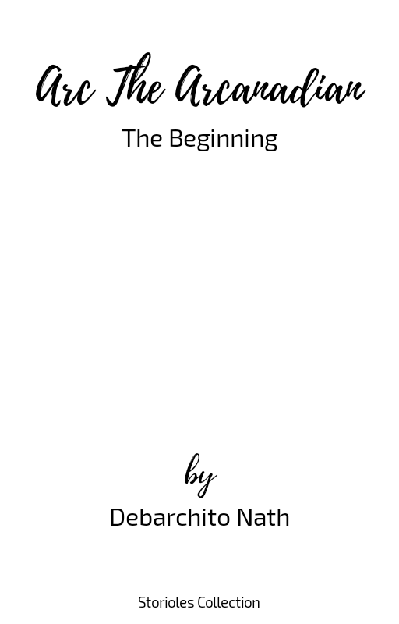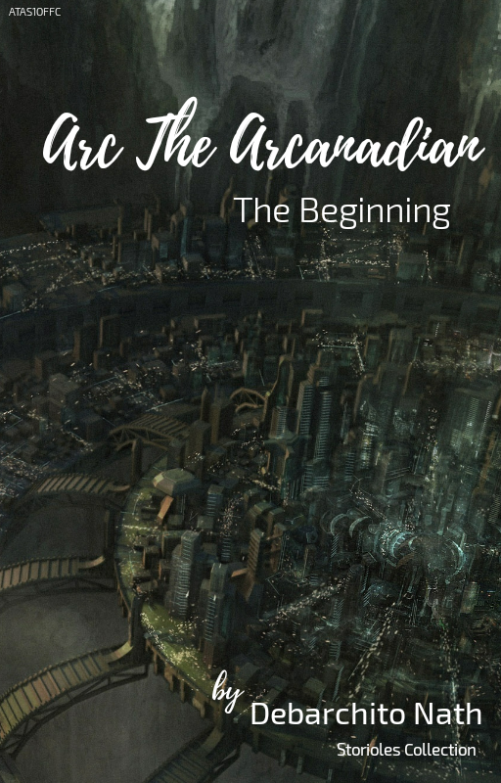

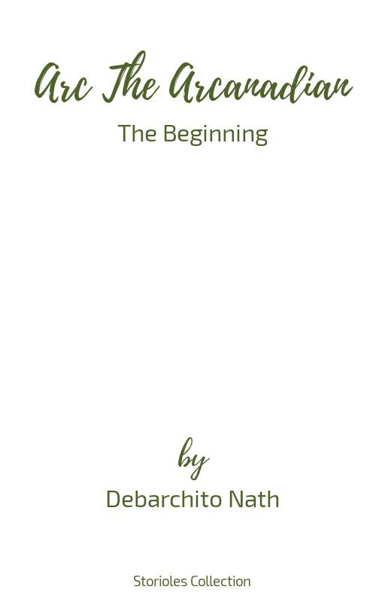

## EBook by Storioles Inc.

*ALL RIGHTS RESERVED*

No part of this EBook may be reproduced or utilized in any form or by any means, electronic or mechanical, including photocopying, recording or by any information storage or retrieval system, without the written permission of **Storioles Inc.** and it’s writer **Debarchito Nath.**

Violation of the above statement may lead to penalty.

*© Storioles Inc. & Debarchito Nath*

# Notes

**1.** The text inside “[“ and “]” in bold font describes the environment as well as the state of a specific character; his/her thinking etc. at it’s respective time.

**2.** The text inside “(“ and “)” in bold font contains some note on some terms which may be both real and imaginary.

**Contents**  Page

**1.** Pre-story 1: *Thales Zu* 1-13

# Pre-story 1

Thales Zu

“...looked towards me and grabbed my finger...”

**2**

**A** planet, 2.36 million light years away; it was not too long ago, when we stopped calling it "home". Our hopes were shattered; we were broken. We asked ourselves, "How long do we need to wait? Will anyone come save us? Will anyone find us?". We started to think that dying was the best option left, but deep down, who wants to die?...Months passed, years passed, but no one, no one came. Just at the moment when we said "no more", we heard him...we heard him cry. He looked towards me and grabbed my finger. He smiled. But, we heard footsteps. We were frightened; we didn't have time to think or act. The door opened and what happened, was something I would never forget. A person stood right there and said, "We have the chance, we have the chance to escape". I said, "What?". He explained everything to me. His points were so descriptive, that it filled all of us with surprise. But we suspected him. We all asked question to ourselves, "Why so suddenly? How does he know so much? It is a trap?". We asked him the same questions. He answered, "I lost my family a

**3**

long time ago. They killed each and everyone I loved. I just never wanted to stay here anymore; I was frightened, but it was a coward step. I just thought about myself, being selfish. But, I am not like that anymore. My family gave me a chance to save my life and I want to share it with everyone. Please believe me; please...I have nowhere to go. Please, please...don't abandon me". He cried, and the tears, they were real. He said, "That was the time when I decided that I will find the slightest weakness that they could have, and today is the day! I found it, I found it!". We looked towards each other and we decided to believe him. We held a discussion and pointed out the various dangers and hindrances but the conclusion was obvious. We preferred to take the risk. Days passed and we observed each and every movement of the guards. Keeping the info in mind, we made our plan. Our spies collected data about the spaceships which included access codes, pilot compatibility and so on. By that time, we all came to know that if we fail in this mission, we were going to die; at least we didn't want it, after we made our mind. At a time, we

**4**

took good care of the newborn; after all, he was the last fragment that connected us to his father. It was going to be the last night that we were to spend in this planet. All our efforts were going to pay. We packed as many supplies as we could, and got everyone ready. It was midnight; we headed towards the space centre. It was an area with high security. We used the info we collected to locate the power supply station. We were able to shut down the system for at least a couple of minutes. This was our chance; we rushed towards the spaceships and ensured everyone was there. We had some very experienced pilots in our team who were selected using the pilot compatibility data. The system was online again; we were spotted, but it was late for them. The thrusters were online and we were ready to fly. They targeted us but our ship's energy barrier was able to withstand that. We knew that this was not going to end so easily...Soon we were in space; watching the planet for the very last time. Just after a few seconds we heard the warning, "Be ready. Warp Drive is online, warping..." and just in no time,

**5**

the planet disappeared from our sight; it was like a dark blanket with shining dots in it. Months passed and we were wandering in emptiness. We had enough supplies to survive for the next two years. At least we felt that we were safe, but the thought of being safe, was just a dream. Our radar started to register disturbances. First we all thought that the disturbances were being registered due to the stars that were being created, but no it was a ship; a "Battle Phoenix" to be precise. We were under attack! Engines were highly damaged. It was an emergency. The energy barrier collapsed. Our ship didn't have anything to defend itself anymore. It was a cargo ship, so there were no weapons, which made the situation worse. Just a few second after, we witnessed an explosion. We rushed towards the window and it was one of the most horrific moments of my life. It was one of our companion ships that just exploded in front of our eyes. We all felt a huge loss. We lost so many people. Just a few seconds later, another ship exploded and the reason was a chain reaction, which started in the nearly destroyed

**6**

fusion reactor of that ship. We thought that it was our end. Suddenly, our radar started to register high frequency radio pulses. We mapped the source and it was coming from a point; invisible but dominated by gravity. It was a Worm Hole; a speculative structure linking disparate points in space-time. Our probability engines probabilised the existence of life on it's other side with a certainty of 99%. That was a huge shock to us, but there was something unnatural. There was a difference in time; a massive difference. But, it was too late! The forces invaded our ship, and our only option was "Escape Pod". We all rushed towards the ejection room. Though, I was running, I was thinking, about the probability. I said, "Why is there so massive difference in time? Can we go to other side? Will we be saved?". Suddenly, we heard firing. I stopped and looked back. "They are going to catch us!", I said. I heard a voice crying, "Don't kill my son!". I was near the tool room of the ship. I rushed to the tool room and grabbed whatever I could and ran towards the voice, wishing nothing happened to her or the

**7**

child. I attacked them as mercilessly, as I could. After which, I said her "Let's go!". At that moment we were the only survivors. Everybody was killed by those damn forces. I heard someone firing at us. She shouted, "Ahhh!". She was badly injured. I didn't know what to do, when she said "Leave me here! Take my child with you. Raise him. Please...". I said "No! I can't leave you here! This child needs it's mother". She gently put her arms in my shoulder and said, "Thanks for everything, but if you stay here, all of us will die; please save my child. He hasn’t seen anything yet; Go towards the Worm Hole. There is a world named "Earth" which lies on the other side. Once the Worm Hole closes, they will not be able to track you, because you will in a different space, and a different time". One of them shouted "I see them, they are here!". "Go! Go!" said the mother. I took the newborn and ran as fast I could. They fired at me; I was injured, but I managed to eject from the ship. I was in the Escape Pod and my life along with the newborn's life was hanging in uncertainty. I accelerated the pod, towards the Worm Hole

**8**

and when we entered it, I don't know what happened; I became unconscious. When I woke up, there were no ships around. I was orbiting a blue planet. I was not happy. After all, I lost so many people. But I couldn't stay in space for long. I accelerated the pod towards the planet and turned off the engine. Gravity pulled us down and our pod went through lot. Temperature was increasing and I just prayed for everything to go right. Within the next 10 minutes, I saw something green at the bottom. I started the engines and thrusted it against gravity. Within a fraction of minutes, our pod crashed in a forest. The pod contained health-aid equipments. I treated myself, and opened the pod's door. Luckily, nothing happened to the newborn. When, I came out, I was shocked to see such greenery. There was a metallic rod standing vertically with a metal plate on top. Something was written on it. I couldn't understand any of that. I went back to the pod and luckily some of it's systems were still working. I used one of the translation systems to translate the writings in metal plate to my native

**9**

language and it stated "Don't drink and drive". There was a road near the rod and I could see a building. I picked up the newborn and ran towards the building. It was a police station. I was shocked, when I saw people just like me; they addressed them as "Humans". But, this was not the time for that; I needed some data about the place, I was in. I again used the translation system to translate to and fro. I came to know that, I was in a country named "Versonia", and the forest is the edge of a city named "Sylus". The police man advised me to visit hospital first, because I was in a very bad shape; because the healing aids just stopped the bleeding but my wounds were still untreated. I was uncertain about the treatment. After all, I don't know anything about this planet. "My biology and the biology of the people living here are different, so will the medicines work on me?", I thought. But, I could at least try! The police man was kind enough to call an ambulance for me. Well, everything looked so old fashioned to me; it was as if, I was in the past. I came to know that internet exists here as well; but was old

**10**

fashioned again. I was in the hospital for the next 2 days, and I surprised to see that the treatment worked and was done for free. Later, I came to know that it was a scheme driven by government; named as "Free Treatment for everyone". As time passed, I started to understand how human society worked. It was not that different from what we used in the past. This really shocked me. I searched the internet for a job. I found a job to earn some money which was essential for us to survive. I also searched the internet for Worm Holes and I found that the theories are still hanging as they haven't detected any one yet. The term "warp drive" was theoretical to them. So, I was convinced, that the info I got from the internet was not going to help me, except learning earthly things. Months passed and I learned their native language, bought a very simple house and was talking care of the newborn. I repaired the escape pod with whatever I got; though I was not able to repair it completely **[it is what I thought until that moment]**. I just managed to keep the systems running. Suddenly, the system

**11**

detected interference in Lifograph **(an imaginary device; used to find life traces)**. At a time I received some odd signals. It had a range of around 10 light years. I translated the signals and it said "Help!". I mapped it's position and used the data I found from internet. It was a planet and they called it "Proxima b" which was 4.24 light years away from Earth. At first, I thought that it was a 4 years old signal [the signal took around 4 years to reach Earth], but I was wrong. I found warp patterns, which meant the signal was warped. I trimmed the time and it was shortened down to about 7 minutes and 4 seconds. It was orbiting a dwarf star named "Proxima Centauri". Even the reports says that this planet falls in the habitable zone therefore there is a chance that it can sustain life, but being so close to it's star, there was a high chance of it being tidally locked **(Tidal locking, in the best-known case, occurs when an orbiting astronomical body always has the same face toward the object it is orbiting. This is known as synchronous rotation: the tidally locked body takes just as long to rotate around its own axis**

**12**

**as it does to revolve around its partner)**. But my pod was neither in the shape nor it was that fast. Just when I started to lose hope, I said "Fast? I wish I had warp drive!". I remembered something. I said, "Wait, it has warp drive! Isn't it?". I rushed to the pod and checked if it really had warp drive and yes it had! I decided to fix this as fast as I can. But my hands stopped and I thought for a second, "I can't take him with me! I can't put him in danger again. I already lost so many of my people...". I stood up and looked towards the sky. It was a hard decision, but at that time, I thought that it was the right thing to do; an orphanage. The next day, at dawn, I placed him in front of the orphanage, and said "Don't worry! You will find a good family. I was given the duty to raise you, protect you but I need to save someone who is in danger. I can't see anyone die anymore!". I left the place and went straight to my home without looking back; the home felt lonely, it was a very hard thing to do, but it was for the best. Months passed and my hard work, finally paid. It was the time to leave. But I wanted to see him; at least once

**13**

before leaving. I went to the orphanage but I didn't find him there. By that time, it became obvious that he finally found someone he could call his own. I left the place smiling. I got my pod ready, accelerated it and said "Bye Earth! I don't know how much time is this going to take but I enjoyed my life here". I heard the same warning, "Be ready. Warp Drive is online, warping...". I closed my eyes and in no time I was back to darkness.