MODFLOW Modeling with ModelMuse
Creating, Running, and Displaying Results of a Simple MODFLOW Model 3
Formulas, Functions, and Global Variables 10
Stress Periods 12
Layer Types 14
Wetting 14
Output Control 15
Spatial Variability without Parameters 15
Spatial Variability with Parameters 17
Wells with Parameters 19
Pumping Rate Interpretation 19
Drains, Rivers, and General Head Boundaries 20
Recharge 20
Evapotranspiration 22
Creating Grids 23
Importing Background Map 30
Importing Rivers from a Shapefile 31
MODPATH and Horizontal Flow Barrier (HFB) package 36
Drain Return Package (DRT) 38
Evapotranspiration Segments (ETS) Package 39
Hydrogeologic Unit Flow (HUF) Package 40
Lake (LAK) Package 42
Streamflow Routing (SFR) Package 45
Multinode Well (MNW2) Package 48
Reservoir (RES) Package 51
Unsaturated Zone Flow (UZF) Package. 52
Seawater Instrusion (SWI2) Package 53
Observations 64
Parameter Estimation Using UCODE and ModelMate 66
Local Grid Refinement 75
Troubleshooting Exercises 82
Answers 84

Creating, Running, and Displaying Results of a Simple MODFLOW Model
Estimated time: 50 minutes
The purpose of this exercise is to introduce some of the basic features of ModelMuse. We will create a simple model with a single well, run the model and display the results.
- Start ModelMuse by double-clicking on its icon.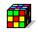
- Choose to create a new MODFLOW model and click Next. 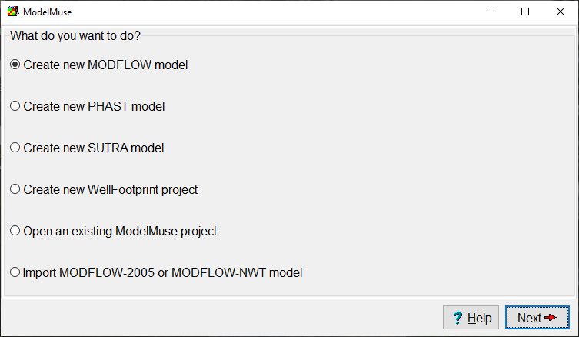
- Enter a description of the model. For the coordinate projection system, you can enter N/A for this model. Then click Next.
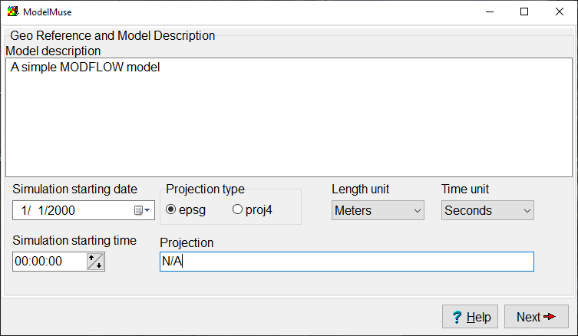
- Change the number of columns and rows each to 100 and the number of layers to 1. Change the name of the single layer group to “Aquifer” and set its bottom elevation to -100. You can leave the Vertical exaggeration blank; ModelMuse will compute a reasonable value. Click Finish when you are done.
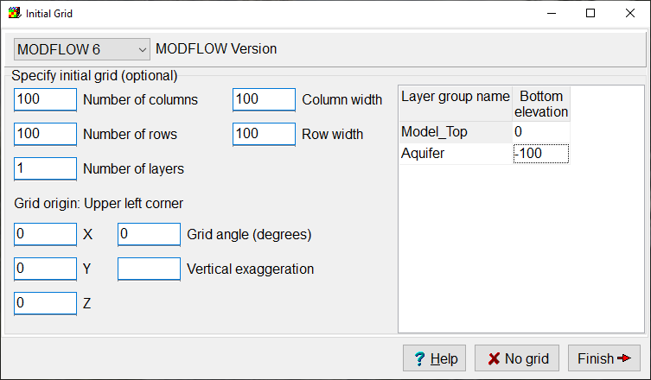
- Select Navigation|Pan and hold the mouse over the grid. Then drag with the mouse. The grid should move with the mouse. Note that there is a toolbar button with the same image as the image in the menu. Any menu item with an image has a matching tool bar button.
- Hold the mouse over the grid and roll the scroll wheel on the mouse, the model should zoom in and out.
- Click the Undo Position button repeatedly until you get back to the original view or just click the Restore Default 2D View button.
The MODFLOW Packages and Programs dialog box is where you activate any of the optional packages in MODFLOW that you want to use. The packages are listed in a tree control on the left. To activate a package check the checkbox or radio-button next to its name. Then set any other options for the package in the part of the dialog box to the right of the tree control. This model will use the Well package.
- Select Model|MODFLOW Packages and Programs… and check the check box for the Well package. Then click OK.
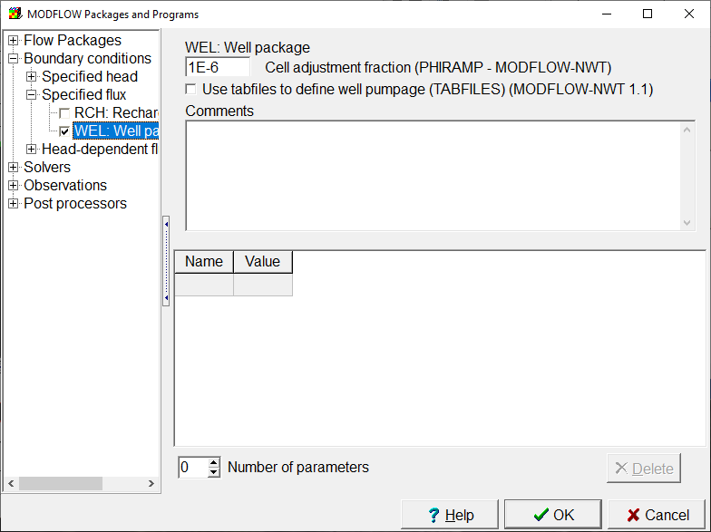
The MODFLOW Options dialog box is used to turn on the “wetting” option, change the model units and select some other options. (Do not turn on the wetting option now. One of the later exercises uses the wetting option but this one does not.)
- Select Model|MODFLOW Options…, switch to the Options tab, change the time unit to “days (4)”, and click OK. (Don’t turn on the wetting option.)
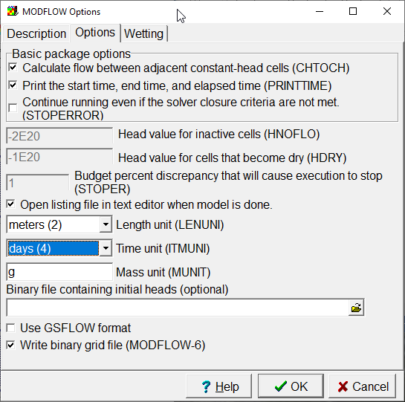
- The MODFLOW Time dialog box is where you set up the stress periods for the model. Select Model|MODFLOW Time… Change the Starting time to 0, the Ending time to 1000, and the length of the first time step to 10. Change from a steady-state to transient stress period. Then click OK.
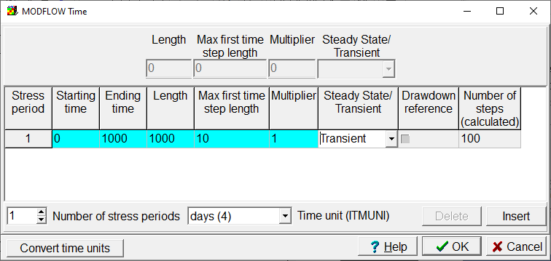
- You will get a warning message that you have to activate the Storage package. Go back to the MODFLOW Packages and Programs dialog box and activate the Storage package.
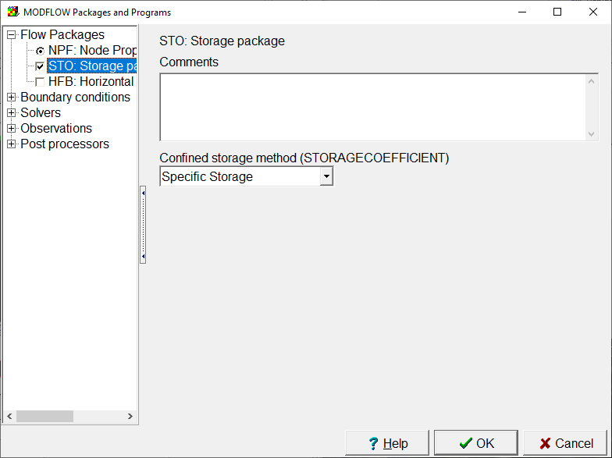
- The aquifer properties, layer elevations and other similar data are specified by data sets. For now, we will assume that all the aquifer properties are uniform and that the layer is flat. Select “Data|Edit Data Sets...” Then select the Kx data set under “Required|Hydrology” and change its default formula to 0.1 and click Apply.
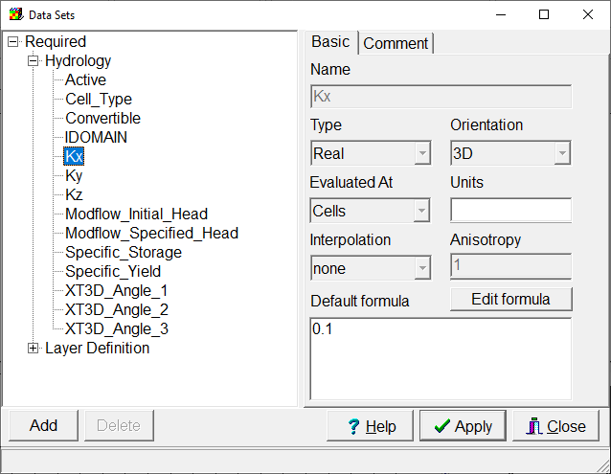
- Objects are used to specify the locations of things like wells, rivers, and drains. They can also used to set up spatially vary properties of data sets. In this case, we will use an object to define a well. Select Object|Create|Point and then click in the center of the grid. The Object Properties dialog box will appear. Switch to the MODFLOW Features tab. Check the check box for the Well package. Enter a starting time of 0, and ending time of 1000 and a pumping rate of -100. Then click OK.
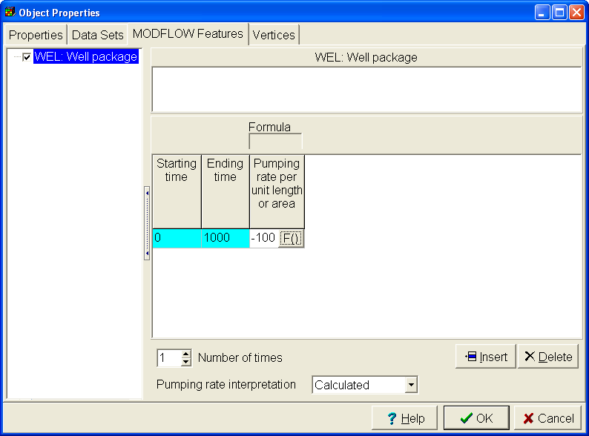
- Select File|Save select a file name such as “Exercise1” and save the file. If you are prompted to create an archive, answer “yes”.
- Select File|Export|MODFLOW Input Files, select a file name and click Save. ModelMuse will create the MODFLOW input files and start running MODFLOW. The progress of the model will be monitored in ModelMonitor. ModelMonitor will display any error or warning messages and graph the percent discrepancy in the budget. If the percent discrepancy is larger than 1%, there is probably a problem with the model. (However, smaller percent discrepancies do not guarantee that the model is OK.) Close ModelMonitor when the model is done running. The listing file will be opened in Notepad when you close ModelMonitor. You can close the listing file. There will also be a command line window that you can close.
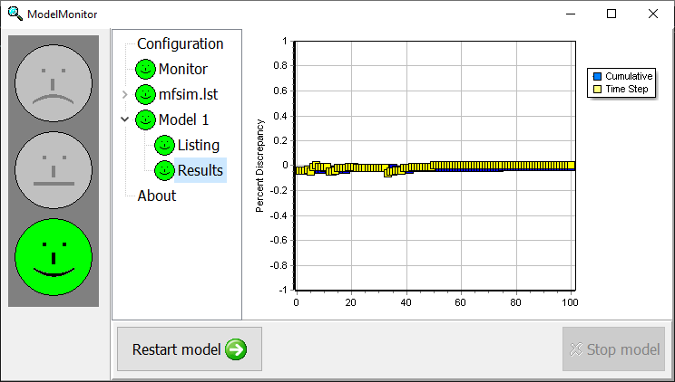
- Select File|Import|Model Results… An Open File dialog box should appear. The file containing the heads should already be selected by default so just click Open. In the Select Model Results to Import dialog box, the checkbox for the last time step should already be checked. Click the Select all data sets button and then click OK. After a wait, the data will have been imported and the grid will be colored with the data for the last time step.
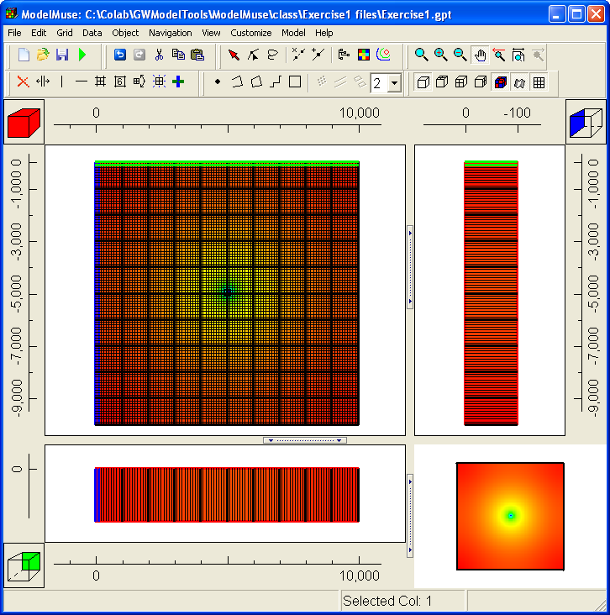
- Select “Data|Show Grid or Mesh Values”. Move the cursor over the model grid and observe the value displayed in the dialog box. This is one way to see what the data value is at a particular location.
- Select “Data|Display Data Set Values”. For the data set, select “Data Sets|Optional|Model Results|3D Data|Head_P1_S100”. Click the Copy button. Open Excel and paste into Excel. If you want to transfer the data to another program, this is one way to do it. Click Close to close the dialog box.
- Select “View|Show or Hide 2D Grid|Show Exterior” to hide the grid lines.
- Select “Data|Data Visualization|Color Grid” and change “Data set or boundary condition” to “none.” Click “Apply” and then “Close”. You can use this dialog box to change how the grid is colored.
- Select “Data| Data Visualization|Contour Data” and change the “Data set” to “Data Sets|Optional|Model Results|3D Data|Head_P1_S100.” These are the results for the last time step. Click “Apply.” You can use this dialog box to contour data.
- In the next steps, we will create an animation of the model results. In an animation, it is usually preferable to use the same contours in all frames of the animation. The current contours are good ones to use because they encompass the full range of the data. Check the “Retain limits and legends (animations)” and the “Specify contours” checkboxes so that when you change data sets, the contours will remain the same. Click the Apply button again.
- Now change the “Data set” to “Data Sets|Optional|Model Results|3D Data|Head_P1_S001.” Click “Apply”. Look at the Legend tab and note that the same legend as before is being used. Then click “Close”.
- Select “File|Export|Image…” You can resize the dialog box if you want to.
- Click on the Text tab and enter the follow for the title.
Heads
Stress Period %SP
Time Step: %TS
Elapsed Time %ET
Note that %SP, %TS, and %ET time are not displayed literally in the title. They are replaced by the stress period number, time step number, and elapsed time respectively. The values for the stress period number, time step number, and elapsed time are extracted from the data set comments.
- Go to the Animation tab and expand “Data Sets|Optional|Model Results”. Check the check box next to 3D data. Note the data sets for the model results are transferred to the table below the tree control.
- Click the Preview button to start viewing the animation. Note that as the animation runs, the time step and elapsed time in the title are updated. If you had clicked the “Save” button instead of the ‘Preview” button, ModelMuse would have saved a series of bitmaps. You could then assemble them into a movie. Windows comes with free software to assemble bitmaps into a movie.
- Start GW_Chart and change the Chart Type to Hydrographs. Change the column and row to 50 and then click the Read button. Select the file with heads for this exercise. GW_Chart can plot the change in head vs time.
- Start Model Viewer. Select File|New and set the model type to a MODFLOW 2000/2005 model. Select the name file for the model and click OK. Accept the defaults for the data selection. Select Show|Solid. Then select Toolbox|Animation and click Run. Try dragging with the mouse to rotate the view of the model. Model Viewer can be used to get a higher quality 3D display of the model results. Model Viewer does not currently work with MODFLOW 6.
- Save your ModelMuse file. However, to save space on your computer, change the file type from .gpt to .mmZLib. You can also save space by deleting the model results (Data|Delete Model Results).

Formulas, Functions, and Global Variables
Estimated time: 14 minutes.
The purpose of this exercise is to introduce you to the use of formulas in ModelMuse. It will illustrate how you can use a formula to link data sets to one another along with the usage of functions and global variables.
- Open the model from Exercise 1 and save it again with a new name such as Exercise2. (Use File|Save As... to save the file with a different name.)
Next we will create a global variable and use it to set the value of the pumping rate.
- Select “Data|Edit Global Variables…” and change the number of global variables to 1. Change the name of the global variable in the table to “MyPumpingRate”, set its type to “Real” and its value to -200. Then click Apply and Close.
- Now double-click on the object that represents the well. The Object Properties dialog box should appear.
- Go to the MODFLOW Features tab and select the cell in the table for the pumping rate. A button labeled “F()” should appear at the right end of the cell. Click that button. This will open the Formula Editor. On the right side you will see a tree control with lists of data sets, global variables and functions. Expand the list of global variables and double-click on “MyPumpingRate” It should appear in the windows on the left. Click the OK button to close the Formula Editor. Now the value listed for the pumping rate will be “MyPumpingRate” instead of -100.
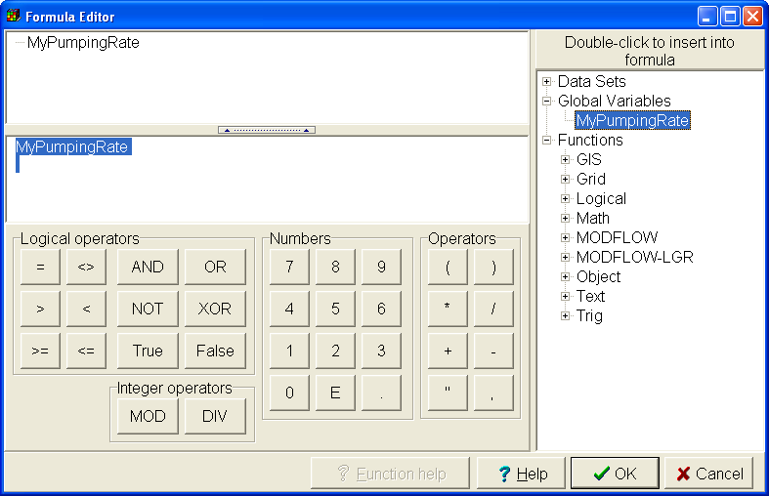
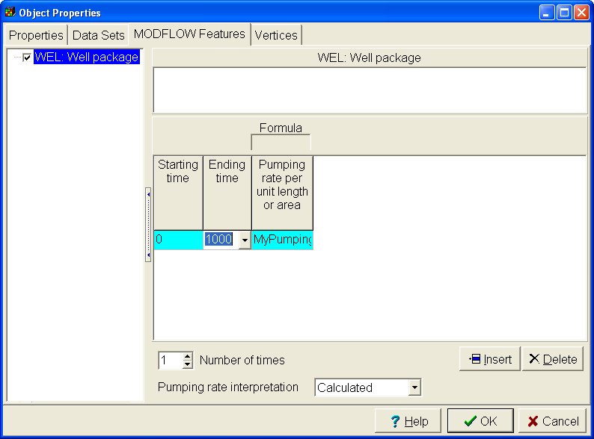
We aren’t specifying a number here. Instead we have a formula that links the pumping rate of the well to the global variable “MyPumpingRate”. If we change the value of the “MyPumpingRate”, the pumping rate of the well will be automatically updated. To illustrate this, we will color the grid with the well pumping rate and then change MyPumpingRate to a new value and check that the pumping rate has been updated.
- First zoom in on the area around the well by clicking on the “Zoom” button and then dragging with the mouse around the area with the well. You should end up with something similar to this.
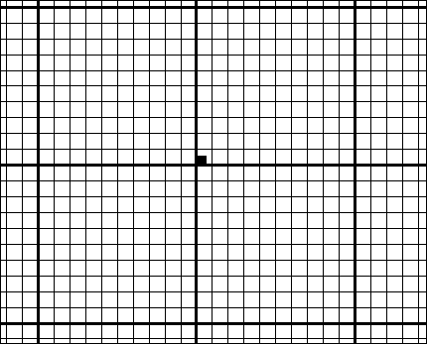
- Next select “Data|Data Visualization” and select “Color Grid”. Then select the well pumping rate (Boundary Conditions, Observations, and Other Features|MODFLOW Well|WEL Pumping Rate) and click “Apply”. Select “Data|Show Grid Values” and move the cursor over the well to check the pumping rate. It should be -200. You can see the pumping rate on the status bar.
- Next select “Data|Edit Global Variables” and change the value of MyPumpingRate to -300. Click Apply and check the pumping rate of the well. It now should be –300.
- ModelMuse has undo and redo buttons . Try clicking them and checking the well pumping rate to see if it changed.
Formulas can be used to link to data sets as well as to global variables. To illustrate this, we’ll use a formula to set the bottom of the layer to top of the layer minus a constant.
- Select “Data|Edit Data Sets…”
- Expand “Required|Layer Definition” and select the “Aquifer Bottom” data set.
- The default formula is -100. Click the “Edit formula” button to open the Formula Editor.
- On the right expand “Data Sets|Required|Layer Definition” and double-click on the Model_Top data set. In the edit window in the middle of the left side of the dialog box, change the formula to Model_Top – 80.
- Before closing the Formula Editor, expand the “Functions|Grid or Mesh”. Then click on one of the grid functions and click the “Function Help…” This will display the help for the selected function.

Stress Periods
Estimated time: 15 minutes
With ModelMuse, the stress periods that you define in the MODFLOW Time dialog box aren't necessarily the stress periods in the model as it is run. For example, you can define the times for a well pumping rate that differs from any of the times in the MODFLOW Time dialog box and ModelMuse will figure out that one or more additional stress periods are needed in order to match the times you have defined. However, if you define times earlier than the first time or after the last time defined in the MODFLOW Time dialog box, those times will be ignored.
To illustrate this, we will create a simple model with a single well that has times defined at times different from the times defined in the MODFLOW Time dialog box and see how ModelMuse handles the situation.
- Start a new MODFLOW 6 model. You can use the default grid.
- Select "Model|MODFLOW Time..."
- Change the number of stress periods to 2. Note that the second stress period is automatically set to be a transient stress period whereas the first stress period is a steady state stress period.
- Set the length of the second stress period to 31557600 seconds (= 1 year) and the maximum length of the first time step to 86400 seconds (= 1 day). Set the multiplier for the second stress period to 1.2. Click OK to close the dialog box.
- Activate the STO, CHD and WEL packages. (Activate them by selecting "Model|MODFLOW Packages and Programs..." and then check the check boxes for these packages.)
In MODFLOW 6, the only way to have a specified head cell is with the CHD package. You use objects to determine where the specified heads should be.
- We'll create two specified head boundaries at opposite corners of the model. Select "Object|Create|Point" and click in one corner of the model. The Object Properties dialog box will open. Note the formulas for the Higher and Lower Z coordinates. It is important to specify the Z-coordinate of the specified head objects to make sure they go into the correct layer. You do that by having 1 or 2 formulas for the Z-coordinate and setting them appropriately. In this case, the formulas should be "Model_Top" and " Upper_Aquifer_Bottom" which puts the object in the top layer. In the Object Properties dialog box, set the times for the CHD boundary to the times for the beginning and end of the model. (You can select these times from a drop down list that appears when you click the cells in the table for the starting and ending times.) Set both the starting and ending heads to 1. Click OK to close the object Properties dialog box.
Note that in the previous step, you did not need to specify separate values for each stress period. MODFLOW will take care of figuring out what values will be needed in each stress period.
- Locate the cube with the red square that indicates the selected layer. 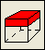 Click on the cube below the red square twice to change the selected layer to layer 3. 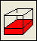
- Click in the corner of the model opposite where you created the first specified head boundary. Note that the formulas for the Z coordinate place the object in layer 3. Use this object to create another specified head boundary except this time set the head to 0. Try using the "Data Visualization" dialog box (Data Data Visualization|Color Grid) to show the specified heads in the model. Try changing the selected column, row, and layer to see how that affects what you see in the top, front, and side views of the model. Try using the mouse wheel while the cursor is over the top, front, or side views of the model. Try dragging with the mouse in the 3D view to see how that affects what you see in the 3D view. Try it again except hold the Shift key down when you drag. Finally, try it again while holding the right mouse button down.
- The next step will be to create a well in the center of the model. Change the selected layer to layer 2 and click close to the center of the model. In the Object Properties dialog box, go to the MODFLOW Features tab, select the Well package, change the “Number of times” to 2, and enter the values in the following table. (15778800 seconds = 1/2 year.) If you are working with an electronic copy of this document, you can select the entire table except the headings and copy it to the clipboard and then paste it into the table in the Object Properties dialog box. Click OK to close the Object Properties dialog box.
Starting time | Ending time | Pumping rate
0 | 15778800 | -0.002
15778800 | 31557600 | -0.02
- Use the Data Sets dialog box (Data|Edit Data Sets...) to change the hydraulic conductivity (Kx) to 1E-5.
- Run the model (File|Export|MODFLOW Input Files). ModelMuse will warn you that there are no wells defined in the first stress period. We didn’t intend to have any wells in the first stress period so we can ignore that warning. Before closing ModelMonitor, look at the Monitor tab and note that the model has 3 stress periods.
We'll use GW_Chart to look at how the head changes with time in the cell containing the Well. First, however, we need to identify the cell containing the well.
- In ModelMuse, put the cursor over the cell with the well in it and read the row and column number of the cell from the ModelMuse status bar.
- Start GW_Chart and select "Chart Type|Hydrographs".
- Enter the column, row, and layer number and click the "Read" button. In the Open File dialog box, change the “File of type” to “Binary head file (*.bhd)”. Select the "bhd" file for your model. You should see a graph of the head vs. time.
- Save your model for use in the next exercise.

Cell Type
In the Node Property Flow (NPF) package, cells can either be confined or convertible. A convertible cell is treated as unconfined if the head in the cell is below the top of the cell. It is treated as confined if the head in the cell is above the top of the cell. You set a cell type to convertible by setting the Cell_Type data set to a value greater than 0.
- Open the model from the previous exercise.
- Make the top layer the selected layer if it isn’t already the selected layer.
- Select “Object|Create|Polygon”
- Draw a polygon that completely surrounds the grid.
- Make sure that the higher and lower z formulas are set to the model top and the bottom of the top layer.
- On the Data Sets tab, check the check box for the Cell_Type data set and set its formula to 1 to make them convertible.
- Run the model but use a different file name than previously.
- Use GW_Chart to look at how the head in the cell with the well varies with time. Be sure to set the layer to layer 2 where the well is located. Compare it to the results when the top layer was confined.
- Try changing the pumping rate for the well for the times 0-15778800 to -0.008 and try running the model again. Did ModelMonitor show you anything different this time? Check the listing file for anything different that ModelMonitor might have shown you.

Layer Types
Estimated time: 10 minutes
In MODFLOW-2005, you set whole layers to confined or convertible instead of individual cells. Switch to a MODFLOW-2005 model and make sure the Layer Property Flow (LPF) and Preconditioned Conjugate Gradient (PCGA) packages are selected in the MODFLOW|MODFLOW Packages and Programs dialog box. In Layer Property Flow package, layers can either be confined or convertible. A cell in a convertible layer is treated as unconfined if the head in the cell is below the top of the cell. It is treated as confined if the head in the cell is above the top of the cell. You set the layer type in the MODFLOW Layer Groups dialog box.
- Open the model from the previous exercise. Select "Model|MODFLOW Layer Groups" and in the dialog box select the top layer in the list on the left. Change the top layer to a convertible layer.
- Run the model but use a different file name than previously.
- Use GW_Chart to look at how the head in the cell with the well varies with time. Be sure to set the layer to layer 2 where the well is located. Compare it to the results when the top layer was confined.
- Try changing the pumping rate for the well for the times 0-15778800 to -0.008 and try running the model again. Did ModelMonitor show you anything different this time? Check the listing file for anything different that ModelMonitor might have shown you.
- Save your model for use in the next exercise

Wetting
Estimated time: 15 minutes.
In the previous model, some cells went dry. In unconfined layers, MODFLOW has the ability to convert cells that have gone dry back to active cells. However, this capability is turned off by default. We'll try turning it on and seeing how the model results are affected.
- Select “Model|MODFLOW Options…” Go to the Wetting tab and check the checkbox for “Wetting active”. Click OK to close the dialog box.
Besides activating the wetting option, the wetting threshold and wetting flag need to be set.
- Select “Data|Edit Data Sets…”, expand “Required|Hydrology”, and select Wet_Dry_Flag. The formula for Wet_Dry_Flag can stay as it is but switch to the comment tab and read what it has to say there.
- Select Wet_Dry_Threshold and change the formula to 0.1.
- Select “WetDry” and examine its formula. The WetDry data set will be exported to MODFLOW. The Wet_Dry_Flag and Wet_Dry_Threshold are used to calculate WetDry. The ModelMuse help contains descriptions of the format for all the MODFLOW input files. Click the Help button and switch to the Search tab in the Help window. Search for “WetDry” to locate it in the help. choose the help for WETDRY in the LPF package. Locate WETDRY in the documentation for the LPF package. It is data set 16, the very last data set. Expand the description of WETDRY and read it.
- Run the model. After closing ModelMuse look for “CELL CONVERSIONS” in the listing file to see which cells went dry and if they converted back to active cells again.

Output Control
Estimated time: 4 minutes.
Sometimes you may wish to change how much information is printed or saved to file when you run MODFLOW. By default, ModelMuse is set up to instruct MODFLOW to save as much information as possible to file. It also will instruct MODFLOW to save the data as text files instead of binary files where possible. You can read the text files with any text editor whereas binary files can only be read by specialized programs. In this exercise, we’ll explore some of the options for controlling the output. We will continue using the model from the last exercise.
- Select “Model|MODFLOW Output Control…” Select “Head” on the left and change “N” to 5. Head will now be saved in time steps 1-5 of each stress period and then on steps 10, 15, and 20.
- Select “Budget” on the left and change “N” to 5. The budgets will now be printed in time steps 1-5 of each stress period and then on steps 10, 15, and 20. Click OK to close the dialog box.
- Try running the model. Is anything different in ModelMonitor when you run it?
- Try looking at the result with GW_Chart. Is anything different?
- Save your model for use in the next exercise.
You could also use the Output Control dialog box to do some other things:
- Have the heads or drawdowns saved in binary files or not at all instead of in text files
- Have the heads or drawdowns printed in the listing file
- Turn off printing of much of the input data in the listing file.

Spatial Variability without Parameters
Estimated time: 25 minutes
The following exercise will first show how to define spatial variability without using parameters. The exercise after that will show how it is done using parameters.
- Continue to work with the same model as before.
- Select Object|Show or Hide Objects. Then uncheck the check box for “All Objects” to hide all the objects.
- Change the selected layer to layer 1 if layer 1 is not already the selected layer.
- Select Object|Create|Polygon.
- Click on the top view of the model to start drawing a polygon. Have the polygon surround part of the grid. When you are finished, double-click and the Object Properties dialog box will appear.
- Switch to the Data Sets tab.
- Expand “Required|Hydrology” and check the check box for the Kx data set.
- Change the formula for Kx to 2E-5 and then click OK to close the dialog box.
- Select “Data|Data Visualization” and then select “Color Grid”, select the Kx data set and click Apply.
- Select Data|Show Grid or Mesh Values and move the cursor over the grid to see what the different colors represent.
- Locate the cube with the red square that indicates the selected layer. Click on the cube below the red square to change the selected layer to layer 2. 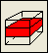 Did the object you drew before affect Kx on layer 2?
- Draw another polygon and use this one to set Kx inside the polygon to 3E-5. Did this polygon affect the values of Kx in layer 2? Did it affect the values of Kx on layer 1?
- Select “Object|Select Objects” and click on one of the objects that sets the value of Kx to select that object. Click on the object again but hold the mouse down and drag the object to a new position. How did moving the object affect Kx?
- Double click on the second object that sets the value of Kx to open the “Object Properties” dialog box. Change the formulas for the Higher Z-coordinate and Lower Z-coordinate so that they are “Model_Top” and “Middle_Aquifer_Bottom” respectively. (You can use the "Edit F()..." button to edit the formulas.) Click OK to close the dialog box. How does this change affect Kx?
- Drag one of the objects that sets the value of Kx so that it overlaps with the other object. What is the value of Kx in the area of overlap?
- Select the second of the two objects that sets the value of Kx data set. Then right-click and select “To Back”. How does this affect the value of Kx in the area of overlap between the two objects?
- Try drawing a polygon on the front or side views of the model, Can you use this object to set Kx values?
Next we’ll look at interpolation. It is only possible to use interpolation to set the value of 2D data sets directly. However, 2D data sets can be used to set the values of 3D data sets. We will create a new 2D data set and use it to set the value of a 3D data set.
- Select “Data|Edit Data Sets, and then click the Add button. Name the new data set Kx_Layer_3. (We will use it to set the value of Kx in layer 3.)
- Make sure the Orientation of the data set is set to “2D Top” and then set the Interpolation method for the new data set to “Triangle Interp.” and the default formula to 1E-5. Click Apply to set the value of the data set.
- Next we will create some point objects and interpolate among them. Select “Object|Create|Point.” Then click on the top view of the model.
- On the Properties tab of the Object Properties dialog box, set the number of Z-formulas to zero and check the check box for “Set values of cells by interpolation” and uncheck the one for “Set values of intersected cells.”
- Go to the “Data Sets” tab and expand “User Defined”. Check the check box for “Kx_Layer_3” and set the formula to 2e-5. Then click OK to close the dialog box. This will not affect Kx right away because we have yet to establish a linkage between “Kx_Layer_3” and “Kx”.
- Create several more points that set the values of Kx_Layer_3 by interpolation and assign a different value to each one.
- Make Layer 3 the active layer.
- Select "Object|Create|Polygon". Then draw a polygon that completely surrounds the grid. In the Object Properties dialog box, expand "Required|Hydrology" and check the check box for Kx. Set the formula to “Kx_Layer_3”. Did this set the value of Kx in layer 3 in the way you expected?

Spatial Variability with Parameters
Estimated time: 13 minutes
MODFLOW allows some of its input to be defined using a combination of parameters, multiplier arrays and zone arrays. The parameter defines a value for a certain type of input. Zone arrays restrict the application of the parameter to certain cells. Multiplier arrays are used to modify the value that is assigned to a particular cell by multiplying the parameter value by the multiplier array value for that particular cell. By defining the model input in terms of a small number of parameters, calibrating the model becomes a tractable problem. Calibration programs such as UCODE and PEST can then be used to find the combination of parameter values that cause the model to best match the observations.
Where the input data is in the form of lists of cells such as wells, parameters may still be defined but there are no multiplier or zone arrays. Instead, there is a list of cells associated with each parameter and a multiplier is defined for each cell in the list.
This exercise will show how to define spatial variability using the Parameters in MODFLOW-2005. Continue using the same model as before.
- Select "Model|MODFLOW Packages and Programs..."
- On the pane for the LPF package (which should already be selected), select HK from the list of parameter types and change the number of HK parameters to 1.
- The default name for the new parameter will be HK_Par1. Change the value for HK_Par1 to 1E-5. Don't check either checkbox for HK_Par1. Click the OK button to close the dialog box. How does this affect the distribution of hydraulic conductivity in the model?
When you use parameters to define aquifer properties, you can no longer set those properties directly with objects. Instead, you must use the parameter values in combination with multiplier or zone arrays to set the aquifer properties. If you don't define a zone array for a parameter, the parameter will apply to every cell.
- Select "Model|MODFLOW Packages and Programs...".
- On the pane for the LPF package define another KH parameter and set its value to 2E-5. Check the checkboxes for "Use Zone" for HK_Par1 and HK_Par2. This will cause zone arrays to be defined for both parameters. Click the OK button to close the dialog box. How does this affect the distribution of hydraulic conductivity in the model?
When you clicked OK, two new data sets were created HK_Par1_Zone and HK_Par2_Zone. Both data sets are Boolean data sets with default formulas of "False". You need to set those data sets to true in certain areas to cause the parameters to apply to those areas.
- Draw a polygon that surrounds part of the grid. In the Object Properties dialog box, go to the Data Sets tab and expand "Required|HK Parameter". Check the check box for HK_Par1_Zone and set the formula to True. Click the OK button to close the dialog box. How does this affect the distribution of hydraulic conductivity in the model?
- Draw another polygon that surrounds another part of the grid. Don't let it overlap the previous object. Check the check box for HK_Par2_Zone and set the formula to True. Click the OK button to close the dialog box. How does this affect the distribution of hydraulic conductivity in the model?
- Now move one of the objects so that it overlaps with the other one. How does this affect the distribution of hydraulic conductivity in the model?
If two parameters apply to the same cell, the parameter values will be added together when calculating the hydraulic conductivity for that cell.
You may wish to make sure that the edges of the two objects used to define zone arrays match each other exactly with neither an overlap nor a gap between them. To do this, you need to select vertices of one object and move them so that they match up with the vertices of the other object. ModelMuse provides an easy way to do this.
- Select Object|Select Vertices and click on one of the vertices of the selected object. The selected vertex will change from a solid square to a hollow square.
- While holding the Shift key down, use the mouse to drag the selected vertex to one of the vertices of another object. When it is in the vicinity of the other object, the cursor will change to one showing a small black circle at the end of the arrow. If you release the mouse button when the cursor is in this state, the vertex that you are dragging will snap to the position of the other vertex.
Next we will look at the effect of Multiplier arrays.
- Select "Model|MODFLOW Packages and Programs...".
- On the pane for the LPF package, check the checkboxes for "Use Multiplier" for HK_Par1 and HK_Par2. This will cause multiplier arrays to be defined for both parameters. Click the OK button to close the dialog box. How does this affect the distribution of hydraulic conductivity in the model?
By default, the multiplier arrays will have a uniform value of 1 so at this point, they don't result in a change in the value of Kx.
- Draw another polygon and have it overlap both the previous polygons. In the Data Sets tab of the Object Properties dialog box, expand "Required|HK Parameter" and check the check box for HK_Par1_Multiplier. Set the formula to 0.3 and click the OK button. How does this affect the distribution of hydraulic conductivity in the model? Did it change the hydraulic conductivity in the area affected by HK_Par1? What about in the area affected by HK_Par2?

Wells with Parameters
Estimated time: 6 minutes
Earlier, we defined a well for this model. You can define wells using parameters too. You define parameters for the Well package in the MODFLOW Packages and Programs dialog box. Then you use objects to define the wells in a way similar to how you define them without parameters.
- Select “Model|MODFLOW Packages and Programs…” Expand “Boundary conditions|Specified flux” and select the Well package.
- On the pane for the well package, change the number of parameters to 1 and assign the parameter a value of -0.002. Click OK to close the dialog box.
- Select “Object|Create|Point” and then click on the top view of the model. On the MODFLOW Features tab, check the check box for the Well package. Note that at the top of the page is a checkbox for the well parameter we just defined. Check that checkbox.
When you check the checkbox for the well parameter a new column appears in which you can enter a pumping rate multiplier.
- Select the starting and ending times for the well as -1 and 31557600. Then enter a value of 0.5 for the pumping rate multiplier. Do not enter anything for the pumping rate. Click OK to close the dialog box.
If you enter a value for the pumping rate, you will be defining a well that does not use parameters. That isn’t what we desire here. If you were to enter a value for both the pumping rate and the pumping rate multiplier, you would define two separate wells. One well would use parameters and the other would not.
- Color the grid with the well pumping rate and examine that pumping rate for the well you just created. It should have a value of -0.001 which is the product of the parameter value (-0.002) and the multiplier value (0.5).

Pumping Rate Interpretation
Estimated time: 14 minutes.
You may have noticed that on the pane for the wells in the Object Properties dialog box, that there was a combo box labeled “Pumping rate interpretation”. For point objects, it doesn’t matter what you choose; the pumping rates are unaffected by the Pumping rate interpretation for point objects. However, you can also define wells using lines or polygons. Of course a polygon wouldn’t really represent a well but you can use the well package to simulate any boundary condition in which the flow is specified. For example, a polygon might represent an infiltration pond or a line might represent a river that loses water to the aquifer at a constant rate. The “Pumping rate interpretation” can be helpful in these circumstances. There are three choices for “Pumping rate interpretation”: Direct, Calculated, and Total per layer.
- With Direct, each well gets the value you specified
- With Calculated, the pumping rate will be multiplied by ObjectIntersectLength (for lines) or ObjectIntersectArea (for polygons) That makes the pumping rate actually a pumping rate per unit length or a pumping rate per unit area.
- With Total per layer the pumping rate will be divided by ObjectLength and then multiplied by ObjectIntersectLength (for lines) or divided by ObjectArea and then multiplied by ObjectIntersectArea (for polygons) That makes the pumping rate actually the total pumping rate for the object so long as the object is on a single layer. It an object applies to several layers, it will be the total rate for each layer. Note that for this to work with polygons, you have to choose to set the values all the cells intersected by the polygon not just those whose centers are enclosed by the polygon.

- Select “Object|Create|Polygon” and then draw a polygon object by clicking several times on the top view of the model. Double-click to finish the polygon. Use the polygon to define a Well boundary and choose the “Tota per layerl” Pumping rate interpretation. Be sure to check the check box for “Set values of intersected cells” as well as “Set values of enclosed cells.” Check the pumping rate assigned to each cell defined by this object. Add up the pumping rates and see if they add up to the pumping rate you specified.

Drains, Rivers, and General Head Boundaries
Estimated time: 6 minutes
Drains, Rivers and General Head Boundaries are defined in ModelMuse in much the same way as the Well boundary.
- Select "Model|MODFLOW Packages and Programs", expand "Boundary conditions|Head dependant flux" and check the check boxes for the DRN, GHB, and RIV packages. Note that you can define parameters for these packages as well. If you want to, you can define comments for the packages. The comments will be included at the beginning of the input files generated by ModelMuse for the packages. Click OK to close the dialog box.
- Try using objects to create drain, river, or general head boundaries. If you defined any parameters for the package, you can check the check boxes for them in the Object Properties dialog box. The parameters affect the conductance assigned to the Drain River, or General-Head boundaries. The "Conductance Interpretation" in these packages is handled in the same way as the "Pumping rate interpretation" in the well package.

Recharge
Estimated time: 24 minutes
Recharge is specified in ModelMuse in much the same way that wells are specified. However, the Recharge Package gives you the option of the having the recharge applied to the top layer, a specified layer or the top active cell. If you want the recharge to be applied to a specific layer, you can have the recharge be applied to the same layer in every stress period or to vary between stress periods.
One difference between the well package and the recharge package is that if you define any parameters, all the recharge must be defined using parameters. You aren't allowed to use parameters to define recharge in one place and not use parameters to define recharge somewhere else.
Another difference between the two packages is that in the Well package, you can have more than one well in a cell but with the recharge rate, there is only one value per cell. However, you can have more than one recharge parameter apply to a cell and in that case the recharge rate will be the sum of the rates defined for each parameter. In addition, you can only apply recharge to one of the layers for any particular row and column.
- First we will use the simplest option of assigning the recharge to the top of the model. Select "Model|MODFLOW Packages and Programs..." Expand "Boundary conditions|Specified flux". Check the checkbox for the RCH package and then click OK to close the dialog box. Note that "Recharge location" option is set to "Top layer".
- Make the second layer the active layer and draw a polygon object on the top view of the model. Only cover part of the grid with the polygon.
- In the Object Properties dialog box, check the checkbox for the RCH package and assign starting and ending times and a recharge rate. Click OK to close the dialog box.
- Color the grid with the recharge rate. Which layer needs to be the active layer to see the colored grid? What value is assigned to cells outside the polygon? If you try to color the grid with the recharge layer, it won't work; recharge will be automatically applied to the top cell and the recharge layer will not be calculated by ModelMuse or MODFLOW.
- Go back the RCH package pane in the "MODFLOW Packages and Programs" dialog box and change the "Recharge location" option to "Specified layer". Click OK to close the dialog box.
- Now try coloring the grid with the Recharge layer. On which layers can you see the colored grid?
- Go back to the RCH package pane in the "MODFLOW Packages and Programs" dialog box and check the check box for "Time varying recharge layers. Click OK to close the dialog box.
- Now double click on the object used to define recharge to open the Object Properties dialog box. Go to the MODFLOW Features tab and select the Recharge Package. There should now be a column for the recharge layer. Assign a value for the recharge layer. Click OK to close the dialog box. Try coloring the grid with the recharge layer.
- Go back the RCH package pane in the "MODFLOW Packages and Programs" dialog box and change the "Recharge location" option to "Top active cell". Click OK to close the dialog box.
- Now try coloring the grid with the Recharge layer. Is the grid colored? If not, why not? If so, explain.
- Go back the RCH package pane in the "MODFLOW Packages and Programs" dialog box and define a recharge parameter. Click OK to close the dialog box.
- Now try coloring the grid with the Recharge rate. Is the grid colored?
- Double-click on the object you previously used to define the recharge to open the Object Properties dialog box. Go to the MODFLOW Features tab and select the Recharge Package. There should be a checkbox for the recharge parameter at the top of the pane. Check it and assign the recharge times and the recharge rate multiplier. Click OK to close the dialog box.
- Now try coloring the grid with the Recharge rate. Is the grid colored?
- Go back the RCH package pane in the "MODFLOW Packages and Programs" dialog box and define another recharge parameter. Click OK to close the dialog box.
- Create another polygon object that overlaps the first object used to define the recharge rate. When you have finished creating the polygon object, go to the MODFLOW Features tab and select the Recharge Package. There should be a checkbox for the new recharge parameter at the top of the pane. Check it and assign the recharge times and the recharge rate multiplier for the new parameter. Click OK to close the dialog box.
- Now try coloring the grid with the Recharge rate. What values are assigned in the areas where the objects do not overlap? What values is assigned in the area where the objects do overlap?
Each parameter that is used to define the recharge rate also will have a zone array associated with it. You don't need to define the zone arrays yourself because ModelMuse uses the objects associated with each parameter to define the zone arrays.

Evapotranspiration
Estimated time: 9 minutes
The input for the EVT (Evapotranspiration) package is defined in the same way as the Recharge package. However, with the EVT package, you must define the Evapotranspiration Surface and Evapotranspiration depth in addition to the rate. Furthermore, the rate that is actually computed by MODFLOW will often be less than the rate you specify because the rate is actually a maximum rate. If the head in a cell is greater than or equal to the evapotranspiration surface, the evapotranspiration rate will be the maximum rate. If the head in the cell drops far enough, no more evapotranspiration from the cell will be simulated. The Evapotranspiration depth says how far below the evapotranspiration surface the head has to fall before evapotranspiration from the groundwater ceases. (There still may be evapotranspiration from the unsaturated zone but that is not part of the model.) One reasonable estimate of the evapotranspiration depth would be the rooting depth because if the head drops below the rooting zone, it isn't likely that any more transpiration from the groundwater will occur.
- Select "Model|MODFLOW Packages and Programs", expand "Boundary conditions|Head dependant flux" and check the check box for the EVT package. Note that you can define parameters for the EVT packages.
- Try using objects to define the Evapotranspiration boundaries. If you defined any parameters for the EVT package, you can check the check boxes for them in the Object Properties dialog box. The parameters affect the maximum evapotranspiration rate.

Creating Grids
Estimated time: 31 minutes
Thus far, the models we have used have all had uniformly sized grid cells and flat layers and were not rotated with respect to North. In this exercise you will get practice in generating more complex grids.
We will create the grid at the (X,Y) coordinates (2.9E5 m, 4.319E6 m) with cells 200 m on a side. (The grid will cover parts of Fairfax County, VA where the USGS headquarters is located.) To move to the correct location, do the following
- Start ModelMuse and create a new MODFLOW model.
- Enter the coordinates for the grid origin, set the number of columns and rows to 100 each and the widths of the columns and rows to 200. Set the number of layers to 1. Assign an appropriate name to the single layer. Set the bottom of the layer to 0 and the top of the model to 100. Click the Finish button.
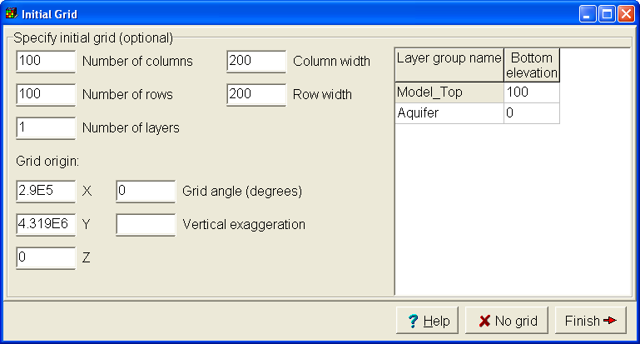
- The coordinates of the model are in meters so select “Model|MODFLOW Options” and, on the “Options” tab, check that the length unit is meters.
- Instead of having a uniform top elevation, let’s import the elevations from a digital elevation model. Select “File|Import|Sample DEM Data…” and select the file “washington-w.txt” (This file comes from http://edc2.usgs.gov/geodata/index.php in the “Alphabetical List” under “1:250,000 Scale Digital Elevation Models (DEM).”)
- In the “Sample Digital Elevation Model” dialog box, change the data set to “Model_Top” and the Filter method to Average of points in cell. Click the OK button. ModelMuse should now look similar to the figure below.
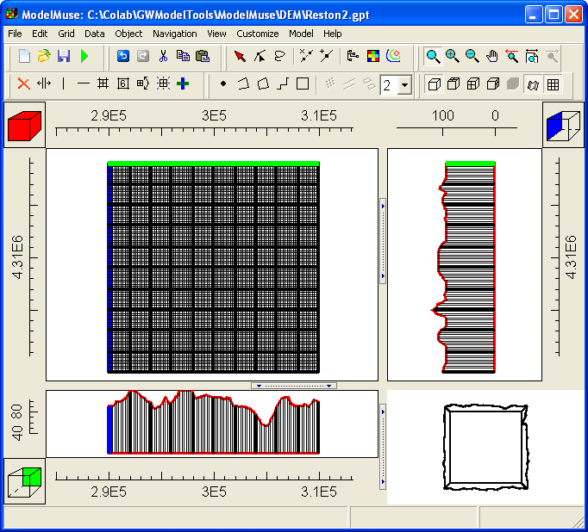
- It can be helpful to color the grid with the elevation of the top of the model to see what it is like. Select “Data| Data Visualization|Color Grid…” and select “Model_Top” under “Data Sets|Required|Layer Definition”. Hiding the grid lines is helpful in this case so select “View|Show or Hide 2-D Grid|Show Exterior” to turn off the display of the grid lines. You should end up with something similar to this.
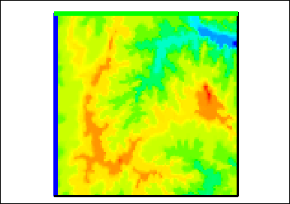
- To see the elevation at an individual cell, select “Data|Show Grid Values”. You can see the value for an individual grid cell when you move the mouse over the cell. You can also see an explanation of how the value was assigned.
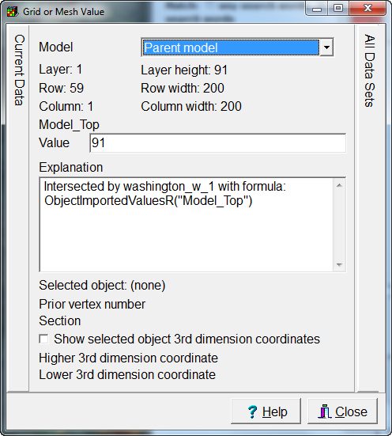
- To get a better idea of what the explanation means, let first locate “washington_w_1”. Select “Object|Show or Hide Objects”. Then expand “Data Sets|Required|Layer Definition|Model_Top”. Check the checkbox next to “washington_w_1”
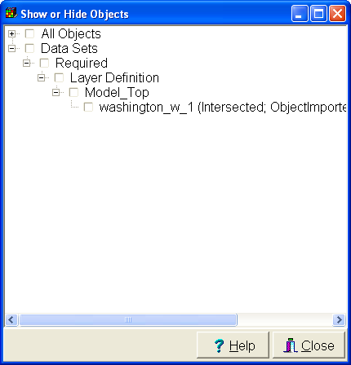
- When you display the washington_w_1 object, the top view of the model will turn black. This is because the object has a vertex in every cell and the cells are small enough that the vertices appear to overlap. To see individual vertices zoom into a small part of the model. To do this select “Navigation|Zoom” and then drag with the cursor over a small area of the model. The area you outline while dragging with the cursor will be displayed. You should now be able to see that there is a vertex in the center of every cell as illustrated below.
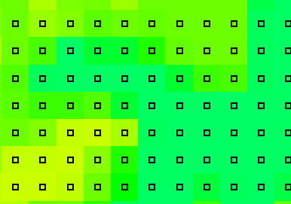
- Select “Object|Select Objects” and then double-click on one of the vertices of the object to show the properties of the object in the Object Properties dialog box. Go to the Vertices tab and note that there is a check box in the “New section” column next to each vertex. This indicates that there is not a line connecting this point and the previous one.
- Go to the Data Sets tab and expand “Required|Layer Definition. You will see that “Model_Top” is checked. If you select Model_Top, you’ll see that the formula used to assign values is ObjectImportedValuesR("Model_Top"). This formula gets a separate value for each section of the object from the values listed on the “Imported Data” tab. Select the “Imported Data” tab to see the values stored there. Click the Cancel button to close the Object Properties dialog box. Then hide the “washington_w_1” object again.
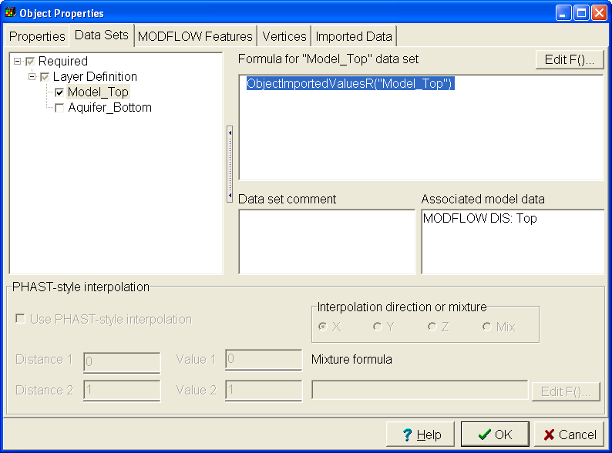
- Save the ModelMuse file now for use in a subsequent exercise. Then save it again with a different name so you can be sure you don’t accidentally overwrite the previous version. In the remainder of this exercise, we will make some changes to this model that we won't want to include when we use this model in the next exercise.
- What would happen to the elevations if you changed the grid? First select "Navigation|Restore default 2D view" . Let’s try subdividing some of the cells and see what would happen. Select “Grid|Subdivide Grid Cells”. Then drag with the mouse over the center part of the grid. When you release the mouse a dialog box will appear. In it, subdivide the selected columns and rows into three and click the OK button.
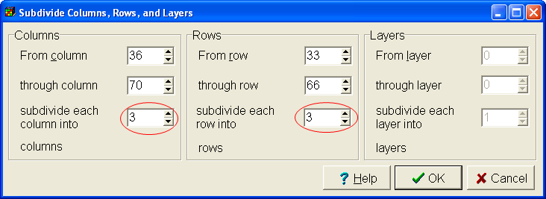
- You will probably get something similar to this.
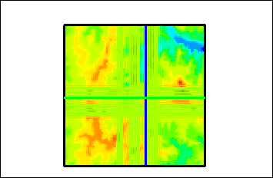
- You can select “Data|Show Grid Values” to find out what is going on. In many places, the elevations are no longer being set by the “washington_w_1” object but are instead being set by a default formula for the data set. These are cells that are not intersected by the “washington_w_1” object.
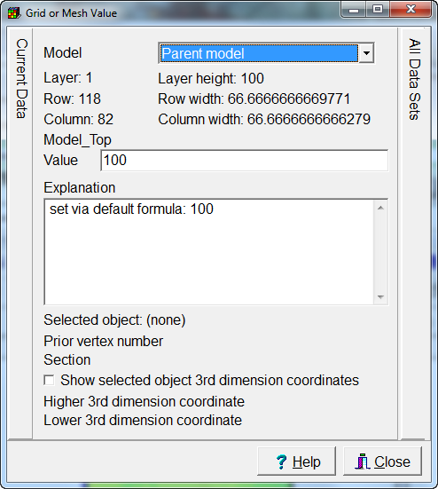
- You could just sample the digital elevation model again but there is another way to handle the problem. Select Data|Edit Data Sets and select the Model_Top data set. Change the interpolation for it to “Fitted Surface” and click Apply.
- Next select “Object|Edit|Select Objects for Editing or Deletion. Locate the the “washington_w_1” object in the dialog box and check its check box. Then click the “Edit” button.
- The Object Properties dialog box will appear. On the Properties tab, uncheck “Set values of intersected cells” and check “Set values of cells by interpolation”. Then click OK. Now, the top elevations will be interpolated among the points specified by the “washington_w_1” object.
- After subdividing the grid cells, we have rather abrupt changes in the grid cell size as illustrated below. To see this, first turn off coloring the grid by selecting “Data| Data Visualization|Color Grid…” and then selecting “None”. After you click “Apply”, select “View|Show 2-D Grid” and zoom in on a location where the grid cell sizes change.
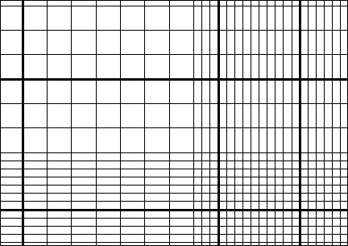
- It is usually better to have a less abrupt change in grid cell size. To smooth out the variations in cell size, select “Grid|Smooth Grid..” Check the check boxes for columns and rows and click OK. The results are illustrated below. There is no longer an abrupt transition in cell size as shown below.
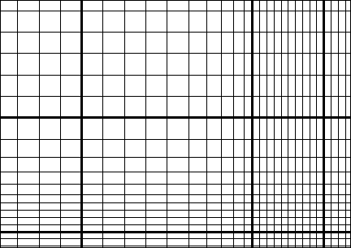
- You can also use objects to define where the grid should be and how big the cells should be. Let’s try that approach. Create a polygon or rectangle object around the area where you want the model grid to be. (This should be approximately the same as where it is now.) When you are finished creating the object and the Object Properties dialog box appears, check the “Use to set grid cell size” checkbox and set the “Grid cell size” to 200. Click OK to close the dialog box.
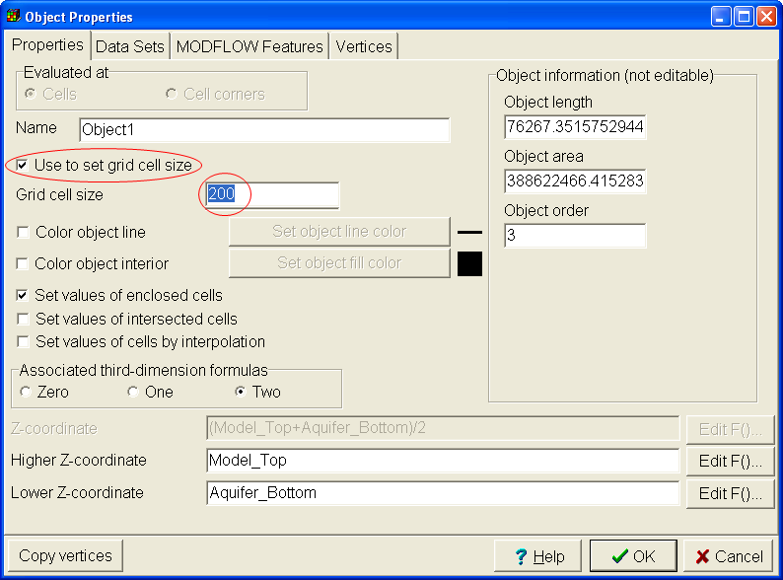
- Next draw another polygon or rectangle object around the area where you want the refined grid to be. Again check the “Use to set grid cell size” checkbox but set the “Grid cell size” to 50. Click OK to close the dialog box.
- Now select “Grid|Generate Grid” and click OK. A new grid will be generated with a smooth transition in cell sizes.
- You can edit the grid in a variety of other ways too. Try out some of the options under the Grid menu and see what they do.

Importing Background Map
Estimated time: 7 minutes
In this exercise you will import several images for use in your model. The images include orthorectified scans of USGS topographic maps and aerial photos that came from http://msrmaps.com. (This was a free service from Microsoft Research. The images displayed on the web site came from the USGS.)

- Reopen the model you saved in the middle of the previous exercise.
- Select “File|Import|Image…” The “Import Image” dialog box will open.
- Click the “Select Image” button and select AerialPhoto.jpg. This is an aerial photo of the modeled area. The URL for this particular image is
http://msrmaps.com/download.aspx?T=4&S=15&Z=18&X=46&Y=672&W=3&qs=12201+Sunrise+Valley+Dr|Reston|VA|
If you go to that URL and select the “Info” link, you can get the UTM coordinates of the image. The coordinates for the upper left corner are (281600.0, 4320000.0). The coordinates for the lower right corner are (313600.0, 4294400.0).
- When you have selected the image a message will appear telling you to “Click on the image and assign real-world coordinates to the points you clicked or fill in the information in the table.” In this case we will increase the number of rows in the table to 2 and fill in the information in the table using the data below. Then click the “OK” button. Select Edit|Show or Hide Images to hide the image.
Pixel X | Pixel Y | X | Y
0 | 0 | 281600 | 4320000
999 | 799 | 313600 | 4294400

- Import the other two images (Map.jpg and DetailedMap.jpg) the same way. For Map.jpg use the same coordinates as you used for AerialPhoto.jpg. For DetailedMap.jpg, use the following coordinates. Select Edit|Show or Hide Images to select which images you want to be visible. Both these images came from msrmaps.com too.
Pixel X | Pixel Y | X | Y
0 | 0 | 293600 | 4314400
999 | 799 | 295600 | 4312800
- Save this model for use in the next exercise.

Importing Rivers from a Shapefile
Estimated time: 1 hour, 15 minutes
In this exercise, you will import the locations of streams and rivers from a Shapefile. You can get the Shapefile used in this exercise at http://nationalatlas.gov/atlasftp.html?openChapters=chpwater#chpwater. It is labeled Streams and Waterbodies and is named hydrogm020.tar.gz. (This is a compressed file which must be uncompressed before it can be read.) Here is how we import the data.
- Select "File|Import|Shapefile..."
- Select hydrogl020.shp and click Open.
- In the "Import Shapefile" dialog box, check "Set values of intersected cells." Also set "Number of Z-formulas" to "One" and set the Z-coordinate formula to "10."
- On the Data tab, check the checkbox for "Name".
- This file has its coordinates in decimal degrees. We'll convert them to UTM coordinates. On the Coordinate Conversion tab, check the "Convert coordinates" check box and set the UTM zone number to 18. Leave the ellipsoid set to the default selection.
This Shapefile contains data from the entire United States. We only want to import data from Virginia and Maryland. We can use the "Import criterion" to do this. The "Import criterion" on the "Options" tab is a formula that will be evaluated for each Shape in the Shapefile. Only if the formula returns true for a particular shape, will it be imported. You can use the Shapefile attributes in the formula. In this case the "STATE" attribute can help us filter the data. The STATE attribute contains the abbreviation of the state (or states) in which the feature resides. If a feature crosses a state line, the abbreviation of all the states that it intersects will be included. Thus we need a formula that tests whether the STATE attribute includes either "VA" or "MD". The "Pos" function can do this. Pos(SubText, Text_Value) returns the position of the first instance of SubText within Text_Value. If SubText does not occur within Text_Value, Pos returns zero. Thus
Pos("VA", UpperCase(STATE)) > 0
would be true if STATE includes "VA" and
Pos("MD", UpperCase(STATE)) > 0
will return true if state includes "MD". Therefore,
(Pos("VA", UpperCase(STATE)) > 0) OR (Pos("MD", UpperCase(STATE)) > 0)
will test whether STATE contains either "VA" or "MD".
- On the "Options" tab click the "Edit F()" button for the Import Criterion. The formula editor will open. Use it to enter the formula. The "Pos" and "UpperCase" function can be found under "Functions|Text." "STATE" can be found under "Attributes." Click OK to close the Formula Editor and then click OK again to close the "Import Shapefile" dialog box and to start the import process. This may take a while.
- When you have finished importing the Shapefile, compare the rivers that were imported with those shown on Map.jpg. Decide for yourself whether the data that were imported are sufficiently accurate as to position and whether any important rivers or streams were omitted. For the purposes of this exercise, however, do not define additional rivers now.
Many of the rivers and streams that were imported lie outside the model grid. Because those won't affect the model we can delete them.
- The first step in deleting them is to hide all the objects that are inside the grid. Click on one of the objects that is inside the grid. Then hold down the shift key and click on the others until all the objects inside the grid have been selected. It may be helpful to hide the images first by selecting “Edit|Show or Hide Images.”
- Right-click and select "Hide Selected Objects"
- Right-click again and select "Select All". Then press the "Delete" key on the keyboard to delete the selected objects.
Now that the Shapefile has been imported, we can use the imported objects to define rivers in the River package. First however, we will change the single layer in the model from confined to convertible and examine the stress periods.
- Select "Model|MODFLOW Layer Groups" and change the layer type to convertible.
- Select "Model|MODFLOW Time..." The MODFLOW time dialog box appears. By default, the model has a single steady-state stress period that ends at time zero. Click "Cancel" to close the dialog box.
- Now activate the River package by selecting "Model|MODFLOW Packages and Programs..." Expand "Boundary conditions|Head-dependent flux" and check the check box for the River package. Then click the OK button.
- Next display the objects imported from the Shapefile. Select "Object|Show or Hide Objects". Expand "Data Sets" and check the checkbox for "User Defined".
- Select "Object|Select Objects" and then right-click on the top view of the model and select "Select All". Then double-click on one of the objects. The Object Properties dialog box will appear. Because you are editing more than one object, the Vertices tab is not visible.
- Go to the MODFLOW Features tab and check the check box for the River package. Set the starting and ending times to -1 and 0 respectively. Click the cell in the table for River Stage and a button will appear in the cell. Click the button and the Formula Editor will appear. Set the Formula to "Model_Top". (You can find Model_Top under "Data Sets|Required|Layer Definition".) Set the river Bottom to "Model_Top – 0.6." (The streams in this area are generally incised by about 2 feet (0.6 m). Set the Conductance per unit length or area to 2e-7. Click OK to close the dialog box.
- Let’s take a look at the river data we have defined. Select “Data| Data Visualization|Color Grid…” and then select RIV stage under “Boundary Conditions, Observations, and Other Features|MODFLOW River.” And click the Apply button. (You may wish to hide the objects again.) Examine how the river stage varies along the length of the river. (The river appears to be going uphill in some locations!) To see exact values of the river stage for a particular cell, select “Data|Show Grid Values” and place the cursor over a cell. In the Data Visualization dialog box, switch to RIV Conductance. Note the conductance varies depending on how much of a cell was intersected by one of the objects that define a river. (The value we entered in the Object Properties dialog box was conductance per unit length. Here we see the conductance.)
Another Shapefile contains additional rivers for the model. It was digitized from the larger map used as a background image in this model. The Shapefile contains a single attribute, RIVCOND, that represents the river conductance. We will import this Shapefile but instead of just importing the geometry, we will import the river conductance too.
- Select "File|Import|Shapefile..." and select AdditionalRivers.shp. Check the check box for "Set values of intersected cells'. Change the "Number of Z-formulas to One and set the Z-coordinate to 10. Set "Imported shapes should be selected". On the Features tab, change the "Feature choice" to the River package. Enter the Starting and Ending times as -1 and 0 respectively. Ignore the parameter name because parameters aren't used in this model. Set the river bottom to 0. (We'll change that to Model_Top - 0.6 later.) Set the River stage to Model_Top. Set the Conductance to RIVCOND. Do NOT use the coordinate conversion option. This Shapefile already uses the coordinate system of the model. Click the OK button.
- All the newly imported objects are selected. Double-click on one of them and go to the data for the river package. Set the river bottom to "Model_Top - 0.6".
To complete the model, we need to define the recharge, hydraulic conductivity and initial head.
- First activate the recharge package. (Select Model |MODFLOW Packages and Programs, expand “Boundary conditions|Specified flux” and check the check box for the Recharge package.)
- Next create a polygon that completely surrounds the grid. In the Object Properties dialog box, go to the MODFLOW Features tab and check the check box for the Recharge package. Enter the starting and ending times to -1 and 0 respectively and the recharge rate to 2e-9. Click OK to close the Object Properties dialog box.
- To set the hydraulic conductivity and initial head select “Data|Edit Data Sets…” Expand Required|Hydrology and select the Kx data set. Set the formula to “3e-5”. Then select the MODFLOW_Initial_Head data set and click the "Edit formula" button to shown the Formula Editor. Expand “Data Sets|Required|Layer Definition” and double-click on “Model_Top” Click OK to close the Formula Editor. "Model_Top" should now be the default formula for MODFLOW_Initial_Head. Click Apply and close the Data Sets dialog box.
- To run the model select File|Export|MODFLOW Input Files. In the "Save MODFLOW input files" dialog box, be sure that the "Execute model" checkbox on the lower left is checked and click the Save button. ModelMuse will start exporting the MODFLOW input file. When it is done, it ModelMonitor will start. It reads the output from MODFLOW as it is being generated and displays some of the data. The Results tab in ModelMonitor shows the percent discrepancy in each time step for which a budget is printed. If the absolute value of the percent discrepancy is greater than 1% that is a sign that there is a problem with the model. (However, just because the percent discrepancy is OK doesn't mean the model is OK.) If any error or warning messages are printed by MODFLOW, they will be shown on the Listing tab. In this case, there are no error or warning messages and the percent discrepancy is OK so a green smiling face is displayed by ModelMuse. A red frowning face or a yellow neutral face could be displayed depending on the results of the model.
- Close ModelMonitor. When you do the listing file will be opened in Notepad. You can close it. There is also a command line window. This is for a batch file that ran ModelMonitor and Notepad. You can close it too.
- Let's look at the model results to see if they are reasonable. Select "File|Import|Model Results..." The file containing the heads should have the extension "fhd" (for formatted heads) and should already be selected by default. If it is not selected, select it and click the Open button.
- The heads in the file will be displayed in the "Select Model Results to Import" dialog box. Because there was only one time step in this model, only one set of heads will be displayed. It should already be selected. Leave all the defaults set as they are and click the OK button. The grid will be colored with the head distribution.
Let's see if any of the computed heads are above ground level. To do that we will create a new data set that represents the difference between the computed head and the top of the model. We'll use that data set to create a map of the heads that are above ground level.
- Select Data|Edit Data Sets and click the Add button. Change the name of the new data set to "Above_Ground_Heads" and change its Orientation to 3D. Then click the "Edit Formula" button to open the Formula Editor. Expand "Data Sets|Optional|Model Results|3D Data" and double click on the data sets for heads (Head_P1_S1). "P1" in the name indicates Stress Period 1. S1 in the name indicates Time Step 1. Then click the button for the minus sign in the "Operators" group of button. Then expand "Data Sets|Required|Layer Definition" and double-click on "Model_Top". The formula should now be "Head_P1_S1 - Model_Top". Click the OK button to close the Formula Editor and then click the Apply button and close the Data Sets dialog box.
- Select "Data| Data Visualization|Color Grid..." and select the "Above_Ground_Heads" data set and click the Apply button. Then go to the Filters tab, check the check box for the lower limit, and set the lower limit to 0. Click the Apply button again. Any cells that are colored will be cells in which the computed head is greater than the top of the model.
- Let's take a look at the flux through the rivers. Select "File|Import|Model Results..." and select the file with the extension "cbc" (standing for cell-by-cell flow). This is a binary file produced by MODFLOW that has the flux terms for each cell. In the dialog box, check the checkbox for the River leakage and unselect the one for Recharge. Click the OK button.
- River leakage will be zero in cells that don't have rivers. To only color the cells with non-zero river leakages select "Data| Data Visualization|Color Grid..." and on the Filters tab, type a 0 in the table for Values to ignore. Then click the Apply button. Negative values of river leakage indicate flow from the groundwater into the river. Positive values indicate flow from the river to the groundwater. Change the lower limit to zero to see only flow from the river to the groundwater. Decide for yourself whether you think these values are reasonable.

MODPATH and Horizontal Flow Barrier (HFB) package
Estimated time: 31 minutes
For this exercise, we will use an example model that comes with ModelMuse. It is a very simplified model of the Rocky Mountain Arsenal. We will add MODPATH information to the model and then see how the pathlines change when we introduce a barrier to flow with the Horizontal Flow Barrier package.
- Open rma.gpt. By default, it will be in “C:\Users\Public\Documents\ModelMuse Examples\examples\MODFLOW”.
Flow is generally from North to South. There is a lake (in dark blue) in the north and a stream (light blue) in the south. There are two basement outcrops (purple) that are modeled as impervious zones. Two wells (green) lie south of the impervious zones and an infiltration pond (red) lies north of them. The water quality of the infiltrated water isn’t satisfactory. We want to get some idea of where that water will end up. We will use MOPATH for that purpose. The lake and stream are modeled as constant head boundaries. The infiltration pond and wells are modeled as wells.

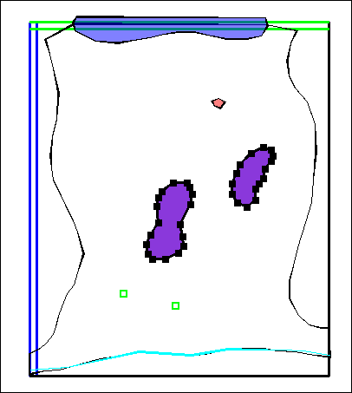
- MODPATH has already been activated. Select “Model|MODFLOW Packages and Programs…” Then expand "Post processors" and note that check the checkbox for MODPATH has been checked.
- On the “Response file options” tab for MODPATH, note that Pathlines is selected. Change the Modpath version to “6”. On the “Output times” tab, note that the time interval for Output has been changed to 10000
- Click OK to close the dialog box.
- You will get a warning the head output file is the wrong type for MODPATH. Select Model|MODFLOW Output Control and change the External file type to Binary.
- Now double-click on the polygon that represents the infiltration pond to open the Object Properties dialog box. This is the source of MODPATH particles.
- In the MODFLOW Features tab, select MODPATH and note that the check box for “Initial particle placement” is checked. Under “Initial particle placement”, the “Number of rows in the X direction” has been set to 5. Click the OK or Cancel button to close the dialog box.
- Run MODFLOW (“File|Export|MODFLOW input files”). By default MODPATH will also run after MODFLOW has been run. You can run MODPATH separately by selecting (“File|Export| MODPATH input files”).
- When MODPATH is done, we will want to import the pathlines into ModelMuse. Select “Data|Data Visualization” and then select MODPATH Pathlines. In the MODPATH Pathline Display dialog box, select the Pathline file (rma.path) and then click Apply.
- It has been proposed that a barrier between the two bedrock outcrops will make it less likely that the water from the infiltration pond will reach the wells. We will test this hypothesis. Our next step will be to define a barrier to horizontal flow using the Horizontal Flow Barrier package.
- Select “Model|MODFLOW Packages and Programs…” Then expand “Flow” and check the checkbox for the HFB (Horizontal Flow Barrier) package.
- Now draw a polyline object between the two bedrock outcrops. It will represent a horizontal flow barrier. In the Object Properties dialog box, select the MODFLOW Features tab and check the check box for the HFB package. For the “Angle adjustment method”, select the third choice. Click OK to close the dialog box.
- Color the grid with the Hydraulic Characteristic (Hydr Characteristic). Horizontal flow barriers are defined at the boundary between two cells so some of the grid cell boundaries will become colored but the cells themselves will remain uncolored.
- Use the Grid Value dialog box to determine the Hydraulic Characteristic of some of the horizontal flow barriers.
The “Angle adjustment method” for horizontal flow barriers deserves a little attention. When a horizontal flow barrier is at an angle to the grid, the length of the zigzag line that defines the horizontal flow barriers in MODFLOW is longer than the length of the object we drew. You could just ignore this discrepancy which is what the first choice, “None” does. You could also reduce the hydraulic characteristic of all the barriers somewhat. That is what the second choice does. Finally, you could set the hydraulic characteristic of all the barriers in one direction to zero and increase the hydraulic characteristic of the other barriers somewhat. That is what the third choice does.
- Run MODFLOW and MODPATH again. Import the pathlines into ModelMuse. Have the pathlines changed much? Why was it important to rerun MODFLOW before rerunning MODPATH? Was the barrier effective in protecting the two wells?

Drain Return Package (DRT)
Estimated time: 8 minutes
The drain return differs from the drain package in that it allows some or all of the water extracted at a drain can be returned to the groundwater at some other location. ModelMuse provides three ways to designate the location to which the water is returned. (1) You can designate the layer, row, and column of the cell where the water should be returned. (2) You can specify X, Y, and Z coordinates of a point and ModelMuse will determine the appropriate cell from those coordinates. You can specify and a point object that has a single third dimension formula and ModelMuse will determine the appropriate cell the location of this object.
- Start a new MODFLOW project and activate the Drain Return (DRT) package. (Select “Model|MODFLOW Packages and Programs…” and then expand “Boundary conditions|Head dependent flux”.)
- Create a point object and set the “Number of Z-formulas” to 1. Click OK to close the Object Properties dialog box.
- Create another object of any type and go to the MODFLOW Features tab. Try changing the drain location method to each of the various choices. You should also note you can specify the “Return fraction.” This is the fraction of the flow coming out of the drain that returns to the groundwater.

Evapotranspiration Segments (ETS) Package
Estimated time: 13 minutes
The Evapotranspiration Segments package is much like the Evapotranspiration package. The difference is that in the Evapotranspiration package, the rate of evapotranspiration falls of linearly with depth below the evapotranspiration surface until it eventually reaches zero. In the Evapotranspiration Segments package, the function relating head to evapotranspiration is not a single line segment but a series of line segments. You define this function by first saying how many segments there are (in the MODFLOW Packages and Programs dialog box) and then specifying the fractional depth and fractional rates (in the Object Properties dialog box). If you only specify one segment, The ETS package will give the same results as the EVT package and you won’t specify fractional depths or rates. As depth below the evapotranspiration surface increases, the evapotranspiration rate goes down so a table of fractional depths and rates might look like this

Fractional depth | Fractional rate
0.1 | 0.9
0.3 | 0.7
0.7 | 0.1
- Start a new MODFLOW project and activate the Evapotranspiration Segments (ETS) package. (Select “Model|MODFLOW Packages and Programs…” and then expand “Boundary conditions|Head dependent flux”.)
- Set the number of segments to 3 and then click OK to close the dialog box.
- Create a polygon object and in the Object Properties dialog box, check the check box for the ETS package.
You will note that you specify the same thing you would for the EVT package except that you must also specify the fractional depths and fractional rates. There are three segments but only two fractional depths and two fractional rates. You don’t need more because the evapotranspiration surface, evapotranspiration depth and the evapotranspiration rate provide the rest of the information required to fully specify the relationship between head and evapotranspiration rate.

Hydrogeologic Unit Flow (HUF) Package
Estimated time: 41 minutes
The HUF package is useful for simulating complex aquifer geometries. For example, if an aquifer pinches out, it is difficult to set up the aquifers properly using the LPF or BCF packages. With the LPF or BCF packages, you would have to assign the properties of an overlying or underlying aquifer to the layer or layers that represent the aquifers that have pinched out. In the illustration below, the green layers represent an aquifer that has pinched out on the right edge. In that area, those layers have been assigned the properties of the overlying blue layers.
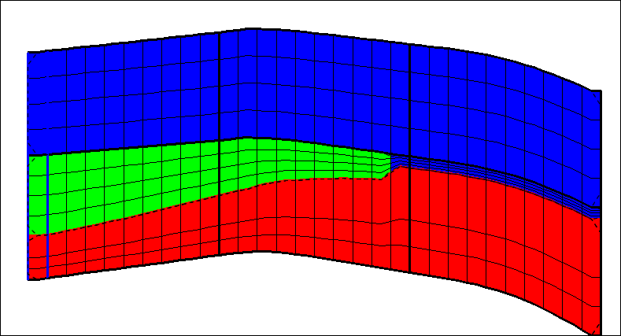
With the HUF package, the geological assignment is independent of the layering. You assign the tops and thicknesses of each aquifer and MODFLOW takes care of assigning the proper properties to each cell. If several aquifers intersect a cell, MODFLOW will combine the properties of those aquifers to determine the properties of the cell. The properties of each aquifer (or more properly hydrogeologic unit) must be assigned using parameters.
When you use the HUF package, ModelMuse creates several optional data sets that are used for displaying how the aquifer properties are assigned to individual cells. In this exercise, we will create a simple HUF model and use the optional data sets to display the aquifer properties assigned to the grid cells.
- Start a new MODFLOW Model and create a grid with 20 rows, 20 columns, and 3 layers.
- Select "Model|MODFLOW Packages and Programs...", expand "Flow" and select the HUF2 package.
- In the list of parameter types, select HK and change the number of HK parameters to 3. (HK defines the horizontal hydraulic conductivity.) Assign values of 0.001, 0.002, and 0.003 to the three HK parameters.
- In the list of parameter types, select VK and change the number of VK parameters to 3. (VK defines the vertical hydraulic conductivity.) Assign values of 0.0001, 0.0002, and 0.0003 to the three VK parameters.
- Click OK to close the MODFLOW Packages and Programs dialog box. When you do, the MODFLOW Hydrogeologic Units dialog box will appear because the HUF package is selected but no hydrogeologic units have yet been defined.
- Click the "Add hydrogeologic unit" button 3 times to add 3 hydrogeologic units. Leave the default names for the hydrogeologic units unchanged.
- Switch to the Parameters tab and select the first hydrogeologic unit from the list on the left. Check the check boxes for the first HK parameter and the first VK parameter. That will cause those parameters to set the values of horizontal and vertical hydraulic conductivity in that hydrogeologic unit.
- In a similar way associate the second HK and VK parameters with the second hydrogeologic unit and the third HK and VK parameters with the third hydrogeologic unit. Click OK to close the dialog box.
- (Optional) Switch to the Print tab and choose whether or not MODFLOW should print the values assigned to each hydrogeologic unit.
You may also note that on the Parameters tab, you can choose to use multiplier and zone arrays with a parameter. These work the same way as multiplier and zone arrays in the LPF package except that they apply to a single hydrogeologic unit. To save time, we won’t try to use multiplier and zone arrays in this exercise.
- Click OK to close the MODFLOW Hydrogeologic Units dialog box. If you want to display the dialog box again, you can do so by selecting "Model| MODFLOW Hydrogeologic Units..."
- Select "Data|Edit Data Sets..." and expand "Required|HUF2" to see the data sets that define the geometry of the hydrogeologic units. Our strategy will be to set the top of each hydrogeologic unit (except the first) to the top of the unit above it minus that units thickness. Then we will set the top of the first hydrogeologic unit and the thicknesses of each unit.
- Select HGU1_Top and set its default formula to "0'. Then select HGU2_Top and set its default formula to " HGU1_Top - HGU1_Thickness". Finally, select HGU3_Top and set its default formula to " HGU2_Top - HGU2_Thickness". Click the Apply button and close the dialog box.
- On the top view of the model, draw a polygon or rectangle object that complete encloses the grid. Use it to set the thickness of HGU1 to 5. (In the Object Properties dialog box, go to the Data Sets tab and expand “Required|HUF2”. Check the check box for HGU1_Thisckness and set the formula to 5.)
- Draw another polygon on the top view of the model but this time only enclose part of the grid. Use it to set the thickness of HGU2 to 15.
- Draw another polygon on the top view of the model the encloses the entire grid. Use it to set the thickness of HGU3 to 25.
- To see how this determines the hydraulic conductivity of the cells, select “Data| Data Visualization|Color Grid…”, and select HUF_Kx. (It will be under “Data Sets|Optional|HUF2".) The horizontal hydraulic conductivity will be a weighted average of the hydraulic conductivities of all the hydrogeologic units that intersect the cell.
- Next, color the grid with HUF_Interlayer_Kz. This is the weighted harmonic average of the vertical hydraulic conductivities of the hydrogeologic units that intersect the region from the vertical center of one cell to the vertical center of the cell beneath it. Because the bottom layer doesn’t have a layer beneath it, its interlayer Kz is zero.

Lake (LAK) Package
Estimated time: 1 hour, 15 minutes.
The Lake package, as its name implies, is used to simulate lakes. The heads in the lakes are allowed to rise and fall due to interactions with groundwater, streams (as simulated with the SFR package) or direct inflows from rainfall, runoff or other sources. The Lake package requires that the lake cells be inactive cells. For this reason, ModelMuse automatically designates lake cells as inactive cells.
In ModelMuse, each lake is defined using an object. The cells enclosed or intersected by the object will be part of the lake.
If a lake bottom will occur in several different layers, it may be convenient to create a new data set to represent the elevation of the lake bottom and then use that data set to define the lower Z-coordinate of the object.
If two lakes are separated by a low barrier, they may combine into a single lake if the water level in the lakes gets high enough. The Lake package can simulate this process.
This exercise will create a model similar to one in the documentation for the lake package.
- Start a new MODFLOW model with 20 rows and columns each 1000 m wide. The model should have two layers. (Later on, we will subdivide the lower layer.) The elevations, from top to bottom, should be 500, 107, and 67.
- Select “Model|MODFLOW Layer Groups…” and set both layers to convertible. Set the discretization of the lower layer group to 4. Click OK to close the dialog box.
- Select “Model|MODFLOW Options…” and on the “Options” tab, set the time unit to days and the length unit to cm. Then on the “Wetting” tab, activate wetting. Click OK to close the dialog box.
- Select Data|Edit Data Sets and set the default formula for Wet_Dry_Threshold to 0.2.
- Select “Model|MODFLOW Time…” and set the starting and ending times to 0 and 5000 respectively. Set the multiplier to 1.02 and make it a transient stress period. Select the cell for “Max first time step length and click on the “F()” button that will appear in that cell. Set the number of steps to 100 and click OK to close the Time Step Length Calculator dialog box. Then click OK to close the MODFLOW Time dialog box.
- Select “MODFLOW Packages and Programs…” and activate the CHD, RCH, EVT, and LAK packages. For both RCH and EVT, set the location option to “Top active cell”. With the pane for the Lake package showing, click on the Help button and read the description of the extra items that you can specify for the Lake package. Click OK to close the dialog box.
- Create a polygon or rectangle object that completely surrounds the grid. Use it to set both the Recharge and ET. Set the recharge rate to 0.0116. Set the ET Rate 0.141 Set the ET Depth to 15. The ET Surface should be a linear trend from 160 on the left to 141 on the right. One way to do this would be with the following formula: “161 - Column”.
- The entire outside edge of the model should be a specified head boundary with a head of 115. Draw a polyline or straight-line object through the cells on the outside edge of the model and use it to specify the CHD package input.
The next step is to define the lake bottom. This data set will be used to define the bottom of the object that defines the lake. The lake bottom in shallower parts of the lake is 107 m. It is 97 deep in the lower parts of the lake. We will create a new data set with a default formula of Model_Top and then draw two polygons. One will define the shallower lake bottom along the edges of the lake. The other will define the deeper lake bottom near the center of the lake.
- Select “Data|Edit Data Sets…” and click the Add button. Change the name of the new data set to “LakeBottom” and its default formula to “Model_Top”. Click the Apply button and close the dialog box.
- Draw a polygon object around the outer edge of where you want the lake to be. In the Object Properties dialog box, change the “Number of Z-formulas” to Zero. On the Data Sets tab, check the check box for the LakeBottom data set and set its formula to 107.
- Draw a polygon object around the edge of the deeper part of the lake. It will be inside the previous object In the Object Properties dialog box, change the “Number of Z-formulas” to Zero. On the Data Sets tab, check the check box for the LakeBottom data set and set its formula to 97.
- Color the grid with the LakeBottom data set. On the Filters tab of the Color Grid of the Data Visualization dialog box, set 500 as a value to ignore. You should get something similar to this.
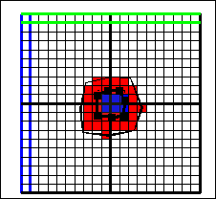
- Select the object for the outer edge of the lake and copy it to the clipboard. Then paste it back into the model as a new object. We will use this new object to define the lake.
- Double-click on the new object to open the Object Properties dialog box. Uncheck the check box for the LakeBottom data set. We will use the LakeBottom data set to set the bottom of this object but we will need to close the Object Properties dialog box and then reopen it before it will allow us to do that. Click OK to close the Object Properties dialog box.
- Double-click on the new object to open the Object Properties dialog box. Change the “Number of Z-formulas” to Two. Set the Higher Z-coordinate to “Model_Top” and the Lower Z-coordinate to “LakeBottom”.
- Go to the ModelFeatures tab and check the checkbox for the LAK package. Set the starting and ending times to 0 and 5000. Set the minimum stage to 109 and the maximum stage to 111. Set the precipitation 0.0116 and the evaporation to 0.0103. Set the Lake ID to 1 and the initial stage to 110. Check the gage output checkbox for time, stage, volume, and concentration.
- Click the help button and read about the items needed for the Lake package. Note that the minimum and maximum stage only apply to steady-state simulations. Because this is a transient simulation the minimum and maximum rates will have no effect.
- Use this same object to set the recharge and evaptranspiration rates to 0 in the RCH and EVT packages.
- Finally, select “Data|Edit Data Sets…” and set the following default formulas
Kx | 30
Lakebed_Leakance | 0.1.
Wet_Dry_Threshold | 0.2
MODFLOW_Initial_Head | 115

- Select “MODFLOW Packages and Programs…” expand “Solvers” and select PCG. Change RCLOSE to 1. Click OK to close the dialog box.
- Run MODFLOW. Then import the heads and plot the final heads. You will probably get a head distribution similar to the one shown below. (Note: ModelMonitor may display the following two messages which it interprets as error messages. However, they actually are not errors.
334: VALUES OTHER THAN DEFAULT CAN BE READ BY SPECIFYING A THETA LESS THAN ZERO THEN ADDING NSSITR AND SSCNCR PER ORIGINAL INSTRUCTIONS.
335: NEGATIVE THETA MUST BE LESS THAN ZERO BUT NOT MORE THAN ONE. THETA IS CONVERTED TO A POSITIVE VALUE.)
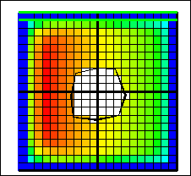
- Save your model to use as a starting point for an exercise using SFR.
- Start GW_Chart and change the chart type to “Lake, Gage, and UZF Plots. Change the data source to Gage file. Then open the gage file generated by MODFLOW and plot stage vs. time. You will probably get a plot similar to this.
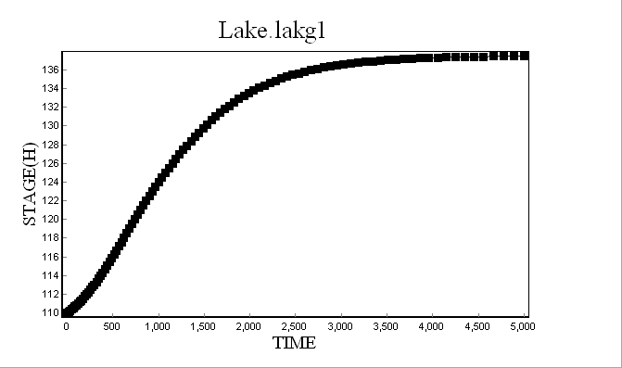

Streamflow Routing (SFR) Package
Estimated time: 1 hour
The Streamflow Routing (SFR) package is an enhanced version of the Stream (STR) package. The most prominent difference between the Streamflow Routing package and the River package is that in the Streamflow Routing package water can flow downstream to another stream cell and infiltrate there. The SFR package also has the capability of calculating the stream depth. The stream depth, in turn, affects the amount of water that is transferred between the stream and the aquifer.
- Reopen your model for the lake package and save it with a new name.
- Select “Model|MODFLOW Packages and Programs…” and activate the SFR package. You may wish to click the Help button and read about the SFR package.
You can use point or polyline objects to define stream segments in the SFR package. However, the direction of the object is important. You should start drawing the object at the upstream end of the stream. If you draw a stream in the wrong direction, you can reverse it by selecting it and then selecting “Object|Edit|Reverse Selected Objects”.
You will create two streams as illustrated in the diagram below. The streams will flow from left to right. The stream on the left flows into the lake. The one on the right flows out of the lake.
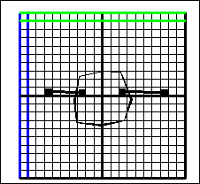
- Make sure that the top layer is the active layer and draw a polyline object to represent the stream segment on the left.
- In the Object Properties dialog box, go to the MODFLOW Features tab and check the checkbox for the SFR package.
- Make this segment 1. Leave the formula for the Reach length unchanged.
- On the time tab set the starting and ending times to 0 and 5000 and set ICALC to “Rectangular channel (1)”.
- On the “Network” tab, select the cell in the table for the outflow segment (OUTSEG). A button labeled “Closest” will appear. Click it. The OUTSEG will be set to -1. A negative number means that the stream flows into a lake. The absolute value of OUTSEG is the lake number. If OUTSEG had been positive, it would have represented the SFR segment number. (Note, Just because the end of the stream is close to or inside the lake, that doesn’t mean that the flow from the stream will flow into the lake. You must set OUTSEG to tell MODFLOW where the flow is supposed to go.)
- On the “Flows” tab, set all the flows to 0.
- On the “Segment” tab, you specify the properties at the upstream and downstream ends of the segment. If the properties are not identical, linear interpolation along the length of the segment is used to set the properties of intermediate cells. In this case, the properties are identical except for the upstream and downstream ends except for the streambed elevation. Set the following properties
Hydraulic conductivity | 30
Streambed thickness | 1
Stream width | 10
Upstream streambed elevation | 135
Downstream streambed elevation | 132

- On the “Channel” tab, set the Channel roughness set to 3.5E-7.
- On the Gage tab, chose the “Last reach” and the standard defaults. Click OK to close the dialog box.
- Draw a second polyline to represent the stream segment on the right. Its properties will be the same as the other stream segment with the following exceptions.
  - It will be segment 2.
  - It will not have an outflow segment (OUTSEG = 0)
  - It will divert water from the lake. (Diversion segment IUPSEG = -1.) You can set the diversion segment the same way you set the outflow segment in the other stream segment.
  - Flow into the upstream end (FLOW) will be 100. This is the amount of water diverted from the lake.
  - The upstream streambed elevation will be 129
  - The downstream streambed elevation will be 121.
- Run the model.
If you drew the streams so that they went into the lake, you may get a warning message about some stream reaches being in inactive cells. Remember that lake cells are automatically designated as inactive cells as required by the lake package. However, if a stream reach is in an inactive cell, MODFLOW will look in underlying layers for an active cell. If it finds one, that cell will be treated as the stream cell.
- Compare the results of this model with the model with just the lake. You may wish to use GW_Chart to look at the gage files produced by the new model.
  - Was the final head in the lake affected?
  - How was the head near the streams affected?
  - Did the gages in the two streams show any flow in the first time steps? Explain why or why not.

Multinode Well (MNW2) Package
Estimated time: 40 minutes
The Multinode Well (MNW2) package is used to simulate wells in which the well screen extends over more than one cell. An earlier version of the Multinode Well package (MNW1) is also included in MODFLOW-2005. In ModelMuse, you usually define a multinode well by creating a point object with two Z-formulas. The values specified by the two third-dimension formulas determine the position of the well screen. If a well has multiple well screens, you can enter the elevations of the beginning and ends of each well screen to define the well. Slanted wells can also be simulated using polylines. If the vertical plane containing the slanted wells is aligned with the grid, the slanted well can be drawn on the front or side views of the model. In other cases, the slanted well can still be defined by carefully specifying the Z-coordinates. The Multinode well package has a number of additional capabilities that will not be discussed here.
- Start a new MODFLOW project with 20 columns, 20 rows, and 5 layers. Make each layer 10 m thick with the top of the model at an elevation of 0.
- Activate the MNW2 package in the MODFLOW Packages and Programs dialog box (under "Boundary conditions|Head dependent flux"). Click OK to close the dialog box.
- Create a point object on the top view of the model.
- In the Object Properties dialog box, set the higher Z-coordinate to -5 and the lower Z-coordinate to -25. These elevations will specify the limits of the well screen for this well.
- On the MODFLOW Features tab, check the check box for the MNW2 package and set WELLID to Well1.
The MNW2 package provides several ways of estimating the well losses. The default method (Thiem) requires that the user specify the well radius on the "Loss Controls" tab. The items on the Loss Controls tab that can be edited depend on the selected model for well loss.
- (Optional) Click the help button and read about the various options provided by the MNW2 package. You will get the help for the MODFLOW Features tab but it has a link to the help for the MNW2 package.
- (Optional) If you click the PUMPCAP check box on the Basic tab, a new "Discharge Adjustment" tab will appear. The controls on that tab are used to specify how the pumping rate is affected by the distance the pumped water needs to be lifted. You can click the Help button to read about these controls but be sure to uncheck the PUMPCAP check box when you are done.
- On the Loss Controls tab, set the well radius to 0.1. (Remember that our model units are meters.) If the well radius varies along the length of the well, you could use a formula to specify how the radius varies.
- On the Pumping rate tab, set the starting and ending times and pumping rate. The other columns of the table on the Pumping rate tab will not be used for this well. Those other columns become enabled if some of the other options for the well are selected.
- On the Well Screens tab, do nothing. If you needed to specify multiple well screens for a vertical well this is where you would do it. If you specify well screens here, the higher and and lower Z-coordinates no longer specify a well screen. Click OK to close the dialog box.
- Color the grid with the well radius. Make the selected row the one containing the well and check if the well is in the right location. (You can't color the grid with the desired pumping rate because that is not a property of individual cells.)
- Draw a polyline object on the front view of the model similar to the one illustrated below. Use it to define a multinode well with a well radius of 0.2. Check which cells are part of the well. By coloring the grid with the well radius.
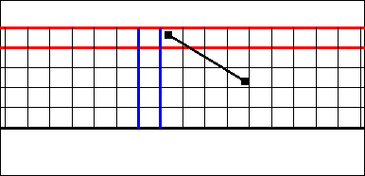
- With the previous object still selected, select "Object|Edit|Add Polyline Sections" and then click on the front view of the model to add a polyline section. Double-click on the front view to add the last point of the polyline section. This new section defines a new open interval of the well that may be separated from the previous open interval.
- Select "Object|Select Objects" and double-click on the current object to open the Object Properties dialog box to edit the well radius. We are going to set the well radius of the second open interval to 0.15. To do that we will need to enter a formula for the well radius instead of a number.
- Click the "Edit..." button next to the well radius to open the Formula Editor. The following formula will do what we want.
CaseR(ObjectCurrentSectionIndex, 0.2, 0.15)
- You can find CaseR under "Functions|Logical" and ObjectCurrentSectionIndex under "Functions|Object". When you select those functions, be sure to click the Function Help button to find out what these functions do. When you have finished editing the object, close the Object Properties dialog box. If you are still coloring the grid with the well radius, you may get a result similar to the one shown below.
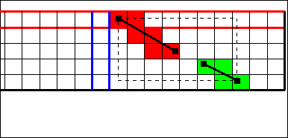
- Now we will create another well with a slanted section but this time we will draw the well on the top view of the model and used the formulas for the upper and lower Z-coordinates to define the slanted section. Draw a polyline on the top view of the model similar to the one below. It should have two vertices that are close together near the beginning of the model. These will represent a vertical part of the well.
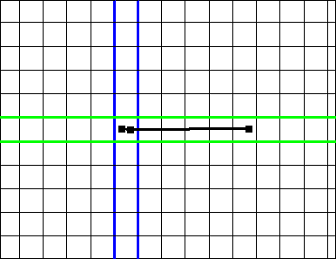
- For the higher Z-coordinate set the formula to "VertexInterpolate(-5, -25, -49)". for the lower Z-coordinate set the formula to VertexInterpolate(-25, -26, -50). Define a multinode well with this object and close the Object Properties dialog box. If you color the grid with the well radius, the front view of the model should appear similar to the illustration below. (You will need to set the selected row to the row that contains the well.)
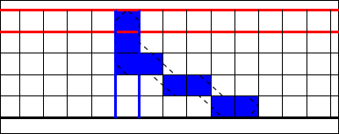

Reservoir (RES) Package
Estimated time: 10 minutes
In some ways, the Reservoir package is similar to the River package; the data that is specified are equivalent to what are specified in the River package and the flow into or out of the reservoir is calculated in the same way. In other ways, the Reservoir package is quite different. The rivers in the river package are defined as a list of cells and their associated properties. In the Reservoir package, there is an array that indicates with which reservoir (if any) a cell is associated. This means that, unlike in the River package, there can't be more than one reservoir in a cell. In addition, instead of specifying a single head for a stress period, the user specifies one head at the beginning of the stress period and another head at the end. If the two heads are different, heads at intermediate times are calculated by linear interpolation.
The Reservoir package also has some similarities to the Lake package. Both define a series of cells that all are constrained to have the same head. However, in the Lake package, that lake level is calculated from the lake inflows and outflows whereas in the Reservoir package, the reservoir level is specified by the user.
Instead of creating the project from scratch, we will import an existing model that includes the Reservoir package.
- Start ModelMuse and choose to import an existing MODFLOW model. Click the Next button.
- In the dialog box, locate the directory in which MODFLOW-2005 and select the name file for the restest model. By default, this model will be located in C:\WRDAPP\MF2005.1_11\test-run. Click the OK button.
- Select Object|Show or Hide Objects… and display the object that defines the reservoir. Double-click on it to inspect the object in the Object Properties dialog box.
- There are several data sets that relate to the Reservoir package. The values of these data sets don’t need to be defined by the same objects that set the reservoir heads. Try coloring the grid with the Reservoir elevation. Note that unlike in the river package, the reservoir bed thickness, elevation, and hydraulic conductivity can not change between stress periods.

Unsaturated Zone Flow (UZF) Package
Estimated time: 40 minutes
The Unsaturated Zone Flow package is used to simulate vertical flow of groundwater through the unsaturated zone and into the saturated zone. It is especially important in GSFLOW in which flows in surface water and groundwater are linked. However, even if surface water is not being simulated, the UZF package can be useful for simulating the time delay between precipitation and recharge.
The UZF package requires a lot of extra memory so if your model is too big, you may not be able to use the UZF package.
We will import an existing model that uses the UZF package.
- Start ModelMuse and select “Import MODFLOW-2005 model” and click the “Next” button.
- Select the UZFtest2.nam file and click OK to import the model. By default UZFtest2.nam will be in the C:\WRDAPP\MF2005.1_11\test-run directory.
- Several new data sets are created when the UZF package is activated. To see them select “Data|Edit Data Sets…” and expand “Required|UZF” and “Required|UZF and FMP” If you switch to the comment tab, you can see what input variable corresponds to each data set. In the help, the Online Guide to MODFLOW can tell you more about each data set.
One data set deserves special mention: Land_Surface. In the UZF package, the land surface is at the top of a cell but the cells don’t all need to be in the same layer. The Land_Surface data set is used to pick the layer whose top is the land surface at any particular location. The layer itself is specified by the UZF_Layer data set. Land_Surface is used in the formula for UZF_Layer. Thus, if you specify Land_Surface, you don't need to specify UZF_Layer and if you specify UZF_Layer, everywhere, Land_Surface won't matter.
- Note that in this model, the Recharge and Evapotranspiration packages are not used. Instead, both processes are simulated by the UZF package. You use an object to specify the infiltration rate and the evapotranspiration data. Open the object “Imported_UZF_Rates” in the Object Properties dialog box to see how these data are specified. The data sets references in Imported_UZF_Rates are set by the object “Imported_Arrays.” If you open it, you will also notice that there is a new tab, “Imported Data”, that contains a separate data value for each cell. On the MODFLOW Features tab, the formulas for the Infiltration rate and ET extinction water content access the imported data.
- The UZF package can produce output files that record data for a particular cell for every time step. Open the three objects named Imported_UZF_Gage1, Imported_UZF_Gage2, and Imported_UZF_Gage3 in the Object Properties dialog box and see how gages are specified.
- The UZF package has can specify both recharge and evapotranspiration. However, if a cell is saturated, some of the recharge may be rejected or there may be groundwater discharge at the surface. This water can be routed to streams or lakes in the SFR and LAK packages. The Discharge Routing data set represents the SFR segment number to which the discharge water will be routed. Color the grid with the Discharge Routing data set and see if the values are reasonable.
- It can be interesting to see how individual budget terms vary with time in individual cells. After running the model, use GW_Chart to display those results. In GW_Chart, change the Chart Type to “Cell Water Budgets or Zeta” and select the .cbc file for the model. One cell that gives interesting results is Column = 6, Row = 13, Layer = 1. In particular note that the recharge rate varies within a stress period. Although the infiltration rate during a stress period is constant, not all of the infiltrated water acts as recharge. Some evaporates or is transpired. In addition, there can be a time delay between when the infiltration occurs and when the infiltrated water reaches the water table.
- Try subdividing all the cells in the grid and color the grid with Kx. Is the distribution of Kx values OK? Why or why not? Try coloring the grid with the UZF Infiltration Rate. Is this distribution OK? Why or why not? Try coloring the grid with the Stream Segment number. Is this distribution OK? Why or why not? If any of these distributions were not OK, how would you approach fixing the problem?

Seawater Instrusion (SWI2) Package
Estimated time: 2 hours, 30 minutes
Bakker, Mark, Schaars, Frans, Hughes, J.D., Langevin, C.D., and Dausman, A.M., 2013, Documentation of the seawater intrusion (SWI2) package for MODFLOW: U.S. Geological Survey Techniques and Methods, book 6, chap. A46, 47 p., http://pubs.usgs.gov/tm/6a46/.
The Seawater Intrusion package is a relatively simple way to simulate saltwater intrusion in an aquifer. In it, the modeler defines zones that vary in their concentration or sea water and thus in their density. MODFLOW then calculates how the interfaces between the zones changes over time. The interfaces between the zones are called zeta surfaces. Another way to simulate saltwater intrusion is to use SEAWAT but it is much more complicated.
For this exercise, we will create a model similar to example 4 from the SWI documentation (http://pubs.usgs.gov/tm/6a46/). The model represents a square island surrounded by the ocean. The model has 61 columns and rows each with a width of 50 m. It has two confined layers each with a uniform thickness of 20 m. The top of the model is at -10 m. Ten rows and columns on all the sides of the model represent the ocean. The island extends from row 11, column 11 to row 51, column 51. The horizontal and vertical hydraulic conductivity are 10 m/d and 2 m/d respectively for all cells. There are three steady-state stress periods with lengths of 200, 12, and 18 years. The first stress period simulates the development of a freshwater lens in the aquifer. In the second stress period, a well in the top layer is introduced pumping water from the freshwater lens at a rate of 200 m³/day. The well is in row 31, column 36. Pumping from this well causes upconing of salt water. At some point, this salt water may affect the water quality in the well though this may not be obvious initially The third stress period is intended to simulate one possible response of the water managers to a deterioration of the water quality in the well.. In the third stress period, a well pumping salt water at a rate of 25 m³/day is added below the freshwater well. This well is intended to limit intrusion of saltwater into the freshwater well. The ocean is represented by a GHB boundary with a head of 0. The conductance per unit area (leakance) of the GHB boundary is 0.025 day⁻¹. The recharge rate over the island is 0.4 mm/day.
In the SWI package, a single zeta surface will be defined that approximates the 50% seawater salinity contour. It separates two zones of uniform salinity (ISTRAT = 1). The maximum slope of tip and toe cells is 0.005. (These control how steep the slope of the interface must be for it to move horizontally into a new cell.) Alpha and beta are set to their default values of 0.1. The Initial zeta surface is one meter below the top of the model under the island and at the top of the model under the ocean. The dimensionless density difference between freshwater and saltwater is 0.025. The default values can be used for the SWI solver. The effective porosity is 0.2.
There are three options for ISOURCE (represented in ModelMuse by the SourceFluidDensityZone data set).
If ISOURCE > 0 – Sources and sinks have the same fluid density as the zone ISOURCE. If such a zone is not present in the cell, sources and sinks have the same fluid density as the active zone at the top of the aquifer.
If ISOURCE = 0 – Sources and sinks have the same fluid density as the active zone at the top of the aquifer.
If ISOURCE < 0 – Sources have the same fluid density as the zone with a number equal to the absolute value of ISOURCE. Sinks have the same fluid density as the active zone at the top of the aquifer. This option is useful for the modeling of the ocean bottom where infiltrating water is salt, yet exfiltrating water is of the same type as the water at the top of the aquifer.
There are two zones in the model. Zone 1 is fresh water; Zone 2 is salt water. The GHB boundary in this model should always have saltwater entering but saltwater leaving the aquifer should be whatever water is at the top of the aquifer. Therefore the SourceFluidDensityZone for it is -2. On the island, recharge is always fresh water so SourceFluidDensityZone is 1. For the saltwater well SourceFluidDensityZone is 2 and the rest of the cells SourceFluidDensityZone is 0.

Instructions
- Specify the grid.
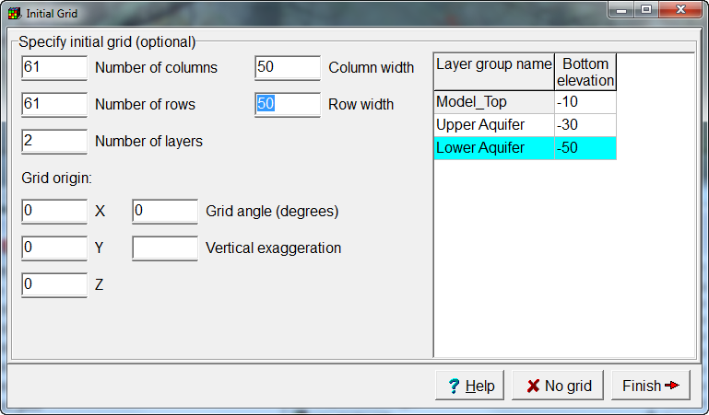
- Set the time and length units to meters and days.
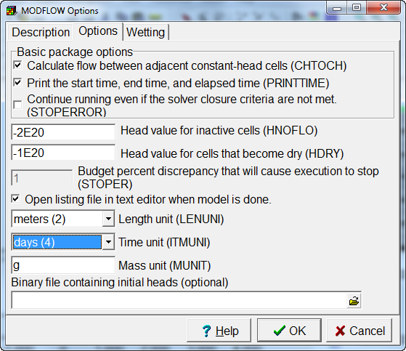
- Set the horizontal and vertical hydraulic conductivity
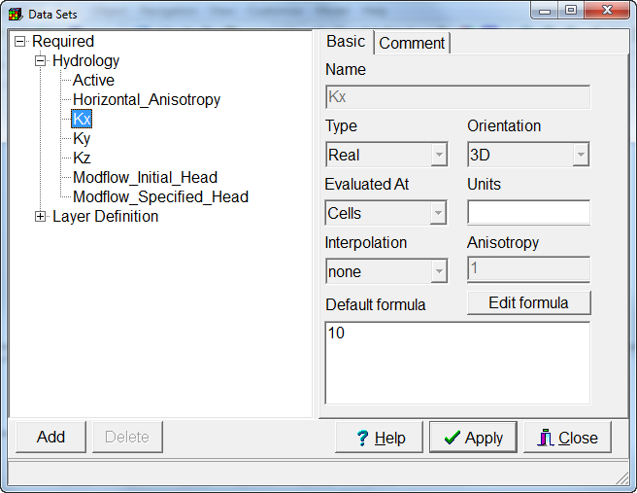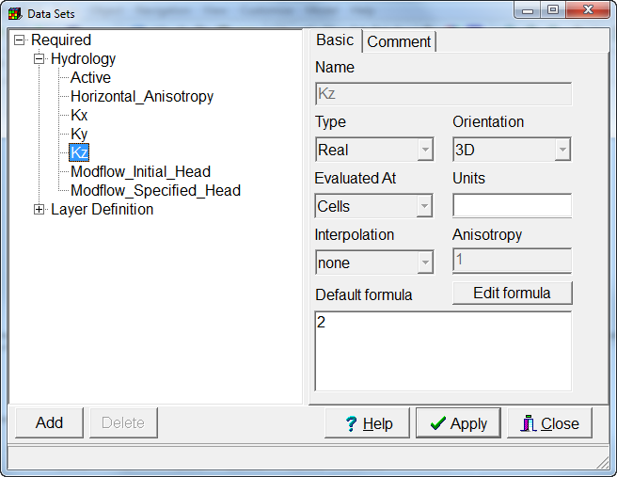
- Define the stress periods. You can use the Convert time units dialog box to convert from years to days. Set the time step length for the first stress period to 60 and to 30 for the remaining stress periods. All the stress periods must be steady-state stress periods.
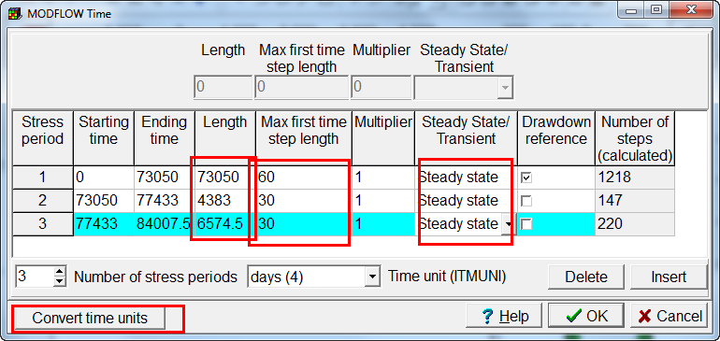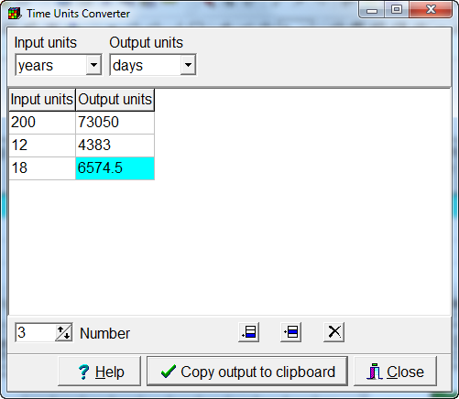
- In the Output Control, change the frequency with which heads are saved to be at the end of each stress period. This will also determine how frequently the zeta surfaces are saved.
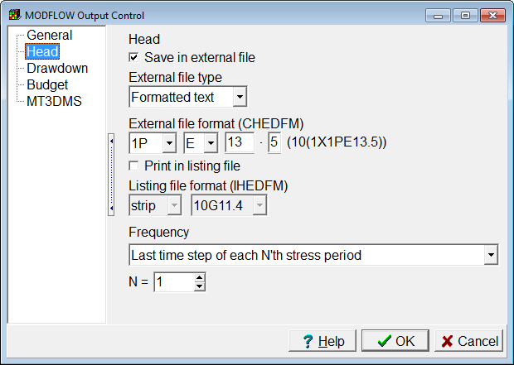
- Activate the GHB and RCH packages.
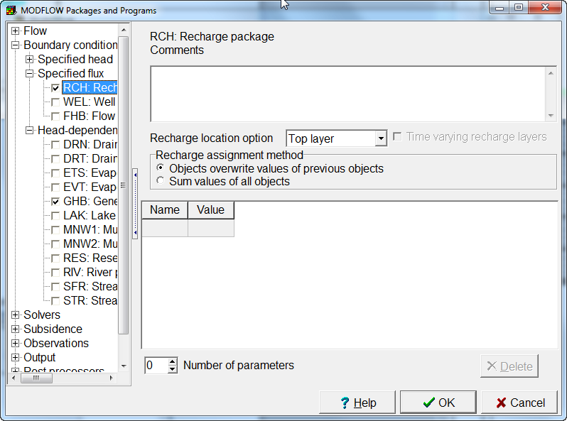
- Create an object covering the part of the grid that represents the ocean. The easiest way to do this is to create a polygon object that covers the entire grid and then add a new section that covers just the island. The second part will define a hole in the object. Use this object to define the GHB boundary.
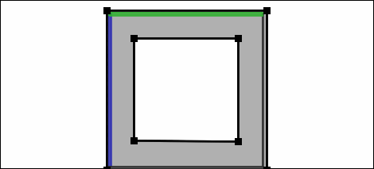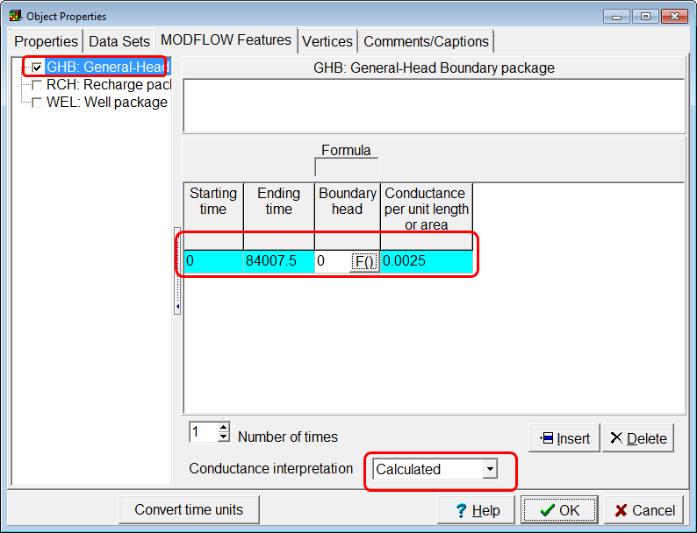
- Draw a new polygon object covering the island. Use it to define the recharge.
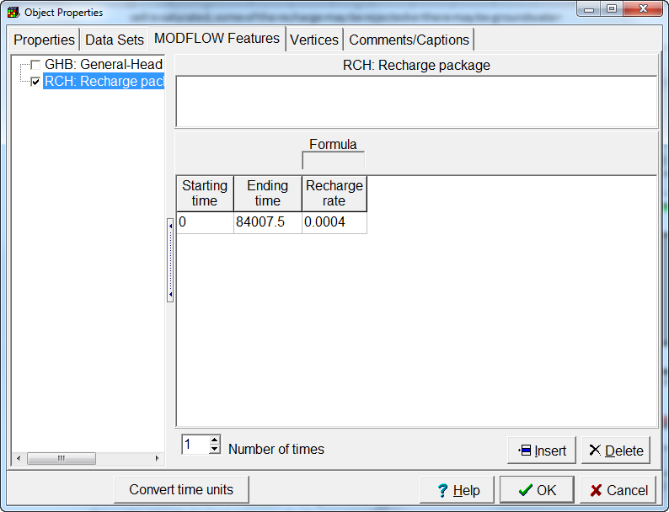
- Activate the Well package and define a well in layer 1, row 31, column 36. The pumping rate should be -200 m³/day starting in the second stress period and extending to the end of the model.
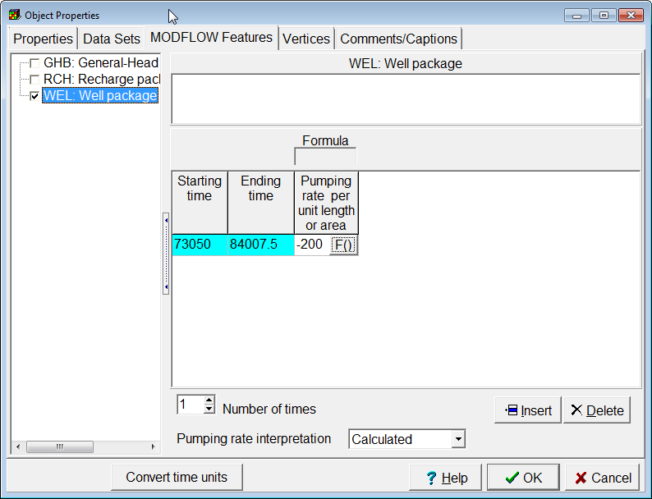
- Define another well in layer 2, row 31, column 36. The pumping rate should be -25 m³/day starting in the third stress period.
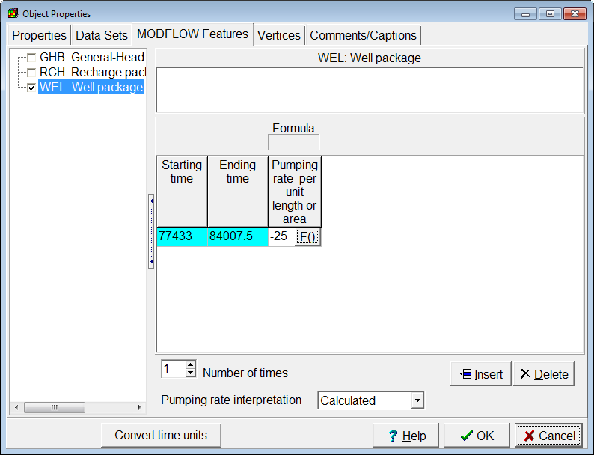
- Select Model|MODFLOW Packages and Programs and activate the SWI2 package. (It is classified under “flow.”) Specify the required non-spatial data for SWI. Change the solver in SWI to the PCG solver. Zone 1 represents fresh water. Zone 2 represents salt water.
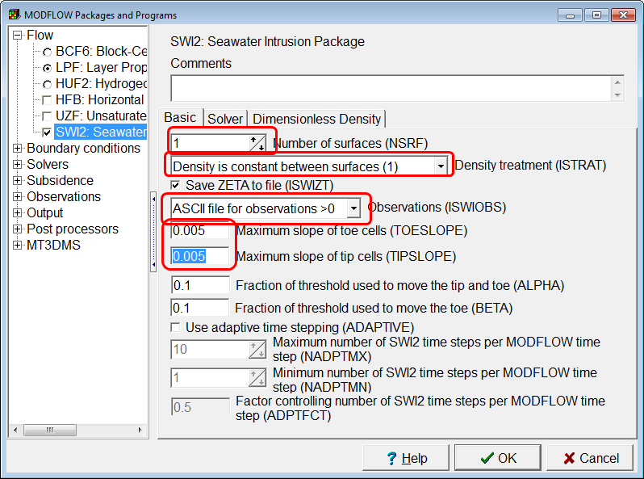 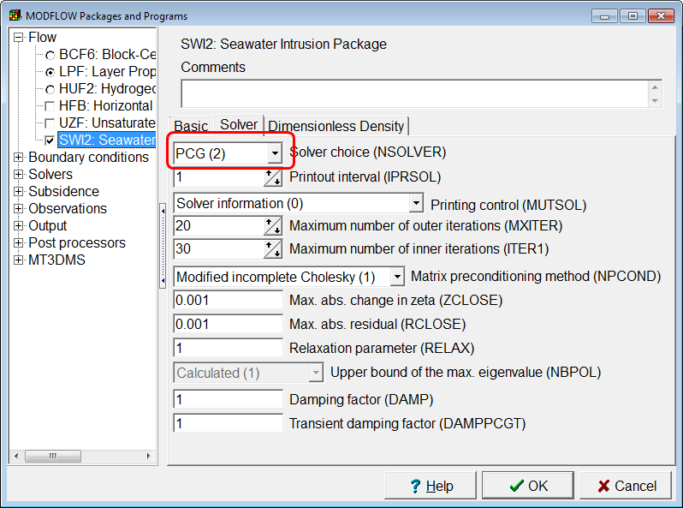 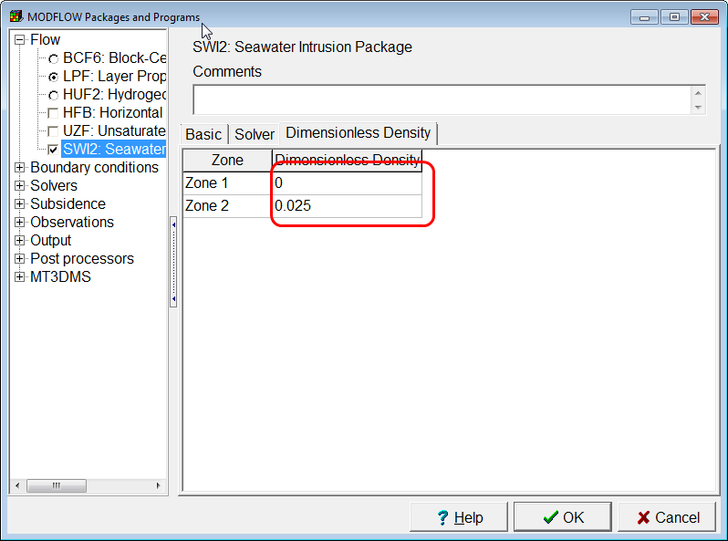
- Use a combination of default formulas and objects to set Active_Surface_Elevation1 to −11 beneath the island and -10 beneath the ocean. Be sure that these values are set for both layers.
- Set the EffectivePorosity data set to 0.2.
- Use the objects that define the ocean (GHB boundary), the recharge boundary and the saltwater well to specify the SourceFluidDensityZone.
  - The ocean gets a SourceFluidDensityZone = -2 because the water that enters from the ocean will always be salt water. The absolute value indicates which zone the water will come from. A negative value indicates that the water will always be in that zone.
  - The recharge and the well in layer 1 get a SourceFluidDensityZone = 1 indicating that the recharge will be fresh water so long as there is fresh water in those cells.
  - The well in layer 2 get a SourceFluidDensityZone = 2 indicating the discharge will be saltwater so long as there is saltwater present
- For each well, define a value for the SWI_Observation_Name data set. The names must be enclosed in double quotes. The names could be “Layer 1” and “Layer 2”.
- Save the model and run MODFLOW. (You can ignore the warning message about the number of time steps.)
- When the model has finished running, select “File|Import|Model Results” and import the file with the extension .zta. This file contains the elevations of the zeta surfaces.
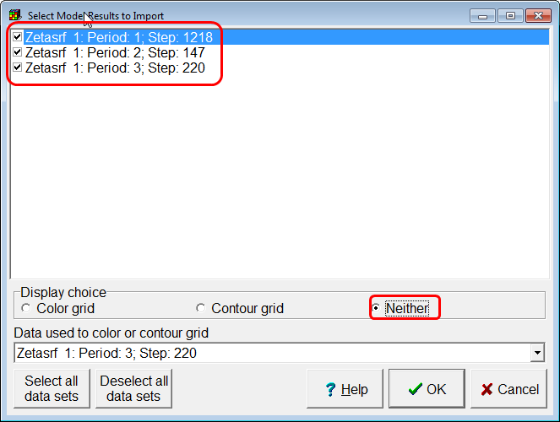
- Select “Data|Data Visualization” and plot the zeta surfaces as cross sections. Make sure to use a different color for each cross section.
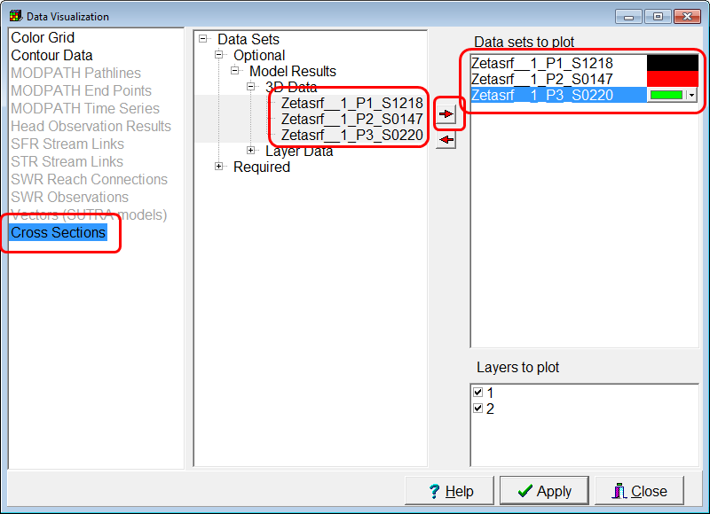
- Make the selected row be the row containing the well. Examine the cross sections. Initially, the interface between the fresh and salt water was at the top of the model under the ocean and 1 m below the top of the model under the island. Where was it after the end of stress period 1? What happened to the interface between salt and fresh water after the well in layer 1 started pumping? What happened to it after the well in layer 2 started pumping?
- Locate the file with the extension .swi_obs. Plot the data it contains in a scatterplot using a spreadsheet program. Based on what you see, do you think that the well in layer 1 is safe from future salt water intrusion? (To plot the data using Excel, open the file in a text editor and copy all of it into Excel. Then select the column containing the data, select “Data|Text to Columns”, and click the Finish button. Then select all the data and select (Insert|Scatter.”) Based on these results, do you think the freshwater well is permanently safe from saltwater intrusion?
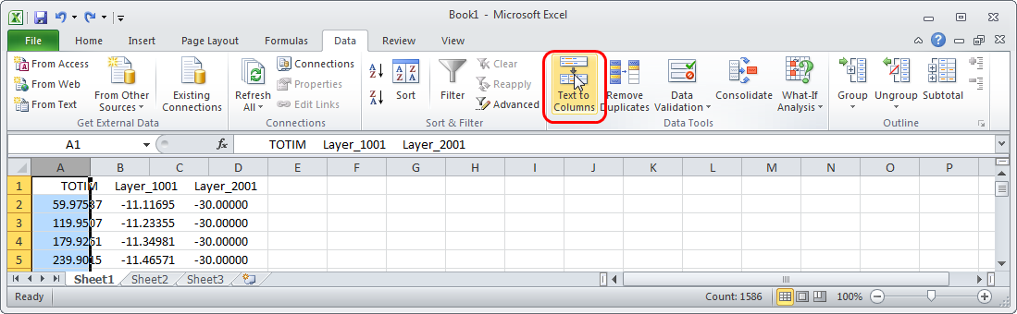 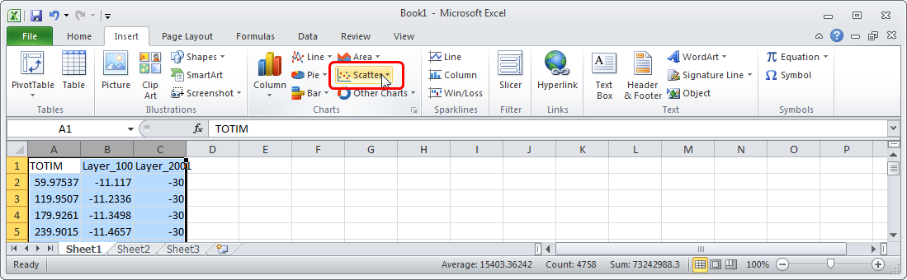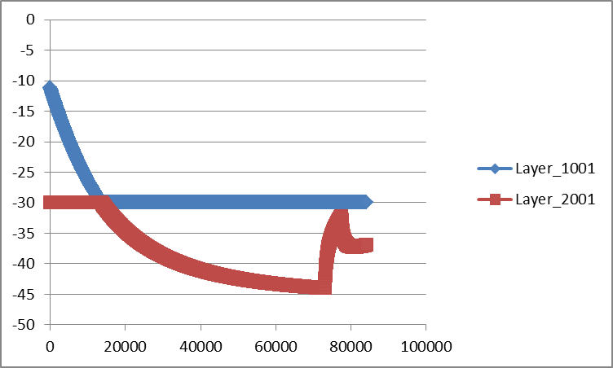
- (Optional) Try changing the pumping rate of the well in layer 1 to -250. Then run the model again and plot the results. What difference do you see in the results?

Observations
Estimated time: 28 minutes
In this example we will use "Simple Model.gpt. This recreates a model used to illustrate the LPF package when it was first introduced in MODFLOW-2000. In this exercise we will add head and flow observations to the model. Automated parameter estimation programs such as UCODE and PEST can use observations such as these to help calibrate a model.
- Open "Simple Model.gpt" and open the MODFLOW Packages and Programs dialog box.
- Expand Observations and check the check boxes for the Head Observation package and the Drain Observation package. Click OK to close the dialog box.
The “Manage Flow Observations” dialog box will appear. This is because the Drain Observation package has been activated but we have not yet defined any drain observations. You can show this dialog box again later by selecting “Model|Manage Flow Observations…”
- Select the Drain observation package from the list on the left and click the Add button. This will add an observation group named, by default, Drob1. This group can have one or more observation times and values associated with it.
- Set the number of times for this observation group to 1. For the time, enter 86400 which is the end of the first (and only) stress period. For the observed value enter -10. MODFLOW does not use the Statistic or StatFlag so you can ignore them for the time being. If you do enter values for Statistic and StatFlag, they can be exported to ModelMate and used to help calibrate the model with UCODE.
- Switch to the Object tab. Select the DrainParam object and move it to the “Used objects” list by clicking the “>” button between the two lists.
By moving the DrainParam object to the “Used objects” list we are saying that the observed flow came from the drain or drains defined by the DrainParam object. We could have moved more objects. If we had more than one observation group we could also have made the same object part of more than one flow observation.
- We could say that only part of the flow from an object is part of the observed flow by setting the “Factor” to a value other than 1. In this case we will leave Factor set to the default value of 1.
- Click OK to close the Manage Flow Observations dialog box.
- Open the DrainParam object in the Object Properties dialog box and switch to the MODFLOW Features tab. Note that we can make an object part of a drain observation by checking the check box for that observation group here. Also note the "Add or remove flux observations". Clicking it will open the Manage Flow Observations dialog box. Click Cancel to close the Object Properties dialog box.
Next we will define some head observations including a multi-layer head observation.
- Make the top layer the active layer, select "Object|Create|Point" and click near the center of column 14, row 2.
- In the Object Properties dialog box, select the MODFLOW Features tab and check the check box for the Head Observation package. Assign a name of your choice to the observation, set the number of times to 1 and enter a time of 86400 and an observed head of 125. You can ignore the Statistic and StatFlag. Leave the “Treatment” set to “Observation”. Click OK to close the Object Properties dialog box.
Parameter Estimation programs can use a calibrated model to estimate the uncertainty of certain predictions. Predictions are entered in exactly the same way as the observations. When you want to run a model to generate predictions, you need to select “Model|Observation Type|Prediction” before exporting the model. (However, don’t change the observation type to “Prediction” for this model.)
- Make the bottom layer the active layer and click near the center of column 10, row 6.
- In the Object Properties dialog box, select the MODFLOW Features tab and check the check box for the Head Observation package. Assign a name of your choice to the observation, set the number of times to 1 and enter a time of 86400 and an observed head of 90. Leave the “Treatment” set to “Observation”. Click OK to close the Object Properties dialog box.
- Make the top layer the active layer and click near the center of column 2, row 9.
- In the Object Properties dialog box, change the Lower Z-coordinate to “Layer_2_Bottom” so that the object spans more than one layer. This object will define a multi-layer observation. Select the MODFLOW Features tab and check the check box for the Head Observation package. Assign a name of your choice to the observation, set the number of times to 1 and enter a time of 86400 and an observed head of 10.5. Leave the “Treatment” set to “Observation”. Click OK to close the Object Properties dialog box.
- Now try running the model. When the model is done look near the end of the Listing file. You should find something similar to this.

HEAD AND DRAWDOWN OBSERVATIONS
OBSERVATION OBSERVED SIMULATED
NAME VALUE VALUE DIFFERENCE
--------------------------------------------------------------------
Head1 10.500000000 11.453888893 -0.95388889313
Head2 125.00000000 124.96041107 3.95889282227E-02
Head3 90.000000000 90.313713074 -0.31371307373

SUM OF SQUARED DIFFERENCE: 1.00989E+00

DRAIN FLOW OBSERVATIONS
OBSERVATION OBSERVED SIMULATED
NAME VALUE VALUE DIFFERENCE
--------------------------------------------------------------------
Drob1_1 -10.000000000 -10.314616203 0.31461620331

SUM OF SQUARED DIFFERENCE: 9.89834E-02

When MODFLOW computes the simulated heads for a particular head observation, it interpolates among the heads in the nearest cells to find the head at the observation location. Thus if you move a head observation to a different location in the same cell, the simulated value will be different.
- Try moving one or more of the objects that define the head observations to different locations within the same cell and see how that affects the simulated head values.

Parameter Estimation Using UCODE and ModelMate
Estimated time: 42 minutes
This exercise introduces using UCODE (Poeter and others, 2005, 2014) and ModelMate (Banta 2011) to perform parameter estimation.
You can get UCODE-2014 from http://igwmc.mines.edu/freeware/ucode/.
You can get ModelMate from http://water.usgs.gov/software/ModelMate/.
We will only estimate one parameter and we will use only two head observations and one flow observation. When we have calibrated the model, we will examine some of the results using GW_Chart.
To begin, let’s import an existing model that has parameters already defined into ModelMuse. A good one to use is “twrip.” This is one of the example models that comes with MODFLOW-2005.
- Start ModelMuse and select “Import MODFLOW-2005 or MODFLOW-NWT model.” Then click the “Next” button.
- Select the name file for twrip and click the OK button to import the model. You can find the model in a subdirectory of the MODFLOW-2005 installation directory. It will probably be in C:\WRDAPP\MF2005.1_11\test-run\
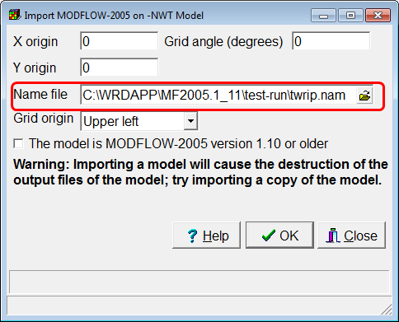
- This model has several parameters. To see what they all are, select “Model|Manage Parameters”. The parameter we will estimate is “HK1” Try coloring the grid with the HK1_Zone data set to figure out where this parameter applies.
- Next we will active the Head Observation and Drain Observation packages in the MODFLOW Packages and Programs dialog box. When we click OK, the Manage Flow Observations dialog box will appear. For now, just close it. We will use it again later.
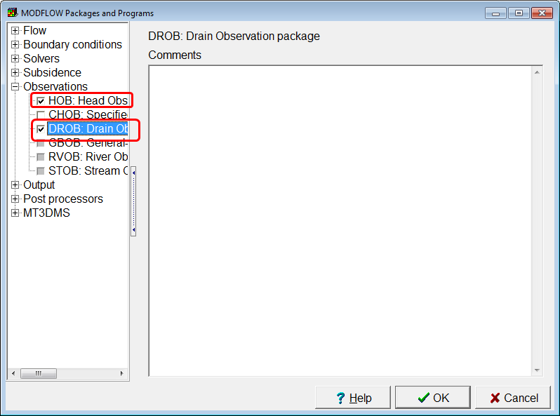
- We have two head observations: a head of 45 in layer 1, row 5, column 4, and a head of 55 in layer 1, row 12, column 7. We will need to create point objects at the centers of those two cells in layer 1 and assign the observed heads. The observation time for both head observations is 86400 which is the end of the first (and only) stress period. We also need to assign values of the Statistic and StatFlag. The statistic is used to determine the weight assigned to the observation during parameter estimation. Ideally, the statistic would represent the measurement error of the observation. For the purposes of this exercise, we will use a statistic of 0.1 ft and set the StatFlag to Standard Deviation.
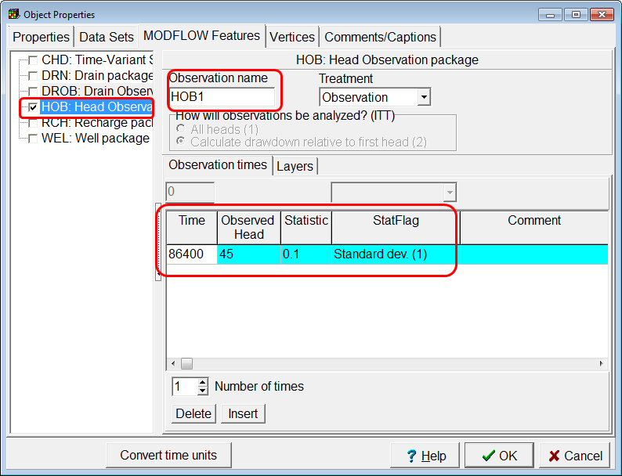’
- Now that the head observations have been defined, we will define the flow observation. Select “Model|Manage Flow Observations…”
- The only flow observation package in the model is the Drain Observation package . Select it and click the Add button to add a new drain flow observation. The value of the drain flow is -30. The absolute value indicates the rate of flow in units of L³/T. The negative value indicates that flow is out of the aquifer. For the purposes of this exercise, we will use a statistic of 1 ft and set the StatFlag to Standard Deviation. Click OK to close the dialog box.
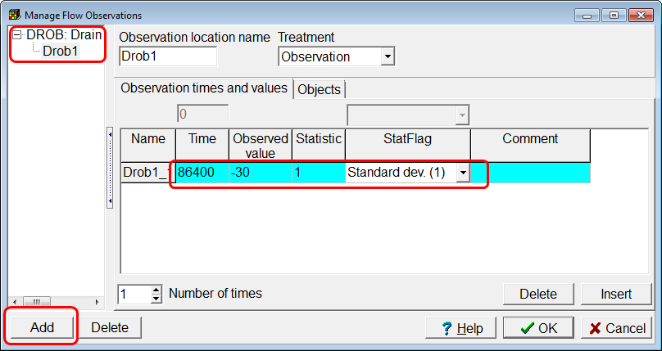
- Now we have to assign the objects that are part of the flow observation. Open the Show or Hide Objects dialog box and double click on one of the objects that defines a drain. In the Object Properties dialog box, check the check box for the Drain Observation package (DROB) and also check the check box for the Drob1 observation group. If you leave “Factor” empty, it will be set to 1. “Factor” determines what fraction of the flow in a drain cell is part of the flow observation. A value of 1, means that all of the flow from a drain cell is part of the flow observation. Click OK and then do the same for the other object that defines drains.
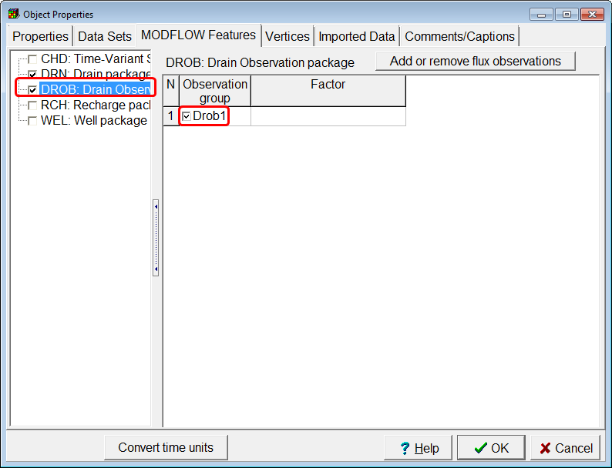
- Open the Manage Flow Observations dialog box again and select the drain flow observation. Go to the Objects tab and note that both of the objects that define drains are part of the drain observation. The Objects tab can be used to add objects to or remove objects from a flow observation.
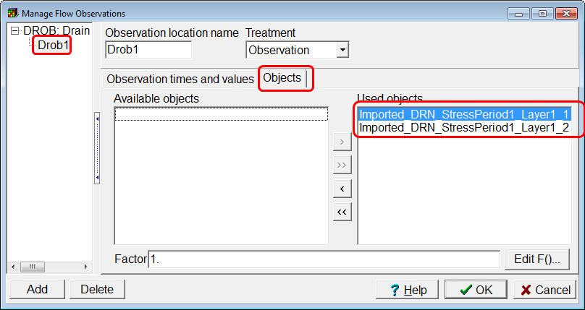
- Now save the ModelMuse file an then run the model (File|Export|MODFLOW-2005). The model should terminate normally although ModelMonitor may show some warning messages.
- Near the end of the listing file, you will find the values calculated by the model for our observations. They will probably be similar but not identical to the values shown below. Record the simulated values for both the head and drain observations. Our next step will be to perform parameter estimation and find out how much these values change.
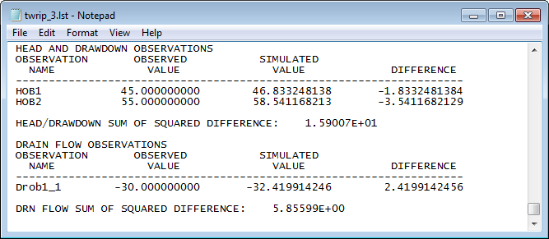
- Now select “File|Export|Export of Update ModelMate File” and select a name for the ModelMate file. ModelMate will open that file. If you wish, you can delete the ParamDefault parameter group because it contains no parameter.
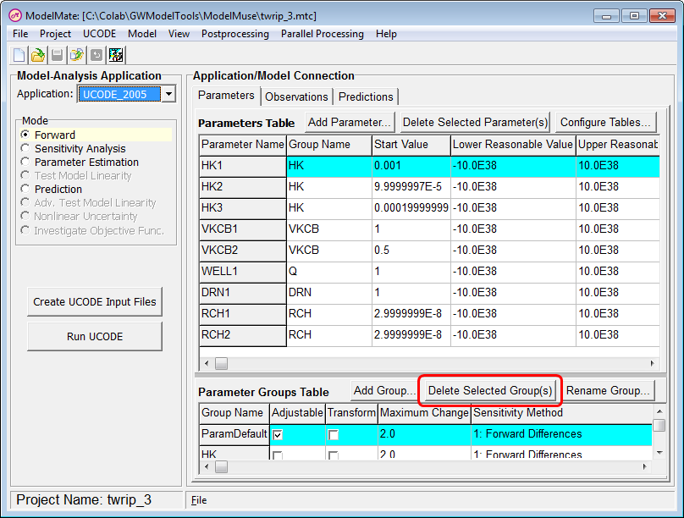
- We only want to estimate the HK1 parameter which is one of three parameters in the HK group. Only adjustable parameters are estimated. Right now, ModelMate is set up so that we specify which parameters are adjustable in the Parameter Groups table. Click the Configures Tables button and change “Adjustable” so that will appear in the Parameters table. Then click OK.
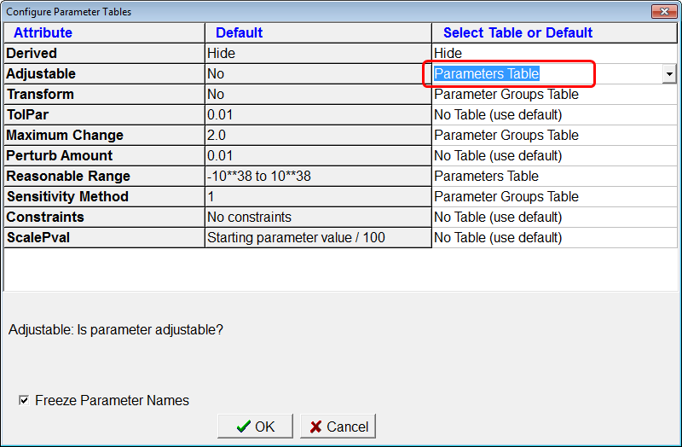
- Next check the “Adjustable check box for the HK1 parameter. Also check the “Transform” check box for the HK parameter group. “Transformed” parameters are log transformed before being adjusted during parameter estimation. Transforming a parameter prevents it from ever adopting a negative value among other benefits. If you wish, you can also specify lower and upper reasonable bounds for the HK1 parameter. The bounds do not affect the parameter estimation process.
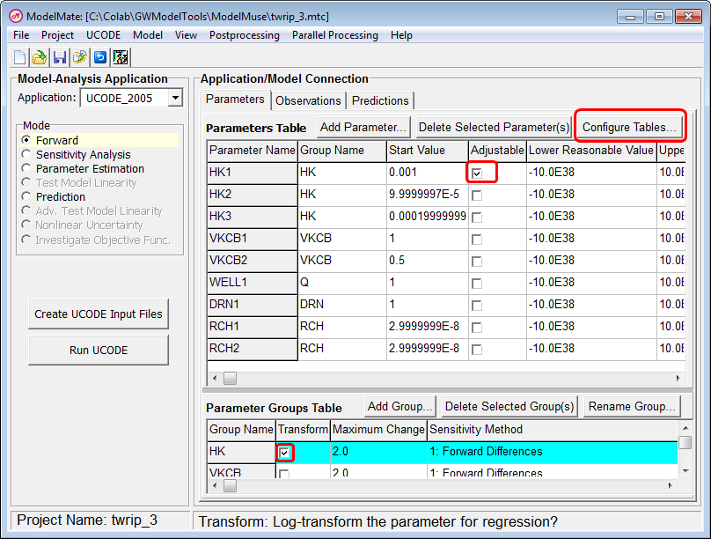
- Select UCODE|File Names and specify a output prefix and UCODE input file name for the primary model. Click OK.
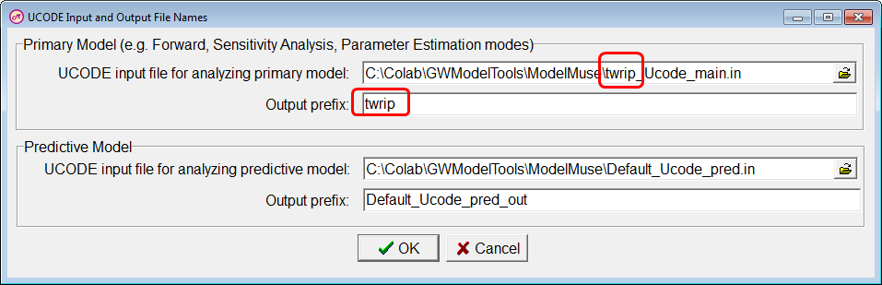
- Select “Model|Create Instruction Files for Observations Defined in ModelMuse.
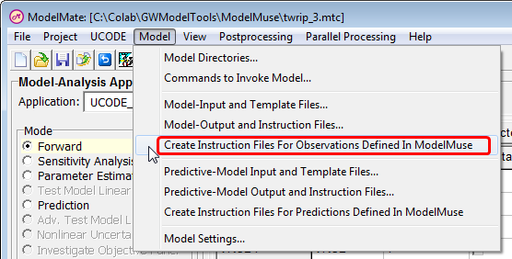
- Select “Project|Program Locations” and make sure that the location for UCODE is correct. Either UCODE-2005 or UCODE-2014 can be used with ModelMate. Check that the location for GW_Chart on your computer is correct too.
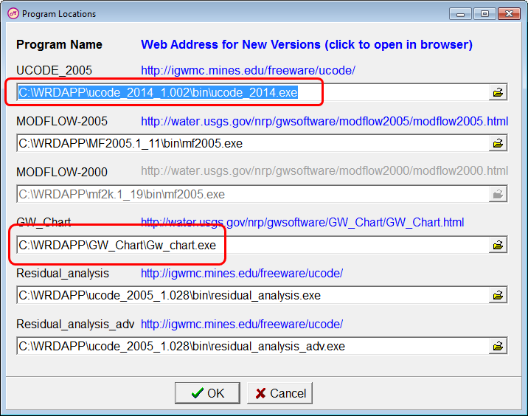
- Change the Mode to “Parameter Estimation” and click the “Run UCODE” button.
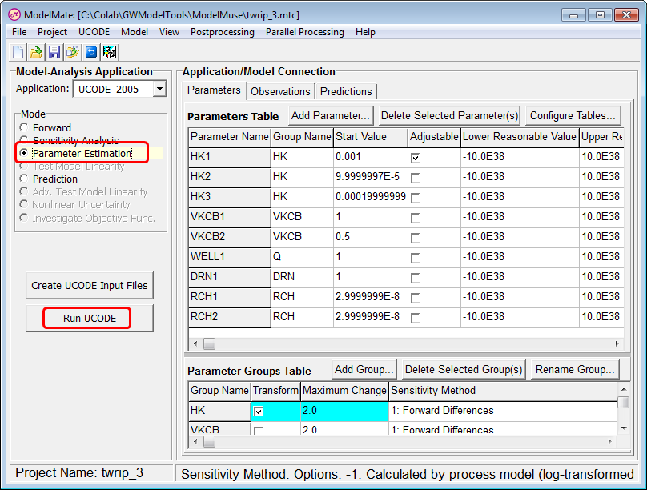
- ModelMate will start UCODE which will run the MODFLOW model with adjusted values of HK1 until it reaches the best value it can. Open the listing file for the MODFLOW model in a text editor and compare the simulated values for the observations to the simulated values from the original run. Are the new simulated values a closer match to the observed values than the original simulated values?
- In ModelMate, select “View|UCODE Main Output File”. Then search for “PARAMETER VALUES FOR EACH ITERATION” in the main output file. You will find a table listing the adjutable parameter values for each UCODE iteration.
- In ModelMate, select “PostProcessing|GW_Chart”. GW_Chart will open and display a graph based on the ._os file generated by UCODE. This is a plot of the unweighted observation values against the simulated equivalents.
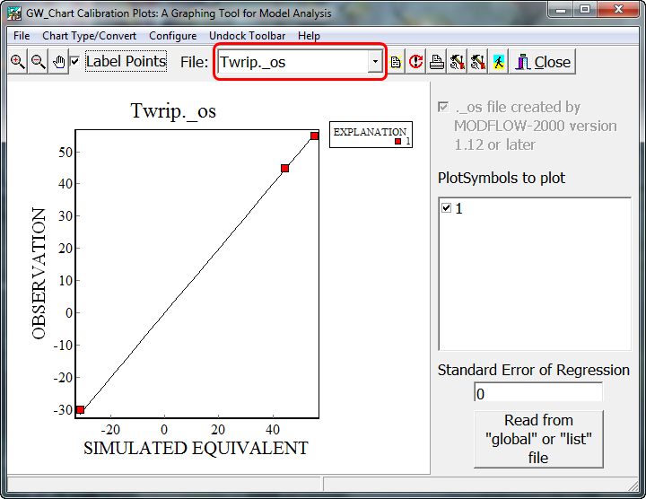
- There are a variety of charts related to this project that GW_Chart can display. Try selecting the ._so file. It shows that for this model, the drain observation had a relatively small effect on the final adjusted parameter value. Changing the statistic for the observations could change the levage of the observations and thus affect the final adjusted parameter values. There is more information about the various plots in the GW_Chart help.
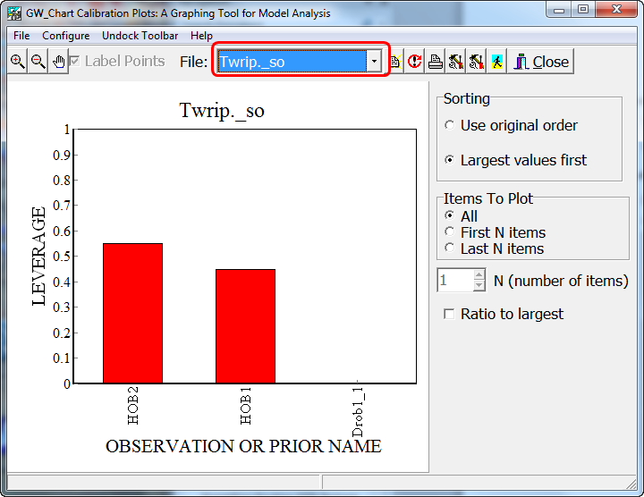
- Go back to ModelMuse and display the “Model|Manage Parameters” dialog box. Click the “Import Pval file button and select the .pval file for the model. The .pval file contains a list of all the parameters and their values. UCODE generates a new .pval file when it adjusts the parameters. Thus by importing the .pval file, you can update your model with the adjusted parameters.

Banta, E.R., 2011, ModelMate—A Graphical User Interface for Model Analysis: U.S. Geological Survey Techniques and Methods, book 6, chap. E4, 31 p.
Poeter, E.P., Hill, M.C., Banta, E.R., Mehl, Steffen, and Christensen, Steen, 2005, UCODE_2005 and Six Other Computer Codes for Universal Sensitivity Analysis, Calibration, and Uncertainty Evaluation: U.S. Geological Survey Techniques and Methods 6-A11, 283p.
Poeter, Eileen P., Mary C. Hill, Dan Lu, Claire R. Tiedeman, and Steffen Mehl, 2014, UCODE_2014, with new capabilities to define parameters unique to predictions, calculate weights using simulated values, estimate parameters with SVD, evaluate uncertainty with MCMC, and More: Integrated Groundwater Modeling Center Report Number: GWMI 2014-02.

Local Grid Refinement
Estimated time: 1 hour, 5 minutes
With “Local Grid Refinement”, the user embeds one or more child grids in a parent grid. The grids communicate with one another through shared nodes. The child grids are more finely discretized than the parent grid and thus can represent more detail while using less memory and time than would be need to refine the entire model. In the child grid the shared nodes are at the edge of the grid and are treated as specified head cells. In the parent model, the shared nodes are treated as specified flux nodes.
Often, the starting point for a model using local grid refinement used is an existing regional model so for this example, we will start by importing an existing model. The model is one of the examples that comes with MODFLOW.
- Start ModelMuse and select “Import MODFLOW-2005 model”. Then click “Next”.
- Select C:\WRDAPP\MF2005.1_11\test-run\twrip.nam as the name file and click OK.
It helps to have a little understanding of this model before proceeding further.
- Select “Model|MODFLOW Layer Groups…” and note that only three of the five layers are simulated and that the top layer is convertible. Then click Cancel.
- Select “Model|MODFLOW Time…” and note that this is a steady-state model. Then click Cancel.
- Select “Model|MODFLOW Packages and Programs…” and note that the CHD, RCH, WEL and DRN packages are selected. Also note that parameters have been defined for the LPF, RCH, WEL and DRN packages. Then click Cancel.
- Use the Show or Hide Objects button to determine where the boundary conditions are located.
- Color the grid with the recharge rate and note that the recharge rate is uniform.
Now let’s create a child grid inside this grid.
- Select Model|MODFLOW-LGR V2. The “Child Models” dialog box will appear. Click the “Create new child model” button.
Recall that the top layer was an unconfined layer. It can be problematic to subdivide an unconfined layer vertically because in the child grid, the specified head cells used to communicate with the parent model in the unconfined layer may have heads lower than the bottom of the cell which will cause the model to abort.
- Switch to the Discretization tab and change the “Child model discretization” to 3 for all but the top layer. Click OK to close the Child Models dialog box. If you want to display it again, select “Model|Child Models.”
The next step is to choose where the child grid should be.
- Select “Object|Create|Rectangle” and draw a rectangle on the top view of the model from column 9, row 4 to column 13, row 8. (The column and row numbers are displayed on the status bar.) In the Object Properties dialog box, set the number of Z formulas to Zero and then switch to the LGR tab. In it, check the radio button under “Define boundary of child model” labeled “Child 1” and click OK. The grid for the child model will be generated
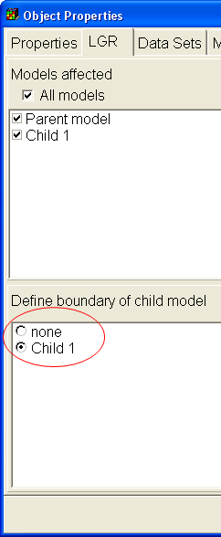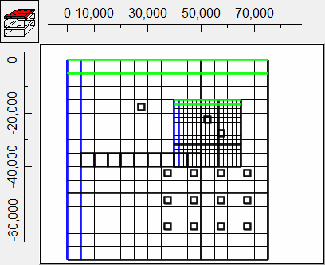
- If it is not still colored, color the grid with the recharge rate. Notice that the recharge rate is still constant. However, If you use MODFLOW-LGR V1, the recharge rates on the shared cells will be automatically adjusted according to the guidelines in the MODFLOW-LGR documentation. If you wish, you can try switching to MODFLOW-LGR version 1 to see this.
The documentation for the Local Grid Refinement version 1 suggests altering the recharge rate in the shared cells because if it is not altered, the recharge will be counted both in the parent mode and in the child model resulting in too much recharge entering the model. ModelMuse automatically adjust the recharge rate in the shared cells in accordance with the guidance in the Local Grid Refinement documentation.
- Color the grid with the drain conductance. Note that the drains In the child grid have had their conductances automatically reduced.
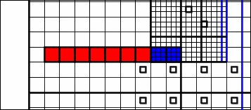
- For MODFLOW-LGR version 1, Note that the drains in the parent grid have had their conductances reduced somewhat. In the child grid, there are no drains in the shared cells. Those drains have been moved to the interior of the grid.
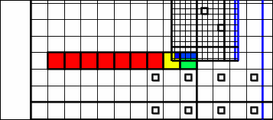
In MODFLOW-LGR version 1, Objects that are entirely inside or on the edge of the shared cells of the child grid are not used to define drain, well, river, stream, or general-head boundaries in the parent grid because that would result in the flow of water into or out of the model being counted twice: once in the parent grid and again in the child grid. The parent grid cells that are entirely inside the child grid need no special treatment in ModelMuse; MODFLOW-LGR will treat those cells as inactive cells in the parent grid.
In the child model of MODFLOW-LGR version 1, the drains have been moved into the interior of the model because if they were at the outer edge of the model they would be at the same location as the specified head cells used to communicate with the parent model and thus would have no effect on the child model.
- The model uses the SIP solver. We will change it to using the PCG solver. Select Model|MODFLOW Packages and Programs and select the PCG solver. Then change the Model in the upper left corner to Child 1 and select the PCG solver for the child model too.
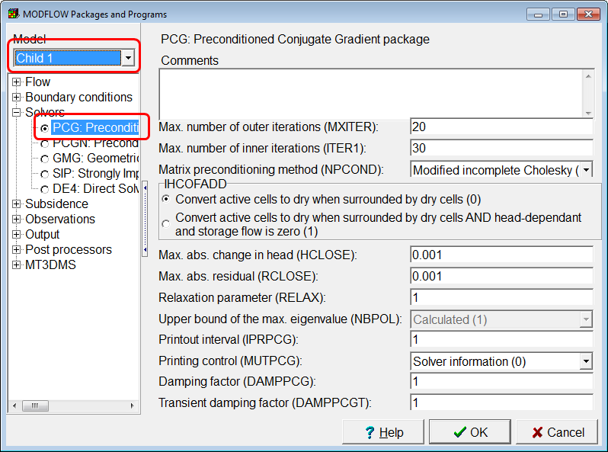
- To run the model, first save the model and then select "File|Export|MODFLOW-LGR Input Files." ModelMonitor will open and will display any error warning messages printed by MODFLOW-LGR as well as a plot of the percent discrepancy in the budget for both the parent and child grids. In this case MODFLOW-LGR ran without any error or warning messages. When you close ModelMonitor, the listing files for the parent and child models will be opened in Notepad (or another text editor of your choice).
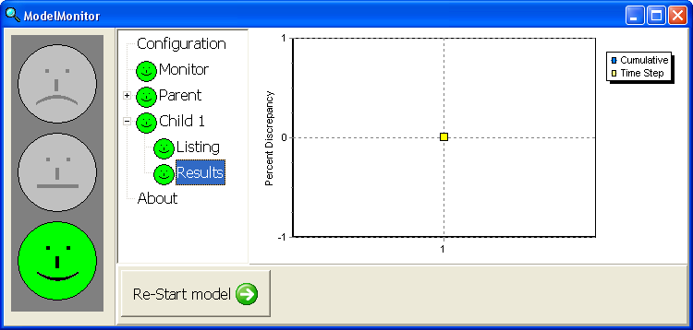
The Errors and Warnings dialog box will appear after you run the model. The one error is that the CHD (time-variant specified-head) package is active in the child model but there are CHD cells in the child model.
- To turn off the CHD package in the child model, select Model|MODFLOW Packages and Programs. In the combo-box in the upper left labeled "Model" select "Child 1". Then expand "Boundary Conditions|Specified Head" and uncheck the CHD package. Now switch to the parent model. Note that the CHD package is still active in the parent model but is inactive in the child model. Click OK to close the MODFLOW Packages and Programs dialog box.
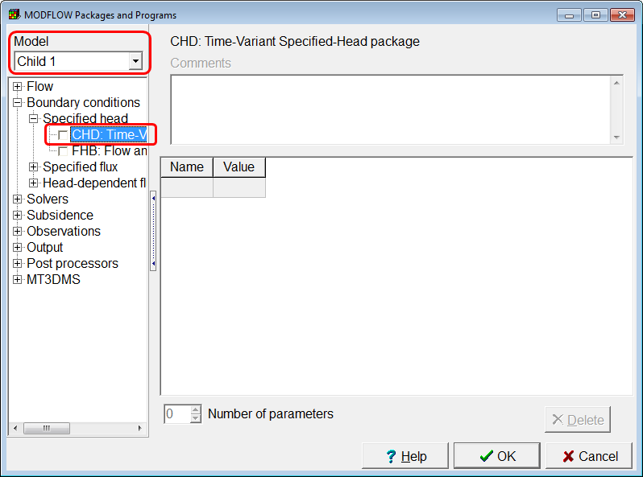
There are also warning messages about well, drain, and recharge parameters not being active in the child models. You can ignore those warnings. ModelMuse does not allow you to specify separate parameters for the child and parent models. Instead it skips those that do not apply to a model.
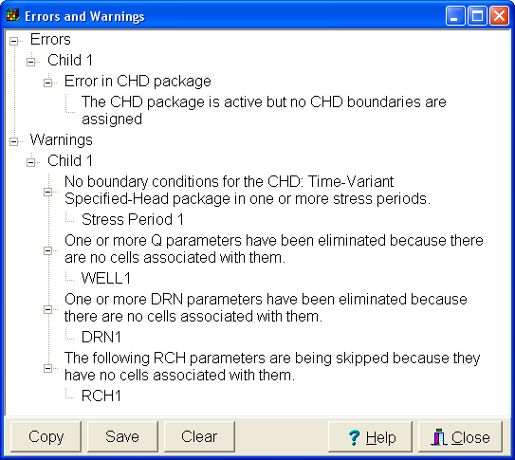
- The next step is to import the model results. Select "File|Import|Model Results". The head file for the parent model should be selected by default so click "Open" and the "Select Model Results to Import" dialog box should appear. At the top will be a table listing the files from which it will import the model results. You can uncheck the "Import Data" check box next to each file in the table if you want to import data from just the parent or just the child. You can also click on a file name, click "Browse" button that will appear and select a different file. In this case, just click OK and the data will be imported and the grids will be colored with the model results.
- To see the value at an individual cell, select "Data|Show Grid or Mesh Values." It will display the value for the cell underneath the cursor. Note that you can choose whether to display data from the parent grid or the child grid in the dialog box.
- Another way to see the data values is to select "Data|Display Data Set Values". This dialog box can display a table with all the values in a layer for either the parent or child models.
ModelMuse has a number of functions related to local grid refinement that you can use in formulas. Some of these are used in the formulas for the imported model results. The (rather long) formula for the imported heads is shown in the figure below. The formula diagram help to show what the formula is doing. First it checks that the grid number is less than or equal to 2. The grid number for the parent grid is 1. The grid number for the child grid is 2. (Grid numbers are assigned automatically and can not be changed by the user. If you were to add another child grid, its grid number would be 3.) If the grid number is less than or equal to 2, the formula next uses a "case" function to give different values to the different grids. For each grid it checks whether the layer number is less than or equal to the number of layers that were in the imported data and if so, it then links to the data set for the appropriate layer. For non-simulated layers, it averages the values of the layers immediately above and below the non-simulated layers. If you wish, you can use a similar technique to apply different values to the parent and child models.
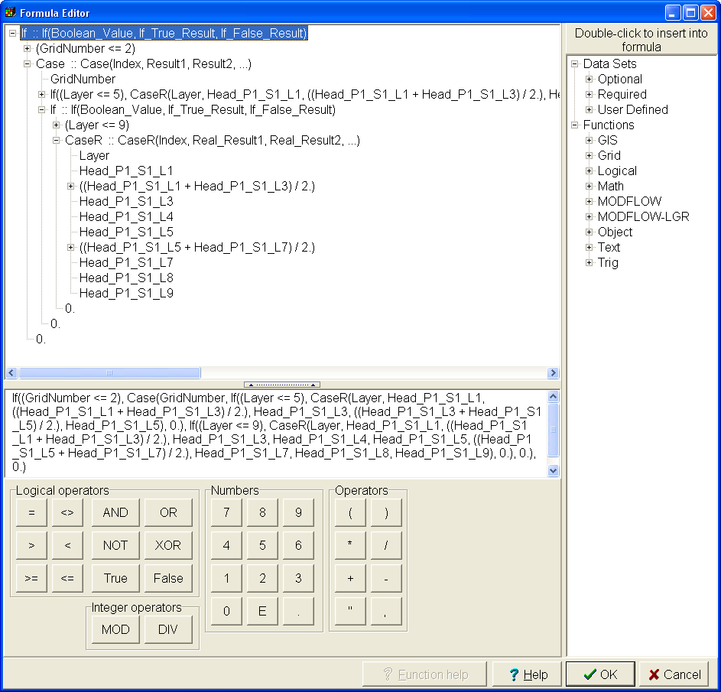
- The data for the individual layers are specified by objects. There is one set of objects for the parent grid and another set of objects for the child grid. To see this, select "Object|Show or Hide Objects". Then expand "Data Sets|Optional|Model Results|Layer Data|Head_P1_S1_L1". In the dialog box, double-click on "Head_P1_S1_L1_Object2" to open that object in the Object Properties dialog box. Go to the LGR tab. Note that under "Model affected" only the child model is selected. If you wish to edit the child model, you can use this technique to create objects that only affect the child model.
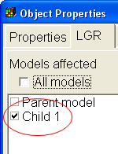

Troubleshooting Exercises
Open the ModelMuse help and refer to the “Troubleshooting” section when answering the following questions.

Problem 1
Open the model named Problem1.gpt. Note that the Well package is active and that there is an object that is supposed to define a well. However, if you color the grid with the well pumping rate, no wells are colored. Why is that?

Problem 2
Open the model named Problem2.gpt. Note that the Well package is active and that there is an object that is supposed to define a well. However, if you color the grid with the well pumping rate, no wells are colored. Why is that?

Problem 3
Open the model named Problem3.gpt. Color the grid with the Kx data set. Note that there are 4 objects that are supposed to each set a different value of Kx. Why do the Kx values all appear to be the same?

Problem 4
Open the model named Problem4.gpt. Color the grid with the Kx data set. Note that there are 4 objects that are supposed to each set a different value of Kx. Why are all the Kx values the same?

Problem 5
Open the model named Problem5.gpt. Color the grid with the Kx data set. The single object in this model is supposed to set the values of Kx for every cell in the grid. However, in the middle layer, Kx is set by the default formula. Why is that and what can you do about it? (Hint: try moving the object so it only covers part of the grid.)

Problem 6
Open the model named Problem6.gpt. Color the grid with the Kx data set. Note that the object is supposed to set Kx for all the cells it encloses but there is a group of cells inside it whose values are set by the default formula. Why is that?

Problem 7
Open the model named Problem7.gpt. Note that the Well package is active and that there is an object that is supposed to define a well. However, if you color the grid with the well pumping rate, no wells are colored. Why is that?

Problem 8
Open the model named Problem8.gpt. Note that the Well package is active and that there is an object that is supposed to define a well. However, if you color the grid with the well pumping rate, no wells are colored. Why is that?

Problem 9
Open the model named Problem9.gpt. Color the grid with the Kx data set. There are two objects in this model that are supposed to set the value of Kx. However, only one of them appears to have an effect. Why is that and what can you do about it?

Problem 10
Open the model named Problem10.gpt. Color the grid with the Kx data set. This model uses three parameters to define the distribution of Kx. Each parameter uses a zone array. The parameters have values of 0.0001, 0.0002 and 0.0003. However, the calculated values of Kx are 0.0001, 0.0003 and 0.0005. Why is that and what can you do about it?

Answers

Problem 1
In the object, the Z coordinate is set to “Model_Top + 1.” which is above the top of the model.
The Grid Value dialog box can help with diagnosing this problem. If you display it and check the check box to display the 3rd-dimension coordinate of the selected object, the Z-coordinate is always listed as “not assigned” regardless of which layer is selected. This indicates that the object does not intersect the grid.

Problem 2
The starting and ending times for the well are 0 and 1. However, the stress period ends at time zero.
When you color the grid, you will get a warning that the end of the last stress period is zero and the last defined time is 1.

Problem 3
The four objects all set the values of Kx for layer 2. The selected layer is layer 1.
The fact that all the cells were blue (instead of green) is a clue that the values are not all the same even though you don’t see any cells that aren’t blue. When everything is the same value, the color from the middle of the color scale will be used to color the cells.

Problem 4
The Grid Value dialog box can help with diagnosing this problem. The explanation says “set using parameters via the formula: 0.001”. Recall that when MODFLOW uses parameters to set the value of a data set, you can’t use objects to set the value of that data set directly. Thus, when determining the value of Kx, the 4 objects have no effect. However, you could use objects to set the values of the multiplier and zone array associated with an object.

Problem 5
In the Show or Hide Objects dialog box, note that the object is marked with the word “Intersected” instead of “Enclosed”. That means it sets the values of cells that it intersects. The edges of the object are outside the grid so they don’t intersect the middle layer. The formulas for the top and bottom of the object are “Model_Top” and “Lower_Aquifer_Bottom”. That causes the top of the object to be at the top of the grid and the bottom of the object to be at the bottom of the grid. Thus the object intersects the top and bottom layer but it doesn’t intersect the middle layer.
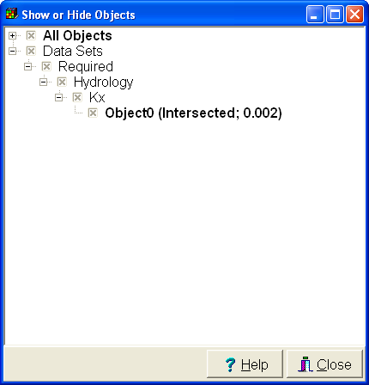

Problem 6
The Grid Value dialog box can help with diagnosing this problem. When you place the cursor over one of the cells where the object is working as it should, it says that the top of the object is at 0 and the bottom is at -10. However, In the cells where the object isn’t working right, it says that the top of the object is at -10 and the bottom is at 0. The top of the object is below the bottom of the object. For an object to enclose anything, its top must be above its bottom. When we look at the formulas for the higher and lower Z-coordinates, they are “Model_Top” and “Upper_Aquifer_Bottom”. Those seem OK so the problem must be with the Model_Top and Upper_Aquifer_Bottom data sets. Color the grid with the Model_Top data set and you will see that the area where KX isn’t set right, the elevation of Model_Top is different. When we place a cursor over this area, the Grid Value dialog box gives as an explanation “Enclosed by Object0 with formula: -10”. If we display the Show or Hide Objects dialog box, we find that Object0 is hidden. When we display and edit it, we find that it sets Model_Top and Upper_Aquifer_Bottom to -10 and 0 respectively. The front view of the model looks like this where the layers top and bottom are reversed. 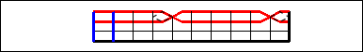

Problem 7
When you color the grid you get an error message that says “No boundary conditions assigned to the WEL: Well package because the object does not set the values of either enclosed or intersected cells.” When we double-click on the object, we see that the error message is correct.

Problem 8
The object is in layer 2. In the MODFLOW Layer Groups dialog box, you will see that layer 2 is a non-simulated layer. You can only have wells in simulated layers.

Problem 9
The Grid Value dialog box can help with diagnosing this problem. When the mouse is over a cell enclosed by the inner object, the explanation it gives for the value of Kx is “Enclosed by OuterObject with formula: 0.0003”. The Rearrange Objects dialog box lists the objects from back to front Inner_Object is listed before OuterObject so OuterObject overrides value set by Inner_Object. You can drag the rows in the Rearrange Objects dialog box to fix the problem. You drag rows by clicking on the gray area to the left of the row and dragging.

Problem 10
Recall that when parameters are used, zone arrays determine where each parameter is applied and then zone arrays further modify the value applied to an individual cell. None of these parameters use multiplier arrays so they are not an issue. The problem must be with the zone arrays. Recall that if no multiplier arrays are used, the value applied to a cell is the sum of the values of all the parameters that apply to a cell. To get the value we are getting, more than one parameter must apply to some cells. Try coloring the grid with each of the Zone arrays. HK_Par1_Zone and HK_Par2_Zone look OK but the HK_Par3_Zone and HK_Par2_Zone overlap. Object3 is used to define where HK_Par3_Zone is true and it uses the formula “If(HK_Par1_Zone, False, True)”. There are at least three ways to fix the problem.
- The formula in Object3 can be changed to If((HK_Par1_Zone OR HK_Par2_Zone), False, True). Actually, the formula could be made simpler by eliminating the If function: “NOT(HK_Par1_Zone OR HK_Par2_Zone)”
- Set the formula for Object3 to “False” for HK_Par1_Zone and HK_Par2_Zone and “True” for HK_Par3_Zone. Then right-click on it and select “To Back”. Then set the formula for Object1 to “False” for HK_Par2_Zone and HK_Par3_Zone and “True” for HK_Par1_Zone. Finally, set the formula for Object2 to “False” for HK_Par1_Zone and HK_Par3_Zone and “True” for HK_Par2_Zone.
- Make a new data set named “MyZones”. It should be a 3D, integer data set. Set it’s default formula to zero. Set the default formulas for HK_Par1_Zone, HK_Par2_Zone, and HK_Par3_Zone to “MyZones = 1”, “MyZones = 2”, and “MyZones = 3” respectively. Then Use Object1, Object2, and Object3 to set the zone number of the MyZones data set. You will need to right click on Object3 and select “To Back”.

