Quadpatch Grid Exporter  
December 15, 2017

# Introduction

Quadpatch Grid Exporter is a utility application for generating MODFLOW-USG unstructured discretization files (DISU), MODPATH supplemental discretization files (GRIDMETA), and MODFLOW-6 vertex-based unstructured discretization files (DISV). The quadpatch grids are defined by specifying a traditional structured MODFLOW base grid and an associated array of grid cell refinement values. Quadpatch Grid Exporter combines the base grid and the grid cell refinement data to produce a smoothed quadpatch grid. An option also is provided to export the unstructured grid cell polygons as ESRI shapefiles for use in graphics display applications. Base grid and refinement data are provided by a simple text-based grid definition file. Examples of the grid definition file are provided with the software distribution. A brief description of the input is provided below. The example grid definition provides a model that can be modified by users to generate their own unstructured quadpatch grids.

# Example Grid Definition File

The grid definition file used to produce the unstructured grid for the MODPATH-7 example ex02 is shown below. The data is arranged in a block format. The modflow grid block defines the basegrid. The quadpatch block defines the refinement data that will be applied to the cells in the basegrid to produce the quadpatch grid.

begin modflow_grid

length_unit = foot

rotation_angle = 0

x_origin = 0

y_origin = 0

nlay = 3

nrow = 21

ncol = 20

delr = constant 500

delc = constant 500

top = constant 400

bottom layer 1 = constant 220

bottom layer 2 = constant 200

bottom layer 3 = constant 0

end modflow_grid

begin quadpatch

refinement layer 1 = array_file ex02_refinement.csv

refinement layer 2 = array_file ex02_refinement.csv

refinement layer 3 = array_file ex02_refinement.csv

end quadpatch

## *modflow_grid* block input

The modflow_grid block contains the following data items:

**length_unit** – length unit used by MODFLOW specified either as foot or meter.

**nlay**, **nrow**, and **ncol** – layer, row, and column dimensions of the basegrid.

**delr** and **delc** – one-dimensional arrays specifying grid cell spacing along rows (delr) and along columns(delc) in the basegrid.

**top** – two-dimensional layer array specifying top elevation of layer 1.

**bottom** – three-dimensional, layer-based array specifying the bottom elevation of layers 1 through nlay.

**rotation_angle**, **x_origin**, and **y_origin** – transform data that allow the grid to be transformed to specific real world coordinates, if desired. The rotation angle is measured in the positive counterclockwise direction relative to the positive x-axis. The x_origin and y_origin values specify the offset location of the x-y origin for the transformed grid. For an untransformed grid, the rotation angle and the x and y origins are all equal to 0. The origin of the untransformed grid is located at the lower-left corner of the basegrid. These transform variables are not used by MODFLOW-USG, MODFLOW-6, or MODPATH. They are provided simply to allow output from those models to be transformed and plotted in specific real world coordinates. For MODFLOW-USG datasets, QuadpatchGridExporter writes the grid origin offset and rotation values to the GRIDMETA file. For MODFLOW-6 datasets, QuadpatchGridExporter writes the grid transformation values to the DISV file. MODFLOW-6 then writes those values to the MODFLOW binary grid file as part of its simulation output. Grid transformation data in the GRIDMETA and binary grid files is available to post-processing programs to transform output from MODFLOW and MODPATH from model coordinates to real world coordinates.

The individual data items can appear in any order within the block.

## *quadpatch* block input

The quadpatch block contains the following data item:

**refinement** – three-dimensional, layer-based array specifying grid cell refinement level data.

## Input format

Scalar and other single-value data items are specified as:

variable_name = variable_value

If the variable_value is a text item, it does not need to be enclosed by quotation marks unless it contains spaces.

One-dimensional and two-dimensional layer arrays can be specified as a single constant value or an array of values using the following syntax:

To assign a single constant value to all elements of the array:

variable_name = *constant* variable_value

To assign an array of values, the values must be read from a separate file that is specified by the syntax:

variable_name = *array_file* filename

The file containing the array values must reside in the same directory as the grid definition file. All one- and two-dimensional array data is read as a one-dimensional series of comma- or space-separated values. As many lines as necessary can be used to specify the array data.

Three-dimensional layer-based arrays are specified as a series of layer data items.

To assign a single constant value to all the elements of a specific layer, the following syntax is used:

variable_name *layer* layer_number = *constant* variable_value

To assign an array of values for the elements of a specific layer, the following syntax is used:

Variable_name *layer* layer_number = *array_file* filename

# Running Quadpatch Grid Exporter

Quadpatch Grid Exporter is a Microsoft Windows application. It consists of an executable file (quadpatch_grid_exporter.exe) and several dynamically-linked library (DLL) files. No special installation is required. The application should run on any computer running Microsoft Windows 7 SP1 or newer. The files can be placed anywhere provided that the executable file and all the DLL files are located in the same directory.

To run Quadpatch Grid Exporter, double click on the executable file in Windows explorer and the application window will appear.

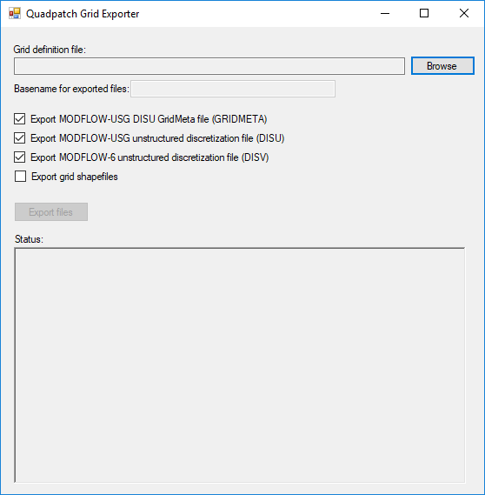

Click the Browse button to find and select a grid definition file.

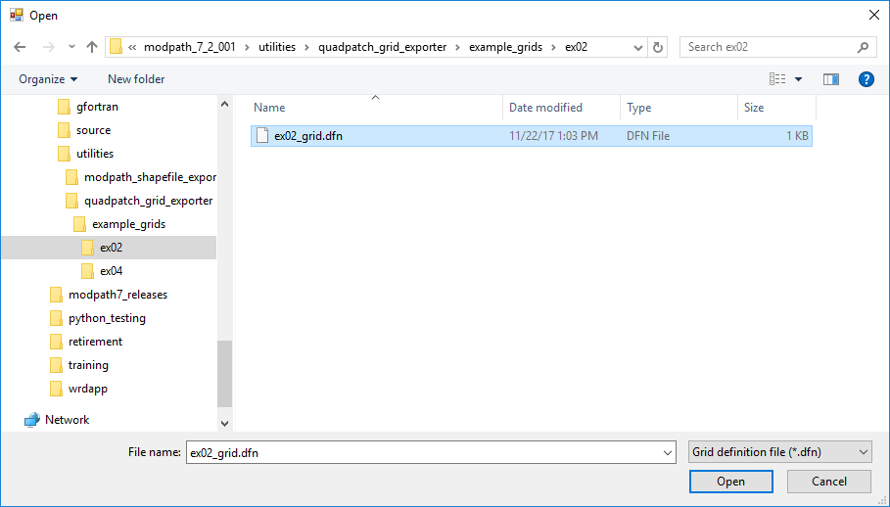

Select the output options you want and click the Export files button.

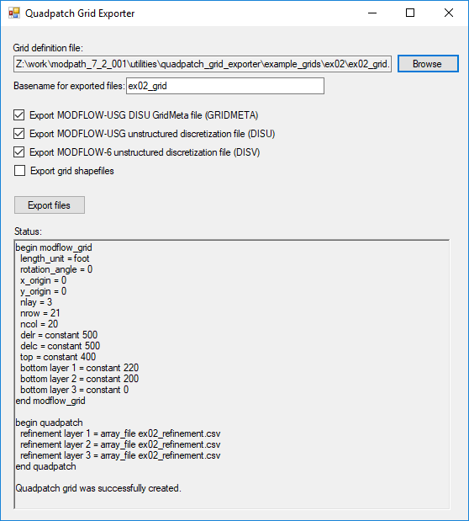

The status of the export operations is displayed in the text box at the bottom of the application window. The grid shapefiles and the DISU, GRIDMETA, and DISV files generated by the application will be created in the same directory as the grid definition files.

