Architecture & System Design
System: The Acity Oracle (RAG chatbot for Ghana Election Results and Ghana 2025 Budget data).

1. Architecture Overview
The system has three layers: (a) data ingestion/indexing, (b) query-time RAG pipeline, and (c) Streamlit UI with a feedback loop. Data is prepared once and reused; each user query runs through retrieval, prompt construction, and model inference.

2. Data Flow Drawing
Figure 1 shows the end-to-end data flow and feedback loop.
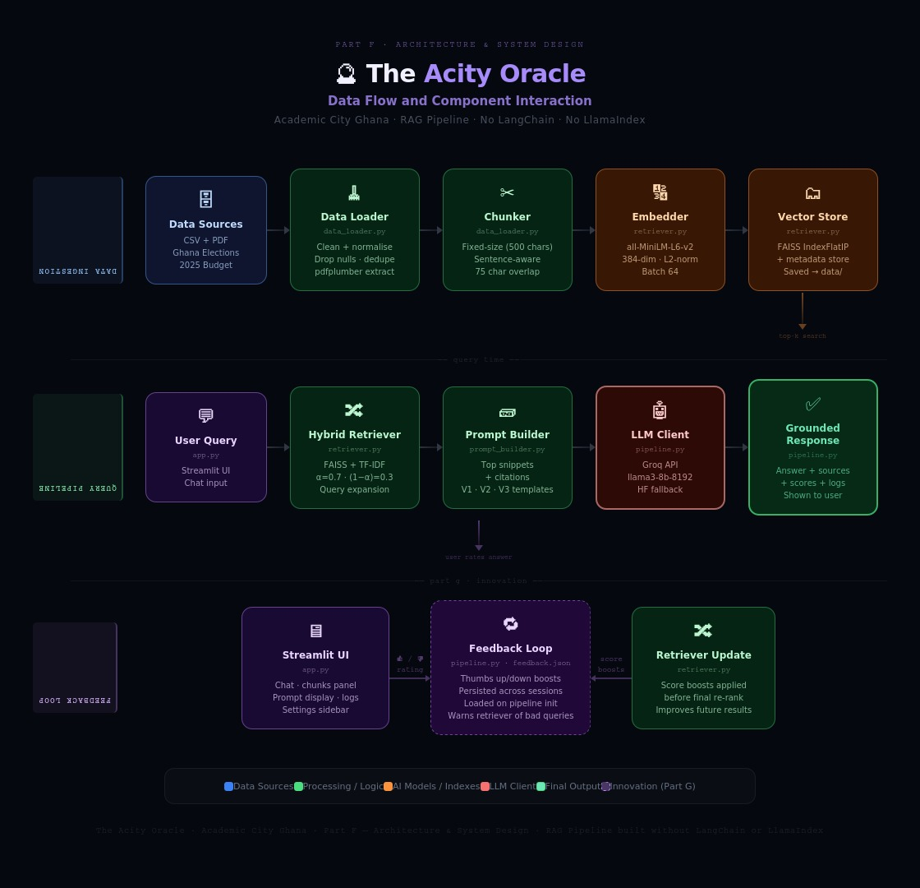
Figure 1: End-to-end data flow and components interaction.

3. Components Interaction
- data_loader.py cleans CSV/PDF data before chunk creation.
- chunker.py splits documents using fixed-size or sentence-aware strategy.
- embedder.py converts chunks into vectors; vector_store.py persists FAISS index and metadata.
- retriever.py combines semantic FAISS results and TF-IDF keyword matching using alpha-weighted fusion.
- prompt_builder.py selects highest-ranked snippets and builds a citation-oriented prompt.
- llm_client.py sends prompt to Groq (or Hugging Face fallback) and returns grounded response.
- app.py displays response, retrieved context, logs, and captures thumbs up/down feedback.
- feedback.py stores chunk-level boosts and injects them into future retrieval ranking.

4. Why This Design Fits the Domain
- Factual grounding is essential for election and budget questions; RAG reduces hallucinations by forcing source-based context.
- The domain has mixed source types (structured CSV + narrative PDF), so dual chunking strategies improve retrieval quality.
- Hybrid retrieval captures both semantic meaning and exact domain terms such as party acronyms and budget entities.
- Transparent UI (chunks, scores, prompt, logs) supports academic traceability and easier marking.
- The architecture is lightweight and practical for student deployment: FAISS on CPU plus API-hosted LLM.

