Storm Center Conference Paper

Authors: Jesse Siu, Gabriella McClinton, Daphne Officer

MODS APPtitude at FAU 2016

July 31st, 2016

ABSTRACT

Background

Learning about storms and how they are formed allows humans to better protect themselves from the perilous effects that natural disasters can have on the earth and their homes.

Methods

During the three-week internship, the Storm Center team utilized programs such as Android Studio, Maya, Illustrator, and Github to aid them in their app development process.

Results

The Storm Center team redesigned a brand-new app updated from last year’s app, with more interactive features rather than just information.

Discussion

The Storm Center team of 2017 will need to improve on the storyline of the app.

Conclusion

The new Storm Center app has improved greatly by featuring a brighter and more attractive user interface. Furthermore, the new app acts as a link between the actual exhibit and users of the app who have never visited the Museum of Discovery and Science in Fort Lauderdale.

References

The mock-up, source code, and group video can be found in Storm Center 2016’s Github repository.

BACKGROUND

The Storm Center exhibit revolves around the causes and effects of disastrous storms such as hurricanes and tornadoes. Despite these storms being exclusive to areas of tropical climates such as Florida, the tips for protecting one’s home before, during, and after a storm are not exclusive to one natural disaster. The Channel 7 News corner of the exhibit delves into the scope of how storms can affect people’s everyday lives. For instance, in the case of a brushfire, people with respiratory issues such as asthma must stay indoors or wear surgical masks to avoid breathing in debris. Moreover, the Storm Center also teaches visitors about the importance of learning more about natural disasters. Robert Penn Warren, American poet and novelist, puts it best: "History cannot give us a program for the future, but it can give us a fuller understanding of ourselves, and of our common humanity, so that we can better face the future." The more humans learn about the forces of weather that threaten their livelihoods, the better protected humanity will be from chaos.

METHODS

The Storm Center team consisted of three members: Jesse Siu (in charge of the Java aspect), Gabrielle McClinton (in charge of the graphics aspect), and Daphne Officer (in charge of the UI aspect). The class at FAU was split into Java & UI and Graphics. Jesse and Daphne learned how to use Android Studio and take advantage of the Android Studio developer’s guide. On the other hand, Gabriella learned how to use Illustrator and Maya to create icons for the main menu and title headers for different activities. The MyBalsamiq mock-up created on the first day of class greatly resembles the final product, which can be found in the Storm Center Github repository. Below is a screenshot of the Storm Center mock-up and an example of code created for the main menu.

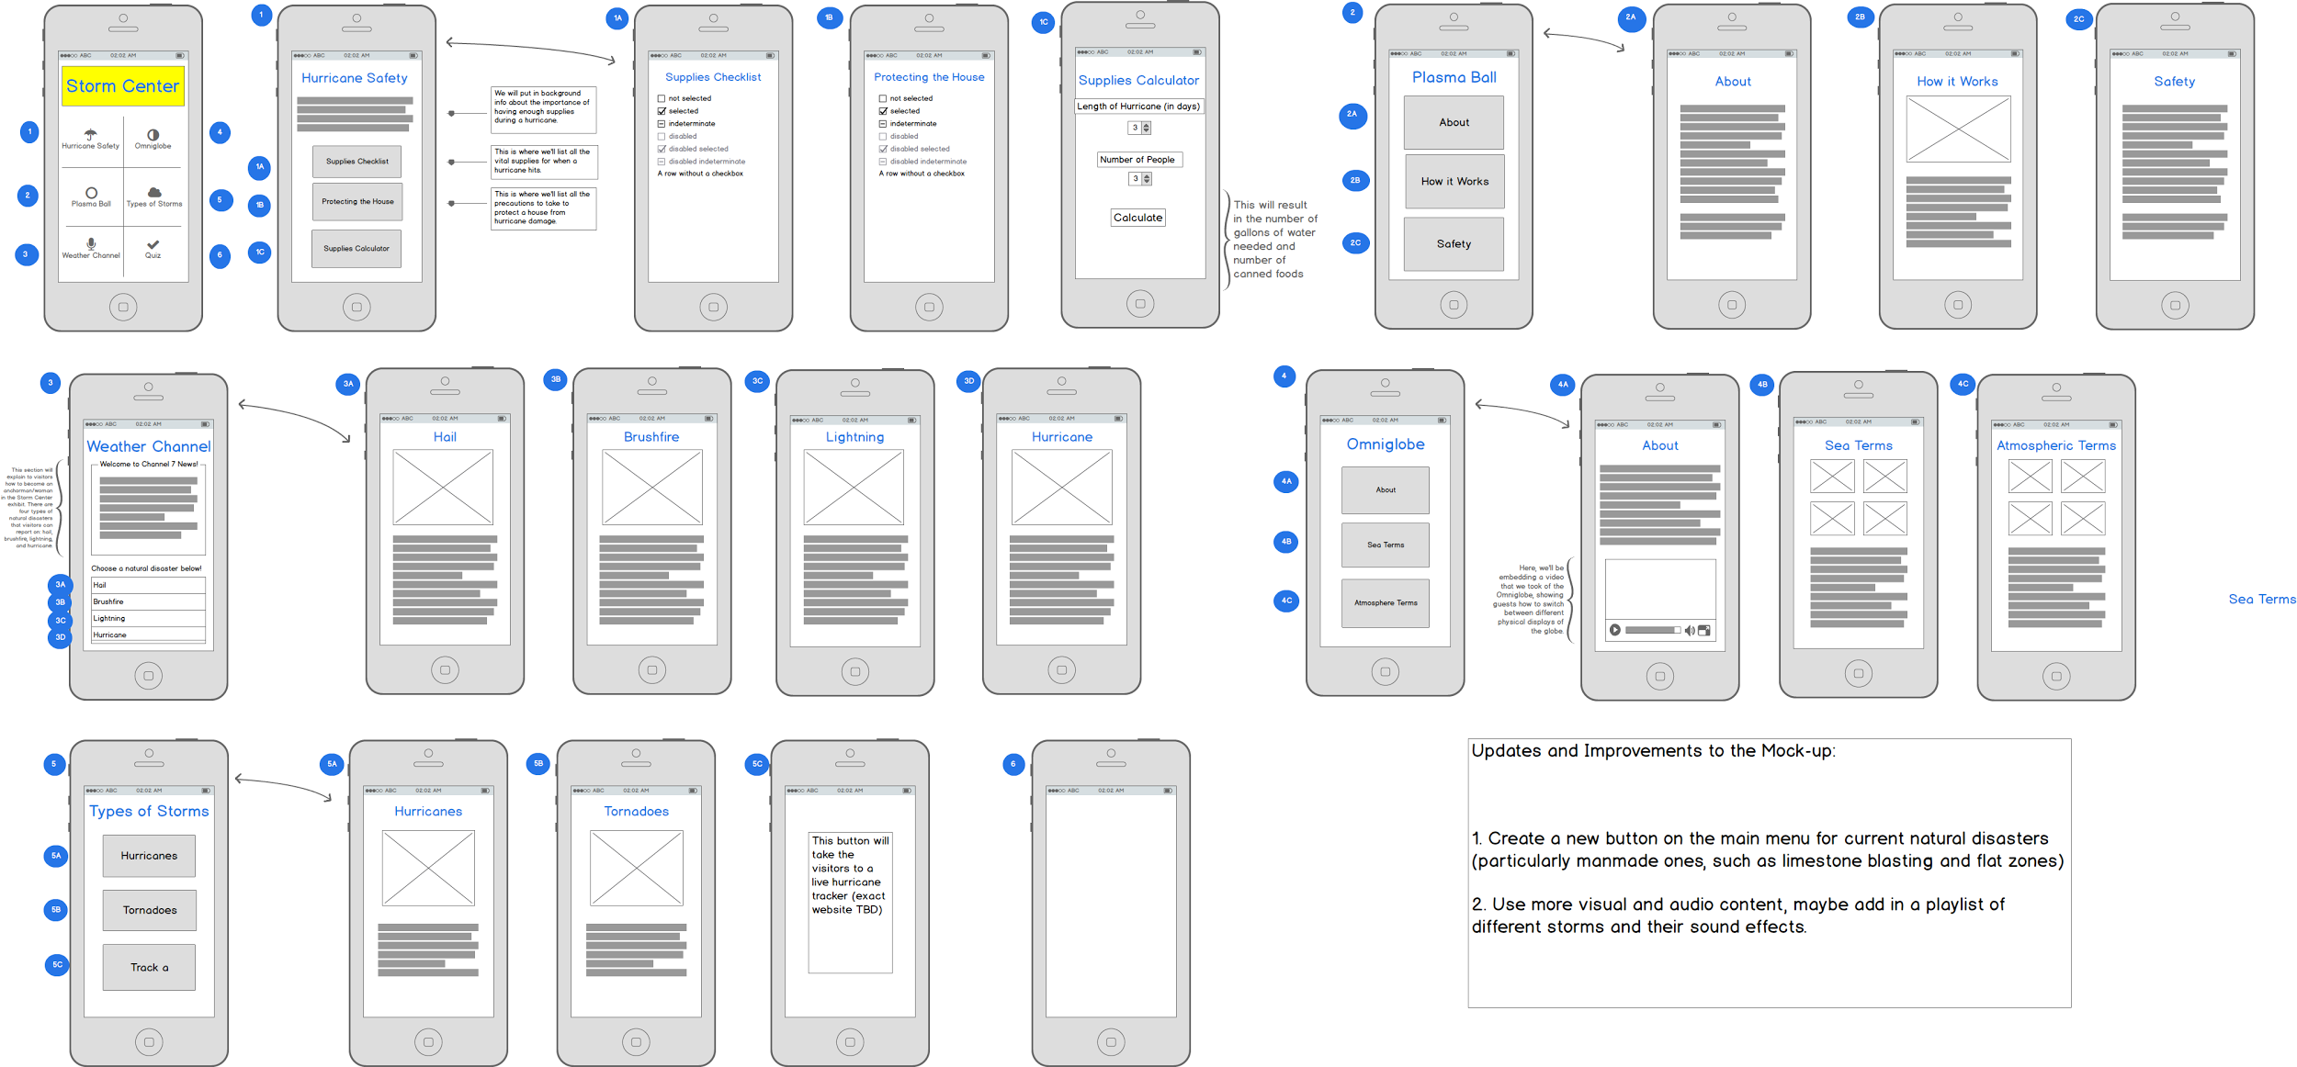

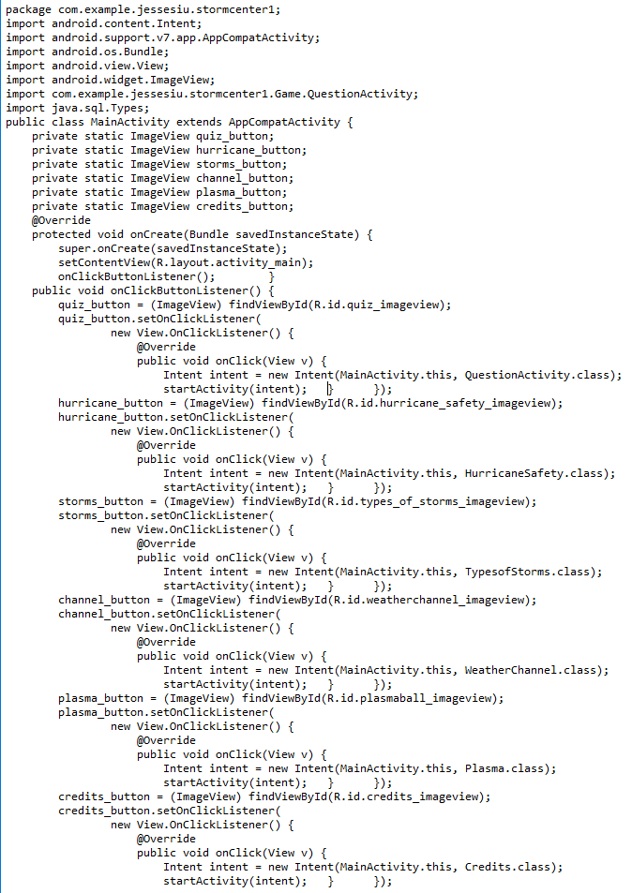

This is an excerpt from the Main Activity class of Storm Center. In the public class MainActivity.java, all the variables for the buttons (icons on the main page) are declared and initialized. Below that is the OnCreate() method, which calls the onClickButtonListener() method, a function that allows movement between various activities when the user tries to click the button icons.

RESULTS

The improvements from last year’s app are as follows: Channel 7 News anchor scripts, a more challenging and detailed quiz, a more polished UI, and cleaner and more organized code. The goal during the past three weeks was to create a product that people could use and learn from without physically visiting the Museum of Discovery and Science or as a supplementary tool to increase the interactivity of the green screen in Channel 7 News and Get Prepared! section of the exhibit. While the two-person Storm Center team from 2015 made impressive efforts to highlight the educational aspect of the exhibit, the 2016 team focused more on connecting the visitors’ experiences in the physical exhibit to the features within the app. Now, visitors can act as actual weather anchors, choosing between a wide range of weather scenarios such as hail, brushfire, hurricane, and lightning. Also, a checklist for pre-storm supplies and a to-do list for protecting the house from natural disasters was created in the ‘Hurricane Safety section of the app.

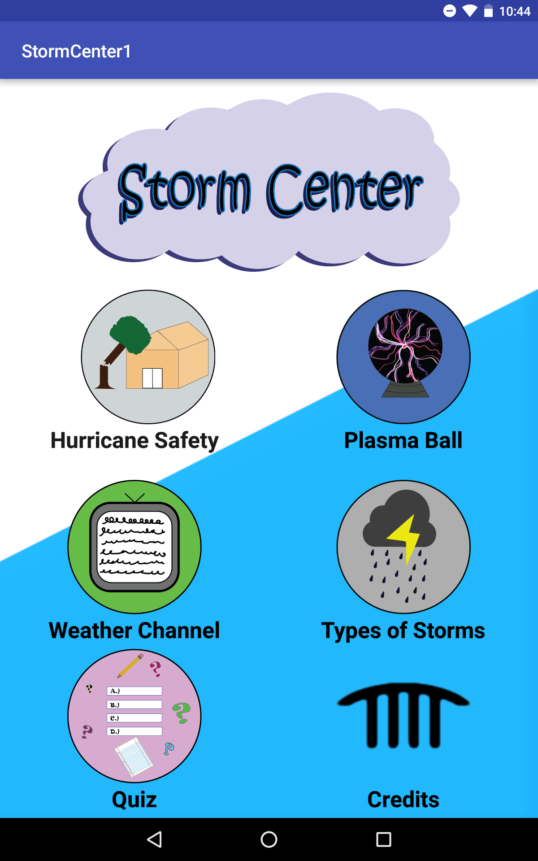 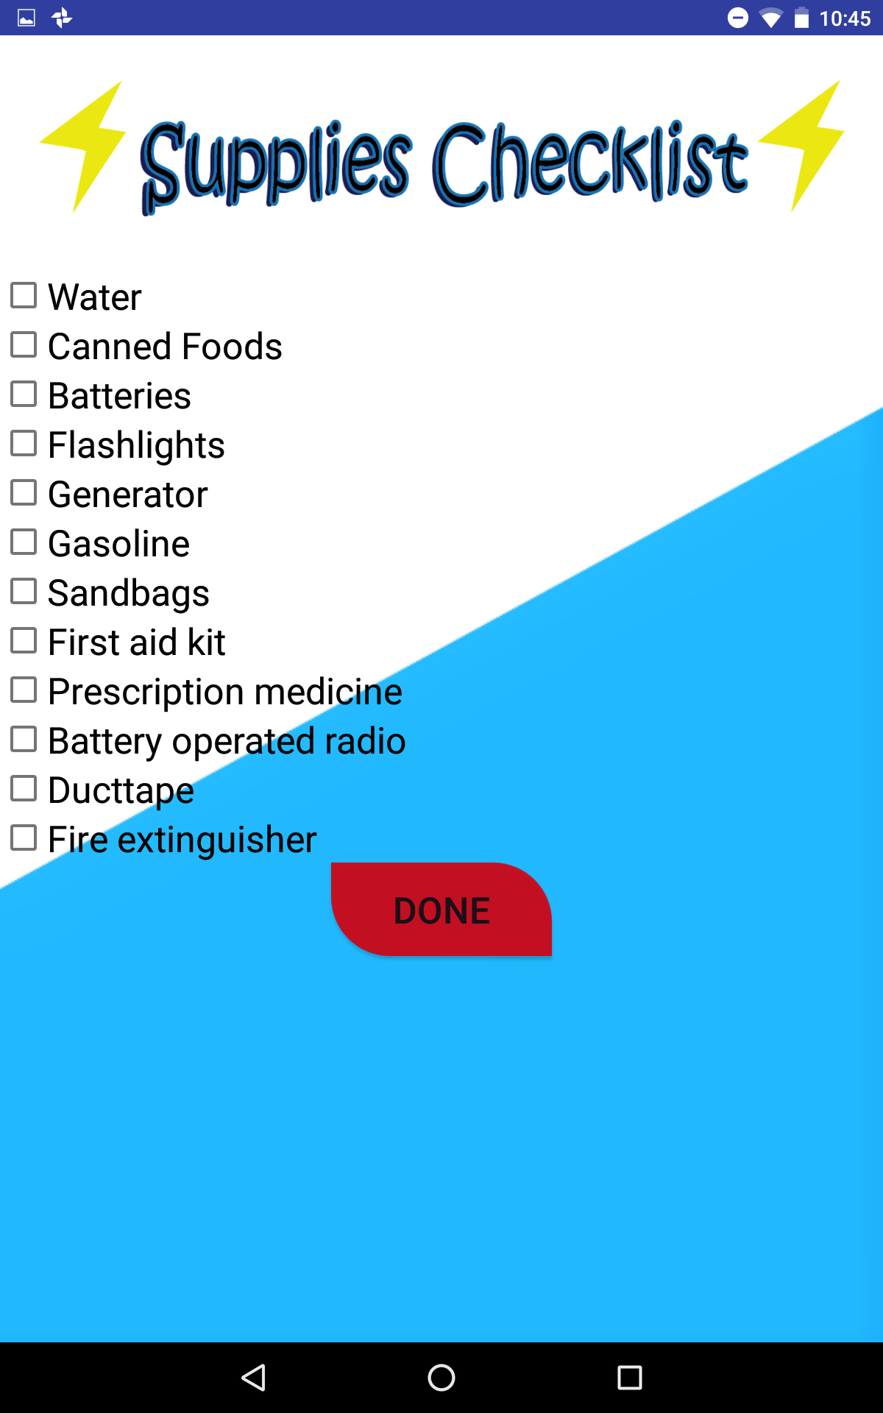

This is a screenshot of the main menu. Users can check off items that they do or

All icons were designed by Gabriella do not have for a storm. Clicking ‘Done’

and the layout was designed by Jesse. returns a list of items checked off by the user.

DISCUSSION

As mentioned in the ‘background’ section, the Storm Center app teaches users the importance of becoming familiar with storms that may harm their homes or health. The excerpts of information found along the walls of the exhibit explain topics such as Florida’s unique climate, technology used to learn more about storms, and lightning and plasma. Next year’s interns should develop more features that the 2016 group was not able to include due to time constraints. For instance, a hurricane tracker or a map that locates the scopes of past hurricanes could be implemented into the app. Also, because the app is still very “content-heavy,” next year’s interns should also consider implementing another game that is more fun and visually-appealing.

CONCLUSION

Overall, the 2016 Storm Center team has created a very stable app that teaches users about natural disasters and precautions to take before a storm hits. There is a very basic storyline that takes users through the process of preparing for a storm, the media’s reaction to storms, and post-research that occurs after a storm hits. However, this app should serve as a foundation for future interns who will make additions that will increase the audience to include visitors of all ages. The code will be available to use on Github for incoming MODS interns.

REFERENCES

The mock-up, group video, and source code can be found at the Storm Center Github repository site https://github.com/MODS16Apps/Storm-Center.