Evaluating Digital Biomarker Implementation in Personalized CPAP Therapy via a Role-Based Clinical Dashboard Architecture

Abstract
Obstructive Sleep Apnea (OSA) affects 17–34% of middle-aged adults and carries serious cardiovascular consequences. Continuous Positive Airway Pressure (CPAP) remains the gold standard treatment, yet 46–83% of patients fail to achieve adequate adherence within the first year . This paper presents SleepCare, a role-based clinical dashboard architecture developed in collaboration with Linde Homecare France that integrates CPAP telemetry from six data sources, digital biomarkers, intervention logs, and patient-reported outcomes through a contract-first backend API. The system generates a shared weekly patient state consumed by three distinct React/TypeScript portals—physician, technician, and patient—enabling synchronized views and AI-assisted triage without information asymmetry across roles. We validate the framework against four research questions concerning real-time data parity, predictive biomarker visualization, dynamic clustering, and event-driven intervention workflows.
Obstructive sleep apnea, CPAP adherence, clinical dashboard, digital biomarkers, telemonitoring, role-based interface, decision support.

Introduction
Obstructive Sleep Apnea is a prevalent chronic disorder associated with cardiovascular and neurocognitive morbidity, and Continuous Positive Airway Pressure remains the standard treatment for moderate to severe OSA when clinical criteria are met . Long-term adherence remains a major challenge, with non-adherence frequently linked to discomfort, low perceived benefit, fragmented follow-up, and delayed intervention after problems emerge . Despite advances in connected devices, many homecare workflows still depend on retrospective compliance thresholds, often centered on four hours per night, which can delay identification of deteriorating patterns .
The SleepCare architecture addresses these gaps by unifying CPAP telemetry, wearable biomarkers, survey responses, and clinical actions into a shared weekly patient representation exposed through a REST API. Drawing on evidence that clinical dashboards improve care processes when designed for immediate clinician access , the system targets four specific goals:
- Eliminate information asymmetry between physicians, technicians, and patients.
- Support AI-assisted prioritization without bypassing clinical judgment.
- Operationalize personalized follow-up through explicit workflow design.
- Enable scalable integration of future medical IoT devices .

Related Work
Recent adherence literature shows that successful CPAP management requires not only the device but also structured support that addresses technical failures, behavioral barriers, and symptom evolution over time . Telemonitoring interventions combining early follow-up and behavioral support consistently improve nightly usage compared with standard care . At the same time, dashboard research demonstrates that clinician-facing tools are most effective when they reduce cognitive load, present role-relevant information, and align with existing workflows .
More recent work by Kakaei Siahkal and colleagues provides a close foundation for the present system. The BHI 2024 paper on integrated feedback systems illustrates how CPAP data and structured intervention logic can jointly improve adherence . The SKIMA 2025 and CBMS 2025 manuscripts extend this line toward digital biomarkers, clustering, and adaptive OSA care pathways, supplying a research basis for personalized monitoring and multi-source feature integration . These contributions, however, focus on modeling and clinical outcomes; the present paper supplies the software architecture that operationalizes them end-to-end under real homecare constraints.

Research Problems and Objectives
The core problem is architectural fragmentation: clinically relevant information is scattered across CPAP exports, spreadsheets, survey systems, and vendor platforms, forcing each stakeholder to reconstruct a partial patient picture . This fragmentation creates operational latency in identifying and responding to risk, inconsistent interpretation of adherence and biomarker trends, and missed opportunities for early intervention.
To address these issues, the work pursues five objectives:
- Obj1: Design a contract-first backend that ingests heterogeneous data without discarding source fidelity.
- Obj2: Construct a weekly patient-state representation suitable for both dashboard display and AI-assisted triage .
- Obj3: Build role-specific interfaces that preserve a single source of truth while tailoring views and actions to physicians, technicians, and patients .
- Obj4: Implement a Human-in-the-Loop triage framework in which algorithmic prioritization supports, rather than replaces, clinical decisions .
- Obj5: Encode intervention tracking as part of the architecture, enabling systematic evaluation of follow-up outcomes relative to physiological and behavioral trends .

System Architecture and Methodology

System Overview
SleepCare is a full-stack telemonitoring architecture ingesting heterogeneous therapy and biomarker data into structured storage, then aggregating them into a weekly patient representation exposed via REST API to three role-specific portals and an AI-assisted risk layer. The architecture reflects a collaboration with Linde Homecare France, in which the same underlying patient state underlies physician review, technician dispatch, and patient engagement, despite differing interface layouts and workflows . The backend is implemented using Python FastAPI and PostgreSQL, deployed on cloud infrastructure. Fig. 1 illustrates the system-level interactions across all actors and use cases.
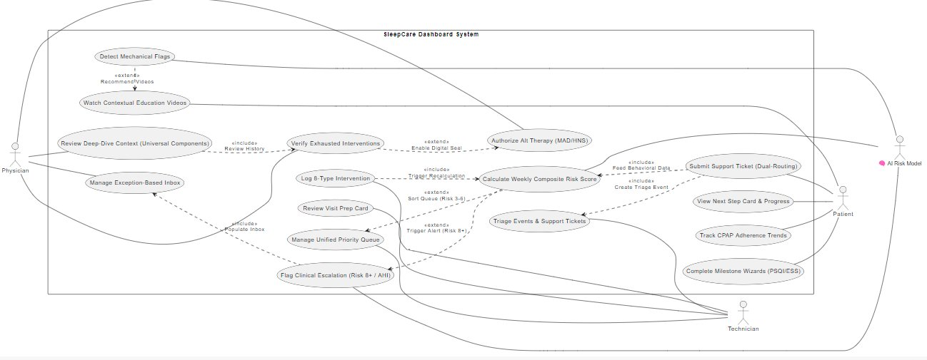
SleepCare Dashboard System — Use Case Diagram showing interactions between Physician, Technician, Patient, and the AI Risk Model across all system features.

Contract-First Database Design
Prior to any implementation, all 16 database table schemas were defined and validated against real source files provided by Linde Homecare France, including device export CSVs and clinical monitoring spreadsheets. Fields with no confirmed data source were removed. Fields present in raw device output but of uncertain clinical relevance were preserved in a dedicated raw payload column rather than discarded, ensuring no data is permanently lost before its utility is confirmed . This contract-first approach minimized structural modifications after implementation and allowed the API contract to be delivered to the frontend developer before backend implementation was complete.

Multi-Source Data Layer
A core challenge of CPAP telemonitoring is that clinically relevant data originates from multiple heterogeneous sources with different formats, collection frequencies, and levels of reliability. The platform integrates data from six distinct origins, mapped to nine database tables as shown in Table 1.
Data Sources and Corresponding Database Tables
Origin | Key Tables | Purpose
LMD / Linde | db_cpap, db_interventions, db_surveys_monitoring | Core therapy and operational follow-up
Withings | db_withings_watch, db_withings_bpm_core | Wearable and cardiovascular signals
Hexoskin | db_hexoskin | Physiological and sleep biomarkers
Somno-Art | db_somnoart, db_somnoart_raw | Sleep analysis data and raw payload
Masimo | db_masimo | Pulse-oximetry measurements
Surveys | db_surveys_medical | Patient-reported outcomes and clinical scales
To manage variability in data completeness, a two-table pattern is applied where appropriate: a primary table stores validated and normalized fields, while a companion raw table preserves the full parsed payload as a JSONB column.

Weekly Aggregation Pipeline
To bridge raw device data and the AI risk-scoring layer, a nightly aggregation job is designed to process all available source tables and produce one row per patient per week in db_patient_week. For each 7-day window, the pipeline computes weekly summaries including average and minimum CPAP usage, nights below the 4-hour adherence threshold, AHI trend, HRV, SpO₂, sleep efficiency, and survey completion status. Week-over-week deltas are computed to capture deterioration trends. Missingness is represented explicitly rather than imputed, as absent data carries clinical significance . The resulting weekly row serves as the unified input to the AI risk-scoring framework described in .

REST API and Separation of Concerns
The backend exposes domain-specific endpoints organized under nine router groups: patients, CPAP sessions, biomarkers, surveys, interventions, weekly state, devices, dashboard aggregations, and auxiliary utilities. The API contract was defined and delivered to the frontend developer prior to backend implementation, enabling parallel development streams. The architecture enforces a strict separation of concerns: the ingestion layer writes raw data to persistence; the aggregation pipeline reads raw tables and writes weekly state; the AI layer reads features and writes risk outputs back; and the frontend consumes data solely through the API, never directly accessing lower-level tables or raw payloads. This separation preserves parity across role-specific interfaces and supports auditability .

Role-Based Clinical Dashboard Design

Physician Portal
The physician interface is implemented as an exception-based dashboard that minimizes cognitive load by surfacing only patients who require clinical attention . Instead of exposing all telemetry detail, it highlights patients for whom AI-based escalation thresholds are triggered (Risk 8+ or complex AHI alerts), interventions attempted over recent weeks, and summary trends in CPAP usage, AHI-related indices, and relevant biomarker availability . The escalation workflow, shown in Fig. 2, illustrates how the physician navigates from the exception inbox through deep-dive context review to therapy authorization.
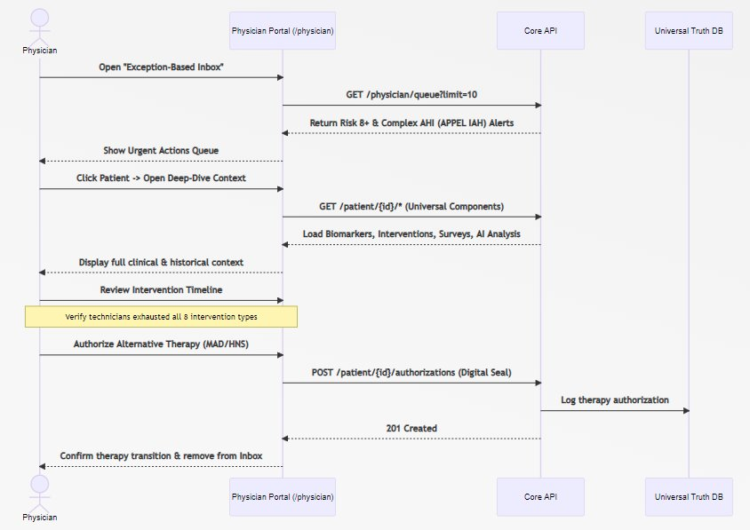
Physician Escalation Workflow — Sequence diagram showing the flow from opening the exception-based inbox, reviewing clinical context, verifying exhausted interventions, to authorizing alternative therapy (MAD/HNS) via digital seal.

Technician Portal
The technician interface focuses on operational follow-up, troubleshooting, and workflow prioritization. It reflects the practical reality that many adherence barriers arise from mask discomfort, equipment issues, and uncompleted follow-up rather than isolated clinical events . The portal supports a priority queue ordered by risk profile (Risk 3–6) and recent deterioration signals, Visit Prep Cards detailing specific mechanical failures, a Device Logistics Tracker linking patients to device serial numbers and replacement schedules, and an internal 8-type intervention taxonomy that structures technician actions . The technician dispatch workflow is shown in Fig. 3.
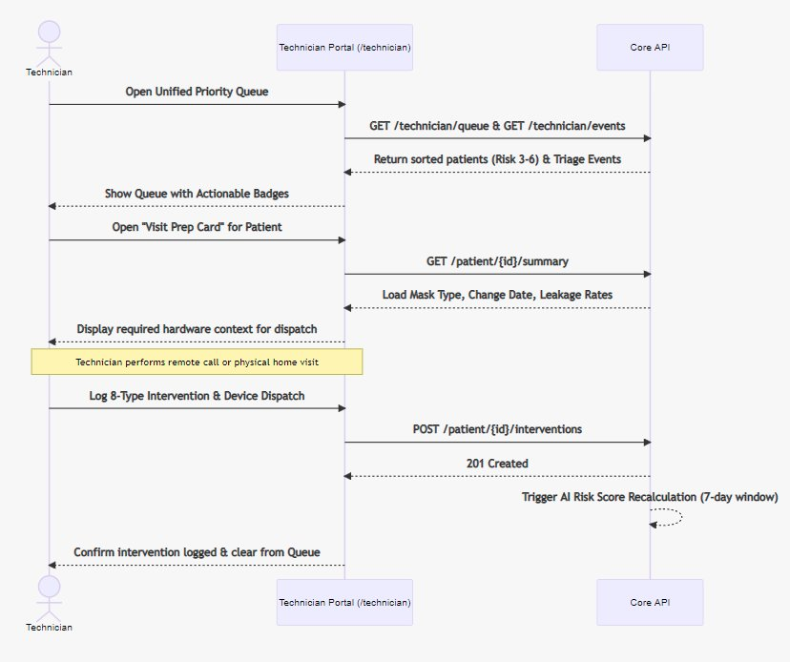
Technician Dispatch Workflow — Sequence diagram showing the flow from opening the unified priority queue, reviewing the Visit Prep Card, performing a remote call or home visit, logging an 8-type intervention, and triggering AI risk score recalculation.

Patient Portal
The patient interface emphasizes simplicity, low-friction reporting, and guided next steps. It supports visual progress cards showing usage and symptom trends, milestone-guided surveys, and a Next Step Card that recommends concrete actions such as mask fitting adjustment or device check . Self-reported signals feed immediately back into the backend via a dual-routing mechanism that simultaneously routes issues to the technician queue and triggers AI risk recalculation . The patient self-report workflow is illustrated in Fig. 4.
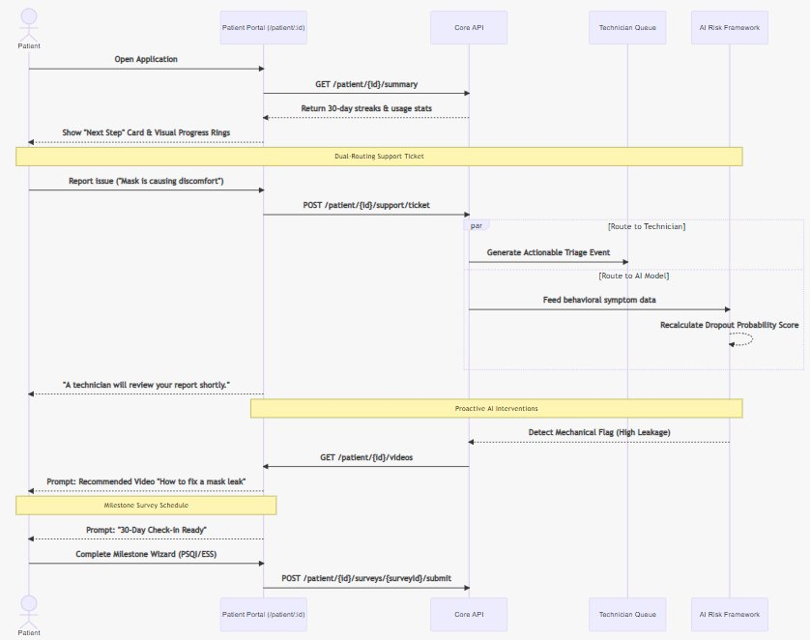
Patient Self-Report Workflow — Sequence diagram showing dual-routing of a support ticket to the technician queue and the AI risk framework, proactive mechanical flag detection, contextual video recommendations, and milestone survey scheduling.

AI-Assisted Triage, Profiles, and Intervention Taxonomy

Weekly Composite Risk Score and Patient Profiles
At the heart of the system is an AI-assisted triage layer that reads the weekly patient state and writes a Weekly Composite Risk Score (0–8+) and associated patient profile . The framework refines the traditional three usage-based adherence categories (Adherent, Attempted, Non-Adherent) into six highly specific profiles using advanced clustering of CPAP monitoring data, digital biomarkers, and patient feedback . This refinement enables the system to move away from generic follow-ups and dynamically trigger the exact right level of intervention tailored to the patient’s real-time physical and behavioral needs. The six profiles are described in Table 2.
Six Patient Risk Profiles and Corresponding Actions
Profile | Usage | Risk | Intervention
Adherent – Low Risk | $≥$4h/night | 0–2 | Stable metrics. Low-intensity monitoring only.
Adherent – High Risk | $≥$4h/night | 3 | Physiological deterioration or behavioral frustration detected. Proactive therapy optimization.
Attempters – High Priority | 2–4h/night | 4–5 | Critical early stage. Urgent targeted interventions to prevent dropout.
Attempters – Low Priority | 2–4h/night | 6 | Struggling but stable. Motivational and educational nudges to transition to full adherence.
Non-Adherent | $<$2h/night | 7–8+ | Highest dropout risk. Immediate high-effort interventions or physician alert.
Unknown | No data | N/A | Insufficient telemetry, surveys, or biomarker data. Data-collection and outreach priority.

8-Type Intervention Taxonomy and Effort Levels
To structure follow-up actions and enable systematic analysis, technicians operate within an 8-type intervention catalogue delivered via three communication channels (Visit, Call, SMS) and formally classified into five operational effort levels . Efficacy is tracked via a 7-day symmetric window comparing metrics before and after each intervention is logged . Table 3 presents the complete taxonomy.
8-Type Intervention Taxonomy with Delivery Channels and Effort Levels
Level | Type | Channel | Description & Codes
A | Educational | SMS / App | Remote notification: push (LISA app), email, or SMS. Codes: O1 (compliance), O2 (leakage).
 | Motivational | SMS / App | Low-effort nudges for mid-range risk and plateauing usage.
B | Behavioral | Call | Personalized phone/video call for compliance or leakage. Codes: O3 (compliance), O4 (leakage).
 | Supportive | Call | Direct patient contact to address emotional barriers and frustration.
C | Technical | Visit | In-person at Linde center or home. Troubleshoot masks, devices. Codes: O6, O7, O8.
 | Structured Follow-up | Visit / Call | Verify impact of prior actions within 7-day window.
Special | Escalation | Call | Physician collaboration for severe AHI. Code: O5 (APPEL IAH AIRGENIOUS).
Support | Administrative | Shipping | Remote equipment dispatch. Codes: ET, EX (hardware replacement).

Validation Strategy and Expected Contributions
Because the present work is centered on architecture and workflow design, validation is framed primarily at the system level rather than as a completed clinical-outcomes trial. Three validation dimensions are pursued: Structural Validation assesses whether the contract-first backend and aggregation pipeline maintain consistent state across all three role-specific frontends ; Operational Validation assesses whether the dashboard logic improves timeliness and coordination of follow-up ; and Methodological Validation assesses whether the platform provides a reliable substrate for future evaluation of clustering models and biomarker-driven adaptation .
The expected contributions are threefold. First, a concrete software-engineering architecture for personalized CPAP follow-up under real homecare constraints, integrating multi-vendor telemetry with Linde Homecare workflows . Second, a translation of integrated-feedback and digital-biomarker research into an operational dashboard workflow implementable across roles . Third, a reusable design pattern combining raw medical-device integration, weekly state aggregation, AI-assisted prioritization, and role-based interface design within a single clinical platform .

Conclusion
This paper presents SleepCare as a role-based clinical dashboard architecture for personalized CPAP therapy that centers on backend-frontend parity, multi-source integration, and AI-assisted workflow support. The framework is grounded in established adherence literature and recent studies on adaptive OSA management, but its main contribution is not a finalized predictive model; it is a scalable engineering structure that can underpin earlier intervention, reduced information asymmetry, and more coherent follow-up for homecare OSA management . Future work includes usability testing with technicians, longitudinal evaluation of clustering performance, and integration with national or institutional CPAP registries to assess the impact of the architecture at scale .

Acknowledgment
This paper presents results developed in collaboration between Linde Homecare France and the University Lumière Lyon 2, DISP Lab. The content reflects an R&D initiative promoted by Linde Homecare France. Responsibility for the information and views expressed lies entirely with the authors.
00
T. E. Weaver and R. R. Grunstein, “Adherence to continuous positive airway pressure therapy: the challenge to effective treatment,” Proc. Am. Thorac. Soc., vol. 5, no. 2, pp. 173–178, Feb. 2008.
D. Dowding et al., “Dashboards for improving patient care: review of the literature,” Int. J. Med. Inform., vol. 84, no. 2, pp. 87–100, Feb. 2015.
Y. Kakaei Siahkal, N. Moalla, A. Sekhari, T. Wang, and O. Grasset, “CPAP adherence improvement for OSA patients through integrated feedback systems,” in Proc. IEEE Int. Conf. Biomed. Health Inform. (BHI), 2024, pp. 1–8.
Y. Kakaei Siahkal, N. Moalla, A. Seklouli-Sekhari, T. Wang, and O. Grasset, “Integrating digital biomarkers with feedback-driven clustering for optimized CPAP adherence in OSA management,” in Proc. IEEE Int. Symp. Signal Image Technol. Internet-Based Syst. (SKIMA), 2025.
Y. Kakaei Siahkal, N. Moalla, A. Seklouli-Sekhari, T. Wang, and O. Grasset, “Dynamic portfolio for personalized CPAP treatment: adaptive digital biomarker-driven strategies across the OSA care pathway,” in Proc. IEEE Int. Symp. Comput.-Based Med. Syst. (CBMS), 2025. [Online]. Available: https://hal.science/hal-05082782
R. N. Aurora et al., “Clinical guideline for the evaluation, management and long-term care of obstructive sleep apnea in adults,” J. Clin. Sleep Med., vol. 5, no. 3, pp. 263–276, Jun. 2009.

