EngiManage - A Management System For Engineering Companies

A Capstone Project Presented
to The Faculty of the College of Information and Technology Education
PHINMA University of Iloilo

In Partial Fulfillment of the Requirements for the degree Bachelor of Science in Information Technology

By:

Sam Jefferson C. Mogato

John Vincent C. Peñaranda

Approval Sheet

In partial fulfillment of the requirements for the Bachelor of Science in Information Technology, this Capstone Project entitled "A Management System for Engineering Companies" prepared and Submitted by Sam Jefferson Mogato and John Vincent Peñaranda who are hereby recommended for corresponding final evaluation.

Cherry Ann Hinalungan, LPT
Adviser

Approved by the Panel of Evaluators with a grade of PASSED

Dr. Arnold M. Fuentes, Ph. D, MPA, MMIT
Chairman

Ryan C. Valeriano
Member

Accepted in partial fulfillment of the requirements of the degree Bachelor of Science in Information Technology

Seth dA. Nono, MSCS
CITE, DEAN

Acknowledgement

First, we thank God for giving us the strength, knowledge, and guidance to complete this capstone project.
We are very thankful to our adviser, Mr. Ryan Valeriano, for his constant support, helpful feedback, and encouragement.
We also thank our panelists, instructors, and the institution for providing the resources and opportunities to complete this project.
To our family and friends, thank you for your continuous support, patience, and inspiration.

Abstract

Engineering companies handle many construction projects at the same time, which makes it hard to manage tasks, workers, and schedules. Many companies still use paper, spreadsheets, and manual reports, which can cause delays, errors, and poor communication.
This study introduces EngiManage, a mobile application designed to help engineering companies manage and track multiple projects more easily. The app allows users to assign tasks, monitor progress in real time, store project files, and generate reports automatically. It also helps improve communication between managers and team members.
The main goal of this study is to make project management faster, more organized, and more accurate. With EngiManage, managers can see project updates anytime, reduce mistakes, and make better decisions. Employees can also clearly see their tasks and deadlines, making their work easier to follow.
However, the system has some limitations. It requires an internet connection, does not include financial features, and is only available for Android devices.
Overall, EngiManage helps improve efficiency, communication, and project tracking in engineering and construction companies.

Table of Contents

Title Page ----------------------------------------- 1

Approval Sheet ------------------------------------- 2

Acknowledgement ------------------------------------ 3

Abstract ------------------------------------------- 3

Table of Contents ---------------------------------- 4

CHAPTER I

Introduction --------------------------------------- 6
Background of the Study ---------------------------- 6
Statement of the Problem --------------------------- 7
Objectives of the Study ---------------------------- 7
Significance of the Study -------------------------- 8
Scope and Limitation ------------------------------- 9
Definition of Terms -------------------------------- 10
CHAPTER II

Literature Review ---------------------------------- 11
Overview ------------------------------------------- 13
Case Studies --------------------------------------- 14
CHAPTER III
Methodology ---------------------------------------- 14
Research Design ------------------------------------ 15
Model Use ------------------------------------------ 15
System Architecture and Design --------------------- 17
System Components and Modules ---------------------- 19
Use Case Diagram ----------------------------------- 20

Data flow Diagram ---------------------------------- 21
Entity Relationship Diagram ------------------------ 22
User Interface Design ------------------------------ 24
Security Considerations ---------------------------- 24
Technology Stack ----------------------------------- 25
Data Gathering techniques -------------------------- 25

CHAPTER IV

Results and Interpretation ------------------------- 28

Task Manager --------------------------------------- 29

Presentation of Results ---------------------------- 30
System Performance and Testing --------------------- 30
User Feedback -------------------------------------- 30
Analysis and Interpretation ------------------------ 30
Code impression Management ------------------------- 31
System/ app screen shot ---------------------------- 31
Features of the system ----------------------------- 32
Project Structure ---------------------------------- 33
CHAPTER V

Summary -------------------------------------------- 33
Conclusion ----------------------------------------- 34
Recommendation ------------------------------------- 34
References ----------------------------------------- 35
Appendices ----------------------------------------- 35
Chapter 1

Introduction to the Study
Engineering companies played a crucial role in building infrastructures that supported economic growth and societal development. These companies often handled multiple construction projects that involved people, materials, equipment, and timelines that needed to be carefully managed. In today’s competitive environment, efficiency and accuracy in project tracking were necessary to ensure timely completion and proper resource allocation.
Construction sites, in particular, were complex work environments. Activities often took place simultaneously in different locations, making it difficult for managers to monitor tasks and supervise progress. Delays, miscommunication, and inaccurate reporting were common issues when there was no systematic way of monitoring daily operations. Traditional methods such as paper logs, spreadsheets, and manual reporting were time-consuming and prone to errors, which often led to increased costs, wasted resources, and project delays.
To address these challenges, EngiManage was introduced as a digital project management application specifically designed for engineering companies. It aimed to consolidate task tracking, progress monitoring, and documentation into a single platform that managers and team members could access anytime. By centralizing multiple projects in one system, EngiManage helped engineering firms improve efficiency, reduce errors, and strengthen accountability in construction site management.

Background of the Study
Engineering projects involved multiple stakeholders such as engineers, architects, contractors, workers, and suppliers. The success of a project depended on proper coordination among these groups. However, without an organized system, construction site managers often struggled to monitor task progress and resource usage effectively.
Many companies still relied on manual methods such as spreadsheets, emails, and paper reports to track site operations. While these tools were simple, they lacked real-time visibility and often resulted in incomplete or inconsistent records. This created problems when managers needed to make quick decisions or generate accurate reports for clients.
EngiManage addressed these issues by providing a mobile application that monitored multiple projects in real time. It served as a unified system where tasks, deadlines, reports, and project files could be stored and accessed conveniently. With its ability to track several projects at once, EngiManage improved communication between teams, reduced mismanagement, and helped managers keep construction projects on schedule.

Statement of the Problem
Engineering companies often faced significant challenges when managing multiple projects across different construction sites. One major issue was the difficulty of consolidating updates from various projects into a single, unified view, which made it harder for managers to oversee overall progress. The lack of real-time monitoring led to delays in identifying issues, while poor communication and scattered documentation made collaboration across teams less efficient. These problems contributed to delays in task completion and difficulties in meeting deadlines, which ultimately affected the overall success of engineering projects.
To address these challenges, EngiManage was designed to provide a centralized mobile application that could handle and track multiple projects simultaneously, offering managers better visibility, improved coordination, and streamlined reporting within one platform.

Objectives of the Study
The main goal of EngiManage was to create a mobile application that helped engineering companies manage and track multiple projects more effectively. Specifically, it aimed to:
1.Build an app that allowed task assignment, progress tracking, and report generation.
2.Improve on-time task completion by setting clear deadlines and reminders.
3.Store and share project files in one place for easy access.
4.Allow team members and managers to communicate within tasks.
5.Make the system usable on smartphones so site workers and managers could access it anywhere.
6.Give managers and team members different roles to make work more organized.
7.Monitor team members’ performance through the assigned tasks.

Significance of the Study
- Engineering Companies – EngiManage helped companies manage and track multiple projects more efficiently, reducing delays and improving overall performance.
2.Project Managers – The system provided managers with real-time updates, better coordination tools, and automatic reports, making decision-making faster and easier.
3.Employees – EngiManage gave a clear view of assigned tasks, improved communication, and made work progress easier to update and monitor.

Scope and Limitations
This study focused on developing EngiManage, a mobile app designed to help engineering and construction companies manage multiple projects more easily and accurately. The system included features such as task assignment, real-time project tracking, document storage, and automated reporting. The study covered the design, development, and testing of the app, including:
1.Task Assignment and Tracking – Managers assigned tasks to employees, set deadlines, and monitored progress in real time.
2.Real-Time Monitoring – Managers received an overview of ongoing projects to quickly spot delays or issues.
3.Report Generation – The app automatically created project reports to save time and reduce mistakes.
4.Document Storage and Sharing – Project files were stored in one place and could be accessed anytime by managers and team members.
5.Mobile Accessibility – The app worked on smartphones so users could access project information from anywhere.
6.Role-Based Access – Managers and employees had different access levels to organize tasks and responsibilities.
7.Employee Performance Monitoring – The app tracked performance based on task completion and deadlines.
8.Internet Connection Needed – The app required a stable internet connection to work properly and update data in real time.

Limitations of the Study

Even though EngiManage was designed to improve project management, there were some limitations:

1.Financial Management – The system did not include financial management features and focused only on project and task management.
2.Limited Analytics – The app provided basic monitoring and reporting but did not include advanced analytics or predictive tools.
3.Limited Support Resources – The system did not provide built-in help or tutorials, so users had to rely on external support for guidance.
4.Not for iPhone Users – The app was not yet available for IOS and worked only on Android devices.
5.Limited Storage – The app had a limit on the number of files or data that could be stored.
6.Possible System Bugs – As with most new systems, technical errors or bugs could appear during early use.

Definition of Terms
1.EngiManage – The mobile application developed in this study to help engineering companies manage and track multiple construction projects.
2.Project Management – The process of planning, organizing, and controlling resources to achieve specific goals and complete a project successfully.
3.Task Assignment – The process of giving specific jobs or responsibilities to employees to complete within a certain time.
4.Progress Tracking – Monitoring how far tasks or projects had been completed and checking if they were on schedule.
5.Report Generation – The automatic creation of summaries or reports showing the progress, status, or results of a project.
6.Real-Time Monitoring – Viewing updates and project progress instantly as they happened.
7.Document Storage – A feature that allowed users to save project-related files in one system for easy access and sharing.
8.Role-Based Access – A system that gave different levels of access or permission to users depending on their position (for example, manager or employee).
9.Mobile Application (App) – A software program designed to run on mobile devices such as smartphones or tablets.
10.Employee Performance – How well an employee completed assigned tasks based on quality, speed, and deadlines.
11.Internet Connectivity – The ability of the device to connect to the internet so that users could send, receive, and update data in the app.
12.Project File – Any document, image, or data related to a project, such as plans, reports, or schedules.

Chapter 2

Review of Related Literature

This chapter talks about studies related to managing construction projects more effectively through systematic approaches and organized systems. The book “Construction Project Management: A Complete Introduction” by Alison Dykstra (2018) provides a detailed explanation of how construction projects can be organized, scheduled, and monitored. It emphasizes the importance of clear task coordination, documentation, and communication among multiple stakeholders. Another useful source is the book “Essentials of Project and Systems Engineering Management” by Howard Eisner (2011), which explains how engineering projects require strong planning, communication, and coordination. It highlights the need for structured systems that can guide teams, track progress, and make sure resources are used properly. The book “Project Management for Engineering, Business and Technology” by John M. Nicholas and Herman Steyn (2017) explains that managing projects requires careful planning, organization, and coordination of people, resources, and timelines. It highlights that engineering projects are often complex and involve multiple tasks happening at the same time. Without proper systems, projects can face delays, errors, and higher costs. This shows the need for digital tools like EngiManage, which can help engineering companies handle projects more efficiently by combining tracking, monitoring, and reporting into one platform. These studies support the idea behind EngiManage, which is to centralize project tracking, progress monitoring, and reporting into one mobile application that helps engineering companies manage tasks, share updates, and complete projects more effectively.

Construction Project Management: A Complete Introduction
According to Dykstra (2018, p. 45), construction projects are inherently complex because they involve multiple parties such as architects, engineers, contractors, suppliers, and workers. Proper planning and project control are critical to avoid delays, cost overruns, and conflicts. The book explains that project management is not only about assigning tasks but also about ensuring real-time coordination of people, resources, and schedules.
Dykstra highlights that traditional methods like paper logs and spreadsheets, while still used by some firms, are highly prone to errors and inefficiencies (p. 112). Modern project management increasingly depends on digital platforms to improve accuracy, reduce mistakes, and provide managers with real-time visibility of progress.

Essentials of Project and Systems Engineering Management
Eisner (2011, p. 43) explains that engineering projects are made up of many connected parts, including people, tasks, schedules, and resources. For a project to succeed, all these elements must be managed together under one clear system. Without a structured approach, projects often face delays, confusion, and wasted resources.
The book also points out that one of the biggest challenges in engineering projects is poor communication between different groups such as engineers, contractors, suppliers, and managers (p. 88). Eisner emphasizes that project managers should use systems that allow real-time updates and proper documentation to avoid mistakes and mismanagement.

Project Management for Engineering, Business and Technology
The book “Project Management for Engineering, Business and Technology” by John M. Nicholas and Herman Steyn (2017) explains that managing projects requires careful planning, organization, and coordination of people, resources, and timelines. It highlights that engineering projects are often complex and involve multiple tasks happening at the same time. Without proper systems, projects can face delays, errors, and higher costs.

Case Studies
Dykstra presents several real-world cases where companies improved project delivery by adopting modern management systems. One example describes how digital scheduling tools helped reduce project delays by providing immediate visibility of task dependencies (p. 310). Another example shows how centralizing documentation allowed managers to quickly generate accurate reports for clients, which improved trust and accountability.
These examples are directly related to what EngiManage intends to achieve: minimizing delays, improving communication, and ensuring accurate reporting across multiple construction projects. By providing managers with a centralized view, EngiManage can help avoid the common problems of missed deadlines, inconsistent documentation, and poor coordination.
Eisner also presents examples where companies improved project outcomes by applying systems engineering methods (2011, p. 310). In one case, a company used an integrated project management system to coordinate work across different teams. This reduced miscommunication and improved decision-making. Another case showed how documenting tasks and progress in a centralized system helped managers keep projects within schedule and budget.
These examples are very similar to what EngiManage aims to achieve: giving engineering companies a single platform to manage tasks, share updates, and track progress in real time.
Nicholas and Steyn (2017) share examples of how project management tools and methods improve project performance in different industries. These cases show that companies using modern project management systems finish tasks faster, reduce costs, and avoid many common problems. Similarly, EngiManage aims to bring these benefits to engineering companies by giving managers a clearer view of multiple projects, reducing delays, and improving teamwork across construction sites.
References:
Dykstra, A. (2018). Construction Project Management: A Complete Introduction. Kirshner Publishing Company. ISBN: 9780982703434.
Eisner, H. (2011). Essentials of Project and Systems Engineering Management. Wiley. ISBN: 9781118276341.
Nicholas, J. M., & Steyn, H. (2017). Project Management for Engineering, Business and Technology (5th ed.). Routledge, Taylor & Francis Group. ISBN: 9781317384809.

Chapter 3

Methodology

This chapter explains the research method that will be used in developing EngiManage – A Project Management System for Engineering Companies. The main goal of this study is to design and build a digital system that will help companies manage multiple projects, assign tasks, track progress, and improve communication between managers and workers. This chapter will discuss the research approach, data collection, system design, tools, and techniques used to achieve this goal.
The research will follow a clear process to make sure the system is developed effectively. First, a review of existing project management practices will be done to identify problems in traditional methods, such as the use of paper, spreadsheets, and manual reports. Based on this, the design and development of EngiManage will start.
To gather important information about user needs, surveys and interviews will be conducted with project managers, engineers, and workers. Their feedback will help shape the features of the system, making sure it is useful and easy to use in real construction projects.
Once the system is built, it will go through testing to check its performance, usability, and reliability. This chapter outlines the methods and processes that will guide the development of EngiManage, making sure the system is well-structured and meets the needs of engineering companies.

Research and Development Stage

The Research and Development (R&D) stage is important in creating EngiManage. During this stage, the feedback from surveys and interviews will be used to guide the design and features of the system.
At the start, the R&D stage will focus on analyzing the information collected from respondents. Their answers will show the main problems in project management, such as delays, poor communication, and lack of real-time updates. These findings will help define what features should be included in the system, like project tracking, file sharing, and task assignment.
Based on this research, the system design will be created. The system will focus on being mobile-friendly, user-friendly, and accessible for both managers and workers. Feedback from respondents will continue to guide improvements during the design and development process.
The system will be built step by step. Each version will be tested, and respondents will provide feedback to make improvements. Once the prototype is ready, user testing will be conducted to ensure that the system is easy to use and effective for real project management tasks.

Software Development Life Cycle (SDLC)
The Software Development Life Cycle (SDLC) is a structured method used in creating the EngiManage System to make sure the project is developed step by step, efficiently, and effectively. The SDLC will guide the process from the first planning stage until the final deployment, ensuring the system fits the needs of construction companies and the feedback of its users.

Key Features of Agile:
● Iterative Development - The system will be created in small, manageable parts (sprints).
● Continuous Feedback - Regular feedback from managers and workers will be used to improve system features.
● Collaboration - Developers, users, and advisers will work closely together to meet real needs.
● Flexibility - Changes can be made anytime, even during later stages of development.

The SDLC will consist of the following stages:
- Planning and Requirement Analysis
In this stage, the researchers will gather detailed requirements for the system. Input from construction managers and employees will be important to find the main problems in project and task management. Surveys and interviews will be used to collect data about needed features such as task assignment, progress tracking, file sharing, and leave requests. The goals, scope, and project timeline will also be set during this phase.
2.System Design
This stage focuses on creating layouts and simple prototypes. The design will be guided by user feedback and will ensure the system is easy to use on both mobile phones and computers. The system will also support multiple projects at the same time. Both the front-end (user interface) and back-end (database and server) will be carefully designed to meet the requirements.
- Development
The system will be developed in short sprints. Each

sprint will focus on creating a specific feature, such as task assignment or progress monitoring. At the end of every sprint, a working version will be presented to users for feedback. Developers will adjust the system based on this feedback to make sure it matches user needs.
4.Testing
Every feature will be tested during and after development. Functional testing will check if features are working properly, while performance testing will make sure the system can handle many tasks at once. Managers and employees will also test the system in real situations (User Acceptance Testing) to confirm that it is accurate, easy to use, and practical.
5.Deployment
After testing, the system will be installed and introduced to companies. Training sessions will be given to managers and workers so they can use the system effectively. Deployment will be gradual to ensure issues are fixed early and the system runs smoothly.
6.Maintenance and Support
After the system is deployed, regular updates will be provided. These will include bug fixes, performance improvements, and new features based on user feedback. Continuous support will make sure the system stays reliable and useful for long-term use.

System Architecture and Design

Overview
This section gives an overview of how the EngiManage - Project Management System is built and designed.
EngiManage is made to help engineering and construction companies manage their projects more easily. It allows users to create projects, assign tasks, track progress, communicate within tasks, and check employee performance. The system is designed to be simple, organized, and easy to use, so both admins and employees can do their work efficiently. Each part of the system works together to make project tracking and communication faster and more accurate.

System Architecture
The EngiManage system is made up of three main parts or layers:
Presentation Layer - This is what the users see and use — the mobile app where admins and employees log in, view the dashboard, create projects, check task progress, and send messages. It’s designed to be simple, clear, and easy to navigate.
Application Layer - This is the part of the system that makes everything work. It handles all the main functions like logging in, assigning tasks, updating progress, sending messages, and checking performance. It connects the user interface to the database so everything runs smoothly.
Data Layer - This is where all the data is stored — including user accounts, project details, tasks, uploaded images, and employee performance records. It keeps all information safe, updated, and ready whenever the system needs it.

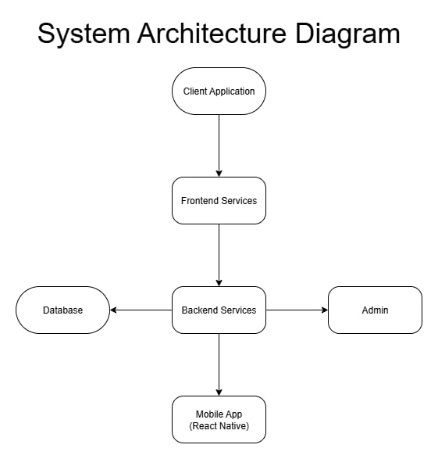
Diagram:

System Components and Modules
Project Management Module - Manages tasks, handles members, progress tracking, employee performance tracking, and report generation. This module provides an overview of ongoing projects, their completion status, and team contributions.

Task Assigning Module - Allows administrators or project managers to assign specific tasks to team members. It defines task priorities, deadlines, and dependencies to ensure efficient workflow and accountability.

File Sharing Module - Enables users to upload, download, and share project-related files securely within the system. This module maintains file versioning, metadata, and access permissions to ensure data integrity and controlled sharing among project members.

Team Handling Module - Facilitates the creation and management of teams within projects. It supports role-based access, team member coordination, and communication, ensuring that every project has the appropriate personnel assigned to it.

Dashboard and Analytics Module - Provides visual insights into project and employee performance. It displays data through charts and metrics such as task completion rate, employee productivity, and project progress percentage to help decision-making and performance evaluation.

Employee Performance Rate Module - Tracks and evaluates the performance of individual employees based on completed tasks, deadlines met, and overall productivity. It assists in performance reviews and incentive or promotion decisions.

Project Productivity Analysis Module - Analyzes overall project efficiency using data from completed tasks, time spent, and resource utilization. This helps identify bottlenecks, underperforming areas, and opportunities for improvement.

Notification Module - Handles in-app notifications for project updates, task assignments, and deadline reminders. Ensures that users stay informed in real-time about important system activities or changes related to their role.

Use Case Diagram

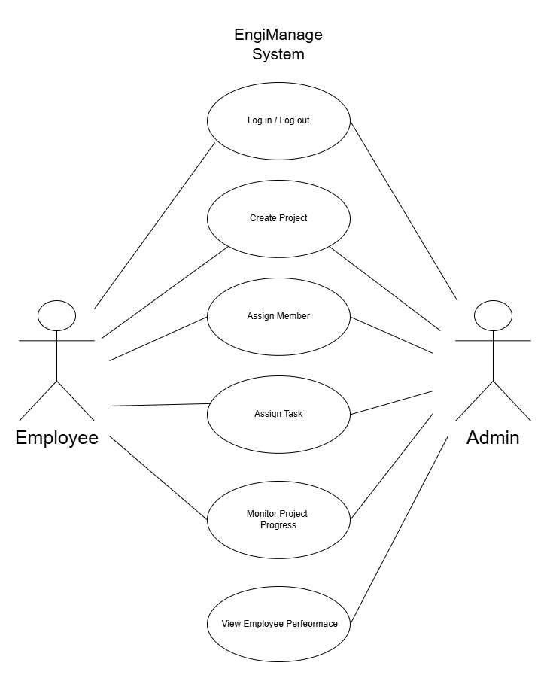

The use case diagram shows how the EngiManage System works and how the Admin and Employee use it. The diagram has two main users: the Admin, who manages the system, and the Employee, who performs tasks and updates progress. Both users can log in and log out of the system. The Admin can create projects, assign members, and assign tasks to employees. Once tasks are assigned, both the admin and employees can monitor project progress to see updates and task completion. The Admin can also view employee performance to track how well each worker is doing on their tasks. This diagram shows how EngiManage helps organize projects, assign work, and monitor performance in a simple and connected way.

Data Flow Diagram
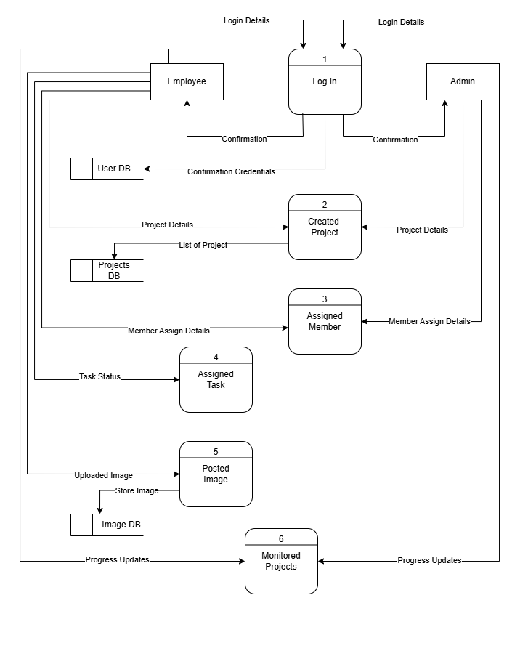

The Data Flow Diagram shows how information moves within the EngiManage Project Management System. It starts when the admin or employee logs in by entering their login details, which are checked in the User Database. After a successful login, the admin can create new projects by adding project details that are stored in the Projects Database. The admin then assigns members to specific projects, and these assignment details are also recorded in the system. Once members are assigned, the admin can give tasks to employees, and employees can update their task status as they work. Employees can also upload images as proof of progress, which are saved in the Image Database. All updates, including task status and uploaded images, are collected and shown under Monitored Projects so both admin and employees can easily track the overall progress of each project.

Entity Relationship Diagram

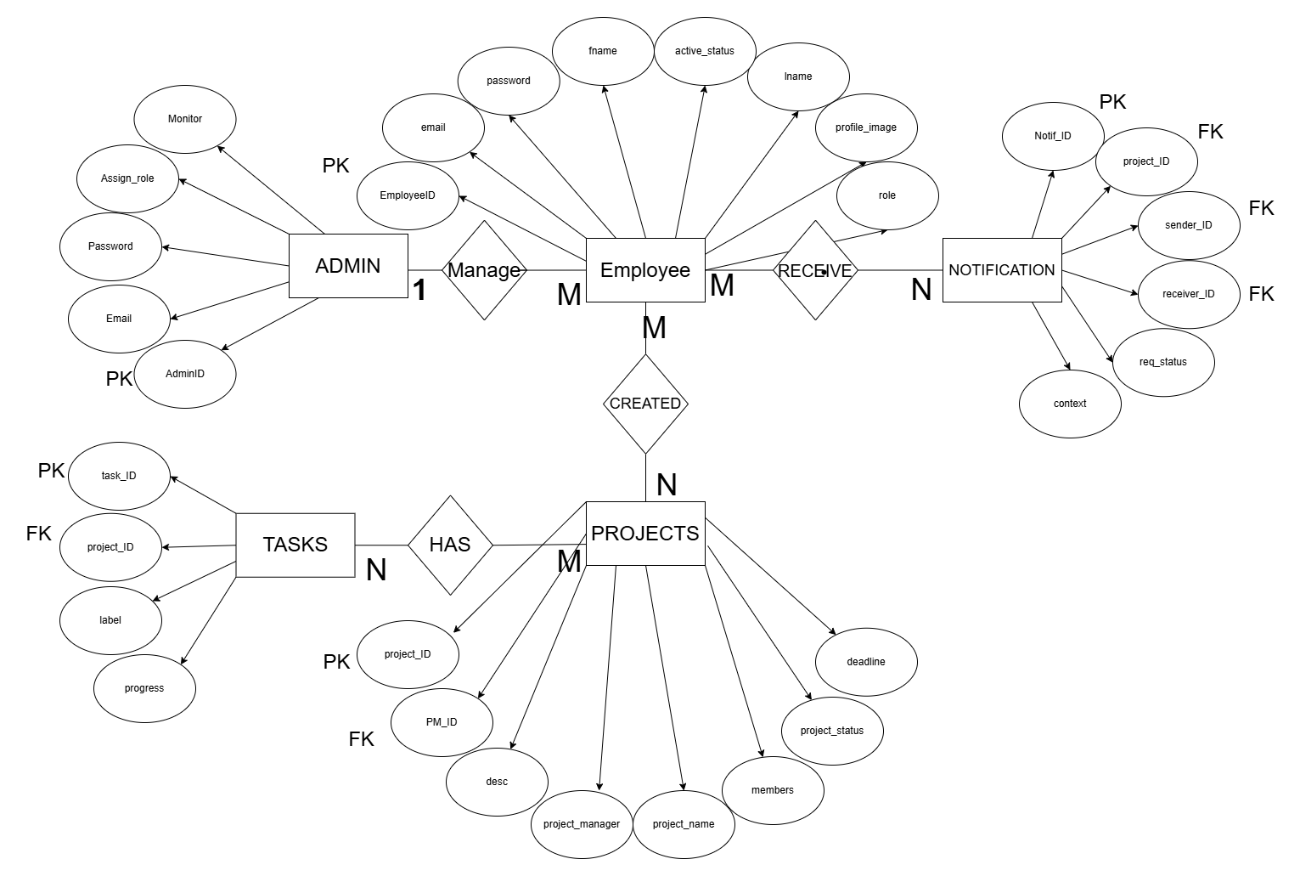

The ERD shows how the management system, called EngiManage, is organized. It has several main parts or entities that work together to keep track of projects, tasks, employees, admins, and notifications.

ENTITIES AND ATTRIBUTES

ADMIN
- AdminID(PK)
- Email
- Password
- Assign_role
- Monitor
The Admin manages the system. They can manage employee accounts, assign roles, and monitor project activities. The Admin has one-to-many relationships with employees.

EMPLOYEE
- EmployeeID(PK)
- Email
- Password
- Lname
- Fname
- Profile_image
- Role
- Active_status
The Employee entity stores details about all staff members. Employees can receive notifications and be assigned to projects or tasks.

PROJECTS
- Project_ID(PK)
- PM_ID(FK)
- Desc
- Project_manager
- Project_name
- Members
- Deadline
This shows the details of each project in the system. Projects are made by project manager and include several tasks that need to be done.

TASKS
- Task_ID(PK)
- Project_ID(FK)
- Label
- Progress
Each task belongs to a specific project and tracks progress and descriptions of work that needs to be completed.

NOTIFICATION
- Notif_ID(PK)
- Project_ID(FK)
- Sender_ID(FK)
- Receiver_ID(FK)
- Req_status
- Context
Handles communication and updates between users. Notifications can be for task updates, project assignments, or requests.

User Interface Design
The EngiManage system is designed to be user-friendly, responsive, and easy to navigate. It allows users to efficiently manage projects by tracking completed, ongoing, and unassigned tasks through the dashboard. The system also provides quick access to project creation, real-time progress monitoring, and task communication features. Users can easily upload images as proof of work, while admins can view employee performance to evaluate productivity. Overall, EngiManage helps improve project organization, communication, and monitoring within engineering and construction teams.

Security Considerations
The EngiManage only have a basic security features like a basic log in and user authentication.

Technology Stack

List all the tools, platforms, and technologies used in the development:
Frontend: React native
Backend: Express/node.js
Database: MySQL

Storage Server: Supabase

Data Gathering techniques

Survey Questionnaire for System Assessment
This survey is for project managers, engineers, and staff. The goal is to know the common problems in project management and what features should be added to the system. Your answers will help improve EngiManage – A Project Management System for Engineering Companies.
1.Do you find it hard to track the progress of projects using the current method (paper, spreadsheets, or manual reports)?
- Yes
- No
2.How often do delays happen in your projects because of poor task management?
- Always
- Often
- Sometimes
- Rarely
- Never
3.Do you think a digital system will help make your work faster and more organized?
- Yes
- No
4.Which feature is most important to you?
- Task assignment
- Team Handling
- File sharing
- Dashboard and Analytics
- Employeee Performance
- Projects Productivity Analysis
- In-App Notifications
5.How do you usually communicate with your team?
- Paper notes
- Phone calls
- Email
- Chat apps
- Meetings
6.Do you face problems with missing or late updates about project status?
- Yes
- No
7.How easy do you want the system to be when using it on mobile phones or computers?
- Very easy
- Easy
- Neutral
- Hard
- Very hard
8.Do you think having all project records in one system will reduce mistakes?
- Yes
- No
9.How helpful will it be if managers and workers can see project updates in real time?
- Very helpful
- Helpful
- Neutral
- Not helpful
10.What other features would you like the system to have?
- ____________(answer)

Sampling Methods for Respondents
A Stratified Sampling method will be used to gather feedback from different groups. People will be grouped based on their roles in project management, and administration. This method ensures that feedback comes from all key parts of the Civil Aviation Authority of the Philippines (Caap) - aklan company. A set number of people from each group will be selected based on how many work in that role, making sure everyone's input is fairly represented.

- Define Strata - The participants will be divided into different groups based on their job roles, such as Project Manager, Finance Officer, Administrator, and others.

- Sampling Within Strata - Participants will be chosen randomly from each group.

- Sample Size - The number of survey participants will be chosen based on the project’s needs, ensuring enough responses to make accurate conclusions.

4.Survey Distribution - The survey will be shared using Google Forms, making it easy for everyone to access. It will be sent via email, social media, or directly to management companies.

Chapter 4

Results and Interpretation

This chapter presents the results gathered from the surveys, interviews, and testing conducted to evaluate the effectiveness of EngiManage – A Project Management System for Engineering Companies. The purpose of this chapter was to find out how well the system helped engineering companies manage multiple projects, improve communication, and make task tracking more efficient. The findings were analyzed and discussed to determine if the system achieved its goals and met user needs.

Summary of the data sources and analysis methods used
The data analyzed in this study came from several sources, including system activity logs, project records, and user testing sessions. The primary data was collected from EngiManage’s database, which recorded task assignments, project updates, and user interactions during the testing period.
Additional data was gathered through user surveys and interviews with engineers, project managers. These provided feedback on usability, system performance, and workflow improvement.
For the analysis, qualitative methods were used to evaluate the effectiveness of EngiManage. Feedback was gathered through user interviews, surveys, and observations during the testing phase. The collected responses were analyzed and categorized based on user satisfaction, ease of use, and suggestions for improvement. This approach provided meaningful insights into how users experienced the system in real project environments and how well it supported their daily project management tasks.

Task Manager:
Week | Task | Programmer | UI/UX Designer | Documenter
1 | Project planning & requirements gathering | ✔ | ✔ | ✔
2 | Research & system design planning | ✔ | ✔ | ✔
3 | Use Case & DFD creation |  |  | ✔
4 | Database design & schema creation | ✔
5 | UI wireframes & mockups |  | ✔
6 | Frontend development begins |  | ✔
7 | Backend development begins | ✔
8 | Integration of frontend and backend | ✔ | ✔
9 | System testing & debugging | ✔
10 | User testing & feedback collection |  |  | ✔
11 | Final revisions (code + UI + content) | ✔ | ✔
12 | Documentation finalization & formatting |  |  | ✔
 | Final project submission | ✔ | ✔ | ✔
✔ = Active role

Presentation of Results
The EngiManage system was developed, tested, and evaluated to see how well it improves project management processes for engineering companies. Testing focused on task assignment, progress tracking, team communication, and overall efficiency.

System Performance and Testing
The system was tested in different situations, such as when many users were using it at the same time and several tasks were being assigned. Most features worked properly, and the system was able to handle multiple projects without crashing. The loading time and response speed were good, with only a few minor bugs and visual errors found.
User Feedback
The system design is user friendly and easy to use for first time user.
Analysis and Interpretation
Qualitative feedback from users was gathered and analyzed to understand their experience with the system. The feedback focused on ease of use, satisfaction, and how the system helped improve project organization and communication.

Code impression Management

There are too many codes, here is the GitHub link to view them:

FrontEnd -

https://github.com/MOGAT0/engimanage?fbclid=IwY2xjawQnSU1leHRuA2FlbQIxMABicmlkETE2WlRNNnZKTkJXaUxHaXBXc3J0YwZhcHBfaWQQMjIyMDM5MTc4ODIwMDg5MgABHvxb6yboEO98e5vKZ9tgCklEwHISJMLnHQ9RYIZz_zQ8mV26B2eOZidgfXFq_aem_WNsMAYNg7NSLgImDU0YSfw

BackEnd -

https://github.com/MOGAT0/EngiManageRestAPI?fbclid=IwY2xjawQnSYNleHRuA2FlbQIxMABicmlkETE2WlRNNnZKTkJXaUxHaXBXc3J0YwZhcHBfaWQQMjIyMDM5MTc4ODIwMDg5MgABHo3qK1rbgAdoGD_HIIVNA7NqweRmOmPwAnPmdZf6QWRTlWJGXlB380mSXR-k_aem_o2vA0po-T-OJ6Hk7LtvTlg

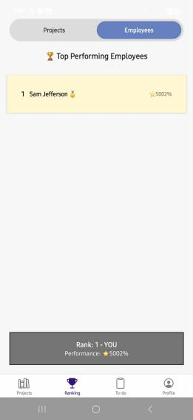
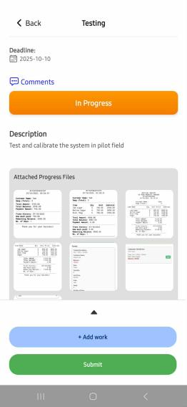
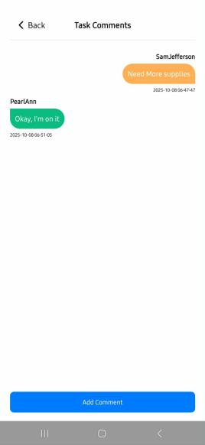
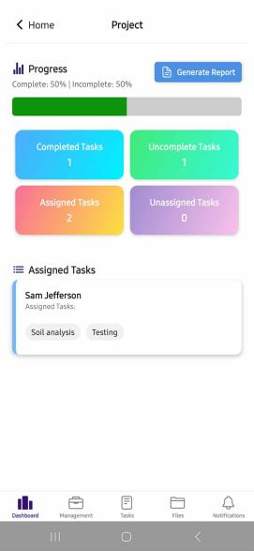
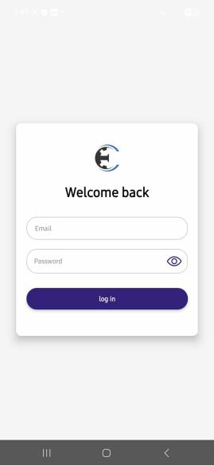
System/ app screen shot
The first image shows the system login page, where the admin and employees can enter their login details to access the system. After logging in, the second image shows the dashboard, which displays an overview of the system. On the dashboard, users can see the list of completed tasks, incomplete tasks, assigned tasks, and unassigned tasks. There is also a create project button in the upper-right corner that allows the admin to add a new project. The dashboard also shows the progress of each project to help track their current status. The third image shows the task communication feature, where users can chat or send messages within a task to discuss updates or instructions. The fourth image shows that the user can upload images as proof of their completed work or progress. Finally, the last image shows the employee performance section, where the system displays how well each employee is doing based on their completed tasks and activity.

Features of the system
Task management - Allows managers to create, assign, and track tasks to keep projects organized and on time.
Team Handling - Enables managers to organize team members, assign roles, and monitor their work.
File sharing (within each project) - Lets team members upload and share project files for easy access and collaboration.
Dashboard and analytics - Provides an overview of project progress and performance through visual data and reports.
Employee Performance Rate - Tracks and measures each employee’s productivity and work quality.
Projects Productivity analysis - Analyzes project efficiency based on time, output, and resource use.
In-App notifications - Sends real-time alerts about tasks, updates, and project activities.

Project Structure
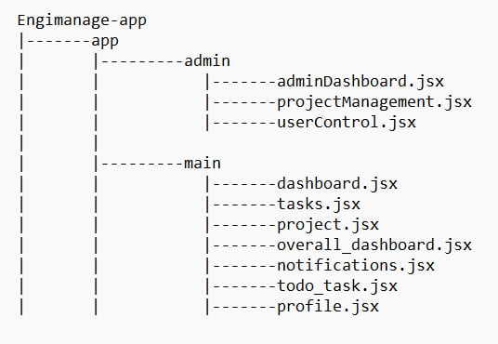

Chapter 5

Summary, Conclusion, and Recommendation

Summary
This study aimed to design and develop EngiManage, a Project Management System for engineering companies that improves task organization, project tracking, and overall efficiency. The system provides real-time updates, task monitoring, and automated notifications to help managers and engineers work more effectively and reduce project delays. The project followed a structured development process, starting from requirement analysis, system design, development, testing, and evaluation.
Results showed major improvements in task completion, communication, and user satisfaction. The system successfully met its goals and proved to be an effective tool for managing multiple engineering projects in a simple and more organized way.

Conclusion
The development of EngiManage successfully achieved its goal of creating a reliable and efficient project management system for engineering companies. The system helped improve task organization, progress tracking, and team communication by providing real-time updates and automated notifications. Through testing and user feedback, EngiManage proved to make project handling faster, more accurate, and more organized compared to manual methods.
Users found the system easy to use and effective in managing multiple projects at once. It also reduced delays and improved collaboration between managers and engineers. Overall, EngiManage demonstrated that technology can greatly enhance project management processes in engineering environments, making work more efficient, transparent, and well-coordinated.
Recommendation
Based on the development and evaluation of the project, the following recommendations are made:
1.Team Communication - Add messaging within each task for better collaboration
2.Employee Performance - Monitor Employee performance rate based on their task
3.Project productivity analysis - Analyze each project’s productivity based on completed tasks
4.Notifications system - Alert members / project manager for their missed / overdue tasks
5.User hierarchy - Each user have different access based on their role
6.UI/UX - Improvements on front end, user experience such as navigating to certain feature of the system

References
Dykstra, A. (2018). Construction Project Management: A Complete Introduction. Kirshner Publishing Company. ISBN: 9780982703434.
Eisner, H. (2011). Essentials of Project and Systems Engineering Management. Wiley. ISBN: 9781118276341.
Nicholas, J. M., & Steyn, H. (2017). Project Management for Engineering, Business and Technology (5th ed.). Routledge, Taylor & Francis Group. ISBN: 9781317384809.

Appendices:

Appendix A: System Interface Screenshots

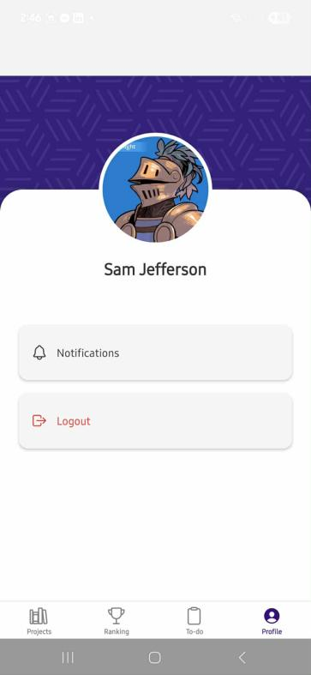
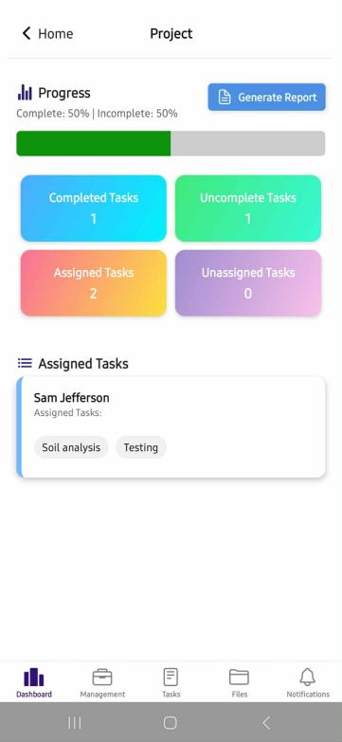
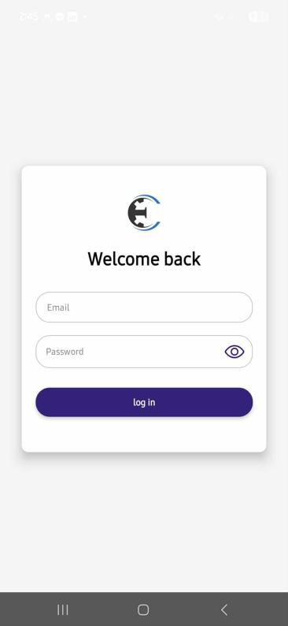
Login Dashboard Profile

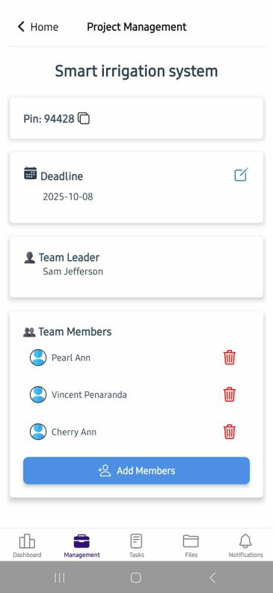
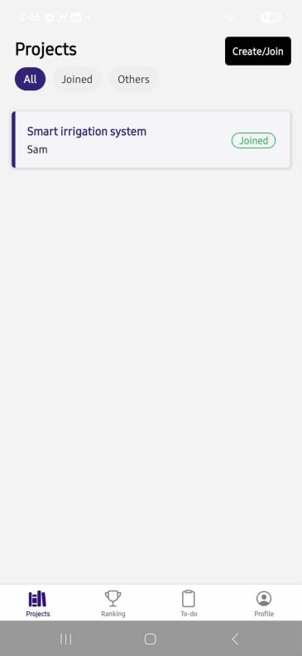
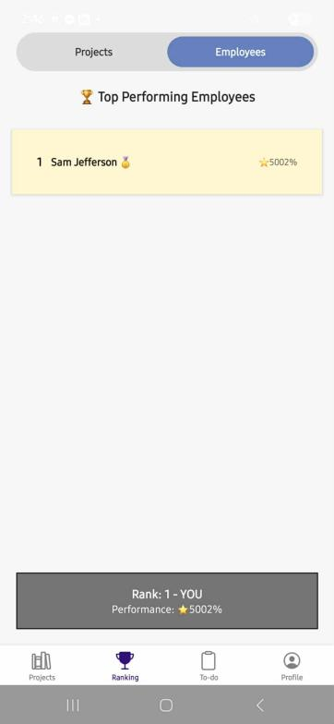
Employee Performance Ctreated Projects Assign Member


Appendix B: Use Case Diagram

Use Case Diagram

The use case diagram shows how the EngiManage System works and how the Admin and Employee use it. The diagram has two main users: the Admin, who manages the system, and the Employee, who performs tasks and updates progress. Both users can log in and log out of the system. The Admin can create projects, assign members, and assign tasks to employees. Once tasks are assigned, both the admin and employees can monitor project progress to see updates and task completion. The Admin can also view employee performance to track how well each worker is doing on their tasks. This diagram shows how EngiManage helps organize projects, assign work, and monitor performance in a simple and connected way.

Appendix C: Data Flow Diagram

Data Flow Diagram


The Data Flow Diagram shows how information moves within the EngiManage Project Management System. It starts when the admin or employee logs in by entering their login details, which are checked in the User Database. After a successful login, the admin can create new projects by adding project details that are stored in the Projects Database. The admin then assigns members to specific projects, and these assignment details are also recorded in the system. Once members are assigned, the admin can give tasks to employees, and employees can update their task status as they work. Employees can also upload images as proof of progress, which are saved in the Image Database. All updates, including task status and uploaded images, are collected and shown under Monitored Projects so both admin and employees can easily track the overall progress of each project.

Appendix D: User Survey Form and Summary
1.Do you find it hard to track the progress of projects using the current method (paper, spreadsheets, or manual reports)?
- Yes
- No
2.How often do delays happen in your projects because of poor task management?
- Always
- Often
- Sometimes
- Rarely
- Never
3.Do you think a digital system will help make your work faster and more organized?
- Yes
- No
4.Which feature is most important to you?
- Task assignment
- Team Handling
- File sharing
- Dashboard and Analytics
- Employeee Performance
- Projects Productivity Analysis
- In-App Notifications
5.How do you usually communicate with your team?
- Paper notes
- Phone calls
- Email
- Chat apps
- Meetings
6.Do you face problems with missing or late updates about project status?
- Yes
- No
7.How easy do you want the system to be when using it on mobile phones or computers?
- Very easy
- Easy
- Neutral
- Hard
- Very hard
8.Do you think having all project records in one system will reduce mistakes?
- Yes
- No
9.How helpful will it be if managers and workers can see project updates in real time?
- Very helpful
- Helpful
- Neutral
- Not helpful
10.What other features would you like the system to have?
- ____________(answer)
UserFeedback
The system design is user friendly and easy to use for first time user

Appendix E: Sample Cover Page
PHINMA University of Iloilo
College of Information Technology Education
EngiManage - A Management System For Engineering Companies
A Capstone Project
Presented to the Faculty of the College of PHINMA University of Iloilo In Partial Fulfillment of the Requirements
For the Degree of Bachelor of Science in Information Technology
By:
Sam Jefferson Mogato,
JOhn Vincent Peñaranda
Date: October 27, 2025

