

**Placement Empowerment Program**

***Cloud Computing and DevOps Centre***

Host a Static Website on a Cloud VM Install Apache on your cloud VM and host a simple HTML website.

Name: Mohamad Riyas P Department: IT



# Introduction

A static website serves pre-written HTML, CSS, and JavaScript files to the end user without requiring server-side processing. Hosting such websites on a cloud-based Virtual Machine (VM) has become a preferred choice for individuals and businesses due to its flexibility, scalability, and cost-effectiveness. By leveraging the cloud, developers can quickly deploy websites accessible from anywhere in the world.

# Overview

Hosting a static website on a cloud VM involves the following key steps:

1. **Provisioning a Cloud VM:** Setting up a virtual machine on a cloud provider (like AWS, Azure, or GCP).
2. **Installing a Web Server:** Configuring a web server such as Apache to serve the website's static files.
3. **Uploading Website Files:** Placing HTML, CSS, and JavaScript files in the web server's root directory.
4. **Configuring Network Access:** Ensuring that the web server is accessible via HTTP (port 80) from anywhere.
5. **Testing and Launching:** Verifying the functionality of the website to make it publicly accessible

# Objectives

The primary objectives of hosting a static website on a cloud VM include:

1. **Learning Cloud Computing Fundamentals:** Understanding how virtual machines operate in a cloud environment.
2. **Practical Web Hosting Skills:** Gaining hands-on experience in setting up and configuring web servers like Apache or Nginx.
3. **Website Deployment:** Successfully deploying and making a static website live on the internet.
4. **Understanding Networking Basics:** Learning about firewall rules, security groups, and HTTP protocol configurations.
5. **Cost-Effective Hosting:** Exploring affordable methods to host lightweight websites without needing managed services.

# Importance

1. **Hands-On Cloud Experience:** Hosting a static website on a cloud VM is an excellent starting point for understanding the capabilities of cloud platforms and virtual machine operations.
2. **Scalability:** Cloud-based hosting provides flexibility to scale resources up or down as the traffic to the website grows.
3. **Global Accessibility:** By deploying on the cloud, the website becomes accessible from any part of the world with minimal latency.
4. **Customization and Control:** Cloud VMs allow complete control over the hosting environment, enabling advanced configurations and optimizations.
5. **Foundation for Advanced Hosting:** It lays the groundwork for more advanced projects, such as hosting dynamic websites, APIs, or using load balancers.
6. **Professional Development:** Learning to host websites on the cloud adds significant value to your skill set, making you proficient in real-world deployment scenarios.

**Step-by-Step Overview** Step 1:

Have an HTML file (with any related assets like CSS/JavaScript) that you want to host in your GitHub repository

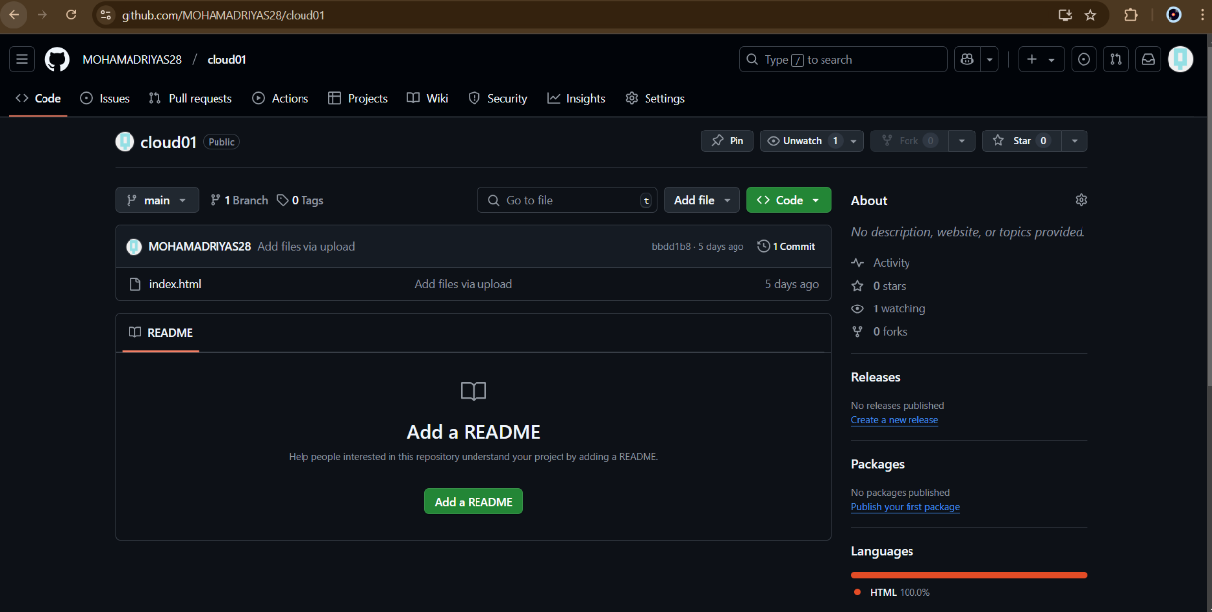

Step 2:

Launch an EC2 instance, select Ubuntu as the OS, configure security groups to allow all network traffic, create a key pair (e.g., new.pem), and download it for SSH access

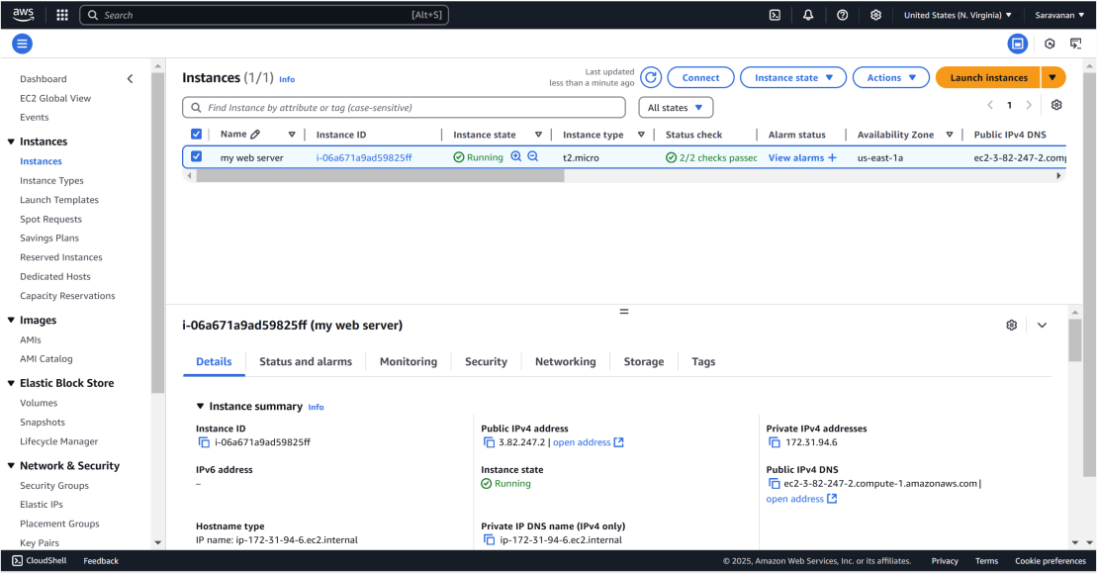

Step 3:

Click the 'Connect' option on your launched instance, go to the SSH client section, and copy the command provided under the 'Example' section.

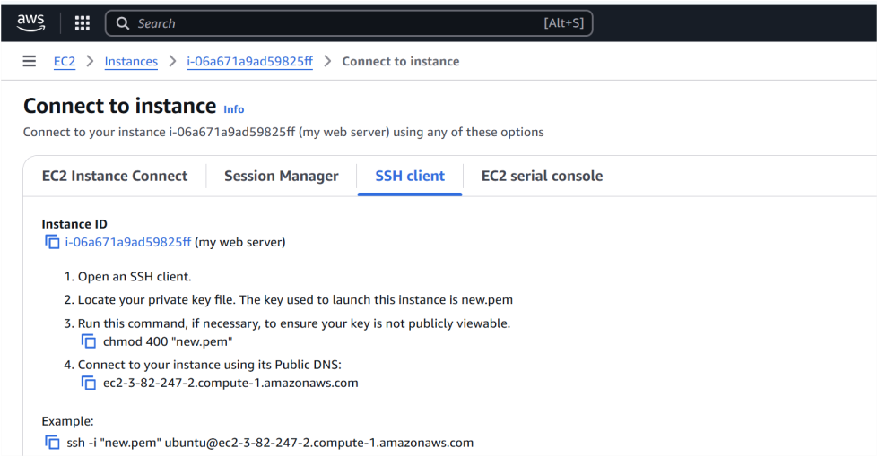

Step 4:

Open PowerShell, navigate to the 'Downloads' directory where the downloaded key pair is located using the **cd Downloads** command



Step 5:

Paste the command copied from the EC2 Connect's SSH client section, replace the key pair name with your downloaded key (e.g., new.pem), press Enter, and type 'yes' when prompted.



Step 6:

Run the command **sudo apt update** to update the package list.



Step 7:

Run the command **sudo apt upgrade**, and press 'Y' to confirm and continue the upgrade process.



Step 8:

Install the Apache server by running the command **sudo apt install apache2**, and press 'Y' to confirm the installation



Step 9:

Insert your files by running the command **git clone**

**<repository_link>** to clone your repository containing the website

files

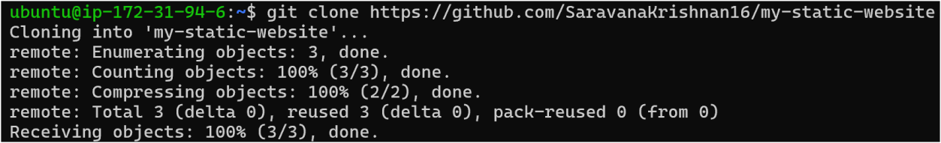

Step 10:

Run the command **cd /var/www/html** to navigate to the web server's root directory, then type ls to verify that your HTML files from the GitHub repository are present.

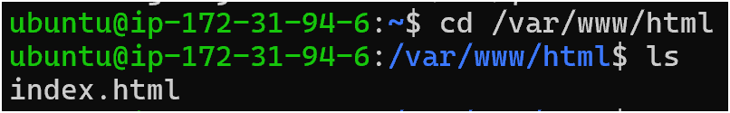

Step 11:

Copy the Public IPv4 DNS from the instance details page in the EC2 console, as shown in the image below.

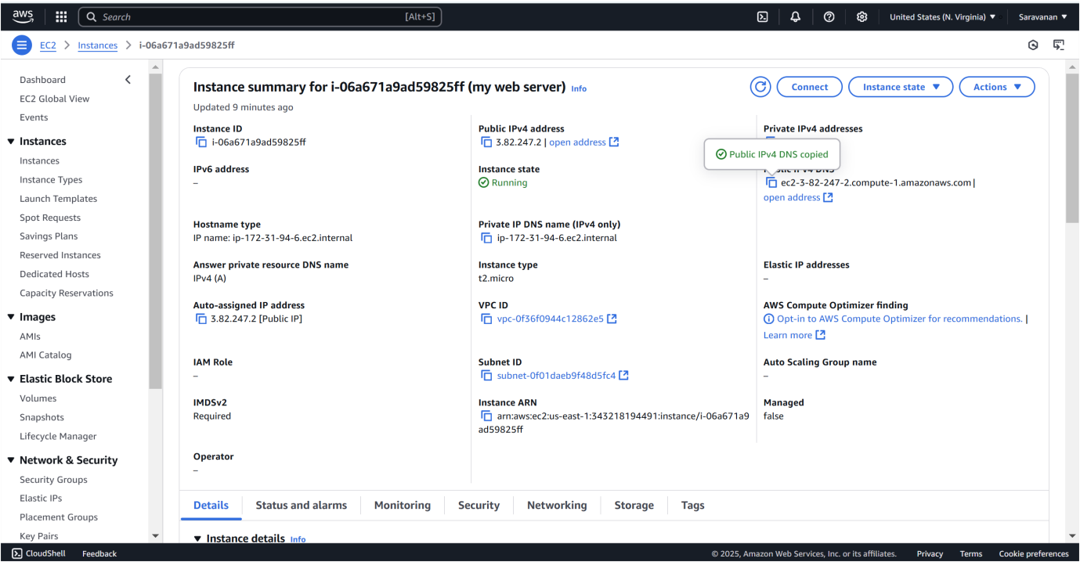

Step 12:

Open Chrome and paste the copied Public IPv4 DNS in the address bar to view the content of your index.html file.

=

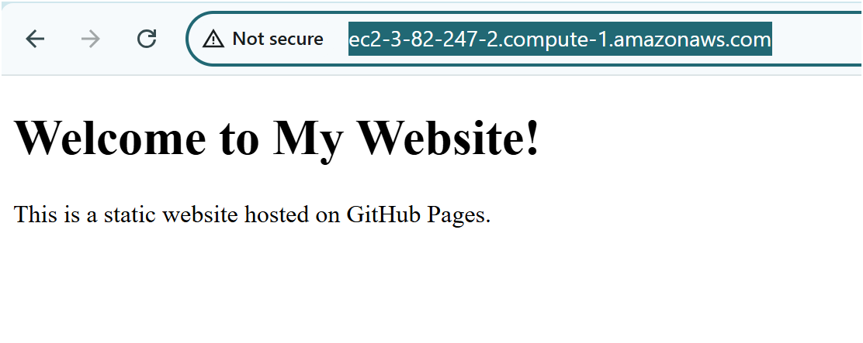

# Outcome

By completing this PoC of deploying a static website using an EC2 instance, you will:

1. Launch and configure an EC2 instance with Ubuntu as the OS.
2. Install and configure Apache web server to serve your static website.
3. Clone your GitHub repository containing your static website files (HTML, CSS, JavaScript) onto your EC2 instance.
4. Upload and place the website files in the Apache root directory (/var/www/html).
5. Access your static website live on the web using the EC2 instance's Public IPv4 DNS.